**QVX Writer Workflow**

In this KNIME Workflow, a data table is created by the Excel Reader node. The Column Filter node removes some of the columns. Our QVX Writer saves this modified table into a QVX file.

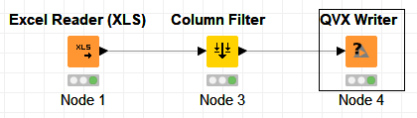

The generated QVX file can be loaded into QlikView as a data table.

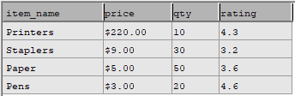

**QVX Writer**

The QVX Writer Converts a KNIME data table into a QVX file. Based on the data table’s information, the Writer can determine the data format that should be used for the QVX file.

To use the node, select an output location for the QVX file. Optionally, modify the default QVX data format by using the “Field Attributes” tab.

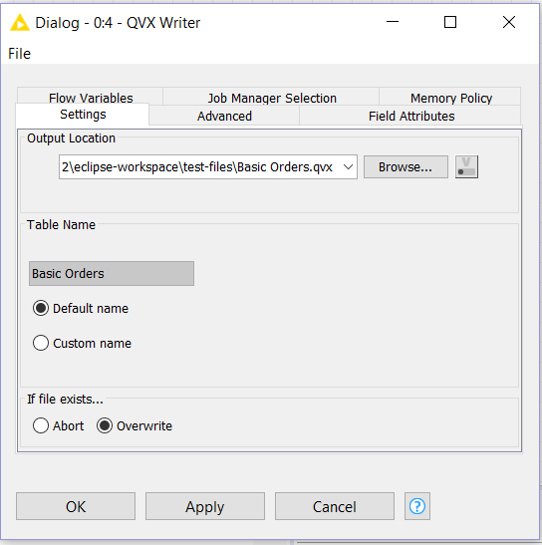



QVX Reader and QVX Writer Nodes

Monica Sangam

Matthew Belanger

KNIME is a data analytics platform. The user can load a dataset into KNIME, manipulate the data, and then produce a report (such as a chart or graph).

QlikView is a business discovery platform that can be used to analyze data. QlikView can read data from QVX files.

Our goal was to create a KNIME node that could load QVX data files. Our other goal was to create a node that could convert KNIME data into a QVX file.

**Technology Stack**

Java Development Kit 8

JAXB (Java Architecture for XML Binding)

Eclipse IDE for Java Developers (Java Oxygen 2019-12 Version 4.10.0), (Node Development Software plugins)

QLIKVIEW Personal Edition X64/X86 bit OS (Windows)

QLIKSENSE Cloud X64/X86 bit OS (Linux)

QVX Data Files

Open for Innovation KNIME 3.7.1(Plug-in Development software)

XML (Extensible Markup Language)

TXT (Text Processing Files)

CSV (Comma Separated Files)

EXCEL

**QVX Reader Workflow**

In this KNIME Workflow the

QVX Reader converts the QVX file into KNIME data table and then displays the data in an interactive table. The QVX Reader node menu execute option converts the configured QVX file into a KNIME node table. The Interactive Table node menu view option displays the data.

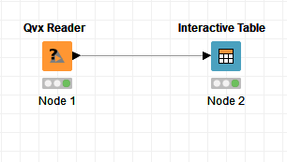

The QVX Reader can process any QVX file that meets QlikView or Qlik Sense specification.

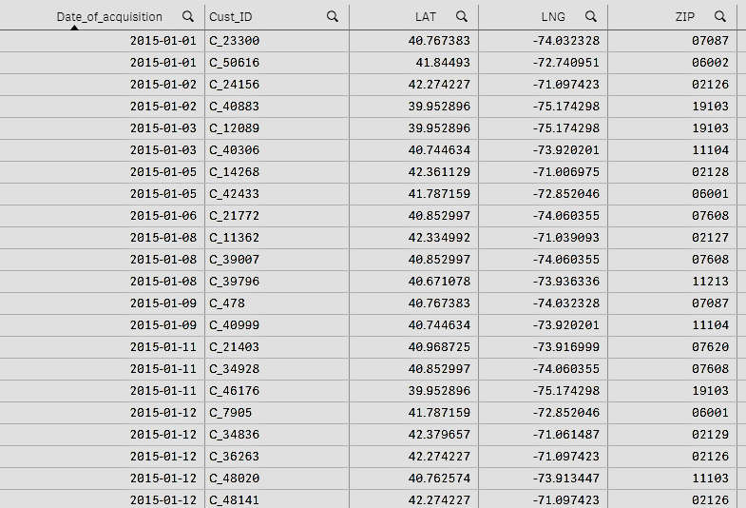

**QVX Reader**

The QVX Reader converts a QVX file into a KNIME data table. QVX Reader maps QVX data types to corresponding KNIME data types. QVX Reader node can be configured to read a file. The KNIME node menu configuration option pops up a dialog as shown below, to choose a file.

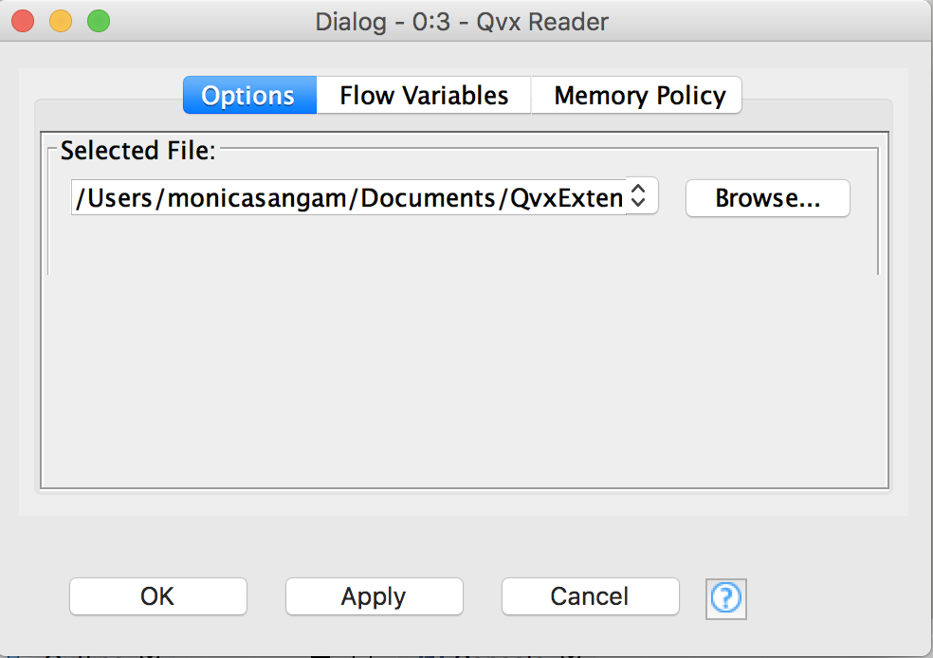

**Contact Us**

Feel free to explore more features on Qlik Sense and KNIME to get an understanding about how these two applications work together in harmony. For further clarification and questions on how Qlik View interacts with KNIME nodes.

PLEASE CONTACT US!

Monica Sangam (Project Manager)

917-645-2236

Matthew Belanger (Developer)

732-318-1109

Vidya Analytiq (Mentor)

480-410-8613

 

**About Us**

We as a team built and deployed our own KNIME node plugin on Eclipse to handle the different field attributes and file specifications required by Qlik View and Qlik Sense.

QVX files can be read and uploaded on KNIME nodes. The KNIME nodes can handle the different field attributes and data types provided by a QVX file.