**QVX Writer Workflow**

In this KNIME Workflow, a data table is created by the Excel Reader node. The Column Filter node removes some of the columns. Our QVX Writer saves this modified table into a QVX file.

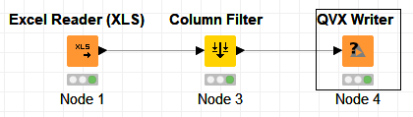

The generated QVX file can be loaded into QlikView as a data table.

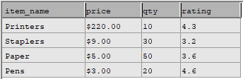

**QVX Writer**

The QVX Writer Converts a KNIME data table into a QVX file. Based on the data table’s information, the Writer can determine the data format that should be used for the QVX file.

To use the node, select an output location for the QVX file. Optionally, modify the default QVX data format by using the “Field Attributes” tab.

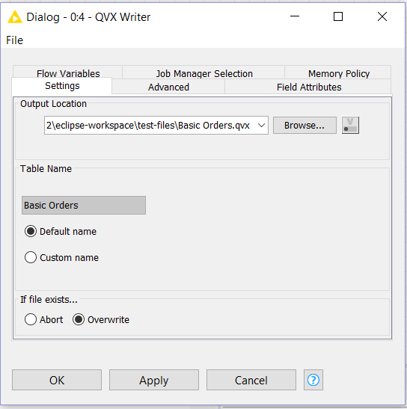



QVX Reader and QVX Writer Nodes

Monica Sangam

Matthew Belanger

KNIME is a data analytics platform. The user can load a dataset into KNIME, manipulate the data, and then produce a report (such as a chart or graph).

QlikView is a business discovery platform that can be used to analyze data. QlikView can read data from QVX files.

Our goal was to create a KNIME node that could load QVX data files. Our other goal was to create a node that could convert KNIME data into a QVX file.

**Technology Stack**

JAXB (Java Architecture for XML Binding)

Java Runtime Environment 10

Java Development Kit 8

Eclipse IDE for Java Developers (Java Oxygen 2019-12 Version 4.10.0), (Node Development Software plugins)

QLIKVIEW Personal Edition X64/X86 bit OS (Windows)

QLIKSENSE Cloud X64/X86 bit OS (Linux)

QLIKVIEW Professional and Personal Edition X64/X86 bit OS

QVX Data Files

Open for Innovation KNIME 3.7.1(Plug-in Development software)

XML (Extensible Markup Language)

TXT (Text Processing Files)

CSV (Comma Separated Files)

EXCEL

**QVX Reader Workflow**

In this KNIME Workflow use the

QVX Reader Node option to

execute the extract, load and

transform operation. The data

read from the QVX file is ready

for review in the Interactive Table

after execution.

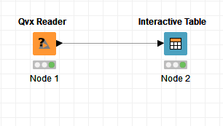

The QVX file can meet the different file specification requirements by Qlik View.

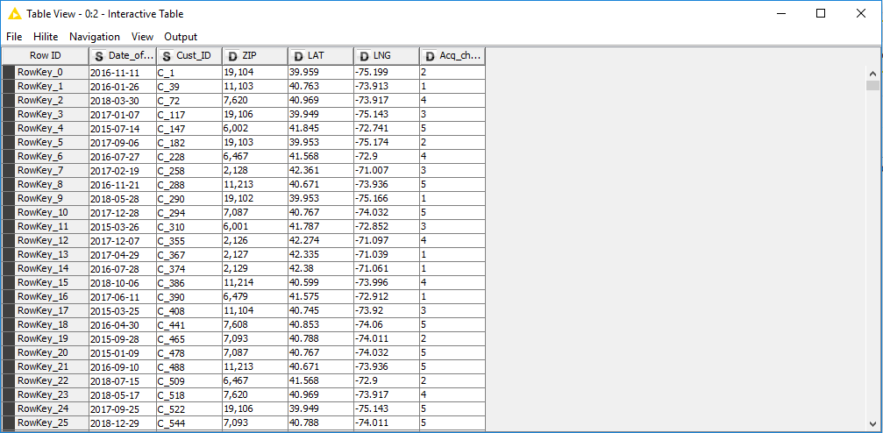

**QVX Reader**

The QVX Reader Converts a

QVX file into a KNIME data

table. Based on the QVX data

types and data format the QVX

Reader converts in to the

corresponding KNIME data types

and format. To use the node, create a QVX Reader Node. Configure the node using the node options. Configuration dialog can set a QVX file location to load and transform.

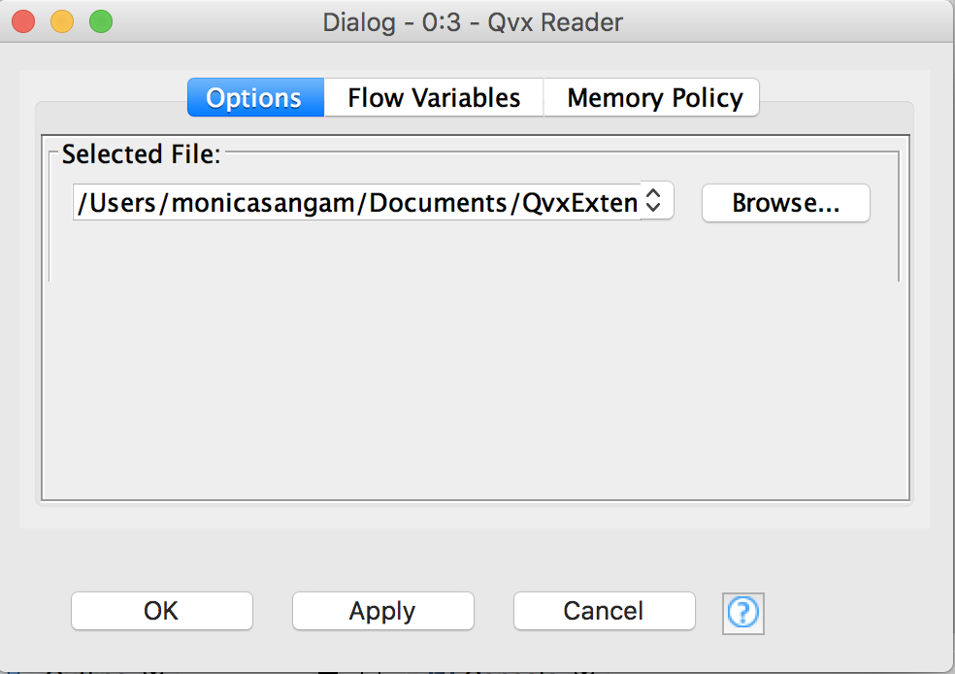

**Contact Us**

Feel free to explore more features on Qlik Sense and KNIME to get an understanding about how these two applications work together in harmony. For further clarification and questions on how Qlik View interacts with KNIME nodes.

PLEASE CONTACT US!

Monica Sangam (Project Manager)

9176452236

Matthew Belanger (Developer)

7323181109

Vidya Analytiq (Mentor)

4804108613

 

**About Us**

We as a team built and deployed our own KNIME node plugin on Eclipse to handle the different field attributes and file specifications required by Qlik View and Qlik Sense.

QVX files can be read and uploaded on KNIME nodes. The KNIME nodes can handle the different field attributes and data types provided by a QVX file.