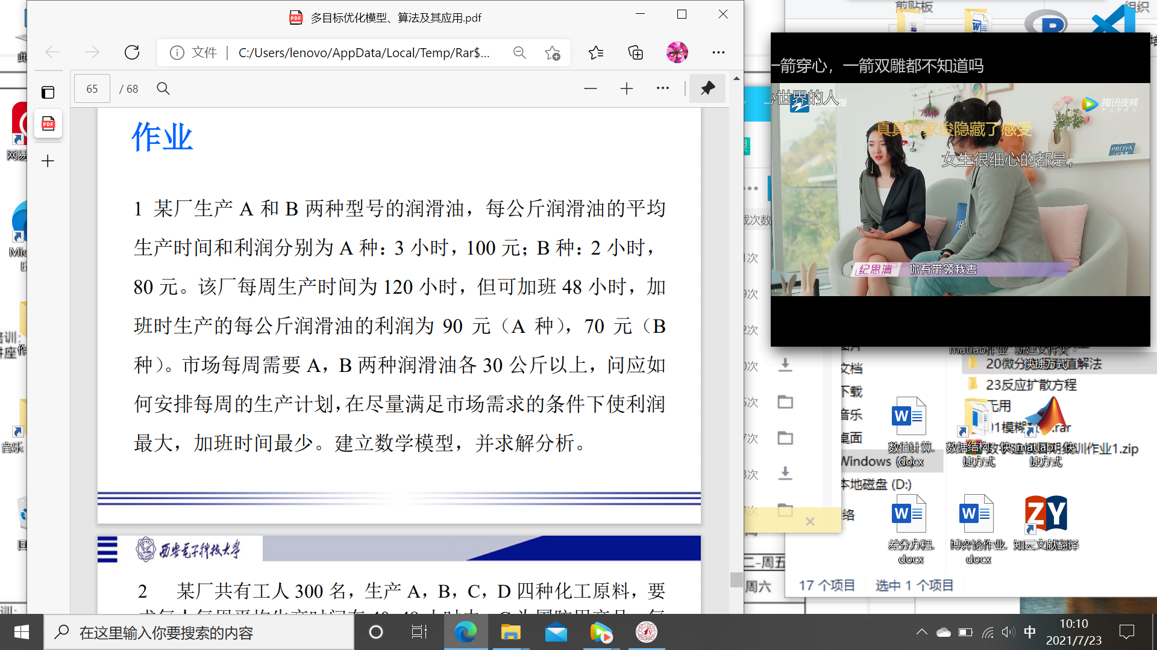

A种x，a，B种y，b

max 100x+90a+80y+70b

min 3a+2b

{ 3x+2y<=120

3a+2b<=48

x+a>=30

y+b>=30

x,y,a,b>=0

}

