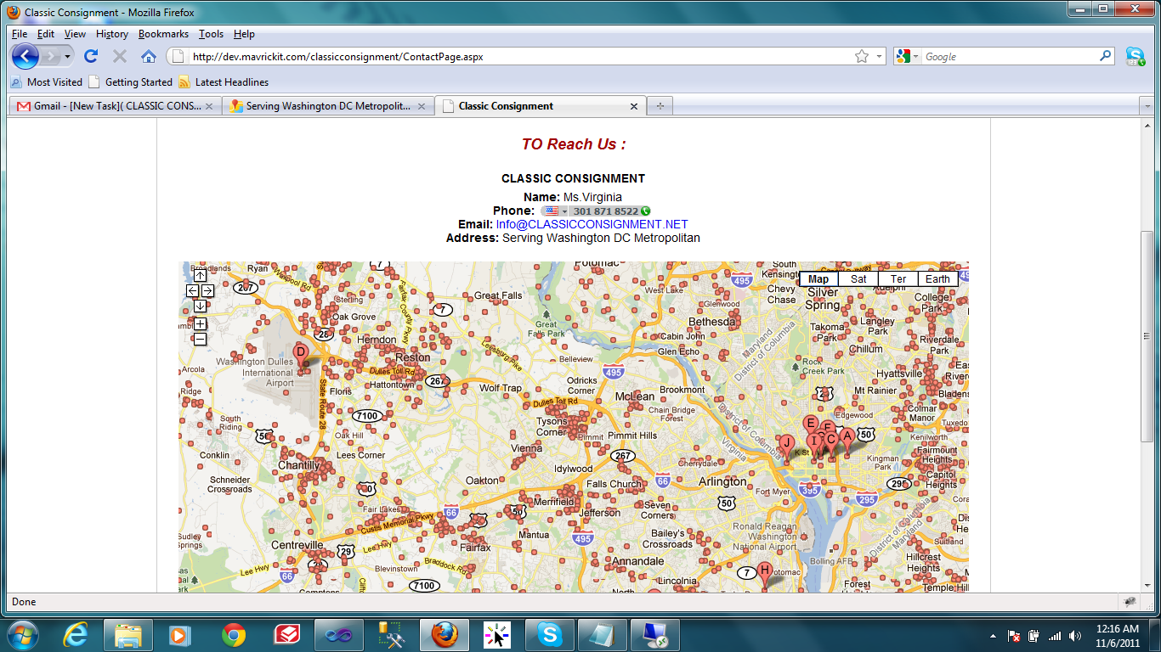

If the recommended address ” Serving Washington DC Metropolitan ” is taken , then the location map is showing the above image that is not correct.

**So, Please give the correct location address.**