Technical University of Cluj-Napoca

Faculty of Electronics, Telecommunications and Information Technology

DOCUMENTATION

Title: Speech recognition and recordings
Name: Bobos Anamaria
Group: 2331
Subject: Microprocessors

1. Introduction… page 2
2. Theoretical background… page 3
3. Implementation… page 4
4. Results… page 7
5. Conclusions… page 8
6. Bibliography… page 8

1) Introduction

Why speech recognition?

I chose to do the project about the matter of speech recognition because it is a theme of actuality, based on the principles of artificial intelligence, which represents the most important part of our future.
The project itself is created using python, in the PyCharm environment, on Ubuntu. The aim of the project is to show how easy a vocal message can be recorded using the most spread programming language, how a vocal message can be transformed into text and saved in a file of your choice.
This project is meant to give perspective on how the artificial intelligence works and how we can use it as programmers in our life and activities.

Brief description of how the project was done

Speech recognition sounds really hard to accomplish, yet there are so many apps that are already using it at a high level.
My project shows a sneak peak into what is possible.
It starts with how you can use python to record a vocal message that is automatically saved in a new file, then it moves to how you can record a vocal message or use a recording to get the result into text that is shown either on the screen or in a new file. This can be all done by using simple google predefined functions and functions with parameters from packages that the PyCharm environment can support and provide, such as pyaudio or speech_recognition.

2) Theoretical background

Theme related:

Over the past few decades, there has been tremendous development in machine learning paradigms used in automatic speech recognition for home automation to space exploration. Though commercial speech recognizers are available for certain well-defined applications like dictation and transcription, many issues in automatic speech recognition like recognition in noisy environments, multilingual recognition, and multi-modal recognition are yet to be addressed effectively.
Automatic Speech Recognition takes speech as the research object, which enables machines to automatically recognize and understand human oral language through speech signal processing and pattern recognition.

Working principle related:

Pyttsx is a cross-platform text to speech library which is platform independent. The major advantage of using this library for text-to-speech conversion is that it works offline. It only works good in Python 2.0.

Relevant for the recording part:
Voice is a signal, an analog signal to be precise and therefore properties like amplitude,frequency is taken into account to recognize the words as individuals.
PyAudio provides Python bindings for PortAudio v19, the cross-platform audio I/O library. With PyAudio, you can easily use Python to play and record audio on a variety of platforms

3) Implementation

For this project, the following packages provided and supported by Python 3.0 were required:
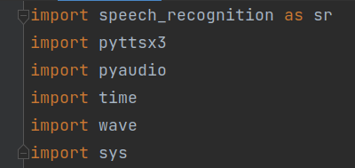

For the speech recognition part, I used the packages speech_recognition, pyttsx3, and pyaudio, and for the recording part, wave is used. The package time is used to make the program pause when running for as many seconds as given, and the package sys was necesarry for the files to be opened and recognised.

The following part provides the code for creating a recording:
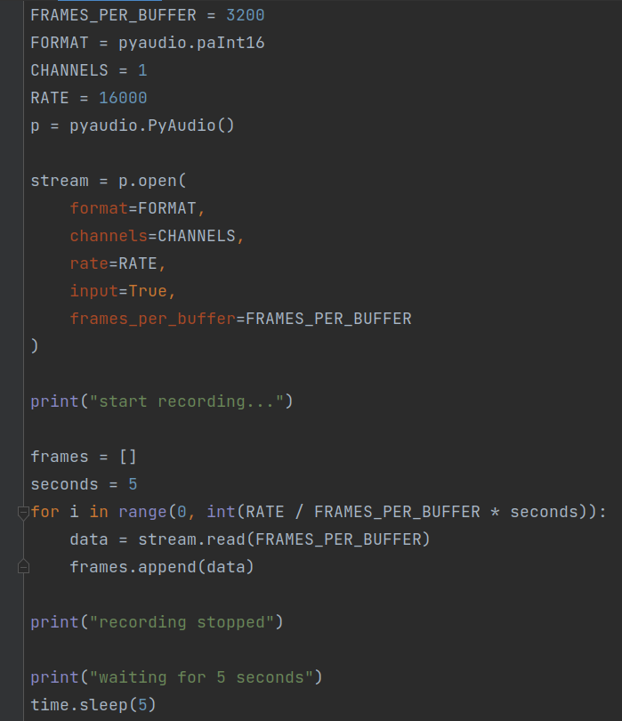

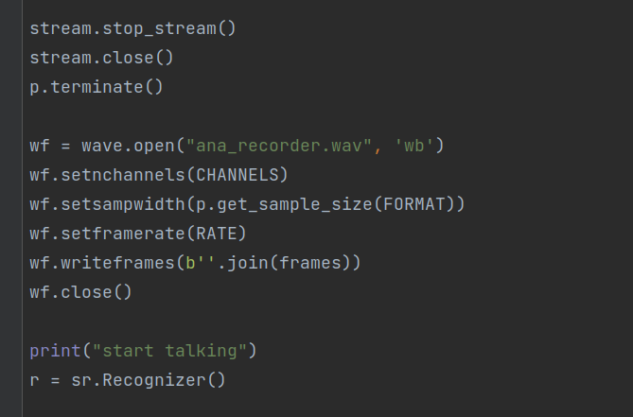

When running the code, a message is shown that gives permission to start recording for 5 seconds when the stream opens. After those 5 seconds, the recording stops, the wav file is opened and a few functions are called- as wf.setnchannels- which set the parameters of the recording that is going to be saved in the file.
The parameters saved in the stream are based on the fact that the recording works as an analog signal which has to be converted.
The principle is really simple to implement.

In the following part, two functions are used to record a new message that is going to be shown on the screen using some google predefined functions:

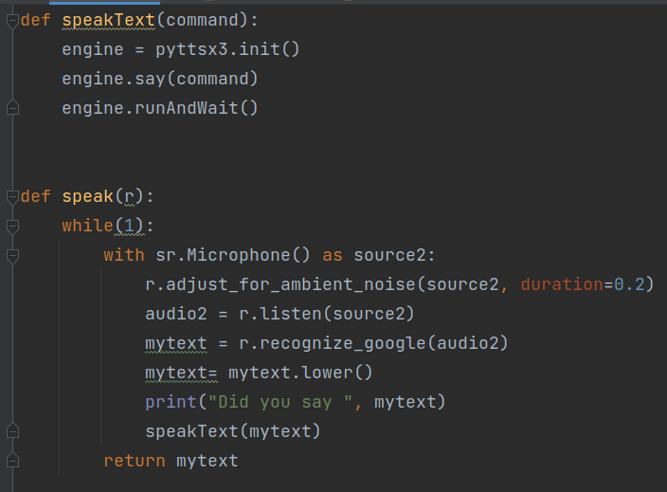

The function speakText uses the package pyttsx3, which is required to get permission to access and use the predefined functions in the next function speak.
There are a few steps to follow: First, the microphone needs to be set for the current device to be able to access it. Then the recording signal must be adjusted to reduce the ambient noise that may interfere in the transcription. The two functions are called, listen and recognize_google, which make the transcription possible. Then on the screen the message should appear.

In the last part, the transcription should be saved in a new txt file.
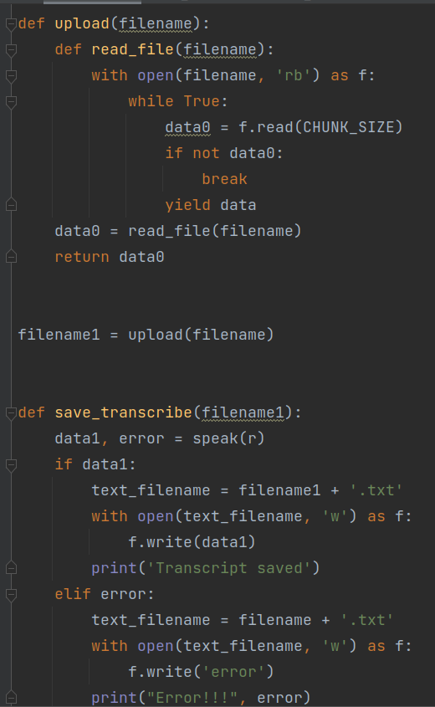

The first function has to open a file which has some parameters necessary when using the package sys, like chunk_size, which is meant to set the size of the file. Then in the save_transcribe, the data from the transcription is verified and a message is shown on the screen as the new txt in which the text has to appear is created.
Here, I had some issues regarding the usage of pptsx3, which is sometimes not supported on python 3.0 and therefore I wasn’t able to solve the errors yet, so the saving of the transcription in the file is not working properly.

4) Results:

After we press run, we can start recording the 5 seconds message which is then gonna be saved in ana_recorder.wav and opened with VLC media player

The message I chose to record was Hello, my name is Anamaria.

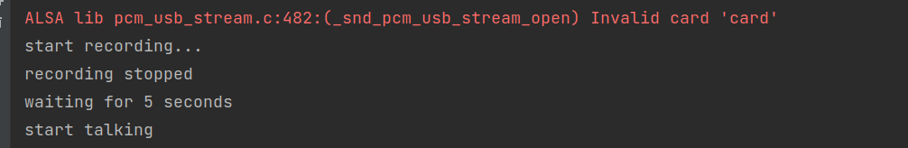
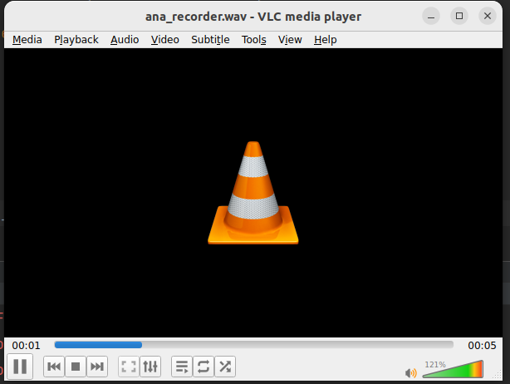

After waiting for 5 seconds, a new message will appear- ‘start talking’. The result is:
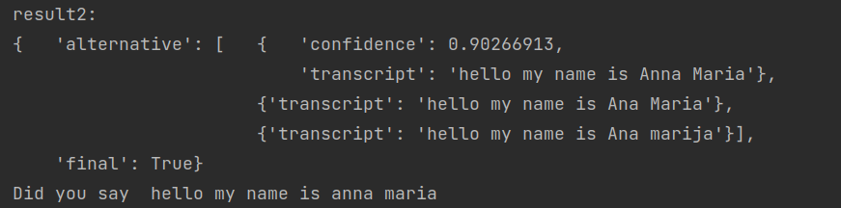

The errors that I’m still trying to solve are:
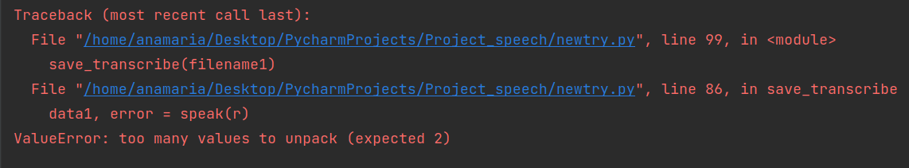
5) Conclusion

Although automatical speech recognition may seem really complicated to be made by a beginner, the python programming tools offer some very easy ways to play with audio signals and data processing.
As shown in the presented project, python has a lot of packages and predefined functions that can work together in helping the purpose of learning how speech recognition works and creating a project of your own.

6) Bibliography

https://en.speechocean.com/Cy/478.html

https://www.geeksforgeeks.org/python-text-to-speech-pyttsx-module/?ref=lbp

https://pypi.org/project/PyAudio/

https://youtu.be/mYUyaKmvu6Y

https://www.assemblyai.com/

