

Data Technician

Name:
Course Date:
Table of contents
Day 1: Task 1 3
Day 1: Task 2 3
Day 3: Task 1 4
Day 4: Task 1: Written 6
Day 4: Task 2: SQL Practical 9
Course Notes 19
Additional Information 19

Day 1: Task 1

Please research and complete the below questions relating to key concepts of databases.

What is a primary key? | A primary key is a field (or a combination of fields) in a database table that uniquely identifies each record in that table.  In simple terms:  👉 it’s how the database knows “this row is this exact thing, and no other.”  Key Characteristics of a Primary Key  A primary key must:  - Be unique  - No two rows can have the same primary key value.  - Never be NULL  - Every record must have a value for it.  - Be stable  - It shouldn’t change over time.  Example (Bookstore)  Books Table  BookID (PK) Title Author  1 1984 George Orwell  2 The Hobbit J.R.R. Tolkien  Here:  - BookID is the primary key  - Even if two books had the same title, their BookID would still be different
How does this differ from a secondary key? | Secondary Key  A secondary key is an attribute used to search, sort, or filter data, but it does not uniquely identify records.  Key points:  - May contain duplicates  - Can be NULL  - Used for retrieval, not identification  - A table can have many secondary keys  - Often implemented as an index  Example (Books table):  - Author  - Title  - ISBN (if not defined as the primary key)
How are primary and foreign keys related? | They’re directly connected — a foreign key exists because of a primary key.  Here’s the clear explanation 👇  Relationship Between Primary and Foreign Keys  Primary Key (PK)  - Uniquely identifies a record in its own table  Foreign Key (FK)  - Is a field in one table that references the primary key in another table  - Creates a link (relationship) between tables  How They Work Together  - A primary key defines what a record is  - A foreign key points to it and says “this record is related to that one”  Example (Bookstore)  Customers Table  CustomerID (PK) Name  1 Ana  2 John  Orders Table  OrderID (PK) CustomerID (FK)  101 1  102 2  - CustomerID is the primary key in Customers  - CustomerID in Orders is a foreign key  - Order 101 belongs to Ana  Key Rules of the Relationship  - A foreign key references a primary key  - The value in a foreign key must exist in the referenced primary key (or be NULL if allowed)  - One primary key can be referenced by many foreign keys  - This enforces referential integrity
Provide a real-world example of a one-to-one relationship | A clear real-world example of a one-to-one (1:1) relationship is:  Person ↔ Passport  Why this is one-to-one:  - One person can have one passport  - One passport belongs to one person  - A passport cannot exist without a person, and a person cannot share a passport  Database Example  Person  - PersonID (Primary Key)  - Name  - DateOfBirth  Passport  - PassportNumber (Primary Key)  - IssueDate  - ExpiryDate  - PersonID (Foreign Key, UNIQUE)  Here:  PersonID in Passport is both a foreign key and unique, enforcing the 1:1 relationship. Other Real-World One-to-One Examples  - Employee ↔ Company ID card  - Vehicle ↔ Vehicle Identification Number (VIN)  - Student ↔ Student locker (if each student has exactly one locker)
Provide a real-world example of a one-to-many relationship | A very common real-world example of a one-to-many (1:M) relationship is:  Customer → Orders  Why this is one-to-many:  - One customer can place many orders  - Each order belongs to one customer only  Database Example  Customers  - CustomerID (Primary Key)  - Name  - Email  Orders  - OrderID (Primary Key)  - OrderDate  - CustomerID (Foreign Key)  Here:  - CustomerID in Orders links back to CustomerID in Customers  More Real-World One-to-Many Examples  - Teacher → Students  - Author → Books  - Department → Employees  - Parent → Children  ERD Representation (Text)  CUSTOMERS (1) ────< (M) ORDERS
Provide a real-world example of a many-to-many relationship | A classic real-world example of a many-to-many (M:M) relationship is:  Students ↔ Courses  Why this is many-to-many:  - One student can enrol in many courses  - One course can have many students  How This Works in a Database  Many-to-many relationships are handled using a junction (link) table.  Students  - StudentID (Primary Key)  - Name  Courses  - CourseID (Primary Key)  - CourseName  Enrollments (Junction Table)  - EnrollmentID (Primary Key)  (or a composite key: StudentID + CourseID)  - StudentID (Foreign Key)  - CourseID (Foreign Key)  - EnrollmentDate  ERD Representation (Text)  STUDENTS (M) ───< ENROLLMENTS >─── (M) COURSES  Other Real-World Many-to-Many Examples  - Books ↔ Authors  - Orders ↔ Products  - Actors ↔ Movies  - Doctors ↔ Patients

Day 1: Task 2

Please research and complete the below questions relating to key concepts of databases.

What is the difference between a relational and non-relational database? | Relational vs Non-Relational Databases  Relational Database (SQL)  A relational database stores data in tables made up of rows and columns, with relationships defined using keys.  Key characteristics:  - Structured, fixed schema  - Uses tables  - Relationships via primary & foreign keys  - Uses SQL  - Strong data consistency (ACID)  Examples:  - MySQL  - PostgreSQL  - Oracle  - SQL Server  Example:  Customers  ---------  CustomerID (PK)  Name  Email  Orders  ---------  OrderID (PK)  CustomerID (FK)  OrderDate  Non-Relational Database (NoSQL)  A non-relational database stores data in flexible formats, not fixed tables.  Key characteristics:  - Schema-less or flexible schema  - No fixed tables  - Designed for large-scale, fast, distributed data  - Relationships handled in application logic  - High scalability  Types of NoSQL databases:  - Document (MongoDB)  - Key-Value (Redis)  - Column-Family (Cassandra)  - Graph (Neo4j)  Example (Document database):  {  "customerId": 1,  "name": "Ana",  "orders": [  { "orderId": 101, "date": "2026-02-01" },  { "orderId": 102, "date": "2026-02-10" }  ]  }  Side-by-Side Comparison  Feature Relational Non-Relational  Structure Tables Documents / Key-Value / Graph  Schema Fixed Flexible  Relationships Keys (PK/FK) Embedded or referenced  Query language SQL Varies  Scalability Vertical Horizontal  Best for Structured data Big / unstructured data  Real-World Analogy  - Relational DB → Excel with linked sheets  - Non-Relational DB → Folder of JSON files
What type of data would benefit off the non-relational model?  Why? | Data that benefits from a non-relational (NoSQL) model — and why  Non-relational databases are best for data that is large-scale, flexible, fast-changing, or highly connected, where strict table structure becomes a limitation.  1. Unstructured or Semi-Structured Data  Examples:  - Social media posts  - Blog articles  - Comments  - Reviews  - Logs  Why it benefits:  - Data fields vary from record to record  - No need to redesign tables when new fields appear  - Easy to store text, images, metadata together  ➡️ Document databases (e.g. MongoDB) excel here.  5. Relationship-Heavy Data (Graph-Based)  Examples:  - Social networks  - Recommendation engines  - Fraud detection  - Knowledge graphs  Why it benefits:  - Relationships are first-class citizens  - Fast traversal of connections  - More efficient than SQL joins  ➡️ Graph databases (e.g. Neo4j) shine here.

Day 3: Task 1

Please research the below ‘JOIN’ types, explain what they are and provide an example of the types of data it would be used on.

Self-join | 1. Self JOIN  What it is  A self join is when a table is joined to itself.  You use it when rows in the same table are related to other rows in that same table.  When it’s used  - Employee → manager relationships  - Parent → child relationships  - Comparing rows within the same table  Example data  Employees table  employee_id name manager_id  1 Ana NULL  2 John 1  3 Maria 1  Here, manager_id refers back to employee_id in the same table.  Use case:  Find each employee and their manager’s name.
Right join | 2. RIGHT JOIN  What it is  A RIGHT JOIN returns:  - All rows from the right table  - Matching rows from the left table  - NULL where there is no match on the left  When it’s used  - When the right table is more important  - When you want to keep all records from the right table  Example data  Orders (left)  Customers (right)  Use case:  Show all customers, even those who haven’t placed an order.  If a customer has no order → order columns will be NULL.
Full join | 3. FULL JOIN (FULL OUTER JOIN)  What it is  A FULL JOIN returns:  - All rows from both tables  - Matches where possible  - NULL where no match exists on either side  When it’s used  - Data comparison  - Finding missing records in either table  Example data  Students and Enrolments  Use case:  - Students with no enrolment  - Enrolments with no matching student  You get everything from both tables.
Inner join | 4. INNER JOIN  What it is  An INNER JOIN returns only rows that match in both tables.  When it’s used  - Most common JOIN  - When you only want valid, related records  Example data  Orders and Customers  Use case:  Show orders only where a customer exists.  If there’s no match → the row is excluded.
Cross join | 5. CROSS JOIN  What it is  A CROSS JOIN returns the Cartesian product:  - Every row in table A paired with every row in table B  When it’s used  - Generating combinations  - Timetables  - Product variations  Example data  Sizes table  size  S  M  L  Colours table  colour  Red  Blue  Result:  S-Red, S-Blue, M-Red, M-Blue, L-Red, L-Blue
Left join | 6. LEFT JOIN  What it is  A LEFT JOIN returns:  - All rows from the left table  - Matching rows from the right table  - NULL where there’s no match on the right  When it’s used  - When the left table is the main focus  - Finding missing related data  Example data  Customers (left) and Orders (right)  Use case:  Show all customers, including those without orders.  Customers with no orders → order fields are NULL.

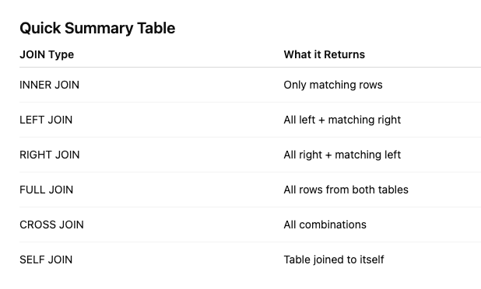

Day 4: Task 1: Written

In your groups, discuss and complete the below activity. You can either nominate one writer or split the elements between you. Everyone however must have the completed work below:

Imagine you have been hired by a small retail business that wants to streamline its operations by creating a new database system. This database will be used to manage inventory, sales, and customer information. The business is a small corner shop that sells a range of groceries and domestic products. It might help to picture your local convenience store and think of what they sell. They also have a loyalty program, which you will need to consider when deciding what tables to create.

Write a 500-word essay explaining the steps you would take to set up and create this database. Your essay should cover the following points:
- Understanding the Business Requirements:
  - What kind of data will the database need to store?
  - Who will be the users of the database, and what will they need to accomplish?
- Designing the Database Schema:
  - How would you structure the database tables to efficiently store inventory, sales, and customer information?
  - What relationships between tables are necessary (e.g., how sales relate to inventory and customers)?
- Implementing the Database:
  - What SQL commands would you use to create the database and its tables?
  - Provide examples of SQL statements for creating tables and defining relationships between them.
- Populating the Database:
  - How would you input initial data into the database? Give examples of SQL INSERT statements.
- Maintaining the Database:
  - What measures would you take to ensure the database remains accurate and up to date?
  - How would you handle backups and data security?

Your essay should include specific examples of SQL commands and explain why each step is necessary for creating a functional and efficient database for the retail business.

Please write your 500-word essay here | 1. Understanding the Business Requirements:  - What kind of data will the database need to store?  Designing a database for a small retail business begins with understanding its needs. The database should store inventory information (product names, categories, stock levels, prices), sales (dates, quantities, totals, and payment methods), and customer information, including loyalty program details such as names, contact information, membership IDs, points, and purchase history.  To meet these needs, three tables can be created: Inventory for product details, Sales to record transactions linking products and customers, and Customers to manage personal and loyalty information.  - Who will be the users of the database, and what will they need to accomplish?  The main users are store staff: cashiers need to process sales efficiently, inventory managers monitor stock levels and reorder products, and the owner requires reports on sales, inventory, and customer activity to make informed decisions.  2. Designing the Database Schema  Figure 1: Corner_Shop ERD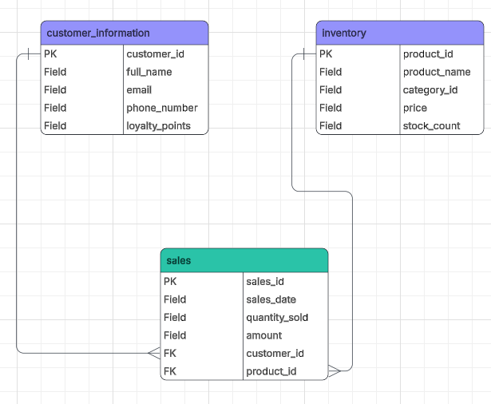  Above is the schema used for our database design. There are 3 entity tables which are named “sales”, “inventory” and “customer_inventory”, customer_information’s primary key is customer_id in the sales table as foreign key and the inventory’s primary key is product_id in the sales table as a foreign key.  3. Implementing the Database  The implementation process begins by establishing the database environment using the CREATE DATABASE command. Once the database is set up, the tables are created to organize the data efficiently. The independent tables are created first to store core information like customer details and inventory, utilizing specific data types and constraints to ensure accuracy. Finally, the transaction table is established. This table uses Foreign Keys to link back to the independent tables, creating a relational structure that ensures every sale is correctly associated with a specific customer and product.  CREATE DATABASE CornerShopDB;  USE CornerShopDB;  CREATE TABLE customer_information (  customer_id INT AUTO_INCREMENT PRIMARY KEY,  full_name VARCHAR(100) NOT NULL,  email VARCHAR(100) NOT NULL,  phone_number VARCHAR(15),  loyalty_points INT DEFAULT 0  );  CREATE TABLE inventory (  product_id INT AUTO_INCREMENT PRIMARY KEY,  product_name VARCHAR(100) NOT NULL,  category_id INT,  price DECIMAL(10, 2) NOT NULL,  stock_count INT DEFAULT 0  );  CREATE TABLE sales (  sale_id INT AUTO_INCREMENT PRIMARY KEY,  sale_date DATETIME DEFAULT CURRENT_TIMESTAMP,  quantity_sold INT NOT NULL,  amount DECIMAL(10, 2) NOT NULL,  customer_id INT,  product_id INT,  FOREIGN KEY (customer_id) REFERENCES customer_information(customer_id),  FOREIGN KEY (product_id) REFERENCES inventory(product_id)  );  2B DESIGNING DATABASE SCHEMA  The database establishes logical connections between customers and sales and inventory and the loyalty program. A customer can make multiple purchases. The sale records all products that were sold together with their respective quantities. The system automatically decreases product stock levels after a sale because it needs to maintain accurate inventory records. The shop tracks inventory products to maintain constant knowledge of available stock levels. Customers who join the loyalty programme are linked to a loyalty account which records points earned or used during purchases allowing the shop to track rewards accurately.  Q4:  Using the table relationships as a guide, I added data to the database in a logical order. In order for each sale to use a legitimate customer_id, I first added customer records. After that, I added inventory information to make sure every product was there before it was connected to sales. Lastly, I connected each transaction to a customer and a product by adding sales records. This method guarantees consistency in stock levels, sales totals, and loyalty points while also preserving referential integrity.  INSERT INTO customer_information  (customer_id, full_name, email, phone_number, loyalty_points)  VALUES  (1, 'Amina Khan', 'amina.khan@email.com', '07123456789', 120),  (2, 'Tom Baker', 'tom.baker@email.com', '07987654321', 40);  INSERT INTO inventory  (product_id, product_name, category_id, price, stock_count)  VALUES  (101, 'Basmati Rice 1kg', 1, 2.49, 15),  (102, 'Washing Up Liquid 500ml', 2, 1.29, 30),  (103, 'Milk 2L', 1, 1.65, 24);  INSERT INTO sales  (sales_id, sales_date, quantity_sold, amount, customer_id, product_id)  VALUES  (5001, '2026-02-05', 2, 4.98, 1, 101),  (5002, '2026-02-05', 1, 1.29, 2, 102),  (5003, '2026-02-05', 1, 1.65, 1, 103);  Q5a. What measures would you take to ensure the database remains accurate and up to date?  Automation, reduce manual input with enforce standardized data entry rules, implement automated validation during entry, conduct regular audits and cleansing, establish clear data governance policies. Proactive monitoring and prompt correction of issues are key to preventing data decay.  provide staff training, and build in feedback loops for continuous improvement.  b. How would you handle backups and data security  Backup policy- Daily/weekly? Local backups (external drives), Cloud backups, Hybrid solutions that combine both  Enable multi-factor authentication.  Encryption, Encrypt all sensitive data.  User access controls, Regular vulnerability assessments, Secure data storage and transfer  Use automated and encrypted backups, Educate employees on security best practices.  Limit access with role-based permissions.  Regularly test and audit security systems

Day 4: Task 2: SQL Practical

In your groups, work together to answer the below questions. It may be of benefit if one of you shares your screen with the group and as a team answer / take screen shots from there.

Setting up the database:

- Download world_db(1)
- Follow each step to create your database

For each question I would like to see both the syntax used and the output.

- Count Cities in USA: Scenario: You've been tasked with conducting a demographic analysis of cities in the United States. Your first step is to determine the total number of cities within the country to provide a baseline for further analysis.

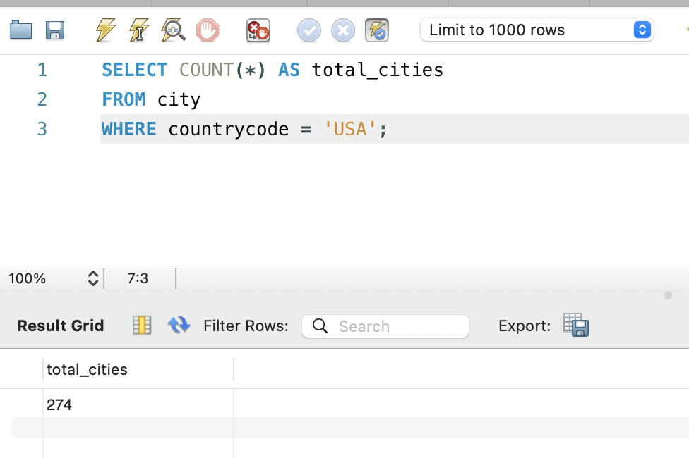

- Country with Highest Life Expectancy: Scenario: As part of a global health initiative, you've been assigned to identify the country with the highest life expectancy. This information will be crucial for prioritising healthcare resources and interventions.

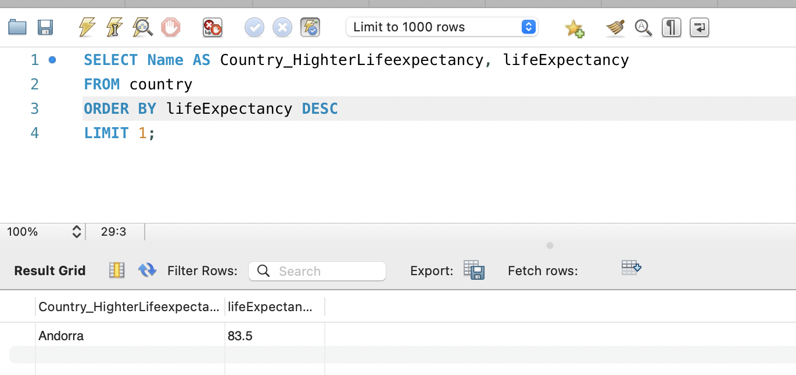

- "New Year Promotion: Featuring Cities with 'New : Scenario: In anticipation of the upcoming New Year, your travel agency is gearing up for a special promotion featuring cities with names including the word 'New'. You're tasked with swiftly compiling a list of all cities from around the world. This curated selection will be essential in creating promotional materials and enticing travellers with exciting destinations to kick off the New Year in style.

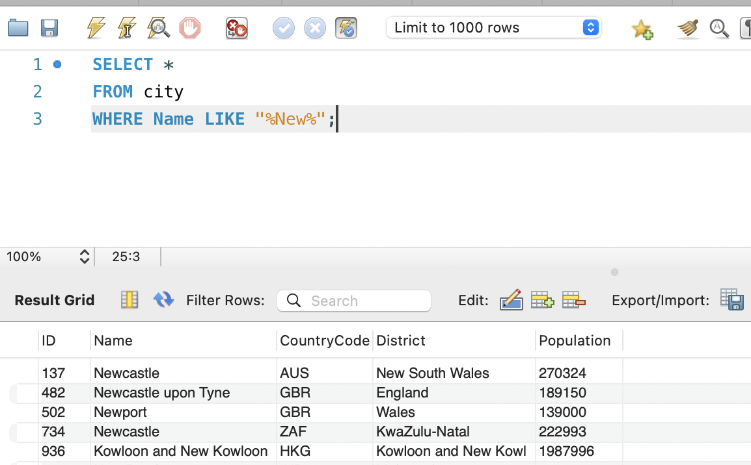

- Display Columns with Limit (First 10 Rows): Scenario: You're tasked with providing a brief overview of the most populous cities in the world. To keep the report concise, you're instructed to list only the first 10 cities by population from the database.

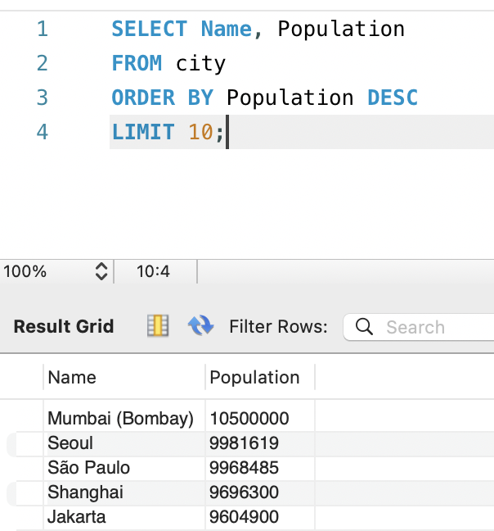

- Cities with Population Larger than 2,000,000: Scenario: A real estate developer is interested in cities with substantial population sizes for potential investment opportunities. You're tasked with identifying cities from the database with populations exceeding 2 million to focus their research efforts.

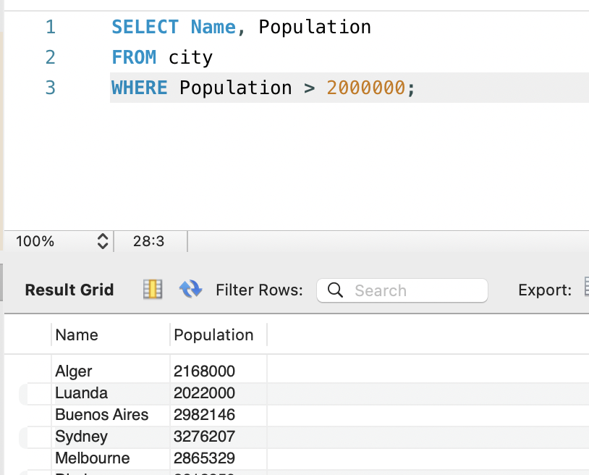

- Cities Beginning with 'Be' Prefix: Scenario: A travel blogger is planning a series of articles featuring cities with unique names. You're tasked with compiling a list of cities from the database that start with the prefix 'Be' to assist in the blogger's content creation process.

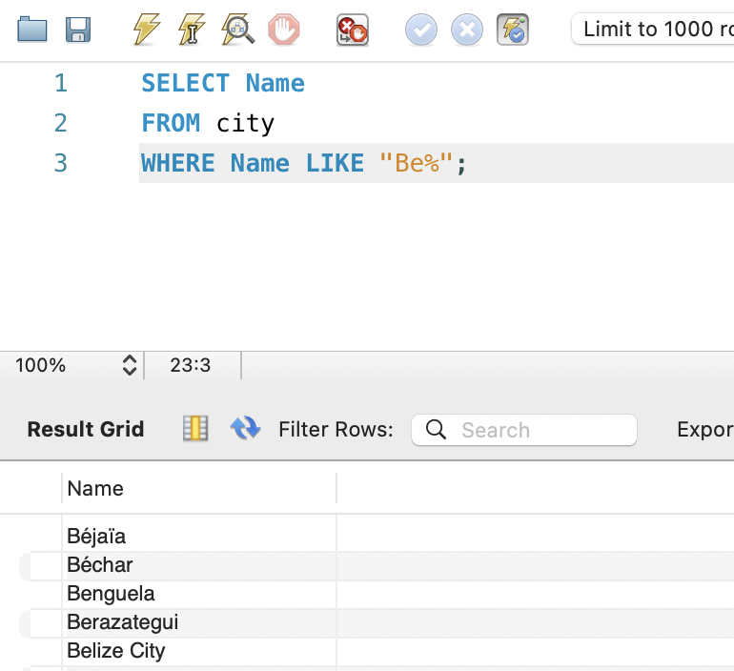

- Cities with Population Between 500,000-1,000,000: Scenario: An urban planning committee needs to identify mid-sized cities suitable for infrastructure development projects. You're tasked with identifying cities with populations ranging between 500,000 and 1 million to inform their decision-making process.

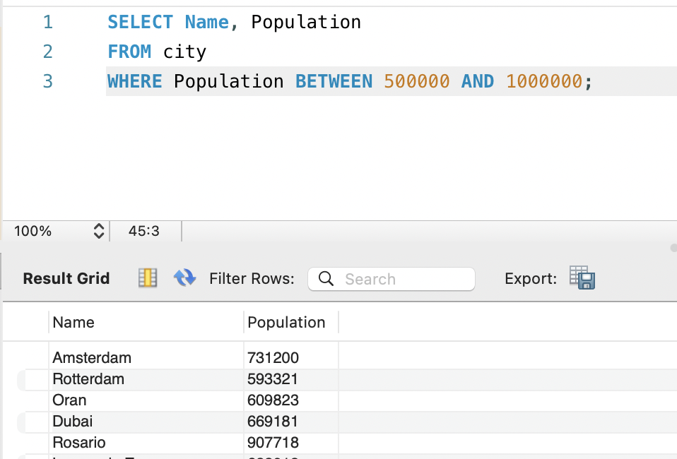

- Display Cities Sorted by Name in Ascending Order: Scenario: A geography teacher is preparing a lesson on alphabetical order using city names. You're tasked with providing a sorted list of cities from the database in ascending order by name to support the lesson plan.

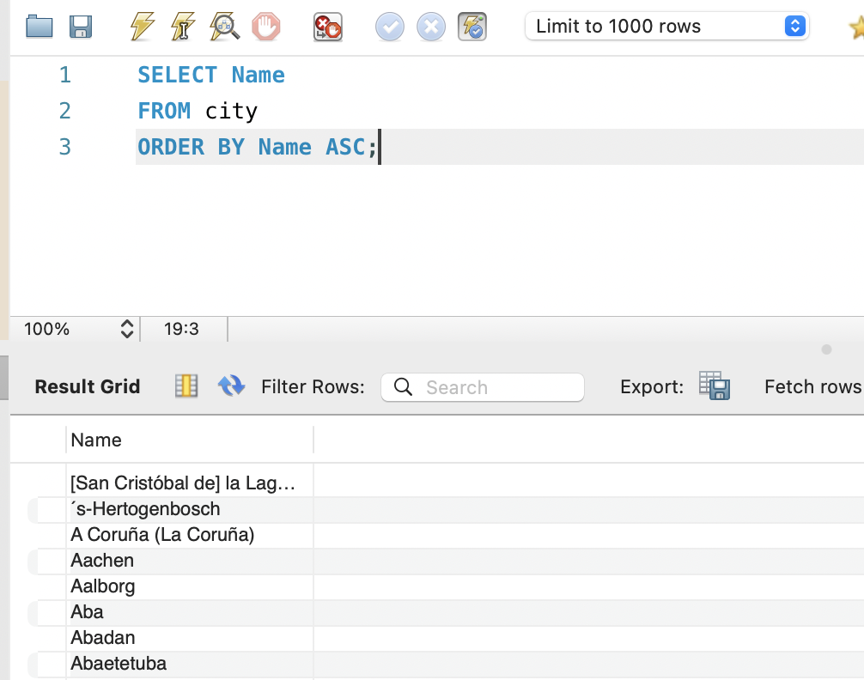

- Most Populated City: Scenario: A real estate investment firm is interested in cities with significant population densities for potential development projects. You're tasked with identifying the most populated city from the database to guide their investment decisions and strategic planning.

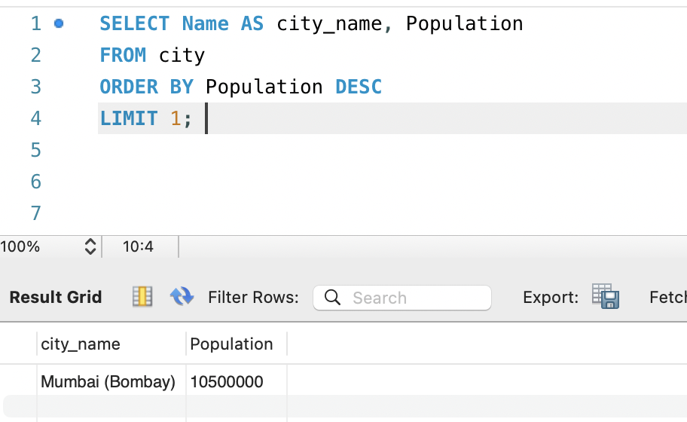

- City Name Frequency Analysis: Supporting Geography Education Scenario: In a geography class, students are learning about the distribution of city names around the world. The teacher, in preparation for a lesson on city name frequencies, wants to provide students with a list of unique city names sorted alphabetically, along with their respective counts of occurrences in the database. You're tasked with this sorted list to support the geography teacher.

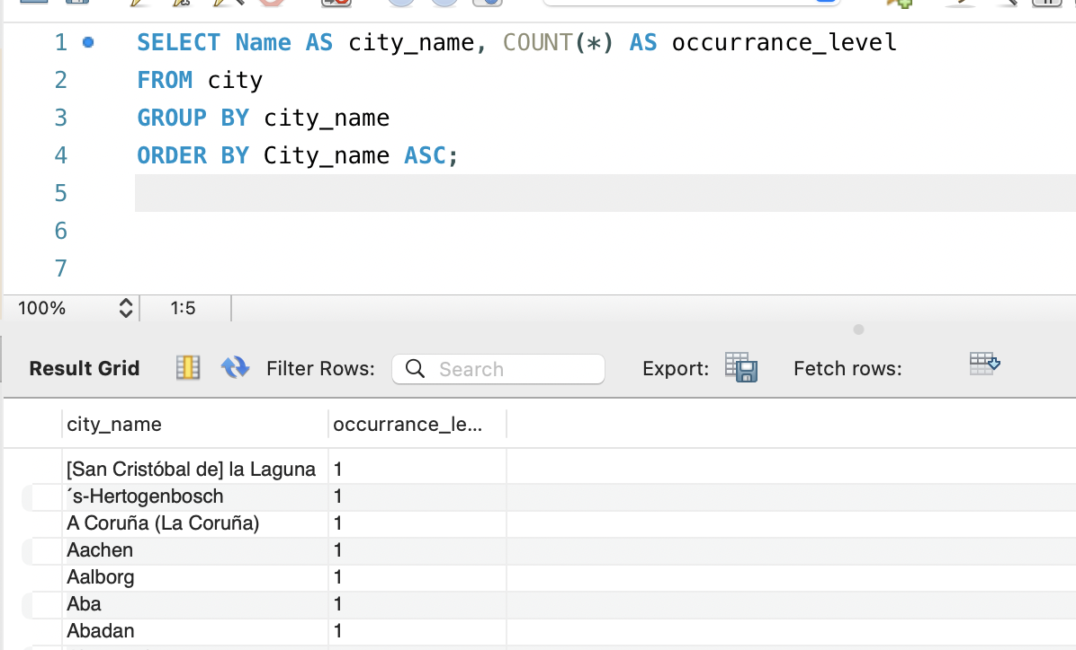

- City with the Lowest Population: Scenario: A census bureau is conducting an analysis of urban population distribution. You're tasked with identifying the city with the lowest population from the database to provide a comprehensive overview of demographic trends.

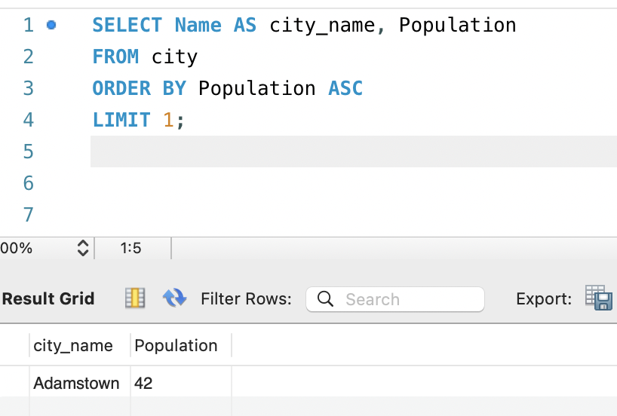

- Country with Largest Population: Scenario: A global economic research institute requires data on countries with the largest populations for a comprehensive analysis. You're tasked with identifying the country with the highest population from the database to provide valuable insights into demographic trends.

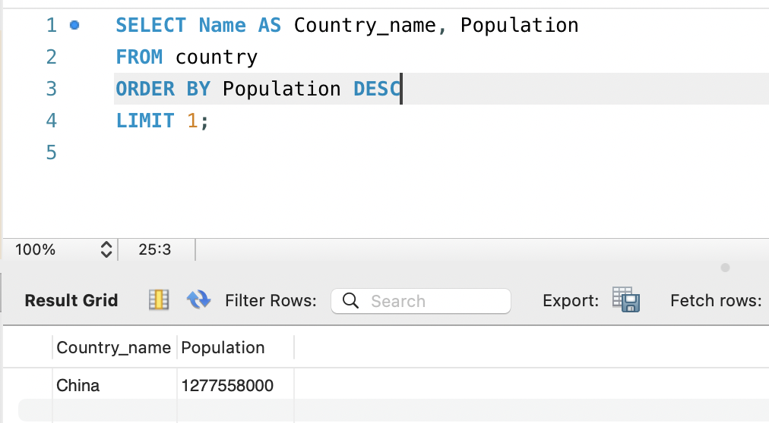

- Capital of Spain: Scenario: A travel agency is organising tours across Europe and needs accurate information on capital cities. You're tasked with identifying the capital of Spain from the database to ensure itinerary accuracy and provide travellers with essential destination information.

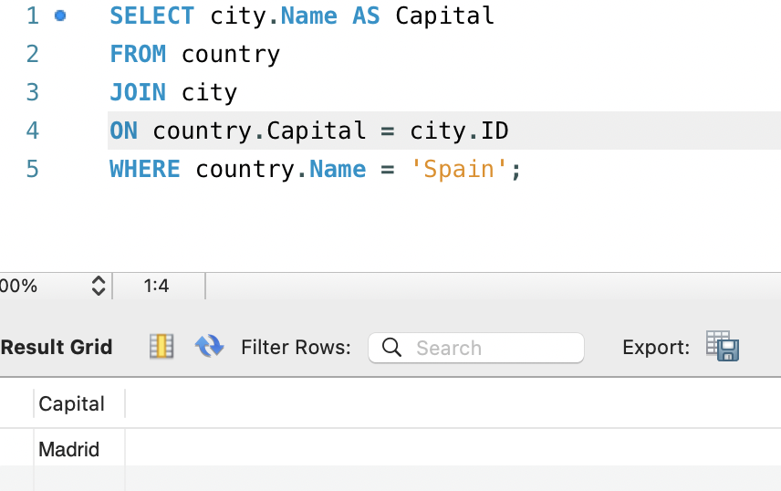

- Country with Shortest Life Expectancy: Scenario: A healthcare foundation is conducting research on global health indicators. You're tasked with identifying the country with the highest life expectancy from the database to inform their efforts in improving healthcare systems and policies.

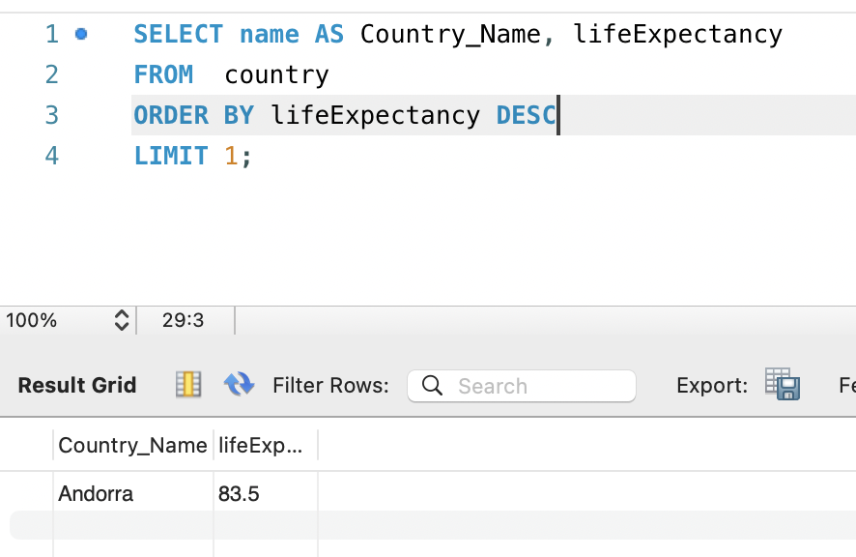

- Cities in Europe: Scenario: A European cultural exchange program is seeking to connect students with cities across the continent. You're tasked with compiling a list of cities located in Europe from the database to facilitate program planning and student engagement.
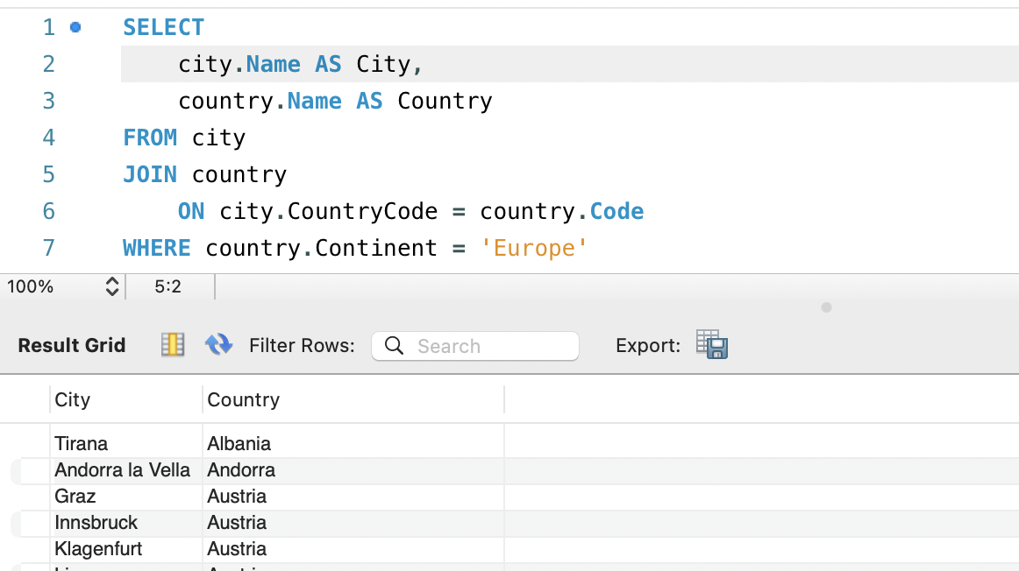

- Average Population by Country: Scenario: A demographic research team is conducting a comparative analysis of population distributions across countries. You're tasked with calculating the average population for each country from the database to provide valuable insights into global population trends.

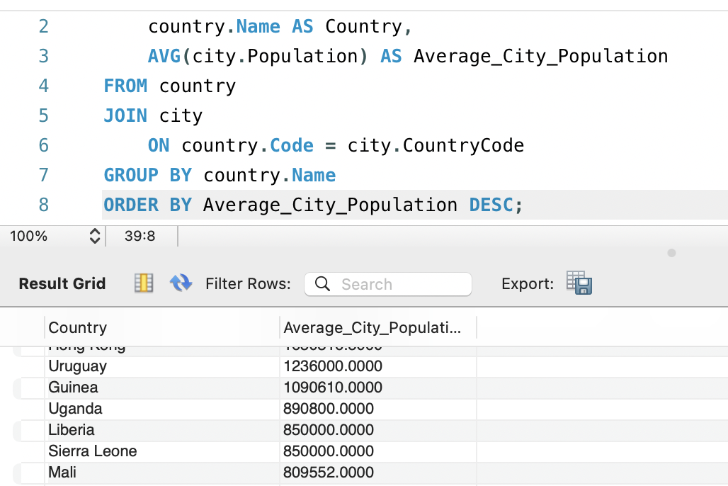

- Capital Cities Population Comparison: Scenario: A statistical analysis firm is examining population distributions between capital cities worldwide. You're tasked with comparing the populations of capital cities from different countries to identify trends and patterns in urban demographics.

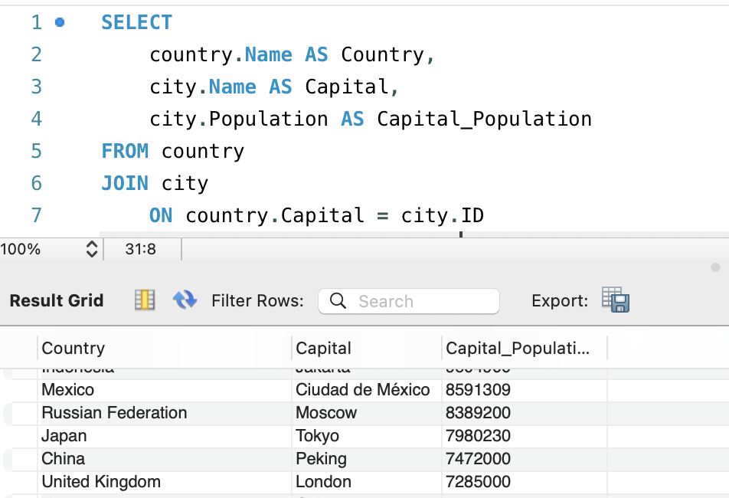

- Countries with Low Population Density: Scenario: An agricultural research institute is studying countries with low population densities for potential agricultural development projects. You're tasked with identifying countries with sparse populations from the database to support the institute's research efforts.

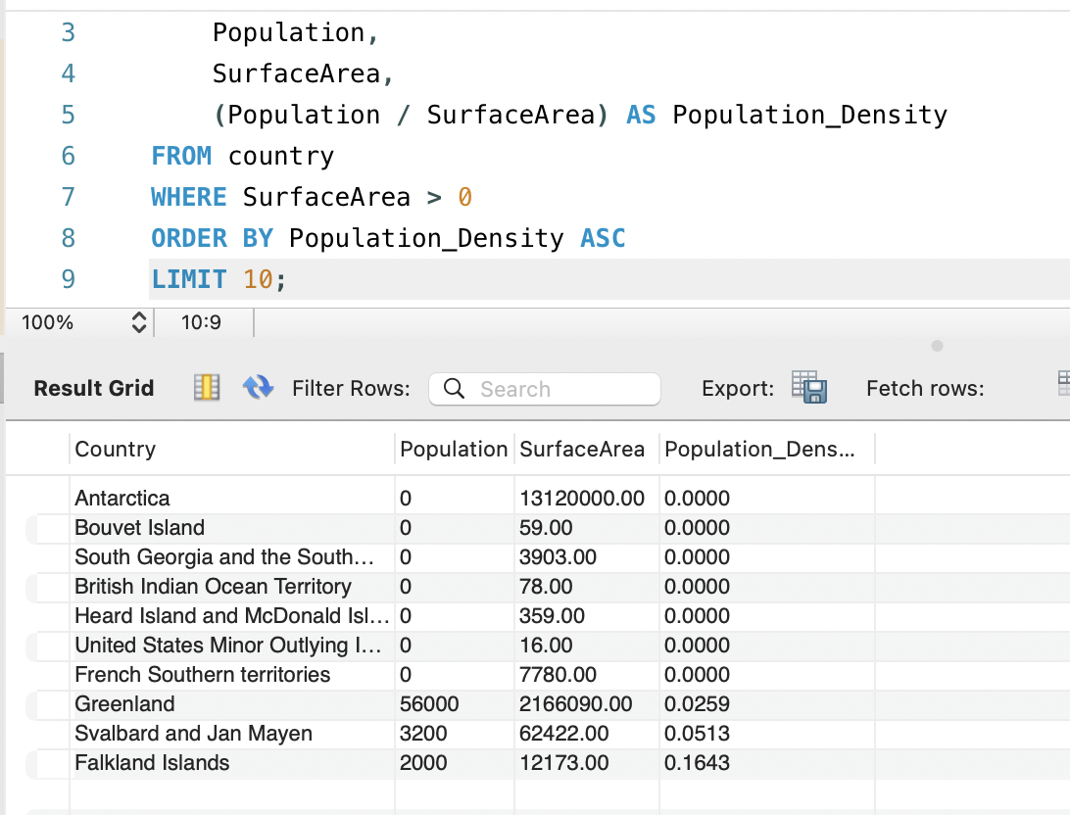

- Cities with High GDP per Capita: Scenario: An economic consulting firm is analysing cities with high GDP per capita for investment opportunities. You're tasked with identifying cities with above-average GDP per capita from the database to assist the firm in identifying potential investment destinations.

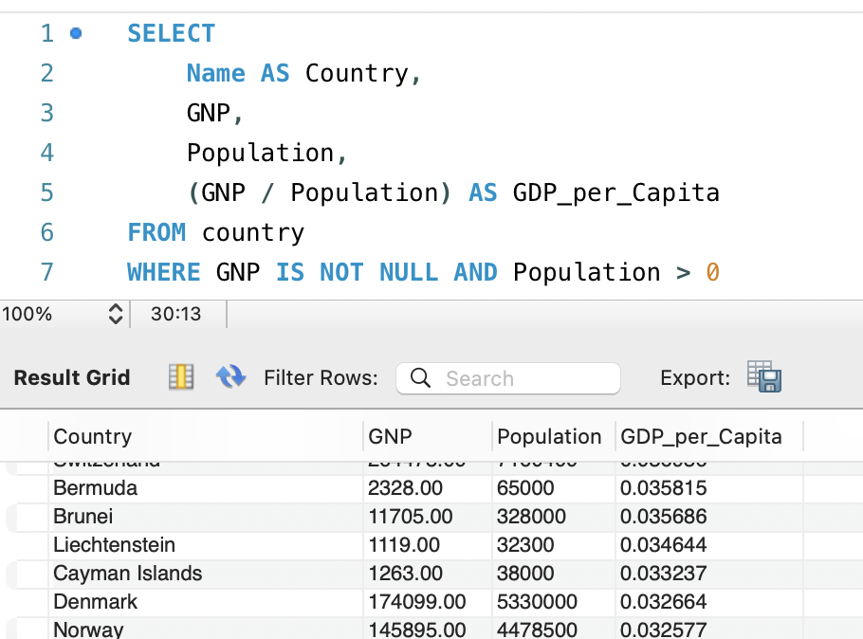

- Display Columns with Limit (Rows 31-40): Scenario: A market research firm requires detailed information on cities beyond the top rankings for a comprehensive analysis. You're tasked with providing data on cities ranked between 31st and 40th by population to ensure a thorough understanding of urban demographics.

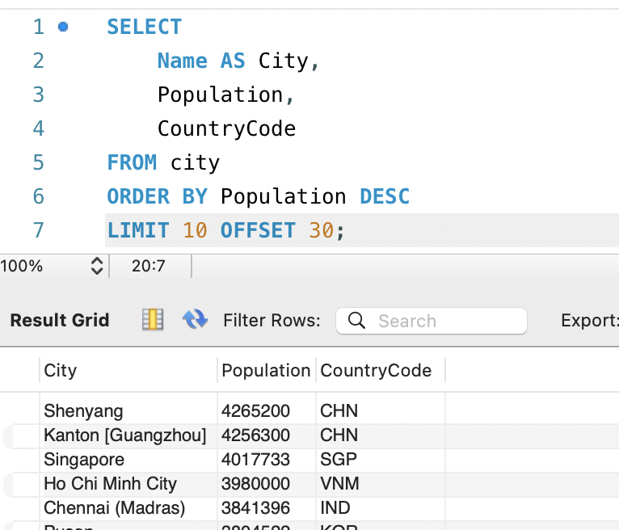

Course Notes

It is recommended to take notes from the course, use the space below to do so, or use the revision guide shared with the class:

Additional Information

We have included a range of additional links to further resources and information that you may find useful, these can be found within your revision guide.

END OF WORKBOOK

Please check through your work thoroughly before submitting and update the table of contents if required.

Please send your completed work booklet to your trainer.

