Final Report – Business
Understanding
Idea Generation

Applied Data Science & AI
Date
Name
Index

Task 1.1: Market Research & Problem Definition 2
Market Research 2
Problem Definition 2
Task 1.2: Stakeholders 2
Task 1.3: DAPS Diagram 3
Task 1.4: Idea Generation 3
References 4

Task 1.1: Market Research & Problem Definition

A. Market Research
Key Problem
Autonomous vehicles are rapidly gaining attention due to advancements in technology and the expanding possibilities in various driving scenarios. An image recognition model designed to detect and identify traffic signs aims to create an environment where consumers can enjoy a safe and worry-free journey to their destinations^{[1]}. Look-Out-Traffic addresses a critical challenge in autonomous vehicle technology—driver distraction. Autonomous vehicles, while reducing human error, still depend on real-time human attention, which can be compromised due to various distractions. Look-Out-Traffic aims to enhance the safety of these vehicles by providing an advanced image recognition system capable of detecting and interpreting traffic signs even when the driver is distracted or unaware.
The system ensures that traffic signs are accurately identified and acted upon, particularly in complex, dynamic driving environments where a driver may not be paying full attention. This is essential in preventing accidents that can occur when drivers are distracted—whether by mobile phones, in-vehicle systems, or external factors—while still allowing autonomous vehicles to operate efficiently. By detecting traffic signs even in challenging conditions, such as poor lighting or unexpected obstructions, Look-Out-Traffic enables vehicles to react quickly and appropriately, compensating for lapses in driver attention.
Market Gaps and Potential Challenges
Successful Traffic Sign Recognition (TSR) systems face several obstacles, as their performance is heavily influenced by environmental factors that affect the visibility of road signs. Road signs may be temporarily obscured due to issues like poor illumination or adverse weather conditions, or permanently less visible due to factors such as vandalism or inadequate sign placement. These challenges hinder the effectiveness of TSR systems, making it difficult to ensure reliable detection and interpretation in all conditions^{[2].}
Additionally, differences in traffic sign appearance across countries, such as the European and American systems (Figure 1), pose further challenges, making it difficult to ensure reliable recognition and interpretation in all locations. These challenges hinder the effectiveness of TSR systems, making it difficult to ensure reliable detection and interpretation in all conditions^{[3].}
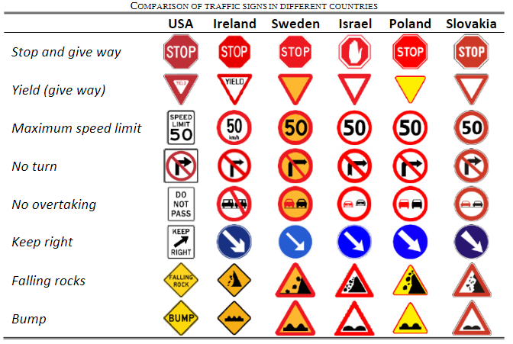
Figure 1: Comparison of Traffic Signs in Different Countries
Level of consumer satisfaction with the current market
Mobileye, a leader in autonomous driving technology, has successfully integrated traffic sign recognition into their Advanced Driver Assistance Systems (ADAS^{)[4]} using high-resolution cameras and machine learning algorithms. Their system effectively detects and classifies traffic signs in real-time, even in urban environments, by leveraging its extensive database of road signs and constant system updates.
Tesla has also made notable strides with its Autopilot system^{[5],} which uses a combination of cameras, radar, and neural networks to recognize traffic signs. By continually training its model with data from millions of miles driven by Tesla vehicles, the system can handle varying road conditions and accurately interpret traffic signs even in challenging situations.
Finally, Volvo's Road Sign Information (RSI)^{[6]} system was developed to enhances driver safety and awareness by displaying critical road sign data, such as speed limits, road changes, and overtaking restrictions, directly on the driver's display and Head-up display. It also offers helpful alerts for speeding violations and proximity to speed cameras, ensuring a smoother, more informed driving experience.
Although traffic sign recognition (TSR) solutions from firms such as Mobileye, Tesla, and Volvo have progressed markedly, they continue to encounter difficulties in fulfilling customer demands. A crucial concern is the system's effectiveness in challenging environmental situations, like low light, bad weather, or driving at night, which may affect visibility and result in undetected objects^{[7].} Moreover, impaired or inadequately maintained traffic signs frequently lead to errors, and intricate road settings with blocked or overcrowded signs may create misunderstandings. Ultimately, the majority of TSR systems are built according to regional road sign standards, which restrict their worldwide usability. These gaps emphasize the necessity for additional enhancements in flexibility and dependability to completely satisfy consumer demands.

B. Problem Definition
Traffic Sign Recognition (TSR) systems are essential for the safe operation of autonomous vehicles, but they face significant challenges in ensuring consistent performance across diverse road conditions and environments. Studies have shown that adverse weather conditions, such as rain or fog, can dramatically reduce sign visibility and hinder recognition (Mohammed et al., 2021). Moreover, damaged or obstructed signs further contribute to the issue, increasing the risk of misinterpretation and potential accidents. According to the National Highway Traffic Safety Administration (NHTSA, 2020), 30% of traffic accidents are linked to visibility issues or misinterpreted road signs.
In addition to environmental factors, distracted driving is a major contributor to traffic accidents. Distracted driving is responsible for over 3,000 fatalities and 120,000 injuries in Europe alone in 2019 (European Commission, 2022^{)[8]}. Drivers using mobile phones are also four times more likely to be involved in a crash (WHO, 2023^{)[9]}. This increases the need for TSR systems that not only perform well in varying conditions but also compensate for lapses in driver attention. An intelligent TSR system could help ensure that the vehicle can detect and act on traffic signs, even when the driver is distracted, thereby improving road safety and potentially saving lives.
These obstacles highlight the necessity for more flexible, dependable, and resilient TSR systems that can tackle these environmental aspects and regional variations. A remedy that can address these challenges would greatly enhance road safety and boost the overall dependability of autonomous driving technologies.

Task 1.2: Stakeholders
Developing an advanced Traffic Sign Recognition (TSR) system—Look-Out-Traffic involves multiple stakeholders, each with distinct interests, power, and influence over its adoption and implementation. This section outlines key stakeholders, their characteristics, and their impact on the project, providing a clear justification for their level of power, influence, and needs.
- Autonomous Vehicle Manufacturers
Power: High - They have the control of implementing the TSR system into their vehicles and they dictate the market trends based on their influence.
Influence: High – Their approval of adoption or rejection of the system might impact its success.
Interest: High – They are always in need of accurate TSR systems that have the capability of improving the performance of their vehicles regarding safety and accuracy.
Expectations: A reliable system which can recognize traffic signs in different environments and to reduce the encounters of failure. They also expect that the system to be easy to integrate with the existing autonomous driving systems.
Needs: High accuracy, robustness, and adaptability to global traffic signs variations; efficient processing for real-time sign detection.
Preferences: New and updatable systems (AI-powered preferable), compatibility with existing technology, cost-effective solutions to integrate the system into their vehicles.
- Government Regulatory Bodies
Power: High – They establish the legal and safety requirements that TSR systems must comply with, dictating industry standards and certifications.
Influence: High – Their regulations determine whether TSR systems can be deployed, influencing manufacturers and technology providers.
Interest: High – Ensuring road safety, standardizing traffic sign recognition across regions, and minimizing accidents caused by misinterpreted or missed signs.
Expectations: A system that meets or exceeds safety and performance regulations, ensures consistency across different environments, and does not introduce new risks.
Needs: Compliance with national and international road safety laws, adaptability to evolving regulations, and transparent reporting of system performance.
Preferences: Reliable and interpretable AI-driven solutions, minimal risk of false detections, and compatibility with regulatory testing and certification processes.
- Automotive Consumers
Power: Low – They do not directly control the implementation of TSR systems but influence demand through their purchasing decisions and feedback.
Influence: Moderate – Consumer preferences and safety concerns drive manufacturers to adopt reliable TSR solutions. Negative experiences can impact brand reputation.
Interest: High – Drivers and autonomous vehicle users rely on TSR for enhanced safety, navigation assistance, and adherence to traffic rules.
Expectations: A system that accurately detects and interprets traffic signs in real-world conditions, including poor weather and low visibility. Minimal false detections and smooth integration with other driver assistance features.
Needs: Reliable performance across diverse environments, real-time processing, and a user-friendly interface.
Preferences: Cost-effective solutions without excessive hardware upgrades, seamless updates, and compatibility with existing vehicle technologies.
- Insurance Companies
Power: Low – They do not develop TSR systems but can incentivize or discourage their adoption through insurance policies and risk assessments.
Influence: High – They impact the adoption of TSR by adjusting premiums based on the system’s effectiveness in reducing accident risks.
Interest: High – TSR systems contribute to accident prevention, reducing claims and liability costs, which aligns with insurers' goals.
Expectations: A system that reliably prevents misinterpretations of traffic signs, ultimately lowering accident rates and improving road safety statistics.
Needs: Proven safety benefits, quantifiable risk reduction, and integration with telematics for policy adjustments.
Preferences: Cost-effective implementations to ensure widespread adoption, clear performance metrics, and compliance with safety regulations.
- Software and AI Developers
Power: High – They are directly responsible for developing and improving TSR algorithms, significantly impacting system performance. While they rely on manufacturers and regulatory approval, their expertise is critical to TSR advancements.
Influence: High – Their work directly impacts the accuracy, efficiency, and adaptability of TSR systems, shaping industry advancements.
Interest: High – Developing cutting-edge AI models that improve TSR accuracy, robustness, and real-time performance.
Expectations: Access to high-quality training datasets, clear performance benchmarks, and collaboration with manufacturers for seamless integration.
Needs: Scalable computing resources, continuous feedback from real-world deployments, and regulatory guidance to ensure compliance.
Preferences: AI models that balance accuracy and computational efficiency, opportunities for continuous innovation, and frameworks that support model interpretability and explainability.
- Ethical & Legal Experts in AI
Power: Low – While they provide guidelines and influence AI policies, they do not directly control TSR system development or deployment.
Influence: High – Their work ensures TSR models comply with ethical AI principles, reducing bias and preventing legal liabilities.
Interest: High – Ensuring that TSR systems are fair, transparent, and unbiased across different demographics, road conditions, and regional traffic regulations.
Expectations: AI models that avoid discrimination, meet legal fairness standards, and are interpretable for auditing and compliance purposes.
Needs: Transparent AI methodologies, fairness assessments in model training, and adherence to data protection regulations.
Preferences: Explainable AI (XAI) models, adherence to AI ethics guidelines (e.g., GDPR, AI Act), and ongoing evaluation to mitigate unintended biases in TSR decisions.
- Government Road Infrastructure Agencies
Power: High – They oversee road infrastructure, which affects TSR performance (e.g., sign placement, maintenance, and visibility).
Influence: Low – While they indirectly impact TSR performance, they do not focus on optimizing TSR system development.
Interest: Low – Their primary concern is maintaining road safety, not directly improving TSR technology.
Expectations: TSR systems should adapt to existing infrastructure without requiring costly sign modifications.
Needs: TSR solutions that can handle varying sign placements, wear conditions, and environmental factors.
Preferences: Cost-effective solutions that do not necessitate frequent road sign updates or new standardization efforts.
- Small-Scale Vehicle Repair Shops
Power: Low – They do not influence TSR system development or policy-making.
Influence: Low – They do not shape market demand for TSR but may interact with vehicles containing these systems.
Interest: Low – TSR does not significantly impact their business unless it affects vehicle maintenance.
Expectations: Compatibility with existing vehicle systems to avoid increased repair complexity.
Needs: Access to technical documentation if TSR systems require occasional servicing or sensor recalibration.
Preferences: Minimal impact on repair workflows, with no additional training required to service TSR-equipped vehicles.
- General Public (Non-Adopters of TSR)
Power: Low – They do not directly impact TSR system development, adoption, or regulation.
Influence: Low – Their feedback is not a primary driver for TSR advancements unless widespread adoption occurs.
Interest: Low – They are not directly affected unless they use TSR-equipped vehicles or interact with autonomous systems.
Expectations: Minimal disruption to existing driving habits and assurance that TSR systems do not create unnecessary complexities.
Needs: Clear public communication on how TSR systems function and their role in road safety.
Preferences: Traditional driving methods without reliance on TSR, with optional adoption rather than mandatory integration.
Business-to-Consumer Power-Interest Matrix
SUBJECTS  Low Power  High Interest  - Automotive Consumers – Influence adoption through feedback and demand.  - Insurance Companies – Assess TSR impact on accident risks and adjust policies.  - Ethical & Legal Experts in AI – Ensure compliance with fairness and transparency standards. | PLAYERS  High Power  High Interest  - Autonomous Vehicle Manufacturers - Collaborate with AI developers and regulators for implementation.  - Government Regulatory Bodies – Set standards, work with manufacturers and legal experts.  - Software and AI Developers – Develop TSR technology, align with manufacturers and regulations.
CROWD  Low Power  Low Interest  - Small-Scale Vehicle Repair Shops – Minimal impact; may need system compatibility knowledge.  - General Public (Non-Adopters of TSR) – Indirectly affected, primarily concerned with driving habits. | CONTEXT SETTERS  High Power  Low interest  - Government Road Infrastructure Agencies – Affect TSR through road conditions but do not focus on system development.
Figure 1. Power-Interest Matrix

Main Stakeholder
The main stakeholder in this case are autonomous vehicle manufacturers. These manufacturers are key players in the development, deployment, and commercial success of autonomous driving systems, which rely heavily on advanced technologies such as image recognition to ensure safe and efficient operations. Their ultimate goal is to create vehicles that can operate with minimal human intervention while ensuring the highest levels of safety for all road users.

Needs: Autonomous vehicle manufacturers require highly accurate and reliable image recognition systems capable of detecting and interpreting traffic signs under varying conditions, including poor lighting, weather, or in cases where the signs are obstructed or damaged. Additionally, the system needs to be adaptable to different regions and countries with varying traffic sign standards. A robust and versatile image recognition system is crucial for enhancing the vehicle's ability to make quick, real-time decisions, especially in complex driving environments where human drivers may be distracted or unaware.

Priorities: The manufacturers' primary priority is to enhance the safety and reliability of autonomous vehicles. They need technology that is not only accurate in detecting traffic signs but also ensures that the vehicle can act on this information quickly and appropriately, especially when the driver may not be paying attention. They also prioritize systems that can be easily integrated into their existing autonomous driving systems and infrastructure. Cost-effectiveness, scalability, and the ability to provide continual updates and improvements are also important factors as they look to remain competitive in the market.

Expectations: Manufacturers expect image recognition systems that can provide consistent performance in diverse road conditions and traffic sign variations, whether it be in different geographical locations or under challenging environmental factors. They expect a system that minimizes false detections and maximizes the vehicle’s ability to react to road signs with high accuracy, reducing the risk of accidents and improving consumer trust in the technology. Additionally, they expect the technology to integrate seamlessly with other systems in the vehicle, ensuring that it enhances, rather than complicates, the overall driving experience.

By addressing the challenges related to traffic sign recognition, autonomous vehicle manufacturers stand to benefit significantly. The implementation of a reliable and intelligent image recognition system can contribute directly to improving road safety, reducing accidents caused by distracted driving, and increasing the overall efficiency and trust in autonomous vehicles. As distractions are a leading cause of accidents, solving this problem will ensure that the vehicles are capable of compensating for human errors, ensuring safer roads for everyone.
As stated in the problem definition, distracted driving is a significant factor contributing to road accidents, with mobile phone use increasing the likelihood of crashes. Addressing the challenges in traffic sign recognition allows autonomous vehicles to compensate for lapses in human attention. The reason for this need is that even when drivers are distracted, an intelligent image recognition system can detect and respond to traffic signs, ensuring safer driving outcomes. By solving this issue, manufacturers can reduce accidents, enhance safety, and foster greater trust in autonomous technology.

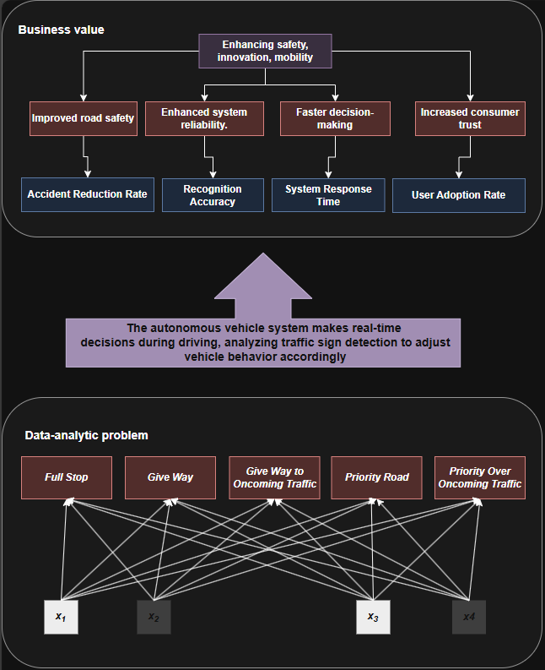
Task 1.3: DAPS Diagram

In my Traffic Sign Recognition (TSR) project, the DAPS framework—Data, Analytics, Processes, and Systems—helps me clearly structure how my work delivers real-world impact. At the highest level, the system I’m building aims to enhance safety, innovation, and mobility for autonomous vehicles. I focus on improving road safety, making the system more reliable, enabling faster decision-making, and increasing consumer trust. These aren’t just abstract goals—I measure them using specific metrics like accident reduction rate, recognition accuracy, system response time, and user adoption rate.

The middle section of the framework highlights how my system behaves on the road. It makes real-time decisions while the vehicle is driving, by analyzing visual input and detecting priority signs—like “Full Stop” or “Give Way to Oncoming Traffic.” Based on the sign it detects, the vehicle adjusts its behavior accordingly. This is where I see the process part of DAPS in action: the system takes the analytics and translates them into vehicle responses that keep driving safe and efficient—even when signs are partially obscured, or the driver is distracted.

At the core of the system is the data-analytic problem: I’m training a model to classify images into one of five classes—Full Stop, Give Way, Give Way to Oncoming Traffic, Priority Road, and Priority Over Oncoming Traffic. The features my model uses, which I label as x1,x2,x3,x4x_1, x_2, x_3, x_4x1​,x2​,x3​,x4​, come from image data processed through convolutional layers in my CNN. These features capture patterns like edges, colors, and shapes. The many-to-many relationships between features and traffic sign classes represent how deep learning works—where multiple features interact to produce a final prediction, rather than relying on any single input.

Overall, my project reflects the full DAPS flow: I take raw image data, apply deep learning techniques, turn those predictions into real-time actions, and support larger business goals like road safety and system adoption. It’s a clear demonstration of how technical solutions can be mapped to meaningful, measurable outcomes in the real world.

Task 1.4: Idea Generation
Problem Definition and Its Link to the Final Product
The primary issue that Look-Out-Traffic aims to solve is the inconsistency and lack of reliability in current Traffic Sign Recognition (TSR) systems, particularly their vulnerability to environmental conditions and the growing challenge of distracted driving.

A survey^{[10]} by Casley et al. conducted in the US found that 57% of respondents were concerned about the AV system’s poor awareness of its surrounding environment, while 74% were worried about malfunctions or system failures. In the same survey, respondents were asked to rank the importance of safety, costs, and laws on their perception of AVs. 82% of respondents ranked safety as the most important aspect for adopting AVs, illustrating that people will not adopt AVs until they are confident the technology is safe. 12% ranked laws as the most important, and 6% prioritized costs, demonstrating that safety is the top concern for public acceptance of AVs.

The rise in distracted driving—especially due to mobile phone usage—makes the problem even worse, as drivers may overlook even clearly visible signs. These combined factors highlight the urgent need for a more resilient and dependable TSR solution.

Look-Out-Traffic directly addresses this challenge by introducing an advanced TSR system specifically designed to recognize priority signs. The system is trained to classify these signs into three essential categories: "give priority," "have priority," and "fully stop", separated during in the preprocessing part into five distinct classes. Each classification is crucial, as it determines how the vehicle should respond—whether to stop completely, proceed cautiously while yielding, or continue at a normal pace. By precisely identifying the priority directive, Look-Out-Traffic ensures vehicles can react appropriately and safely in real time.

What sets the system apart is its ability to withstand environmental challenges and partial obstructions. Unlike conventional TSR systems that frequently fail under difficult conditions, this solution is designed to detect priority signs even when they are partially hidden, damaged, poorly lit, or affected by adverse weather. This robustness is critical for real-world driving scenarios, where signs are rarely in perfect condition, and environmental variables constantly change. By maintaining accurate recognition despite these obstacles, Look-Out-Traffic enhances road safety and acts as a critical fail-safe against driver distraction and environmental limitations.

In summary, Look-Out-Traffic is built to make roads safer by providing a dependable, resilient Traffic Sign Recognition system. By accurately identifying priority signs across a range of challenging conditions, it minimizes the risk of accidents caused by overlooked or misinterpreted signs. This improved reliability supports safer vehicle operation and contributes to the broader advancement of autonomous driving and intelligent driver-assist technologies.

Addressing the Needs of the Main Stakeholder
Look-Out-Traffic is designed to directly support autonomous vehicle manufacturers by delivering a highly accurate, adaptive, and reliable Traffic Sign Recognition (TSR) system. Unlike conventional solutions, it ensures consistent detection and interpretation of priority signs even in challenging conditions, such as poor lighting, adverse weather, or partial obstructions.
By leveraging advanced deep learning models, Look-Out-Traffic enables real-time decision-making, allowing vehicles to respond instantly and appropriately to traffic signs. Its adaptability across different regions ensures compliance with varied traffic regulations, making it a scalable solution for manufacturers targeting global markets.
Integration is aiming to be seamless, with low-latency processing and compatibility with existing autonomous driving frameworks. The system is designed to be cost-efficient and upgradable, allowing for continuous improvements and future-proofing.

Business Value Delivered by Look-Out-Traffic
Look-Out-Traffic delivers substantial business value to autonomous vehicle manufacturers by enhancing safety, reducing costs, and driving market expansion. Designed to recognize and interpret European traffic signs, it ensures highly accurate performance even in adverse conditions, minimizing the risk of accidents caused by missed or misinterpreted signs. This reliability could strengthen public trust in autonomous vehicles—an essential factor for widespread adoption—while also reducing liability costs and enhancing brand reputation.

Beyond safety, the product provides a strategic advantage in a competitive market. While it is initially optimized for European traffic regulations, its adaptable architecture could allow expansion into other global regions, such as the United States, with adjustments to accommodate different traffic sign standards. This flexibility enables manufacturers to scale their autonomous vehicle solutions across multiple markets without the need for entirely separate TSR systems. Additionally, seamless integration with existing autonomous driving frameworks could help reduce development costs, allowing companies to focus on innovation in AI, sensor technology, and other critical areas.

The system also has the potential to offer valuable data-driven insights, capturing real-world traffic patterns and driver behavior to refine autonomous vehicle performance. This data could be leveraged for continuous improvements or monetized through partnerships with smart mobility and transportation companies. By providing a regionally optimized yet globally adaptable TSR solution, Look-Out-Traffic positions manufacturers to lead in the autonomous vehicle industry while delivering safer and more reliable self-driving experiences.

References
[1] Mohammed, Dilshad & Horváth, Balázs. (2021). A review on detection and recognition of traffic signs by autonomous vehicles
[2] Hoang, T. M., Baek, N. R., Cho, S. W., Kim, K. W., & Park, K. R. (2017). Road lane detection robust to shadows based on a fuzzy system using a visible light camera sensor
[3] Toth, Štefan. (2012). Difficulties of Traffic Sign Recognition
[4] Intel Corporation. (2020, July 19). Fact sheet: Mobileye advanced driver-assistance systems (ADAS). Mobileye. https://www.mobileye.com/blog/fact-sheet-mobileye-advanced-driver-assistance-systems-adas/
[5] Tesla, Inc. (n.d.). Autopilot. Tesla. https://www.tesla.com/support/autopilot
[6] Volvo Cars. (2024, October 17). Road Sign Information. Volvo Cars. https://www.volvocars.com/en-th/support/car/xc60/article/2aeecd47af834a2ec0a80151418eeaf5
[7] Kandasamy, K., Natarajan, Y., Sri Preethaa, K.R. et al. A Robust TrafficSignNet Algorithm for Enhanced Traffic Sign Recognition in Autonomous Vehicles Under Varying Light Conditions. Neural Process Lett 56, 241 (2024). https://doi.org/10.1007/s11063-024-11693-y
[8] European Commission. (2022). Road safety thematic report – Driver distraction. European Road Safety Observatory. https://doi.org/10.2832/82312
[9] World Health Organization. (2023, December 13). Road traffic injuries. World Health Organization. https://www.who.int/news-room/fact-sheets/detail/road-traffic-injuries
[10] Othman, K. Public acceptance and perception of autonomous vehicles: a comprehensive review. AI Ethics 1, 355–387 (2021). https://doi.org/10.1007/s43681-021-00041-8

