Name- Anamay Sarkar

This project is done as a part of Take-Home Coding Assignment from Eightfold for the Front-End Position.

1. Implemented multi-select autocomplete-

This is the initial loading page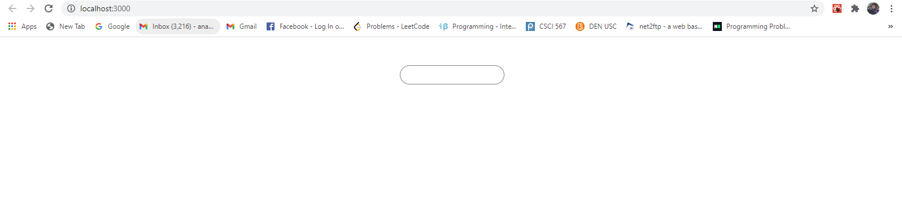

1. The API used for fetching movie data was OMDB Api.

Note - The api from OMDB was returing a single movie with all the details if I use their "t" paramter. I used the "s" paramter to get a list of movie suggestions,with type=movie. This does not return Director name, so I am displaying "Year" with the movie "Title".

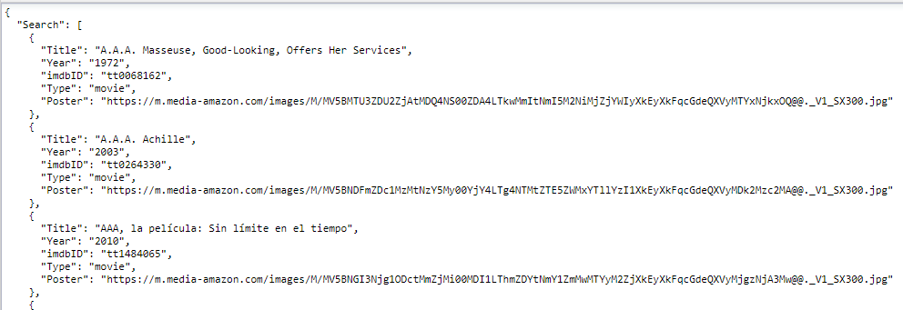

1. The user is able to type and see the autocomplete list of movies.

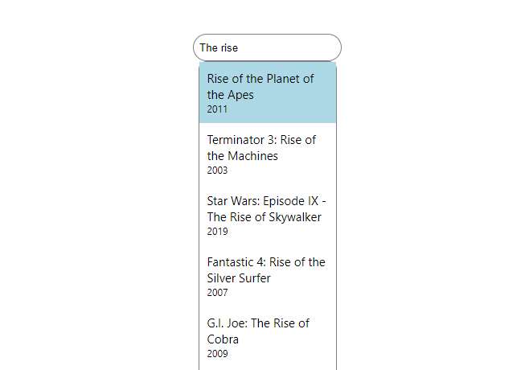

1. A user can select a movie title and that will be added to the field as a pill.

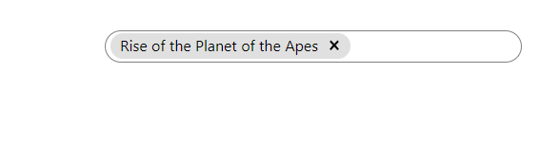

5. If a user clicks outside the suggestion box, the suggestion box disappears. I have used ref to achieve this.

6. User is able to delete the selected movies from the pill.

7. User is not able to add more than 5 movies, it gives a red warning message at the bottom.

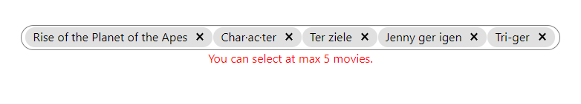

8. The component renders under 200ms.

9. If you type, few characters, the API returns an error message. I am modifying the message and displaying it.

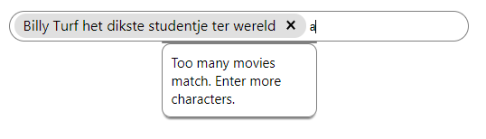

10. If no movie, match, I am showing an error message.

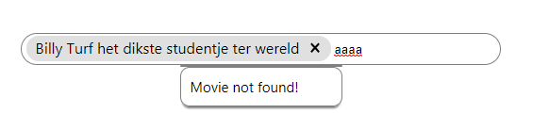

11. To ensure the same movie is not selected again, I am filtering it before showing it in the recommendations.

12. Used proper css to match the requirements.

13. I have used module.css to ensure that the class names of the component do not conflict with the same class names of other components.