Gaussian Beam Profiles and Beam Diameter vs Distance
This file contains Gaussian fits to the transverse beam profiles at different distances from the laser, as well as a summary plot of the beam diameter as a function of position. Given the manual provides an accurate conversion of pixels to physical size of 3.2µm/ pixel.

Beam profile at 25 cm
Gaussian fit parameters: I0 = 240.21, x0 = 348.59, w (radius) = 189.81, offset = -3.00.
Uncertainty on w: ±1.62 (so diameter = 379.62 ± 3.25 pixels).
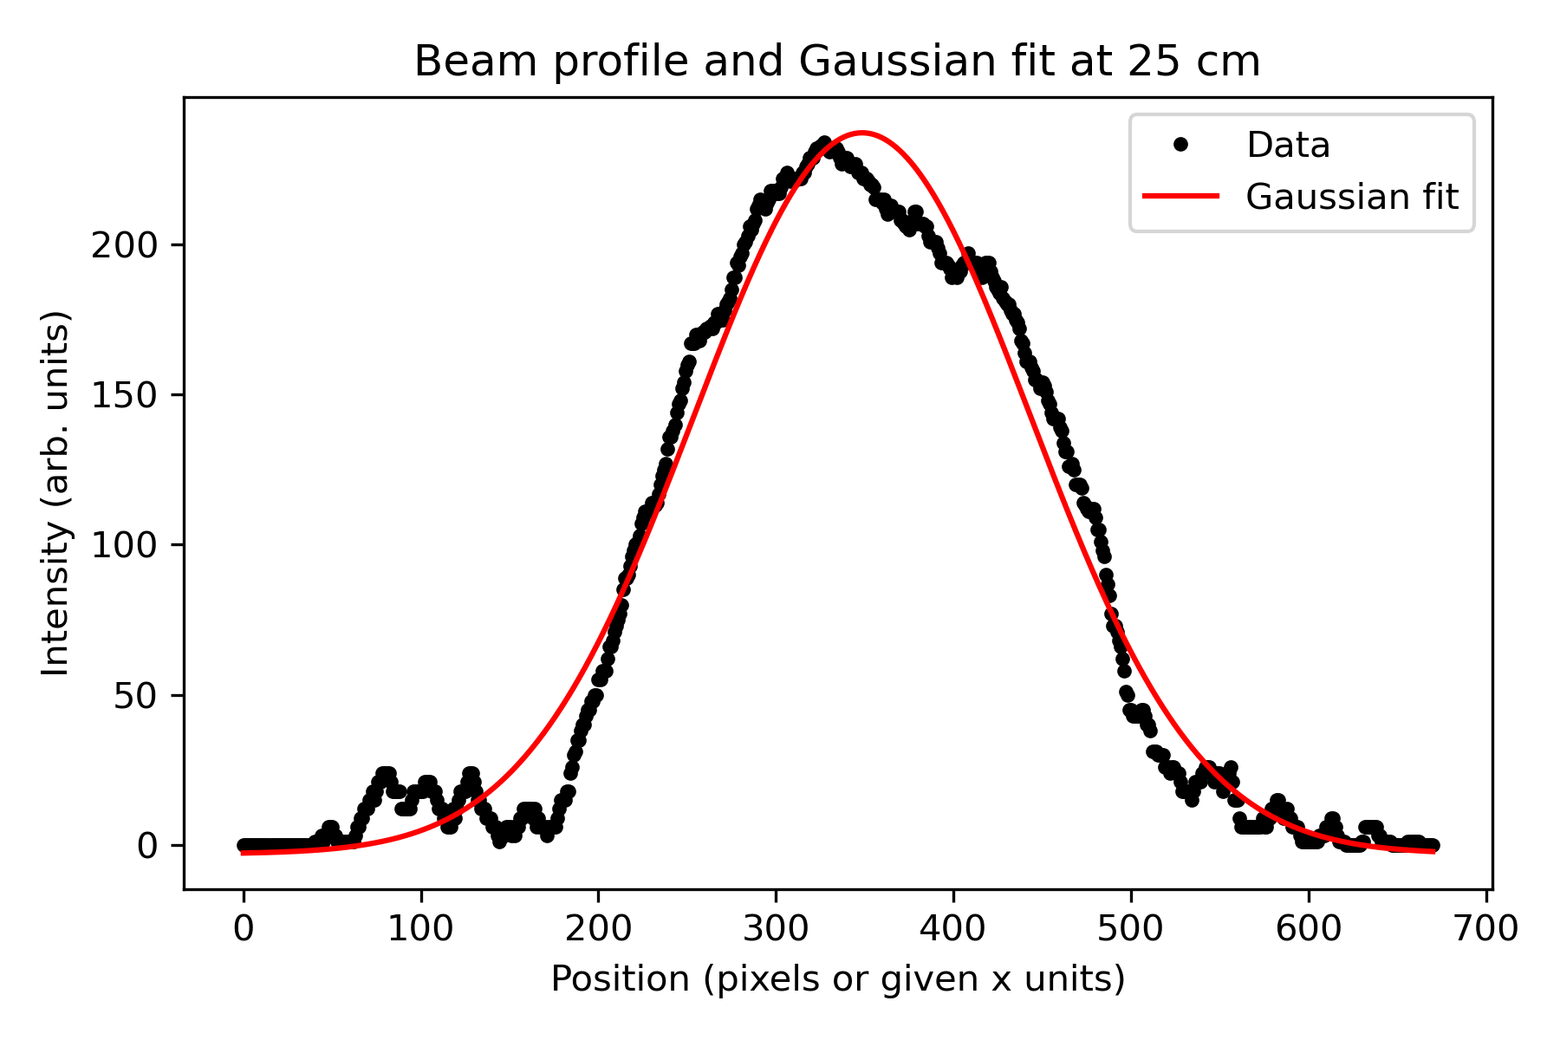

Beam profile at 50 cm
Gaussian fit parameters: I0 = 239.59, x0 = 408.64, w (radius) = 244.75, offset = -10.59.
Uncertainty on w: ±1.79 (so diameter = 489.50 ± 3.58 pixels).
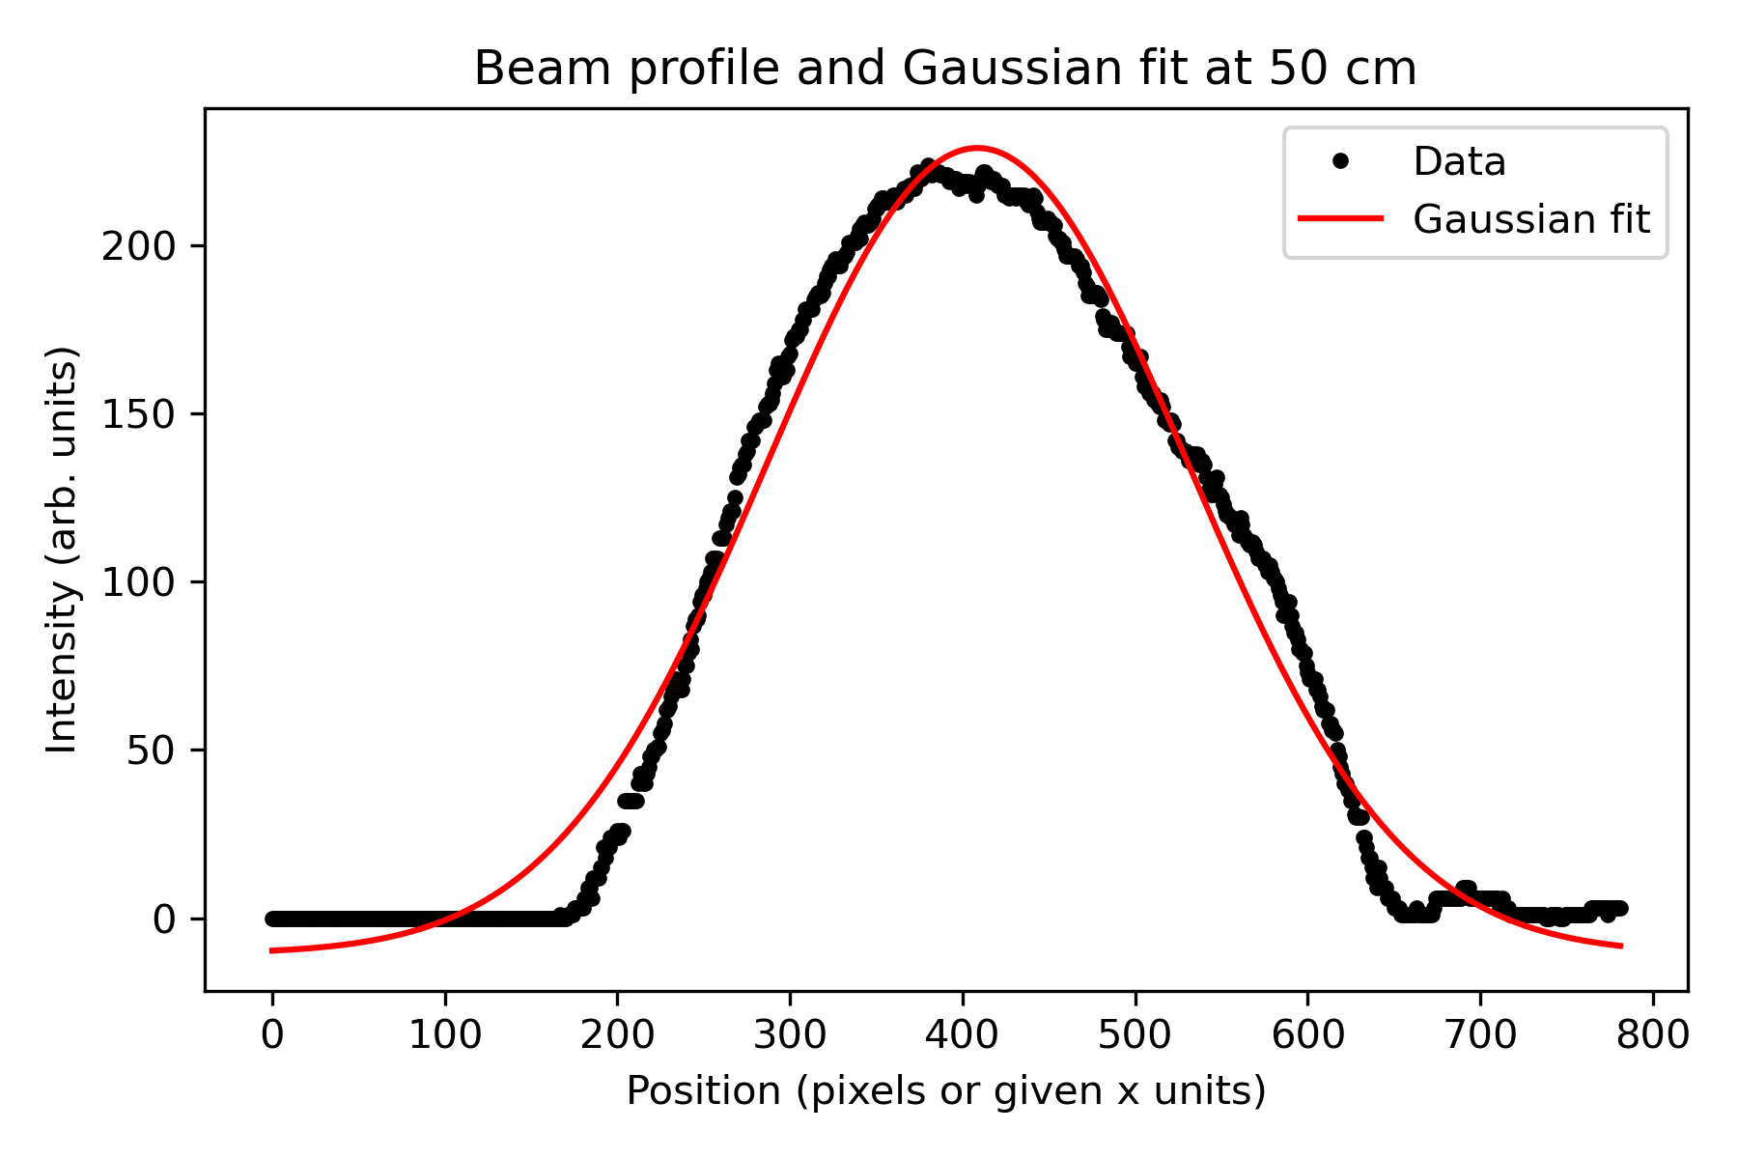

Beam profile at 75 cm
Gaussian fit parameters: I0 = 223.19, x0 = 746.33, w (radius) = 235.44, offset = 29.41.
Uncertainty on w: ±4.01 (so diameter = 470.87 ± 8.02 pixels).
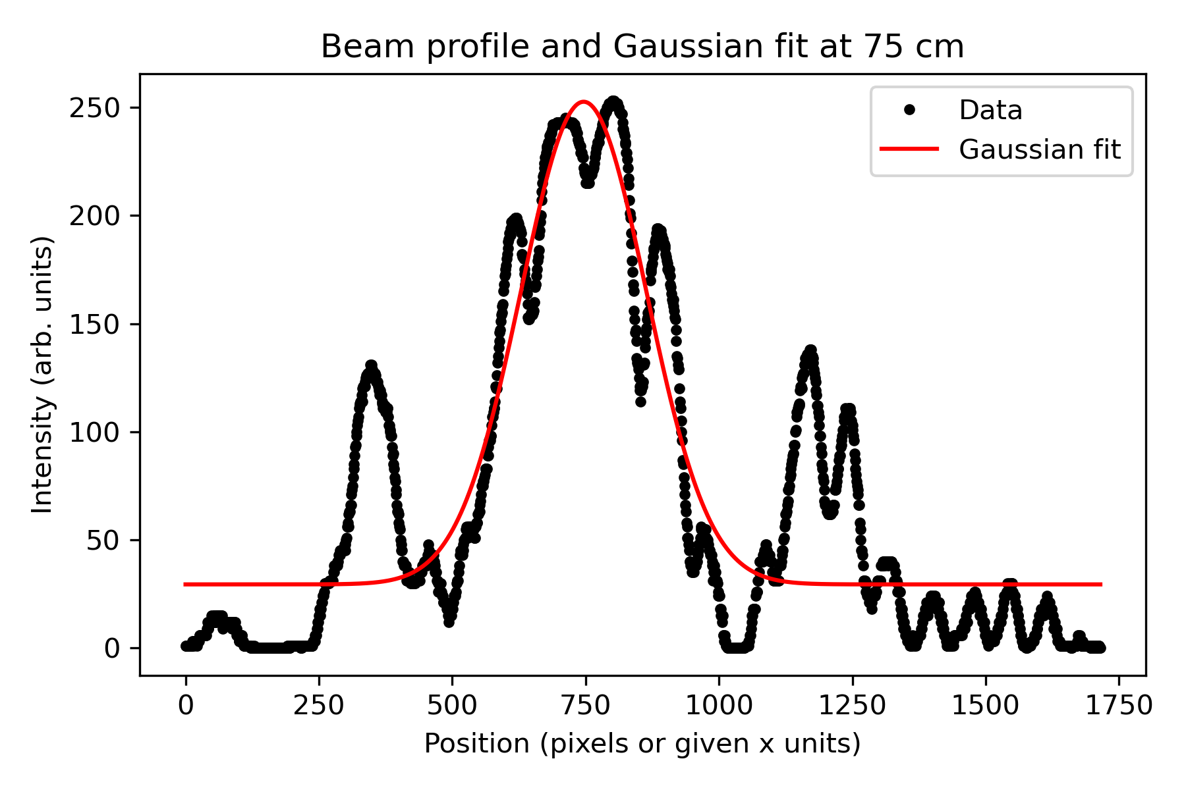

Beam profile at 100 cm
Gaussian fit parameters: I0 = 250.23, x0 = 791.28, w (radius) = 286.63, offset = 16.44.
Uncertainty on w: ±2.90 (so diameter = 573.27 ± 5.80 pixels).
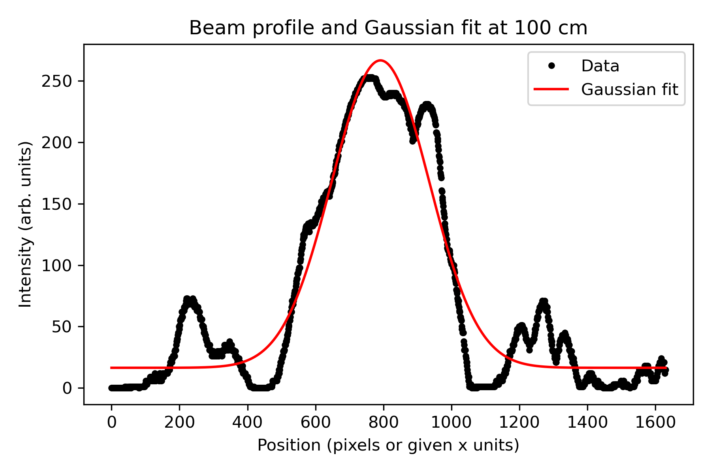

Beam profile at 125 cm
Gaussian fit parameters: I0 = 148.01, x0 = 546.46, w (radius) = 458.91, offset = -15.96.
Uncertainty on w: ±12.81 (so diameter = 917.81 ± 25.61 pixels).
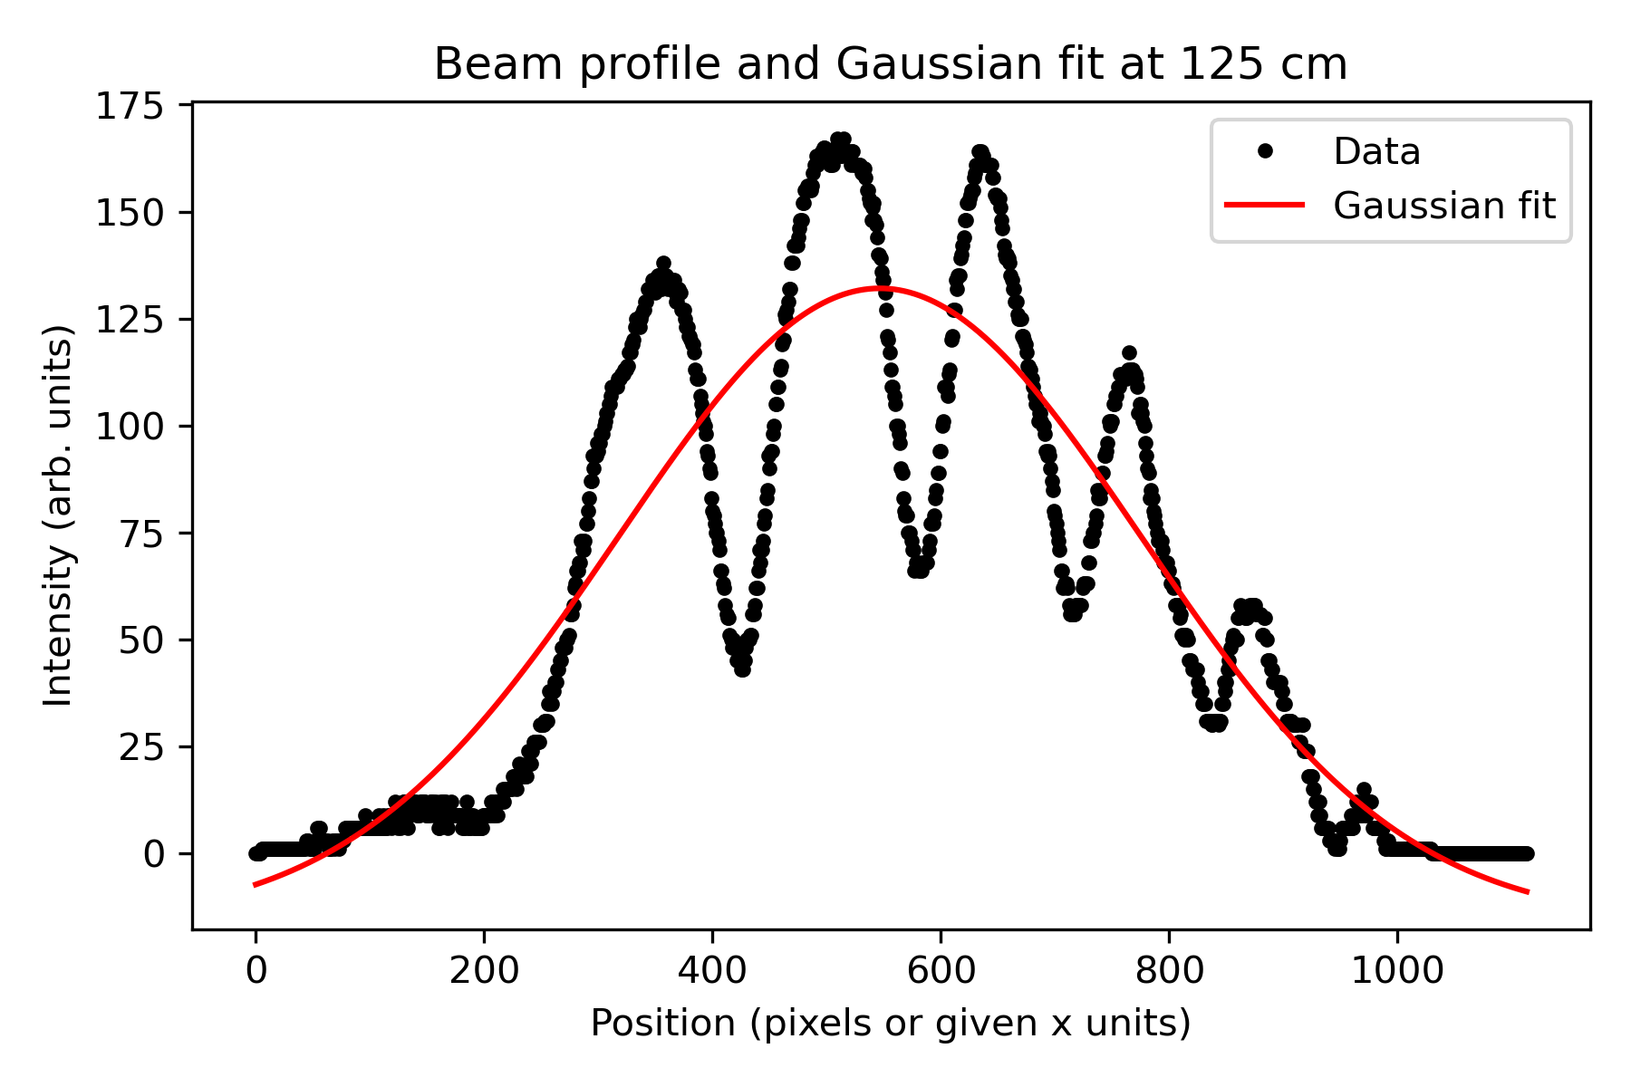

Beam profile at 150 cm
Gaussian fit parameters: I0 = 170.69, x0 = 752.63, w (radius) = 338.14, offset = 8.07.
Uncertainty on w: ±4.86 (so diameter = 676.28 ± 9.72 pixels).
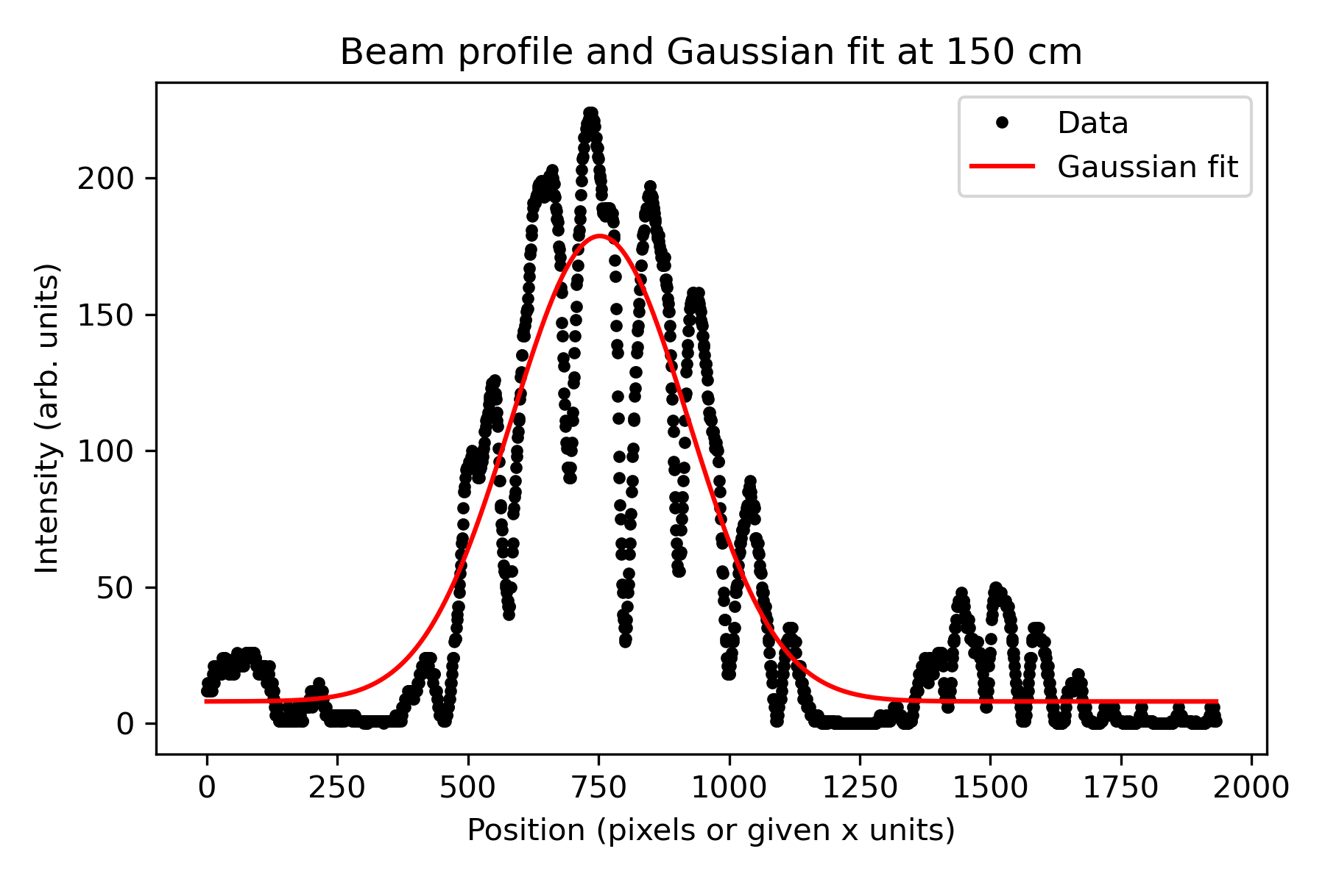

Beam profile at 175 cm
Gaussian fit parameters: I0 = 116.32, x0 = 822.38, w (radius) = 420.28, offset = 10.87.
Uncertainty on w: ±6.00 (so diameter = 840.56 ± 12.01 pixels).
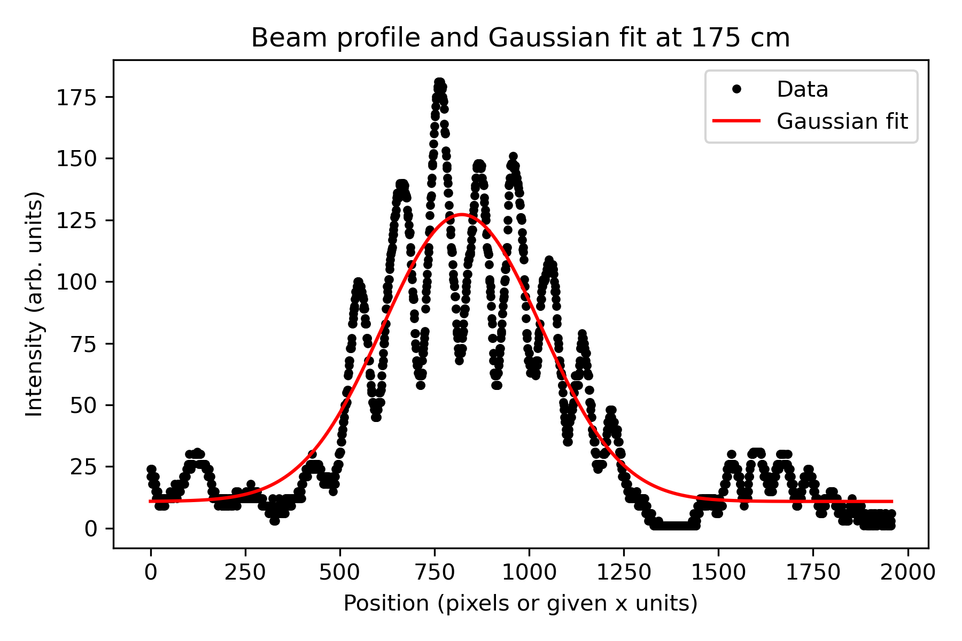

Beam profile at 200 cm
Gaussian fit parameters: I0 = 120.93, x0 = 951.79, w (radius) = 384.98, offset = 13.22.
Uncertainty on w: ±3.93 (so diameter = 769.96 ± 7.85 pixels).
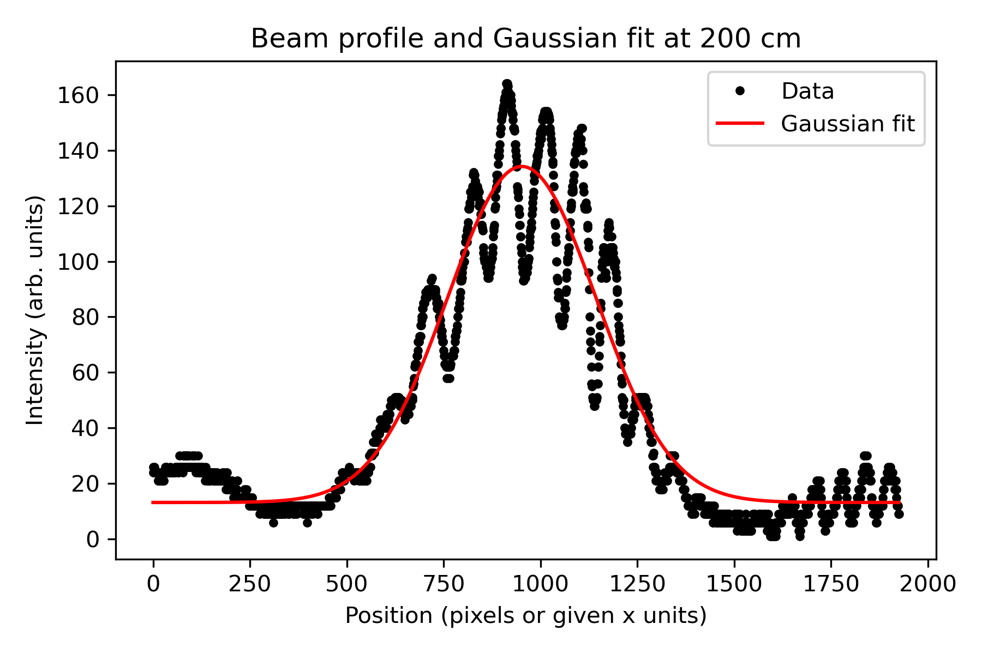
In our measurements along the propagation axis, we did not observe a sharp, well-defined minimum in the beam diameter within the accessible range of positions. The beam size changed only slowly with distance, and any minimum in the measured radius was within the experimental uncertainty rather than a clear, tight focus. This suggests that the beam leaving the laser head is already nearly collimated, with a large Rayleigh range, so over the distances we could move the camera the beam radius is almost constant. In other words, the true waist is either inside the laser housing (near the internal collimating optics) or the 25cm spot where we observed the smallest waist at 607.39 µm

Beam diameter vs distance
The following plot shows the fitted 1/e² beam diameter (in pixel units) as a function of distance from the laser.
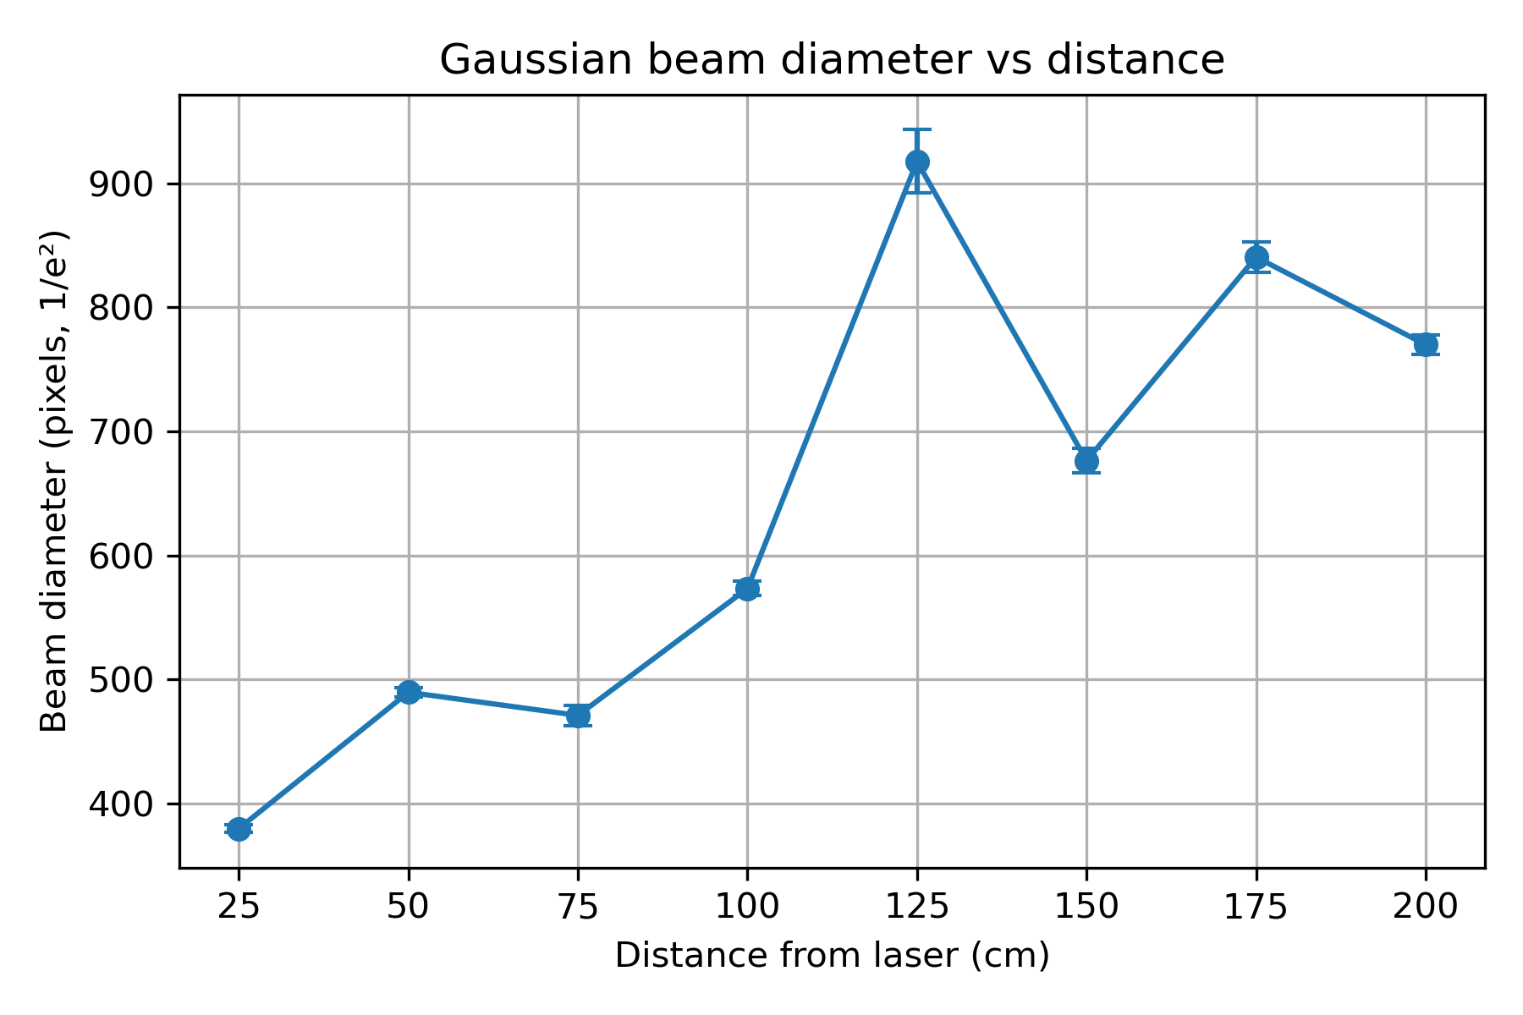

Numeric results
Table of fitted beam diameters (1/e²) as a function of distance from the laser.
Distance (cm) | Diameter (pixels) | σ(Diameter) (pixels) | w (radius, pixels) | W (radius, µm)
25 | 379.62 | 3.25 | 189.81 ± 1.62 | 607.39 ± 5.18
50 | 489.50 | 3.58 | 244.75 ± 1.79 | 783.20 ± 5.73
75 | 470.87 | 8.02 | 235.44 ± 4.01 | 753.41 ± 12.83
100 | 573.27 | 5.80 | 286.63 ± 2.90 | 917.22 ± 9.28
125 | 917.81 | 25.61 | 458.91 ± 12.81 | 1468.51 ± 40.99
150 | 676.28 | 9.72 | 338.14 ± 4.86 | 1082.05 ± 15.55
175 | 840.56 | 12.01 | 420.28 ± 6.00 | 1344.90 ± 19.2
200 | 769.96 | 7.85 | 384.98 ± 3.93 | 1231.94 ± 12.58

Focused Beam Waists for Different Lenses

Lens with focal length f = 25.4 mm
Gaussian fit parameters (in pixel units):
I0 = 192.65, x0 = 739.81, w = 117.95, offset = 1.59.
Uncertainty on w: ±0.54 pixels (1/e² radius).
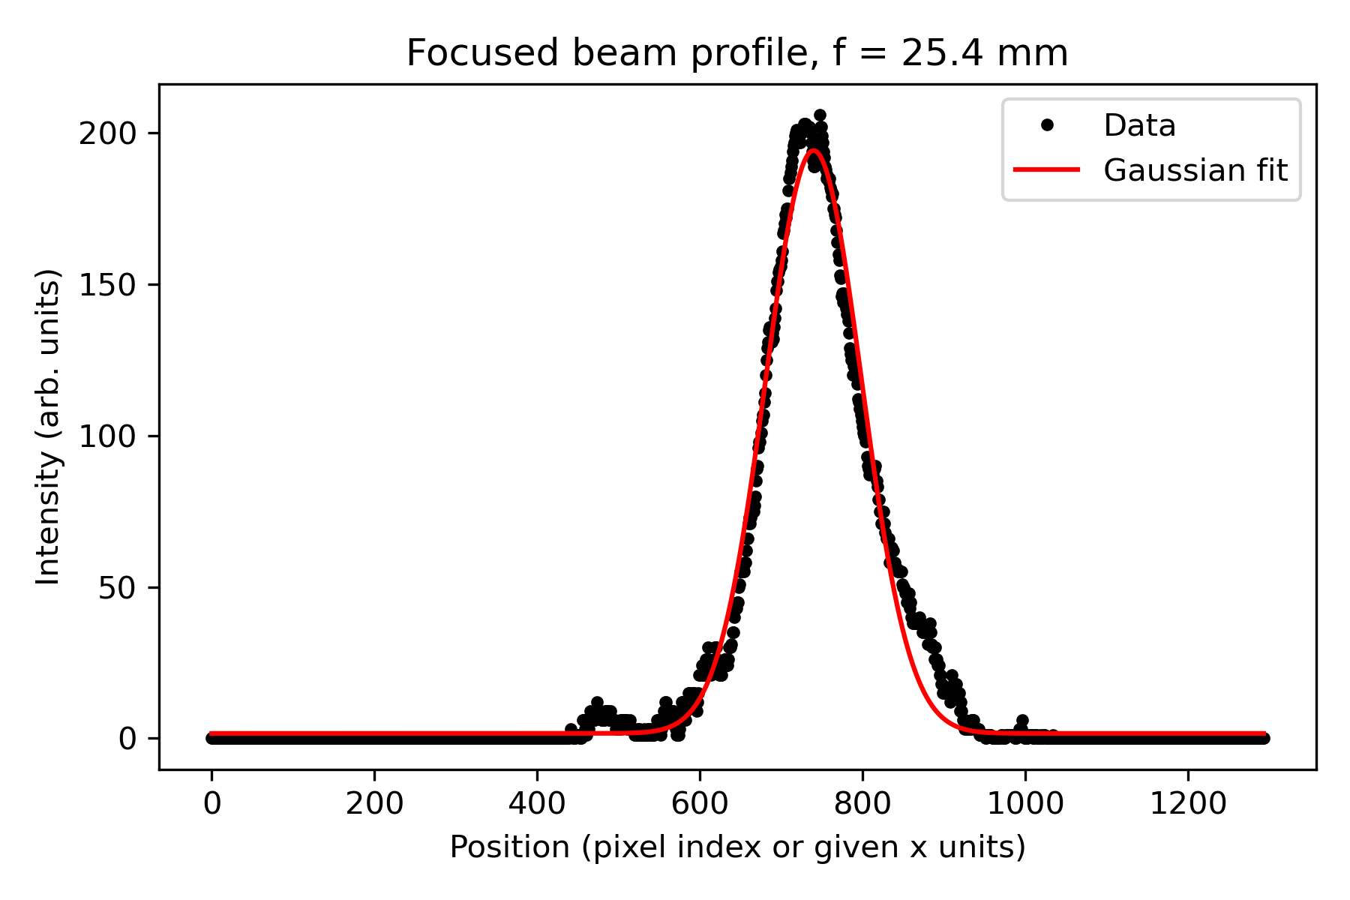

Lens with focal length f = 100.0 mm
Gaussian fit parameters (in pixel units):
I0 = 262.30, x0 = 72.58, w = 37.55, offset = -11.68.
Uncertainty on w: ±1.67 pixels (1/e² radius). 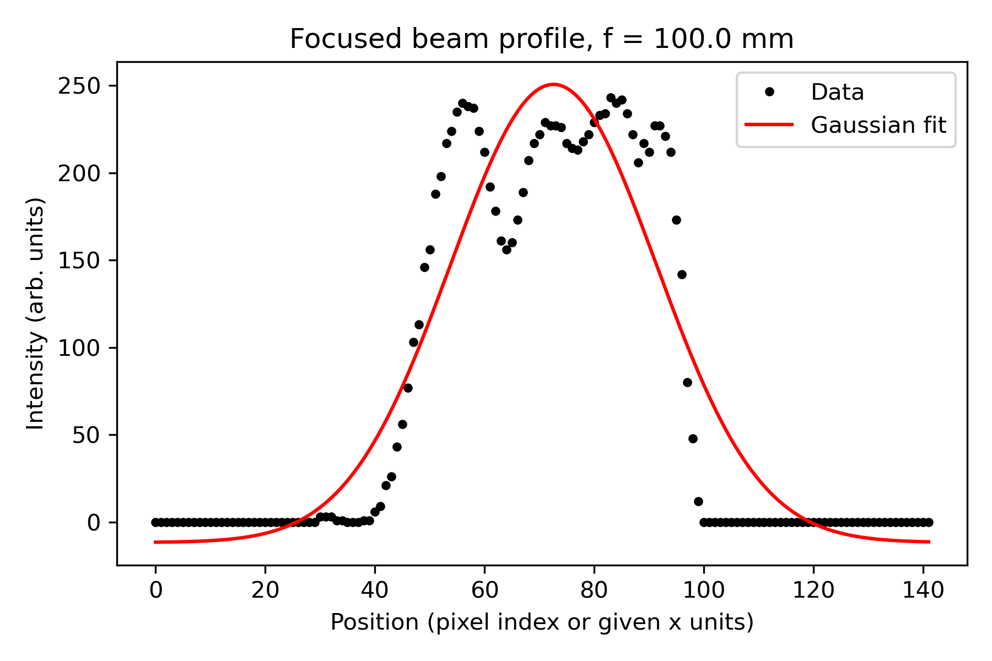

Lens with focal length f = 200.0 mm
Gaussian fit parameters (in pixel units):
I0 = 271.37, x0 = 108.99, w = 59.07, offset = -11.17.
Uncertainty on w: ±0.83 pixels (1/e² radius).
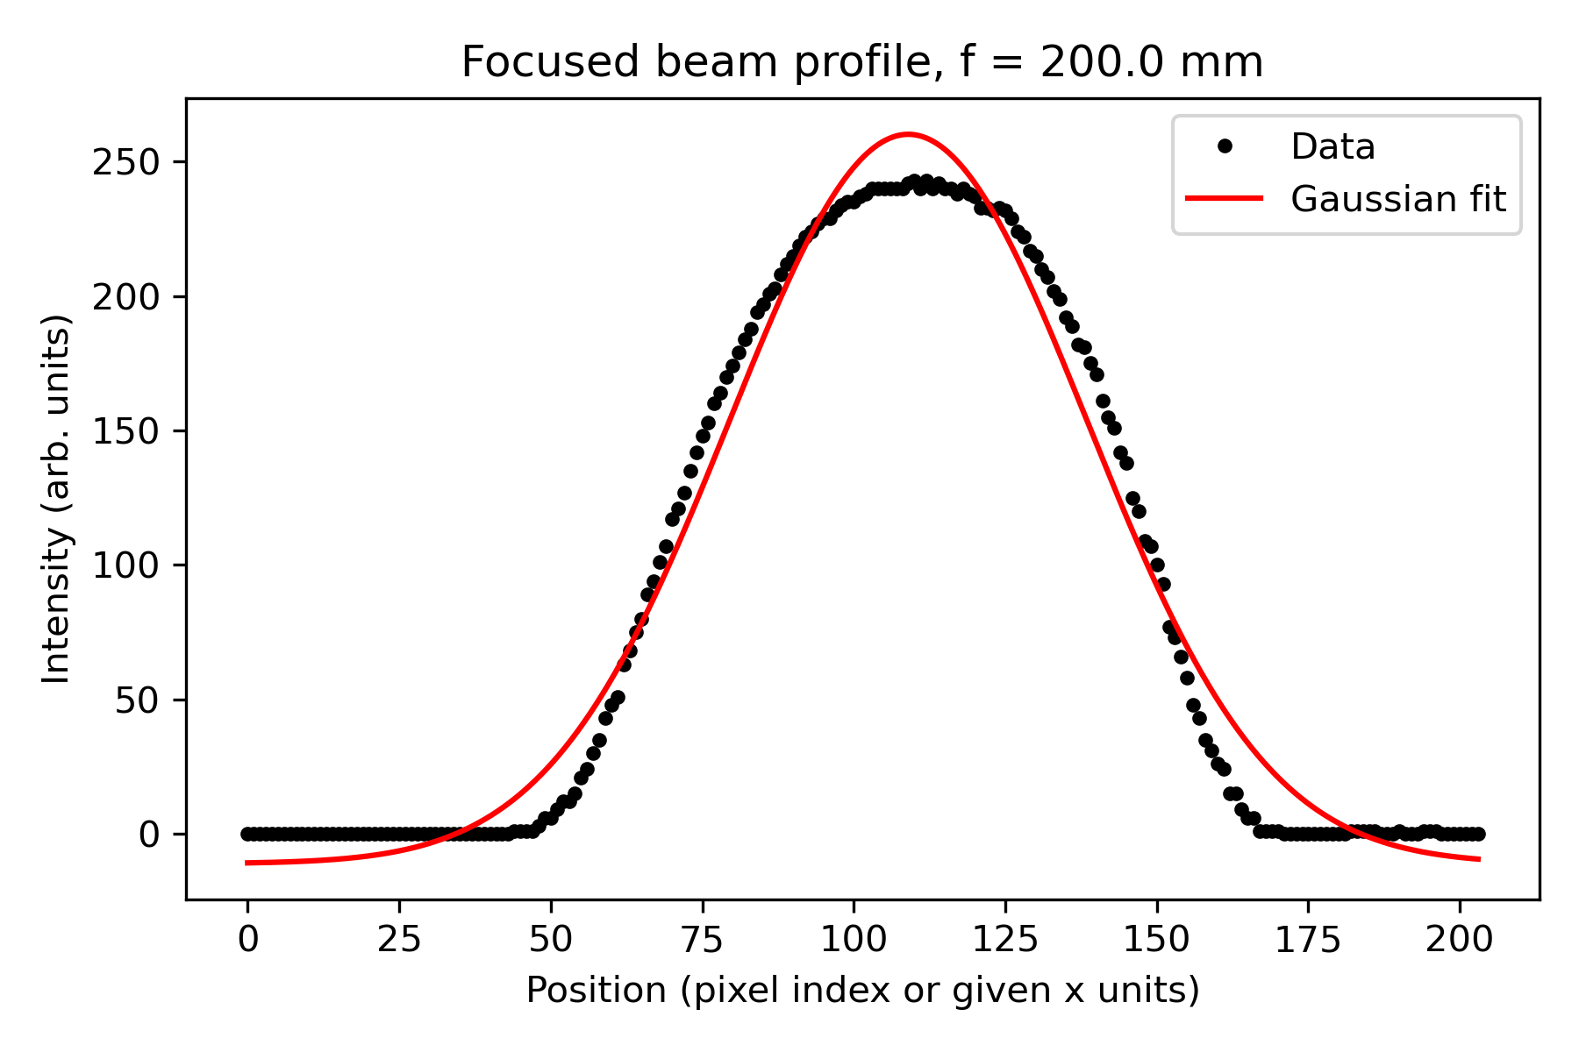

Summary of fitted waists
Focal length f (mm) | w (pixels) | w (µm) | σ_w (pixels)
25.4 | 117.95 | 377.44 | 0.54
100.0 | 37.55 | 120.16 | 1.67
200.0 | 59.07 | 189.02 | 0.83

Beam Expander Results
This section shows the transverse beam profiles and Gaussian fits measured before and after the beam expander, along with the resulting expansion factor.
Optical Layout of the 4× Beam Expander
To increase the diameter of the laser beam by approximately a factor of four, we implemented a two-lens (Keplerian) beam expander in an afocal “telescope” configuration. A collimated Gaussian beam first passes through a short-focal-length lens L1 (focal length f1 = 25.4 mm). This lens focuses the beam to an intermediate waist located near its back focal plane. A second positive lens L2 (focal length f2 = 100 mm) is then placed so that its front focal plane coincides with this focus. In practice, this means the separation between L1 and L2 is set to approximately f1 + f2 ≈ 125.4 mm.
In this arrangement, a collimated input beam remains collimated after passing through the second lens, but its radius is expanded. For an ideal afocal beam expander, the transverse magnification M is given by
M = w_out / w_in = f2 / f1
where w_in is the input beam radius at L1 and w_out is the output beam radius after L2. With f1 = 25.4 mm and f2 = 100 mm, the expected magnification is
M ≈ 100 / 25.4 ≈ 3.9 ≈ 4.
Thus, the beam radius (and therefore the beam diameter) after the expander is approximately four times larger than before. Experimentally, we aligned the lenses by first ensuring that the input beam was collimated, then adjusting the lens separation to be close to f1 + f2, and finally fine-tuning the positions until the output beam appeared collimated over the distance to the camera. The transverse beam profiles measured before and after the expander, and fitted to Gaussian functions, confirm this increase in beam size.

Before beam expander
Gaussian fit parameters (before expander):
I0 = 190.49 ± 2.21, x0 = 304.35 ± 1.01, w = 212.23 ± 3.63 (pixels, 1/e² radius), offset = -10.35 ± 2.06.
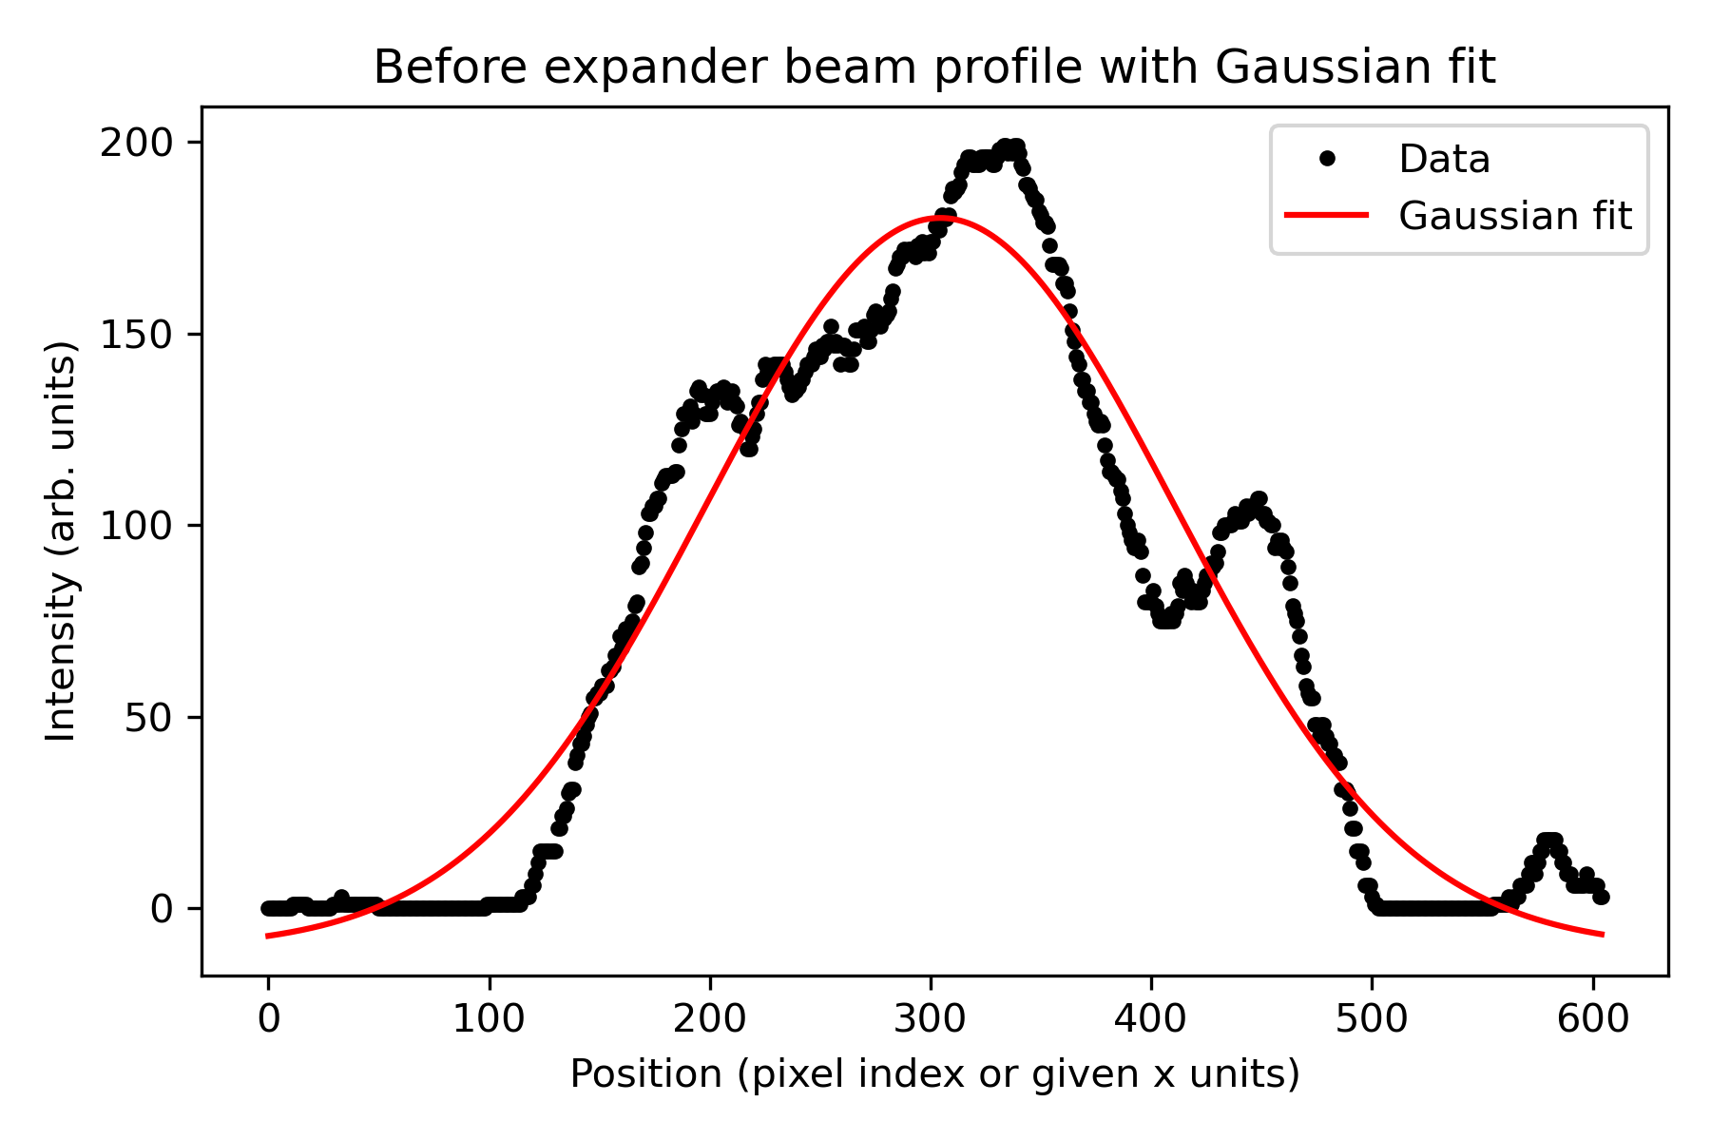

After beam expander
Gaussian fit parameters (after expander):
I0 = 162.91 ± 1.61, x0 = 684.73 ± 2.09, w = 557.23 ± 7.95 (pixels, 1/e² radius), offset = -2.51 ± 1.57.
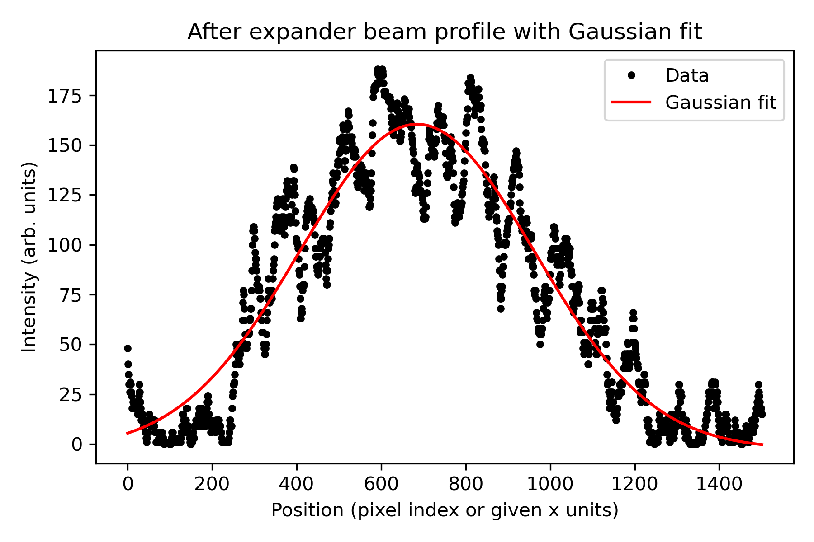

Summary of beam expander performance
The table below lists the fitted 1/e² beam radii before and after the beam expander. The measured expansion factor is calculated as the ratio of these waists.
Profile | w (pixels) | σ_w (pixels) | W ± σ_w (µm)
Before expander | 212.23 | 3.63 | 679.14 ± 11.62
After expander | 557.23 | 7.95 | 1783.14 ± 25.44
Measured expansion factor (radius): M = w_after / w_before = 2.63 ± 0.06. The diameter ratio is identical, since the beam diameter is defined as 2w.

