The Rubidium Atom– Lab Report

What are the allowed values of J for the 5S and 5P states of rubidium?
For the 5S state of Rb, the only allowed total angular momentum is $J=1/2$(5S₁/₂).
For the 5P state, the allowed values are $J=1/2$and $J=3/2$(5P₁/₂ and 5P₃/₂).
This figure is called an energy level diagram, but splittings are noted in frequency.
How does one convert from frequency to energy units?
To convert a frequency splitting $Δν$into an energy splitting, we use
$\boxed{ΔE=h Δν}$,
where $h=6.626×{10}^{-34} \text{Js}$. If we want the result in eV instead of J, we divide by the elementary charge:
$ΔE(\text{eV})=\frac{h Δν}{e}$.
What wavelength of light corresponds to the 5S to 5P energy splitting?
The 5S→5P splitting corresponds to a photon with wavelength
$λ=\frac{c}{ν_{0}}$.
Taking $ν_{0}≈3.8×{10}^{14} \text{Hz}$, we obtain
$λ≈7.9×{10}^{-7} \text{m}≈790 \text{nm}$,
which is in the near-infrared / red region of the spectrum.
What are the allowed F values for the 5S1/2, 5P1/2 and 5P3/2 states of 85Rb?
For ⁸⁵Rb (I = 5/2):
• 5S₁/₂: F = 2, 3
• 5P₁/₂: F = 2, 3
• 5P₃/₂: F = 1, 2, 3, 4
Given the above selection rules, and the energy level diagram of Fig. 5.2, list all allowable electric-dipole transitions.
The lab states the selection rules):
- ΔL = ±1
- ΔF = −1, 0, +1
looking at the D₂ line: $5S_{1/2}⟶5P_{3/2}$
for ⁸⁵Rb, where:
- Ground: 5S₁/₂ with F = 2, 3
- Excited: 5P₃/₂ with F′ = 1, 2, 3, 4
We apply ΔF = F′ − F = −1, 0, +1:
- From F = 2:
  - $F=2→F^{'}=1$(ΔF = −1)
  - $F=2→F^{'}=2$(ΔF = 0)
  - $F=2→F^{'}=3$(ΔF = +1)
- From F = 3:
  - $F=3→F^{'}=2$(ΔF = −1)
  - $F=3→F^{'}=3$(ΔF = 0)
  - $F=3→F^{'}=4$(ΔF = +1)
What are most probable speed for a room temperature distribution of Rubidium?

For a gas obeying the Maxwell–Boltzmann distribution, the most probable speed is
$$v_{p}=\sqrt{\frac{2k_{B}T}{m}}$$
where
- $k_{B}=1.380 649×{10}^{-23} \text{J/K}$
- $T$= room temperature (take $T≈293 \text{K}$, i.e. ~20 °C, unless your lab says otherwise)
- $m$= mass of one rubidium atom
the atomic mass is about
$$m≈85 u≈85×1.6605×{10}^{-27} \text{kg}≈1.41×{10}^{-25} \text{kg}.$$
$$v_{p}=\sqrt{\frac{2(1.380649×{10}^{-23} \text{J/K})(293 \text{K})}{1.41×{10}^{-25} \text{kg}}}$$
$$v_{p}≈\sqrt{5.7×{10}^{4}}\text{ m/s}≈2.4×{10}^{2} \text{m/s}.$$
What doppler shift does this correspond to for our 380T Hz laser?
For non-relativistic velocities, the Doppler shift along the beam axis is
$$Δν≈\frac{v}{c} ν_{0}$$
where
- $v≈v_{p}≈240 \text{m/s}$
- $c≈3.0×{10}^{8} \text{m/s}$
- $ν_{0}≈3.80×{10}^{14} \text{Hz}$
Compute the ratio:
$$\frac{v}{c}≈\frac{240}{3.0×{10}^{8}}≈8.0×{10}^{-7}$$
Then
$$Δν≈(8.0×{10}^{-7})(3.80×{10}^{14} \text{Hz})=3.0×{10}^{8} \text{Hz}$$

Rubidium Doppler-Broadened Absorption Analysis
Results: Gaussian Fits to Doppler-Broadened Features
Peak # | Time (s) | Center (GHz) | FWHM (MHz)
1 | -0.063783 | 10.583 | 229.0
2 | -0.057979 | 11.375 | 261.4
3 | -0.044477 | 13.314 | 269.8
4 | -0.032212 | 14.991 | 254.5

Plots from Gaussian Fit Analysis (Cell 1)
Raw Moku traces: cell vs scaled background
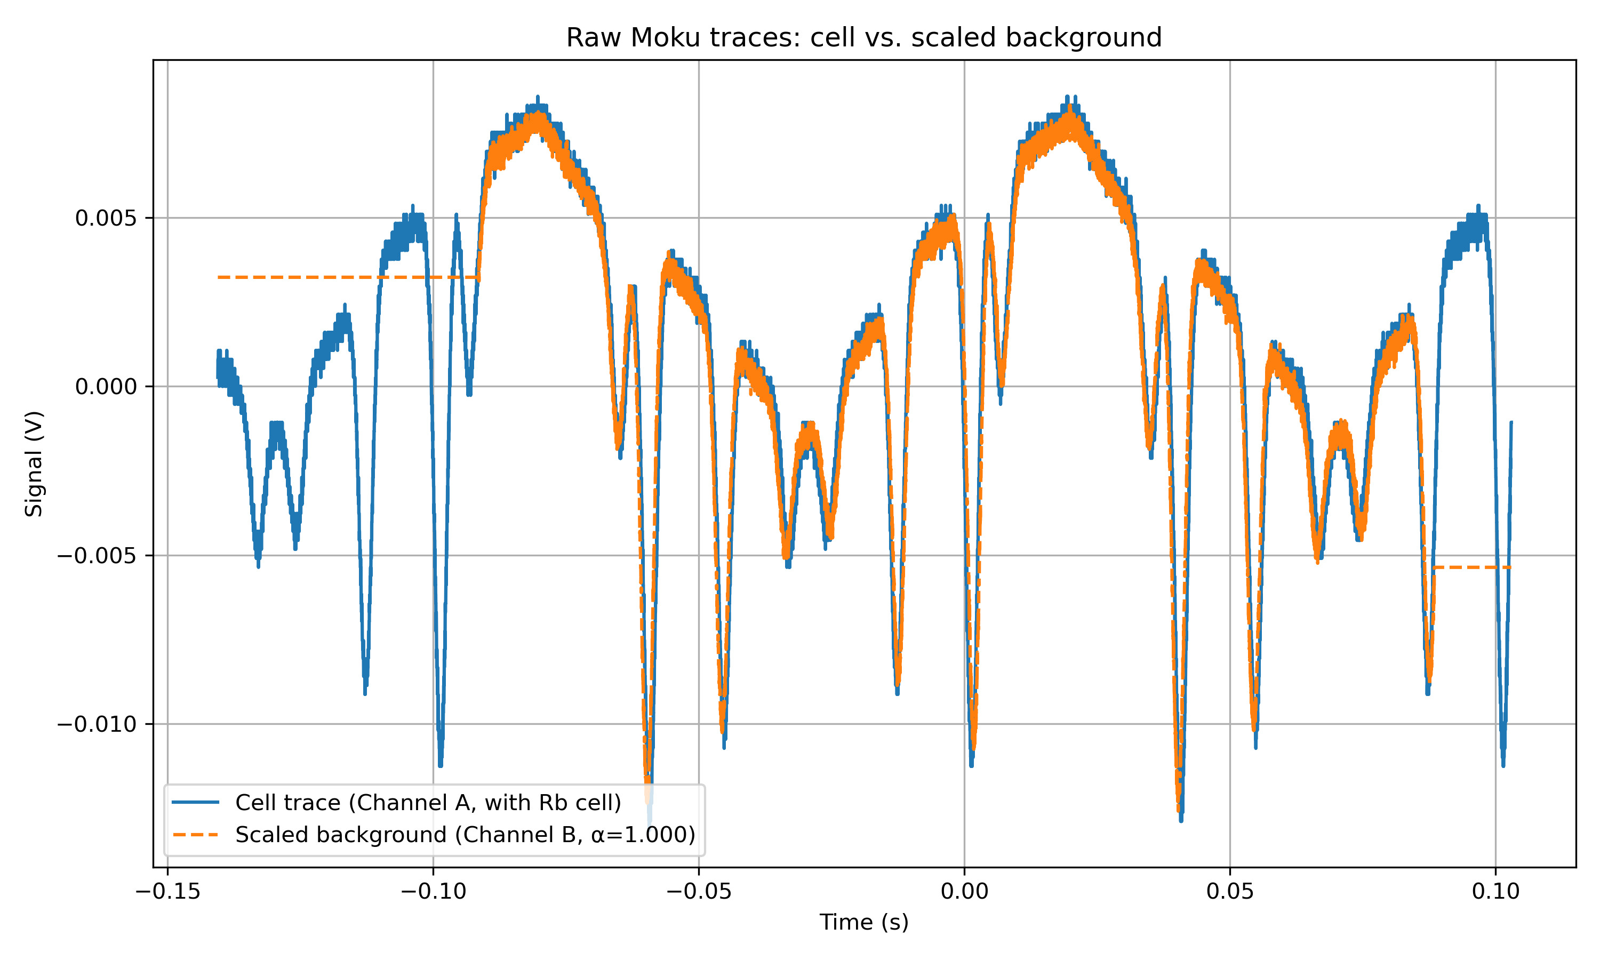
Background-subtracted Doppler-broadened features vs time
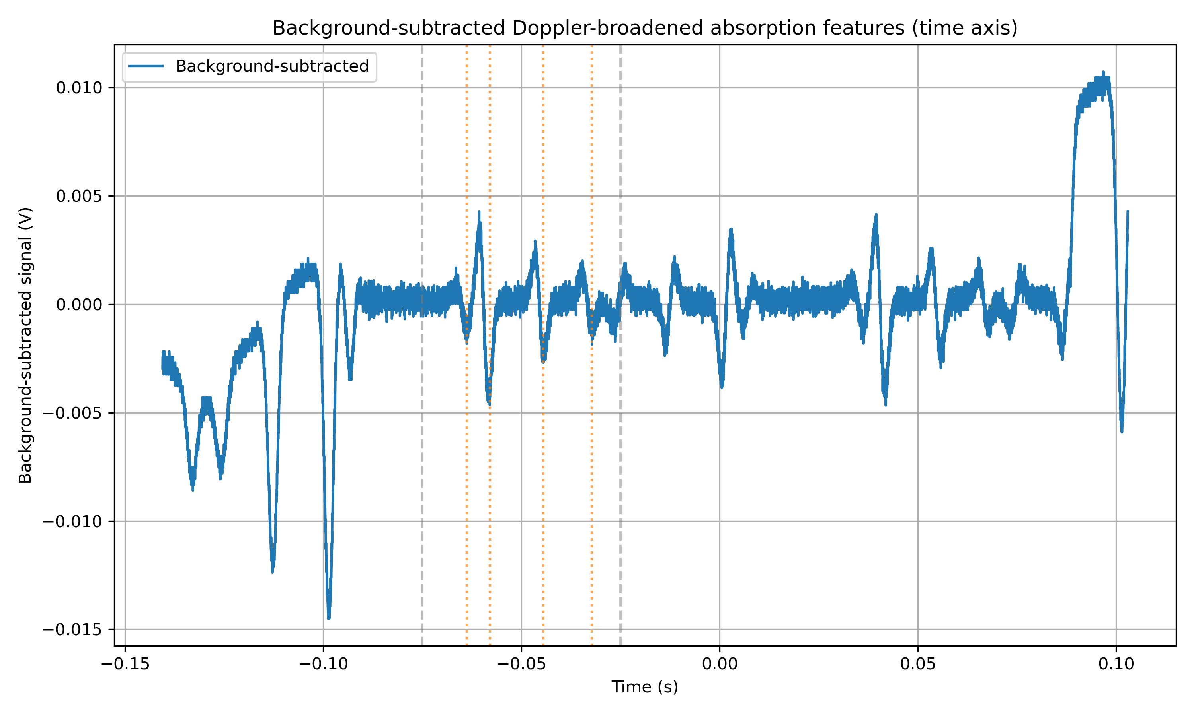
Background-subtracted spectrum with Gaussian fits
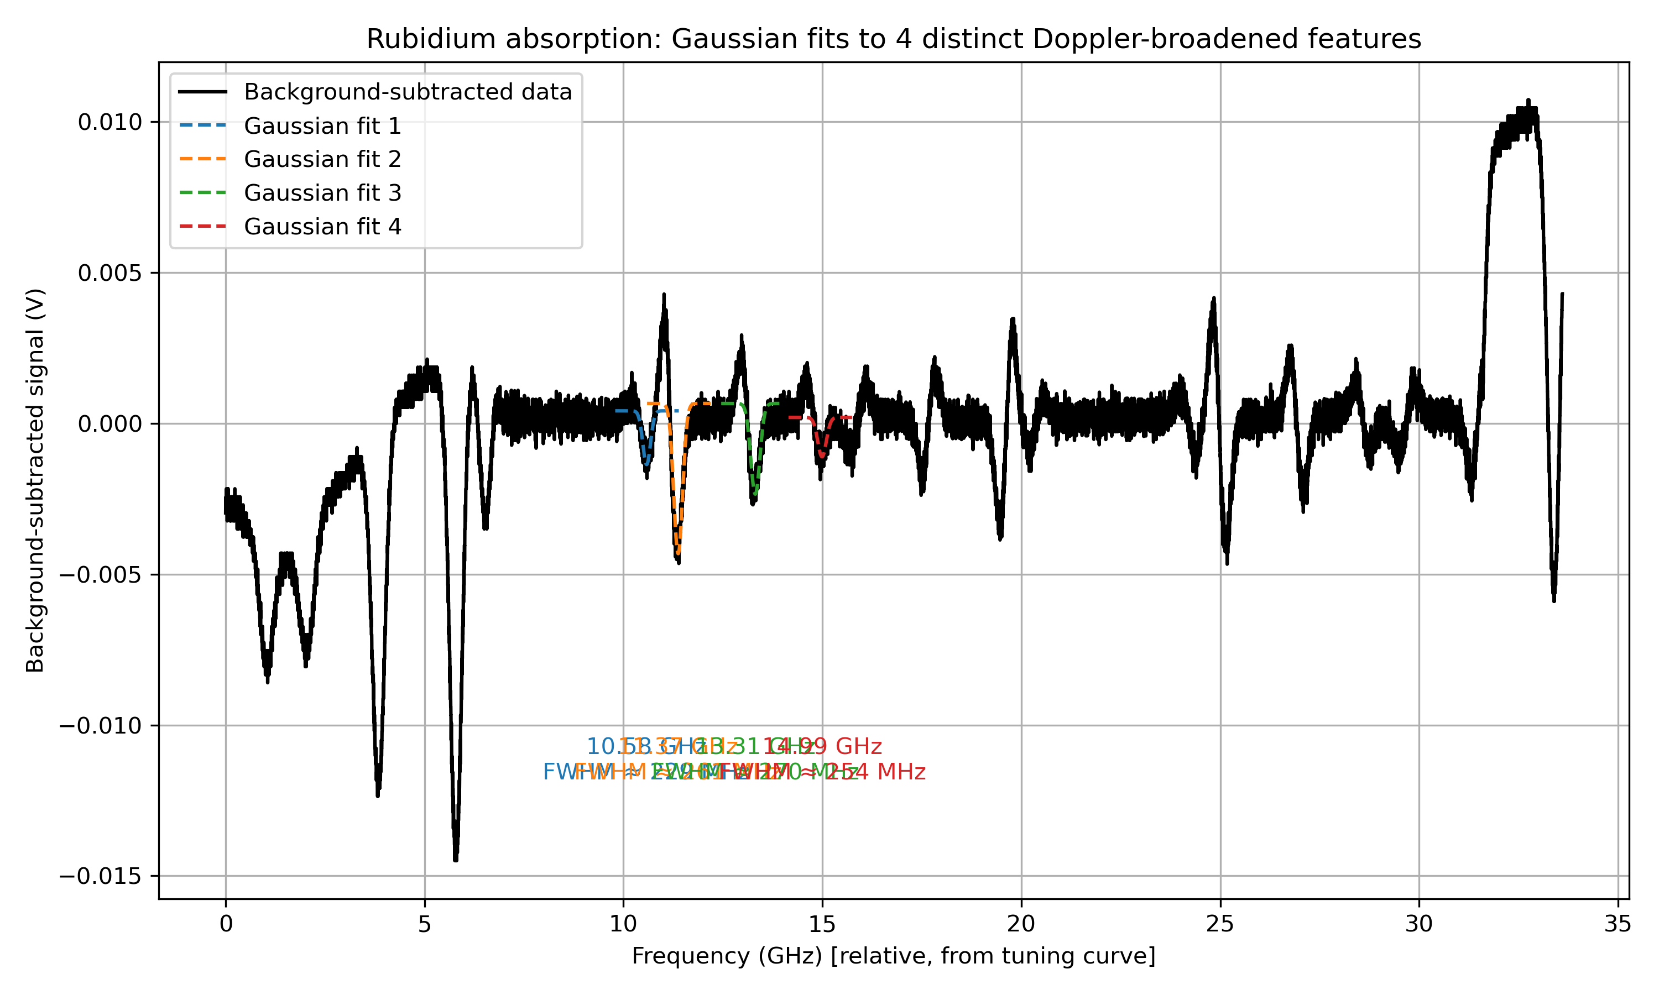

Results: Number Density and Vapour Pressure
Deepest absorption time t_min: -0.057979 s
Transmission at line centre T_min: 0.346095
Number density n: 4.716e+13 m^-3
Vapour pressure P: 1.908e-07 Pa (~1.431e-09 Torr)

**The code required is attached as a separate file. It was completely generated by AI(ChatGPT 5.1 with Extended Thinking)

