Auto Rig System
Ana Mei
Advisor: Stephen Lane
University of Pennsylvania

Abstract
In films such as Disney’s Tangled, we see digital characters behave as if they are real people. When modelers first built these characters, they are just 3D meshes; great to look at but static like sculptures. These models will eventually be passed down to a team of animator to be posed and animated. Before this can be done, a 3d model must be bounded to a system of joints and bones that act similarly to a skeleton for animators to pose.
This process can be extremely time-consuming and tedious when done manually. I want to create a tool that can automate steps in between to create fast and efficient rigs that can be passed down through the pipeline. Some of these steps include placing the skeleton, organizing a proper joint hierarchy, setting up forward and inverse kinematics systems, adding squash and stretch, and creating controls for animators to use.

Project Blog: http://pyautorig.blogspot.com/
GitHub Repository: https://github.com/anamei92/SeniorDesign

INTRODUCTION
In the 3D animation pipeline, modelers build characters that will be passed on to the animators to be brought to life. Before that can happen, these meshes needed to be handed over to the character riggers who will bound the meshes to a system of joints and control handles so that the meshes can be posed. A character rig is comparable to a real skeleton and is consisted of joints and bones, each of which acts as a handle that deforms a certain part of the character. This process, when done manually, can be very time consuming. There are a lot of repetitive tasks and the riggers can become more prone to mistakes as the skeleton grows in complexity.
Having parts of the process automated will provide a more efficient method for riggers. There are already a lot of auto rig systems that exists. However, most of them simply provide a pre-made skeleton for the riggers to place and setup. Usually, the skeleton is made in the T-pose. Thus, the meshes are often modeled in the same pose to match the auto-generated rig. For those meshes not made in the T-pose, the riggers will have to do a lot of adjusting to place the joints in the correct place. This can definitely improved on with a skeleton extraction method. This method will generate a skeleton based on the polygon of the mesh. It will be able to generate a skeleton that matches the mesh and save riggers time to place joints.

This project makes the following contributions:
- Simplify the character rigging process by using a skeleton extraction method
- Enable character riggers to focus on refining the model and rig by completing the initial basic setups.

Design Goals
This auto rig system would mainly target character riggers as well as others who would like a quick rig for animation. This program will take care of the repetitive portion of the process and speed up the rigging process for the users. Because of this, the users can spend more time focusing on defining the small details, such as how much influence a joint is suppose to have over the body of the mesh.

Projects Proposed Features and Functionality
This project makes the following features:

- Generating a curve skeleton using the mesh contraction method
- Placing joints on the curve skeleton and organizing the skeletal hierarchy
- Limbs with FK/IK switch system
- Creation of control handles for easy posing of the character

RELATED WORK
There has been much research concentrated on automated rigging, with a heavy emphasis on skeleton extraction. Some of these systems were built to animate the characters base on motion capture data. What I hope to create is an auto rig system that enables the character riggers to move joint controls to pose and animate the character.

Prior Work on Automated Rigging
It is recognized that manual rigging can be a tedious and laborious process. Thus, a lot of research was dedicated to simplify this process. Ilya Baran and Jovan Popovic made their contribution by building a prototype system called Pinocchio[BP07]. This system involves embedding a skeleton into the mesh’s interior and then calculating the optimal joint positions based on a penalty function. In their next step, they computed the weight of each joint based on the proximity to the mesh.
While Baran and Popovic’s method involves inserting the skeleton into the mesh, Bharaj’s did not [BTS*12]. Bharaj’s algorithm calculated a contact graph by segmenting the mesh into individual components. The contact is then simplified into a tree so there can be a one-to-one mapping to the joint skeleton. This allows a transfer of animation from the skeleton to the model.

Prior Work on Skeleton Extraction
In order for the mesh to be animated correctly, a suitable skeleton is needed to drive its movements. As a result, a lot of research was put into finding efficient ways of generating a skeleton. For example, there exists a prototype called the RigMesh. This system asks the user to sketch the silhouette of a shape and then generates a polygon consisting of cylinders, joints, and skin weights attached to the surface. [BJD*12]. The RigMesh combines mesh and skeleton creation into one step. Besides RigMesh, there are other skeleton extraction processes that use a modified dijkstra method. It divides the mesh into voxels and continuously removes pieces until only a skeleton remains [RSL10].
Other methods involve calculating a curve skeleton base on polygon processing. Some researchers attempted to solve this problem by focusing on the 3D silhouette, which simply is the 2D silhouette with added depth. Then they calculate the medial axis from the silouhette to determine the location of the joints [PYX*09]. In addition, curve skeleton can also be created through mesh contraction [ATC*08]. The algorithm performs Laplacian smoothing and degenerate face removal repeatedly until only a curve skeleton is left. The leftover curve skeleton will serve as the guideline for skeleton placement.

PROJECT PROPOSAL
The purpose of this project is to create a plugin to assist character riggers in their tasks. It is expected to be able to generate a skeleton for any a mesh of arbitrary pose, setup the FK/IK switch systems for limbs, and create controls as user interface for animators.

Anticipated Approach
To build this auto rig, the first step is generating the curve skeleton. This involves traversing the vertices and faces of a mesh to remove details until only a curve is left. For this step, it is best to start off with a simple polygon shape and generate a spline from it. Once the curve skeleton is generated, the next step involves figuring out the joint placements. The curve skeleton will have more vertices than the number of joints so it is necessary to perform a clustering algorithm to reduce the complexity of the curve. Once the skeleton is created, the user will be able to setup FK/IK limbs and controls.

Target Platforms
This program will be coded in Python and developed in Maya.

Evaluation Criteria
A successful implementation of my auto rig would involve the ability for users to animate and pose the mesh with ease. The users should be able to move the skeleton with the control joints and be able to switch between FK/IK modes for expressive animation. In addition, this program is aimed to be able to create a skeleton for unusual meshes, such as an octopus, rather than the normal biped or quadruped.

RESEARCH TIMELINE
Project Milestone Report (Alpha Version)
- Completed all background reading
- Have a simple demonstration of generating splines from polygon.
- Created user interface on Maya’s end for users

Project Milestone Report (Beta Version)
- Extracted skeleton from a model
- Placed joints on curve skeleton
- Setup FK/IK limb system

Project Final Deliverables
- A Maya plugin used for quick auto rigging.
- A demo of the skeleton extraction and creation process.
- Documentation on how to use this system

Project Future Tasks
- Improve speed and the ability to create skeleton from high poly meshes
- Be able to name and organize the joint hierarchy
- A user study test to improve user friendliness

You will fill in the following sections as you make progress on your project, particularly for the alpha review and the final deliverable. In these sections, list pseudo-code, charts, images, examples, etc. to show what you’ve done over the course of the semester.

Method

RESULTS

CONCLUSIONS and FUTURE WORK
APPENDIX
- Optional Appendix
Some text here. Some text here. Some text here.

(remove line)

References
[ATC*98] | AU O. K., TAI C. L., CHU H. K., OR D. C, LEE T. Y.: Skeleton Extraction by Mesh Contraction. In Proc. SIGGRAPH ’08 (2008), vol. 27.
[BJD*12] | BOROSAN P., JIN M., DECARLO D., GINGOLD Y., NEALEN A.: RigMesh: Automatic Rigging for Part-Based Shape Modeling and Deformation. ACM TOG 31, 6, 198:1 – 198:9.
[BP07] | BARAN I., POPOVIC J.: Automatic Rigging and Animation of 3D Characters, SIGGRAPH ’07
[BTS*12] | BHARAJ G., THORMAHLEN T., SEIDEL H.P., THEOBALT C.: Automatically Rigging Multi-component Chracters. Proc. urographics’12).
[PYX*09] | PAN J., YANG X., XIE X., WILLIS P., ZHANG J. J.: Automatic rigging for animation characters with 3D silhouette. Computer Animation and Virtual Worlds (2009), 20, pp.121-131
[RSL10] | RAMIREZ J. E, SUSIN. A., LLIGADAS. X.: Adjusting Animation Rigs to Human-Like 3D Models. Lecture Notes in Computer Science (2010), vol. 6169, pp. 300-309

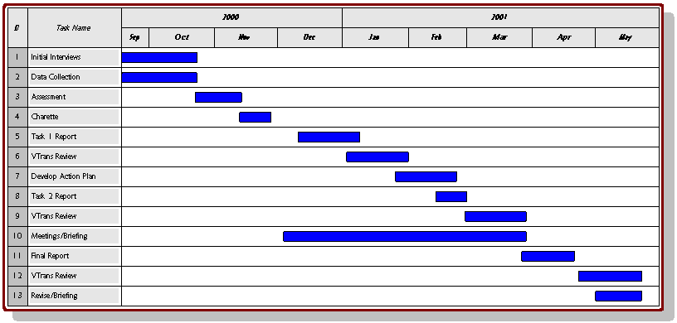
Figure 2: For publications with color tables and figures that span two columns like your gant chart or results will.

