**HTML TERMINOLOGY**

**Ana Carolina de Souza Mendes**

**SID: 809-25-8083**

1. Quizlet Multiple Choice

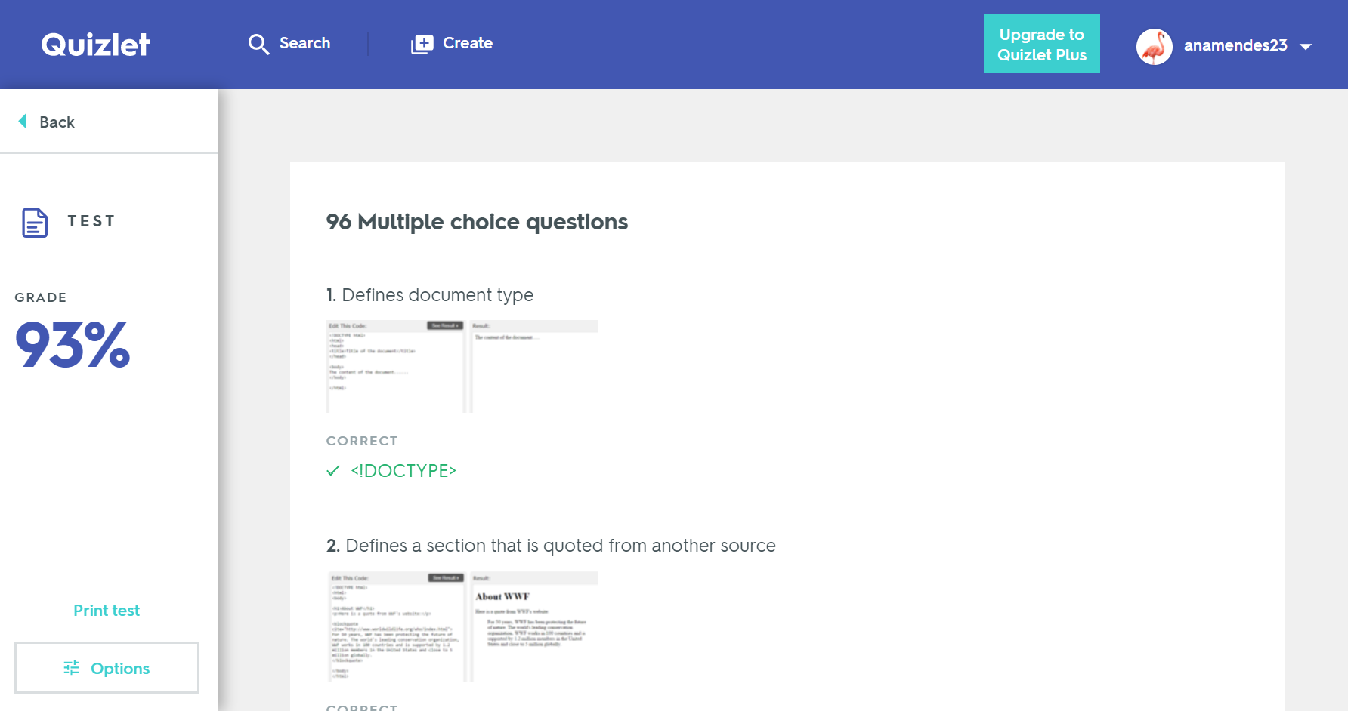

1. Quizlet Match

