CSI 145 – Web Design

Ana Carolina de Souza Mendes - 809258083

**Quizlet: Match**

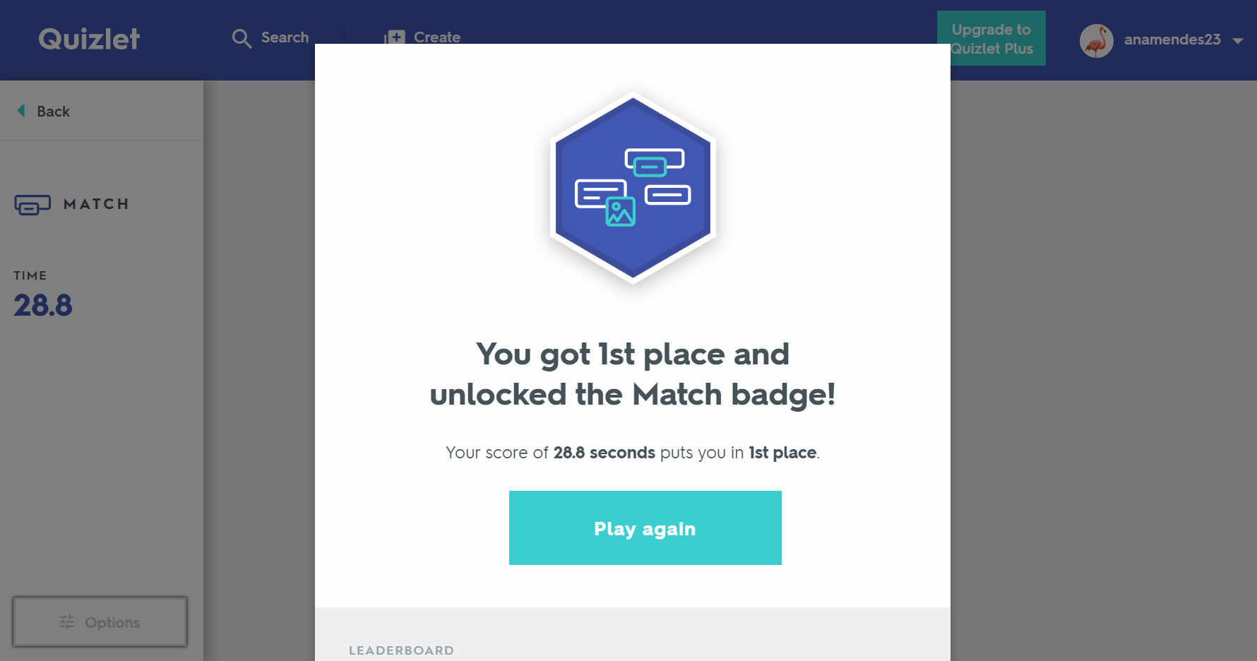

**Kahoot!**

