Outlier DNA Methylation in TCGA-BRCA
Progress report for the meeting of 28 August 2026
Anam Giri
What this report is
It answers the four questions set in the pre-meeting email, then reports three things that came out of answering them: a mechanism explaining why the outlier flags behave as they do, a bug that changes a previously reported result, and a tested recommendation for what to use instead.
Every number is reproducible from a named script and CSV in the project repository. Where a claim is not yet supported, it is labelled as such rather than softened.

Summary
The four questions, answered.
# | Question asked | Answer
1 | Summarise chromosome 22 by methylation state | Done — both tissues, all six states, three methods (§2)
2 | At high sites, is there ever a “too high” flag? At low sites, a “too low” one? | Yes, routinely — up to 6.3% of measurements at tumour H sites (§3)
3 | If so: which sample, which site, and why? | Three samples supply a third of them. The pattern is strongly consistent with the geometry of the threshold, though biology is not excluded (§4)
4 | Debug the per-sample summary, where N37 came top | N37 ranks 41st of 53 chromosome-wide. Its top rank was an artifact of the 100-site window. It does carry one candidate real event (§5)

What came out of answering them.
- The flags at the methylation extremes are statistically real but very small. 97% of flags at high-methylation sites shift methylation by less than 0.10 on a 0–1 scale. This holds genome-wide, not just on chromosome 22.
- They are also not reproducible. Adding measurement noise the size of the array's own error changes more calls than there were flags to begin with.
- A typo was deleting an entire methylation state from three earlier analyses — 40% of tumour sites and 65% of the tumour flags. Fixed; the corrected table changes the conclusion.
- A one-line fix — requiring a minimum size of difference before a flag counts — triples reproducibility. It is the strongest option of seven tested, but the exact cut-off still needs a biological justification.
The one decision I need from you
Is the goal of this project to (a) evaluate whether this outlier method works, or (b) find real biological epimutations in BRCA? The work so far answers (a) well and is not yet in a position to claim (b), because probe quality-control has not been done. Committing to one changes what comes next.

1. Background — what you need to know to read the tables

The data
TCGA breast cancer (BRCA): 53 normal and 53 tumour samples, measured on the Illumina 450k array at 380,355 CpG sites. Chromosome 22 holds 6,809 of them. Each measurement is a beta value between 0 (no methylation) and 1 (fully methylated).
Each CpG site carries a label describing its usual methylation level, assigned beforehand: L (low), LM (low-medium), M (medium), HM (high-medium), H (high), and R (the remainder). An “outlier flag” marks one sample at one site as unusually high (+1), unusually low (−1), or normal (0).

The three methods being compared
Method | How it decides what counts as an outlier | Why it is here
bio | At L/LM sites, flag a sample above the 99th percentile of the 53 values. At H/HM sites, flag below the 1st percentile. No rule at M/R sites. | The state-aware rule proposed in our earlier meetings
self | Thresholds calculated from the same 53 samples being tested | How the software was run in Tasks 10–15
ext | Thresholds from a separate published panel of 2,015 independent samples | How the software was designed to be used

Important: two of the three methods cannot show a result
With 53 samples, the 99th percentile falls between the 52nd and 53rd ranked value. So exactly one sample can ever exceed it — the largest one. The bio and self methods therefore hand out a fixed number of flags to every site, no matter what the data says, at every significance level from 0.01 down to 0.00001.
You can see this directly in the tables that follow: every self row reads 1.89 / 96.23 / 1.89, which is exactly 1/53, 51/53 and 1/53.
They are kept in the tables as a negative control — they show what “no signal” looks like. Only the ext column can carry a finding.

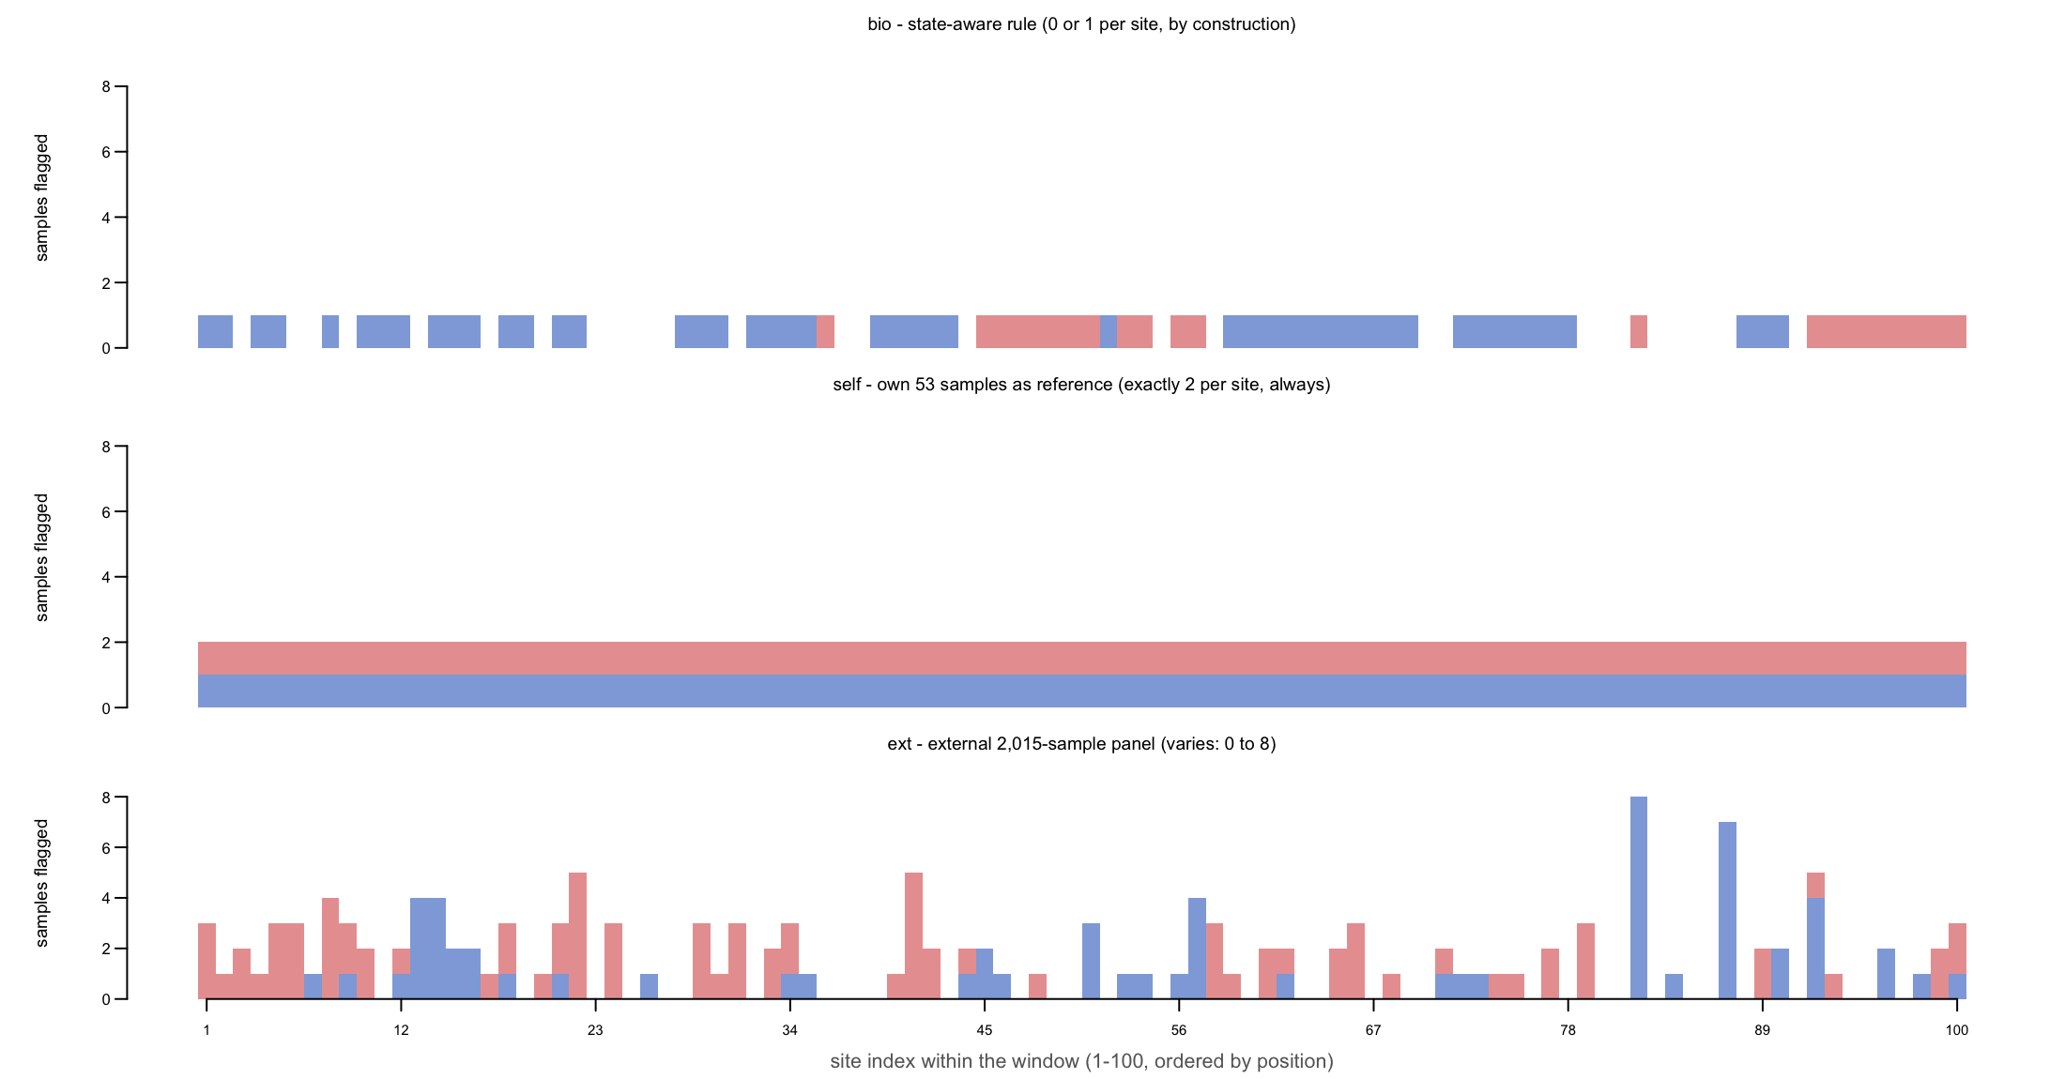
Figure 1. The same 100 sites under each method, one bar per site. self is a flat block of exactly two flags at every single site — that is the arithmetic artifact, not a result. bio gives 0 or 1. Only ext varies with the data (0 to 8). This is why only the ext column can carry a finding.

Two things that cause confusion if unstated
(a) What is being counted changes between sections.
Unit | What one count means
CpG site | One probe on the array. 380,355 in total.
Measurement | One sample at one site. 53 per site.
Sample burden | All flags belonging to one sample, added up.
Event | A run of 3 or more flagged neighbouring sites within 1,000 base pairs, counted once.

A sample can have eleven flags and one event. That is not a contradiction — it is one biological event measured by eleven probes.
(b) The external panel does not cover every site, and the gaps are uneven.
Sites missing from the 2,015-sample panel return no answer, so the ext method is scored on fewer measurements than the other two. Coverage differs by state, which matters when comparing states to each other:
Methylation state | Sites missing from panel — Normal | Tumour
H | 1.05% | 0.46%
L | 2.94% | 2.34%
HM | 3.30% | 3.38%
R | 8.91% | 8.27%
LM | 14.39% | 11.47%
M | 16.29% | 24.82%

Source: Task26_DenominatorAudit_*.csv | Script: Task26.ReviewResponse.Aug28.2026.R
All percentages in this report are calculated over sites that were actually measurable, so each is internally correct. But comparing raw counts between methods at LM or M sites compares different denominators.

2. Question 1 — Chromosome 22 summarised by state
The email's example — “H, 11 CG sites” — identifies the window exactly: the first 100 chromosome-22 sites by position, in which 11 are H-state. Reproduced in full.
Normal tissue, 100 sites, chr22:11,915,060–17,085,407. Read the ext rows.
State | Sites | Method | −1 | 0 | +1 | % −1 | % 0 | % +1
L | 8 | bio | 0 | 416 | 8 | 0.00 | 98.11 | 1.89
 |  | self | 8 | 408 | 8 | 1.89 | 96.23 | 1.89
 |  | ext | 8 | 359 | 4 | 2.16 | 96.77 | 1.08
LM | 14 | bio | 0 | 728 | 14 | 0.00 | 98.11 | 1.89
 |  | self | 14 | 714 | 14 | 1.89 | 96.23 | 1.89
 |  | ext | 21 | 718 | 3 | 2.83 | 96.77 | 0.40
M | 24 | bio | 0 | 1272 | 0 | 0.00 | 100.00 | 0.00
 |  | self | 24 | 1224 | 24 | 1.89 | 96.23 | 1.89
 |  | ext | 12 | 1241 | 19 | 0.94 | 97.56 | 1.49
HM | 38 | bio | 38 | 1976 | 0 | 1.89 | 98.11 | 0.00
 |  | self | 38 | 1938 | 38 | 1.89 | 96.23 | 1.89
 |  | ext | 16 | 1952 | 46 | 0.79 | 96.92 | 2.28
H | 11 | bio | 11 | 572 | 0 | 1.89 | 98.11 | 0.00
 |  | self | 11 | 561 | 11 | 1.89 | 96.23 | 1.89
 |  | ext | 2 | 571 | 10 | 0.34 | 97.94 | 1.72
R | 5 | bio | 0 | 265 | 0 | 0.00 | 100.00 | 0.00
 |  | self | 5 | 255 | 5 | 1.89 | 96.23 | 1.89
 |  | ext | 5 | 256 | 4 | 1.89 | 96.60 | 1.51

Source: Task20_Chr22_index100_StateSummary_Normal.csv | Script: Task20.Chr22.TightWindow.Concordance.Aug28.2026.R
Notice every self row: 1.89 / 96.23 / 1.89, identical in all six states. That is the arithmetic artifact described on page 2, visible in the data.
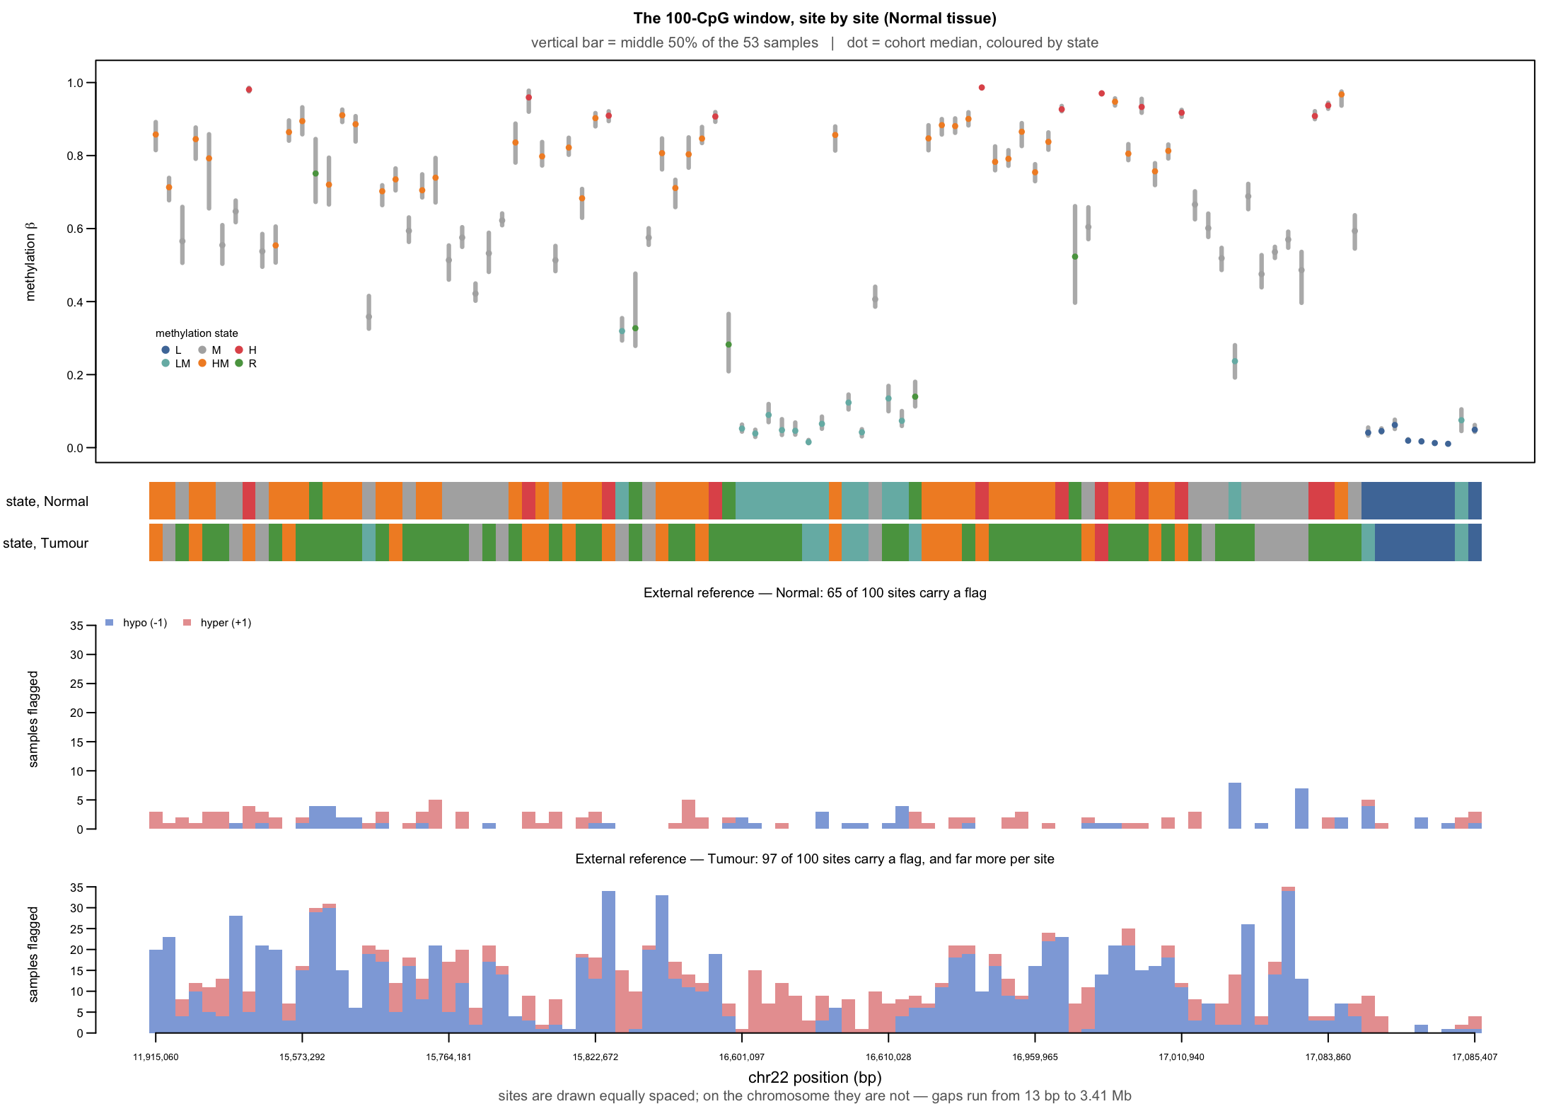
Figure 2. All 100 sites at once. Top: the methylation landscape — each vertical bar is the middle 50% of the 53 samples, the dot is the median, coloured by state. Middle: the state of each site in normal and tumour tissue, showing how differently they are labelled. Bottom: how many samples the external reference flags at each site. Tumour flags far more sites (97 of 100) and far more samples per site than normal (65 of 100).
Tumour tissue, same 100 sites. The state labels are assigned separately per tissue, so these sites sit in different states here: R grows from 5 sites to 52.
State | Sites | −1 | 0 | +1 | % −1 | % 0 | % +1
L | 7 | 4 | 307 | 7 | 1.26 | 96.54 | 2.20
LM | 8 | 29 | 362 | 33 | 6.84 | 85.38 | 7.78
M | 13 | 178 | 473 | 38 | 25.84 | 68.65 | 5.52
HM | 19 | 204 | 760 | 43 | 20.26 | 75.47 | 4.27
H | 1 | 14 | 39 | 0 | 26.42 | 73.59 | 0.00
R | 52 | 551 | 2010 | 195 | 19.99 | 72.93 | 7.08

Do not read the tumour H row
It contains a single CpG site. “26.42%” means 14 flagged measurements at one probe. A percentage over one site estimates nothing. The L and LM rows, at 7 and 8 sites, are also thin. This is a property of the window, not of tumour biology — the tumour annotation moves most of these sites into R. The genome-wide table in section 7, where H has 30,080 sites, is the one to quote.

3. Question 2 — Are there flags pointing where there is no room?
A “too high” flag at a site that is already highly methylated, or a “too low” flag at one that is already low, points in the direction with the least room to move. You asked whether any exist.
Yes — in every state, in both tissues, at every scale tested.
Tissue | State | Flag that contradicts the state | Count | of measurements | Rate
Normal | L | too low (−1) | 39 | 2,120 | 1.84%
Normal | LM | too low (−1) | 5 | 530 | 0.94%
Normal | HM | too high (+1) | 9 | 1,113 | 0.81%
Normal | H | too high (+1) | 16 | 848 | 1.89%
Tumour | L | too low (−1) | 52 | 2,014 | 2.58%
Tumour | LM | too low (−1) | 33 | 583 | 5.66%
Tumour | HM | too high (+1) | 47 | 1,060 | 4.43%
Tumour | H | too high (+1) | 40 | 636 | 6.29%

External reference, 100-site tight window (see section 6). Source: Task20_Chr22_tight100_ContraryCounts_*.csv
A necessary qualification
“Contradicts the state” means the flag points opposite to a six-level summary label — not that it is biologically impossible. Real variation within a state exists, and a genuinely under-methylated sample at a low site is perfectly possible.
What makes these flags questionable is not their direction but their size, which is the subject of the next section.
Note also that the bio rule returns zero in every row here — by construction it can only flag in the state-consistent direction, so its zero is not evidence of anything.

4. Question 3 — Which sample, which site, and why

Which samples
Three samples supply about a third of all state-contradicting flags on chromosome 22, and they are the same three in both tissues.
Sample | Contradicting flags | All its flags | % contradicting
N17 | 410 | 1,250 | 32.8%
N15 | 381 | 1,297 | 29.4%
N14 | 369 | 1,039 | 35.5%
N48 | 356 | 496 | 71.8%
N31 | 301 | 405 | 74.3%
N27 | 264 | 278 | 95.0%

Source: Task21_Chr22_ContraryDrivers_Normal.csv | Script: Task21.Chr22.SampleBurden.Aug28.2026.R
N15, N17 and N14 also lead the flag count at every scale in both tissues, and their chromosome-22 burden tracks their genome-wide burden closely (rank correlation 0.76 normal, 0.84 tumour). This is a property of those whole samples, not of chromosome 22 — plausibly global methylation loss, tumour purity, or a technical batch effect. None of these has been tested yet.

Which sites
Of the 69 contradicting flags in the tight window: none fall in a CpG island, none have a known genetic variant within 10 base pairs, only 2 are also outliers by the standard Tukey test, and 48 are isolated with no flagged neighbour nearby. The usual technical explanations do not apply.

Why — the flagged differences are very small
For every flagged measurement, how far is it from the middle of the cohort? Measured genome-wide across all 380,355 sites:
State | Tissue | Sites | Flags | Median difference | % smaller than 0.10
H | Normal | 61,845 | 78,259 | 0.031 | 96.97%
L | Normal | 104,540 | 174,567 | 0.042 | 81.53%
HM | Normal | 97,094 | 114,575 | 0.119 | 39.82%
M | Normal | 36,785 | 25,087 | 0.153 | 16.98%
R | Normal | 23,455 | 38,131 | 0.269 | 3.68%
H | Tumour | 30,080 | 68,114 | 0.028 | 96.16%
L | Tumour | 76,106 | 163,788 | 0.031 | 85.21%
R | Tumour | 153,479 | 1,608,650 | 0.213 | 19.92%

Source: Task26_GenomeWideMagnitude.csv | Script: Task26.ReviewResponse.Aug28.2026.R
Nearly every flag at a high-methylation site corresponds to a change too small to matter biologically. At R-state sites, the same method produces flags eight times larger. The chromosome-22 figures reproduce genome-wide to within one percentage point.
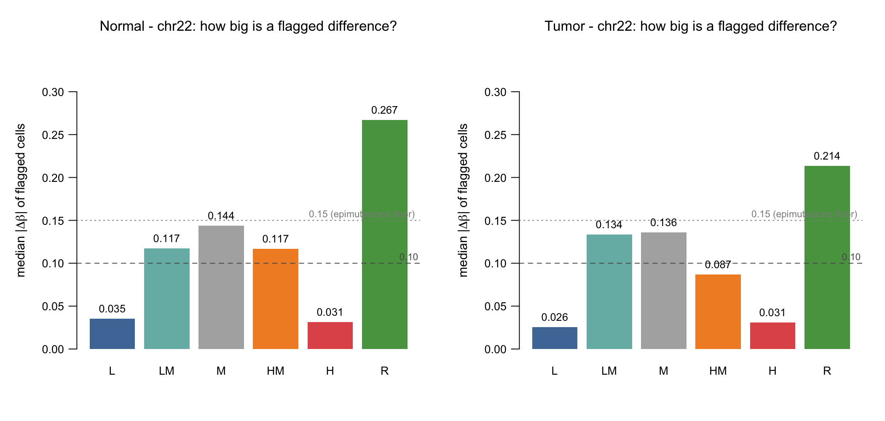
Figure 3. How big is a flagged difference? Bars show the median change in methylation for flagged measurements. The dashed line at 0.10 is a common threshold for “biologically meaningful”; the dotted line at 0.15 is the cut-off used by the published epimutacions software. Flags at L and H sites fall far below both.

5. Question 4 — Debugging the per-sample summary (N37)
N37 topped the earlier summary with 11 of 71 flags, about eight times the expected share. Widening the comparison settles it:
Scale | Sites | Method | Flags | Expected | Rank of 53
100-site window | 100 | bio | 11 | 1.3 | 1st
100-site window | 100 | ext | 1 | 2.8 | 30th
tight 100-site window | 100 | bio | 1 | 1.7 | 17th
whole chromosome 22 | 6,809 | bio | 24 | 108.3 | 41st
whole chromosome 22 | 6,809 | ext | 114 | 182.0 | 25th

Source: Task21_Chr22_SampleBurden_Normal.csv
Three separate reasons N37 came top, none of them “N37 is an unusual sample”:
- The window was not representative. Across the whole chromosome N37 carries less than a quarter of its expected flags and ranks 41st of 53.
- The external reference does not see it — one flag, ranked 30th.
- Ten of the flags are one event. They collapse into three runs of neighbouring sites; the largest holds seven consecutive probes.

But the underlying event looks real
Seven consecutive sites across 1,740 base pairs, where N37 sits far above everyone else:
Site | Position (chr22) | N37 | Cohort median | Next highest | Margin
cg01836687 | 16,601,097 | 0.553 | 0.052 | 0.141 | 0.413
cg26822097 | 16,601,691 | 0.402 | 0.039 | 0.341 | 0.061
cg12431879 | 16,601,897 | 0.442 | 0.089 | 0.289 | 0.152
cg00332021 | 16,602,522 | 0.435 | 0.048 | 0.213 | 0.222
cg00816224 | 16,602,592 | 0.438 | 0.046 | 0.243 | 0.195
cg15554678 | 16,602,673 | 0.356 | 0.015 | 0.111 | 0.245
cg23572163 | 16,602,837 | 0.276 | 0.065 | 0.211 | 0.064

Source: Task21_Chr22_N37_Cluster_Normal.csv (restricted file — contains individual-level values)
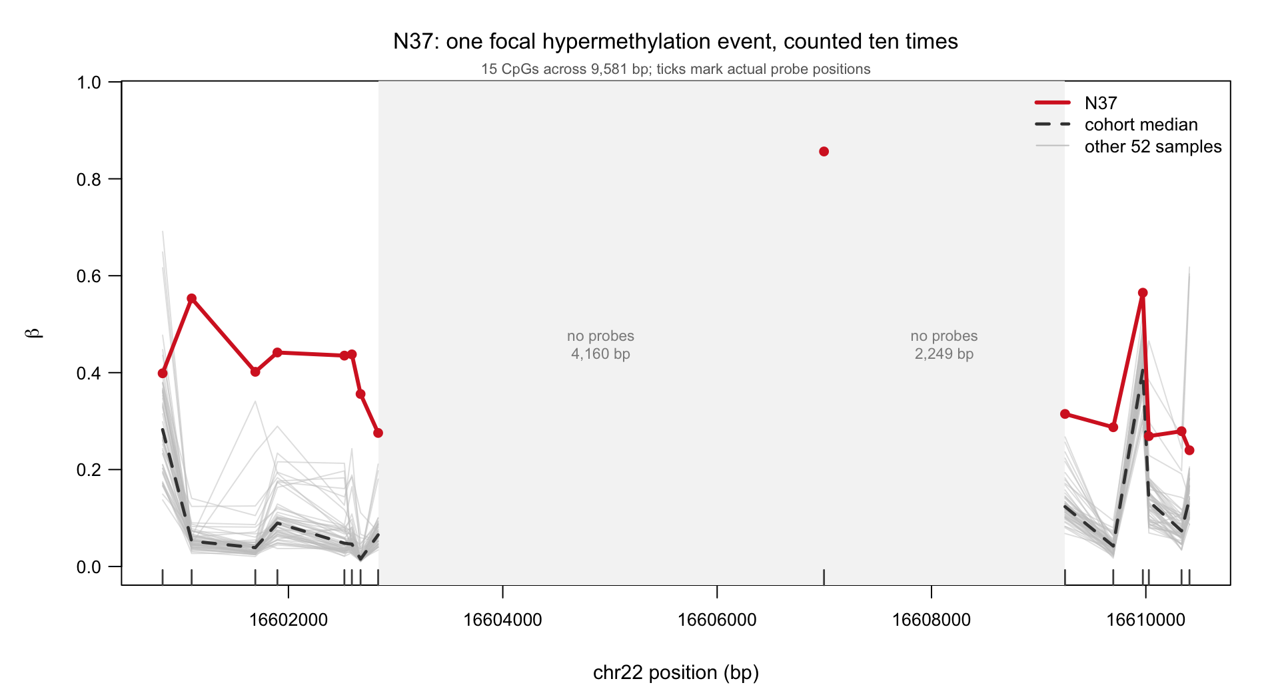
Figure 4. N37 (red) against the other 52 samples (grey) across this region. The shaded band marks a stretch with no probes on the array; lines are broken there rather than drawn across it. Tick marks show actual probe positions.
This must not be called a real finding yet
The region sits at chr22:16.6 Mb, next to the centromere on a repetitive, poorly-mapped part of the chromosome. A run of seven elevated probes there is also exactly what a probe cross-hybridisation artifact looks like. Standard probe-quality filtering has not been applied to this project.
Correct wording: a candidate focal event, pending probe quality control. What can be said without qualification is narrower — the per-sample summary counted one continuous run seven separate times.

6. Two supporting checks

The original 100 sites were not close together
The email asked for sites close to each other. The 100 used previously are consecutive by position in the file, not by distance:
Window | Total span | Median gap | Largest gap | Neighbours within 1 kb
Original 100 | 5,170,347 bp | 512 bp | 3,410,179 bp | 61 of 99
New tight 100 | 73,399 bp | 187 bp | 13,823 bp | 80 of 99

Source: Task20_Chr22_WindowComparison.csv
The new window is the 100 consecutive sites with the smallest span on chromosome 22 (chr22:50,459,312–50,532,711). Both are analysed side by side throughout, so the earlier result stays reproducible. The choice matters: N37 falls from 1st to 17th between them.

The state-aware rule and the external reference disagree
Simple percent agreement is misleading here, because more than 95% of all measurements are “not flagged” by both methods — so any two methods agree about 96% of the time just by both saying nothing. Two better measures:
- Agreement among flagged — of measurements flagged by at least one method, how often both gave the same answer.
- Cohen's kappa — a standard agreement score corrected for agreement expected by chance. 0 means chance-level; 1 means perfect.
Tissue | Methods compared | Flagged by either | Both agreed | Agreement | Kappa
Normal | bio vs ext | 172 | 21 | 12.2% | 0.21
Normal | self vs ext | 235 | 63 | 26.8% | 0.41
Tumour | bio vs ext | 415 | 28 | 6.8% | 0.11
Tumour | self vs ext | 455 | 99 | 21.8% | 0.33

Source: Task20_Chr22_tight100_Concordance_*.csv
The two approaches define “outlier” differently rather than offering two views of the same underlying set. One caution: with this much imbalance, kappa is sensitive to the overall flag rates and should be read alongside the agreement column. Both point the same way here.

7. Why the flags behave this way
The thresholds the software used can be recovered from its own output, which also confirms the pipeline is correctly aligned: across 13,618 site-by-tissue combinations there was not one case where a flagged sample's value sat inside the unflagged range.

The outlier zones are extremely lopsided
For each state, how much of the 0–1 methylation scale counts as “too high”, and how much as “too low”:
State | “Too high” zone width | “Too low” zone width | Gap between the two samples either side of the line
L | 0.900 | 0.021 | 0.024
LM | 0.774 | 0.049 | 0.057
M | 0.318 | 0.360 | 0.028
HM | 0.090 | 0.677 | 0.013
H | 0.037 | 0.886 | 0.003
R | 0.238 | 0.269 | 0.052

Normal tissue, chromosome 22 medians. Source: Task22_Chr22_ThresholdGeometry_Normal.csv
At an H site the “too high” zone is 0.037 wide and the “too low” zone is 0.886 — 24 times larger. Yet 87.8% of the flags that actually occur are “too high”. Adjusting for the room available:
The calculation, in full
There are 1,283 flags at H sites in normal tissue.
“Too high”: 1,283 × 87.8% = 1,126 flags in a zone 0.037 wide → 30,363 per unit
“Too low”: 1,283 × 12.2% = 157 flags in a zone 0.886 wide → 177 per unit
Flags are 171 times denser in the direction the site's own state already restricts. At L sites the same calculation gives 44 times. A method with no directional preference would give roughly 1.

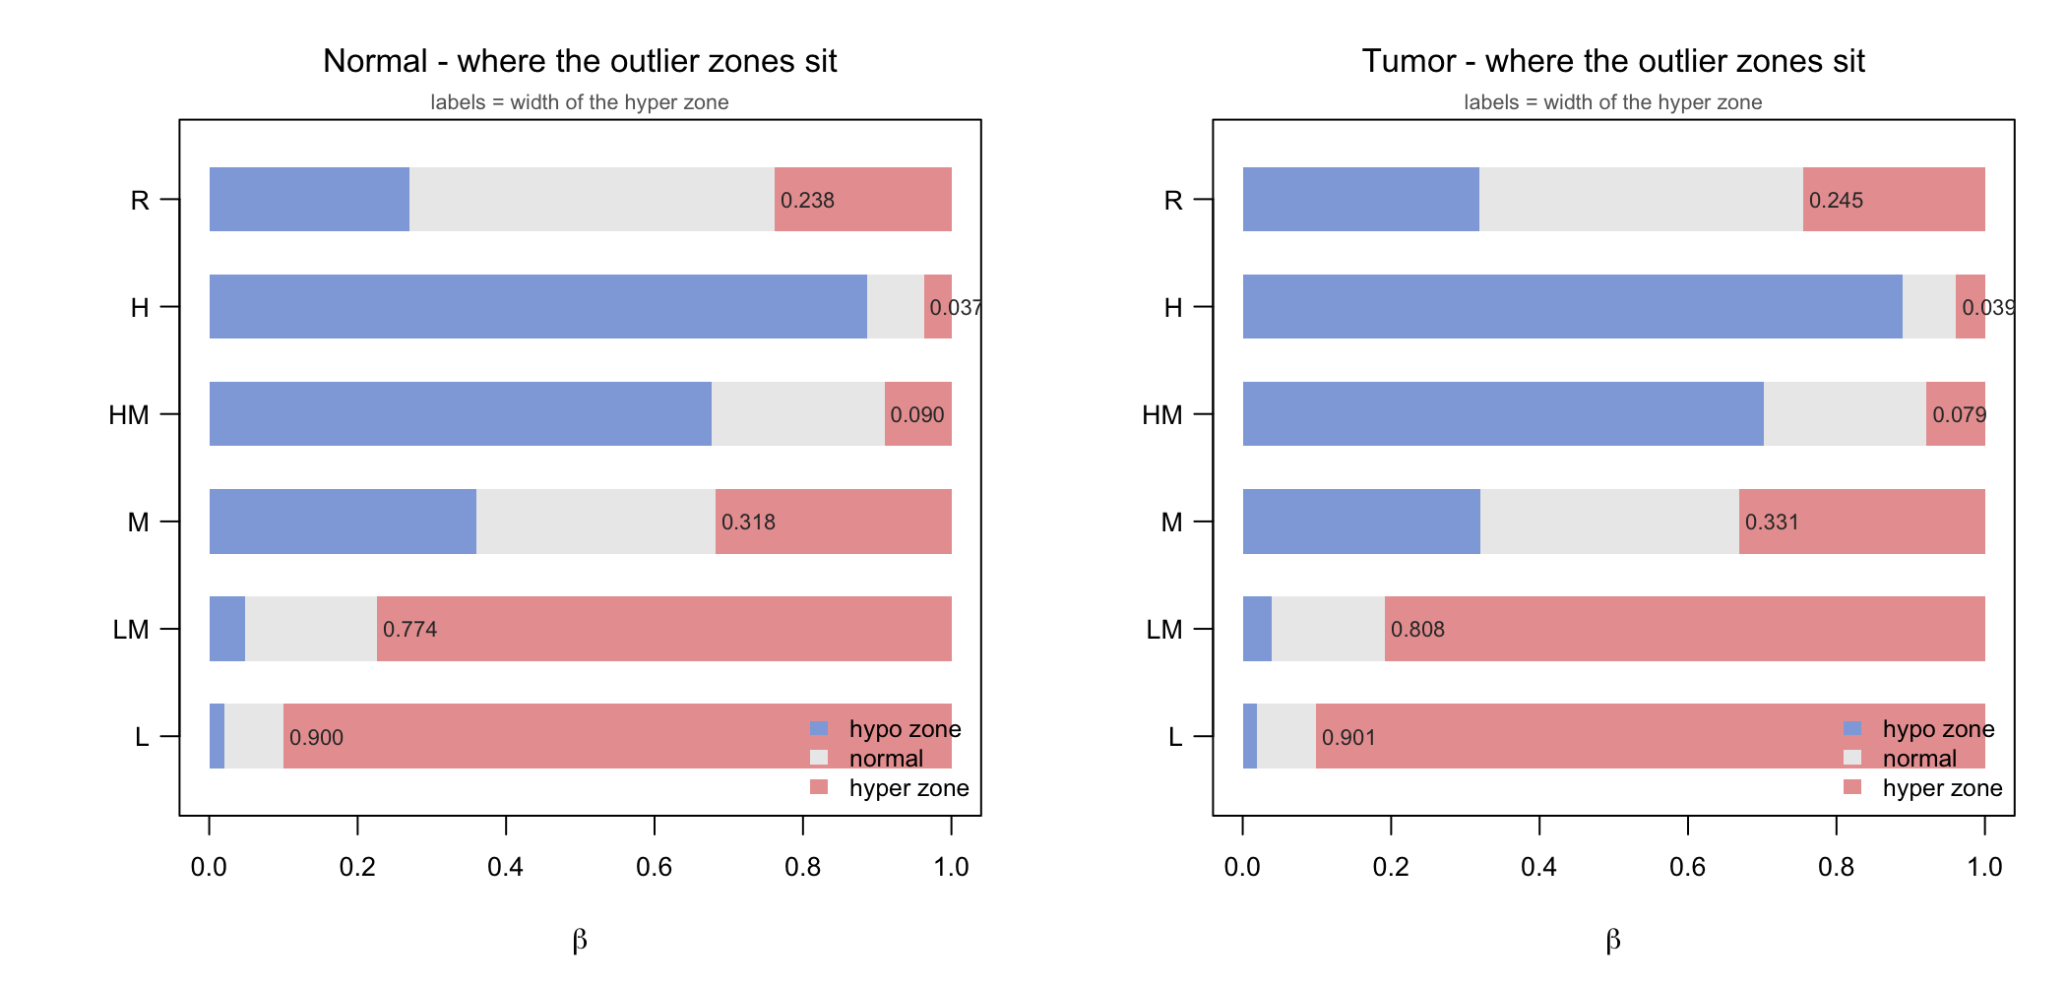
Figure 5. Where the outlier zones sit. Each row is one state. The coloured bands are threshold zones, not data — blue is the range counted as too low, red as too high, grey as normal. The number beside each red band is its width. Compare the red band at H (0.037) with the one at L (0.900).

The dividing line falls inside the array's own measurement error
At H sites, the two samples either side of the threshold differ by 0.003. The 450k array's repeat-measurement error is roughly 0.01–0.03 — several times larger. Adding artificial noise and re-running the flagging:
Noise added (sd) | Flags lost | Flags gained | % of original flags lost | Changed calls ÷ original flags
0.005 | 1,487 | 6,833 | 15.4% | 0.86
0.010 | 2,062 | 13,467 | 21.4% | 1.61
0.020 | 2,693 | 23,187 | 27.9% | 2.68
0.050 | 3,485 | 43,726 | 36.1% | 4.91

Normal tissue, chromosome 22, 9,648 original flags, 20 repeats per level. Source: Task22_Chr22_FlagStability_Normal.csv
At noise of 0.01 — within the array's own error — more calls change than there were flags to begin with. Instability follows the compressed states exactly: H 34%, L 25%, against R 8%.
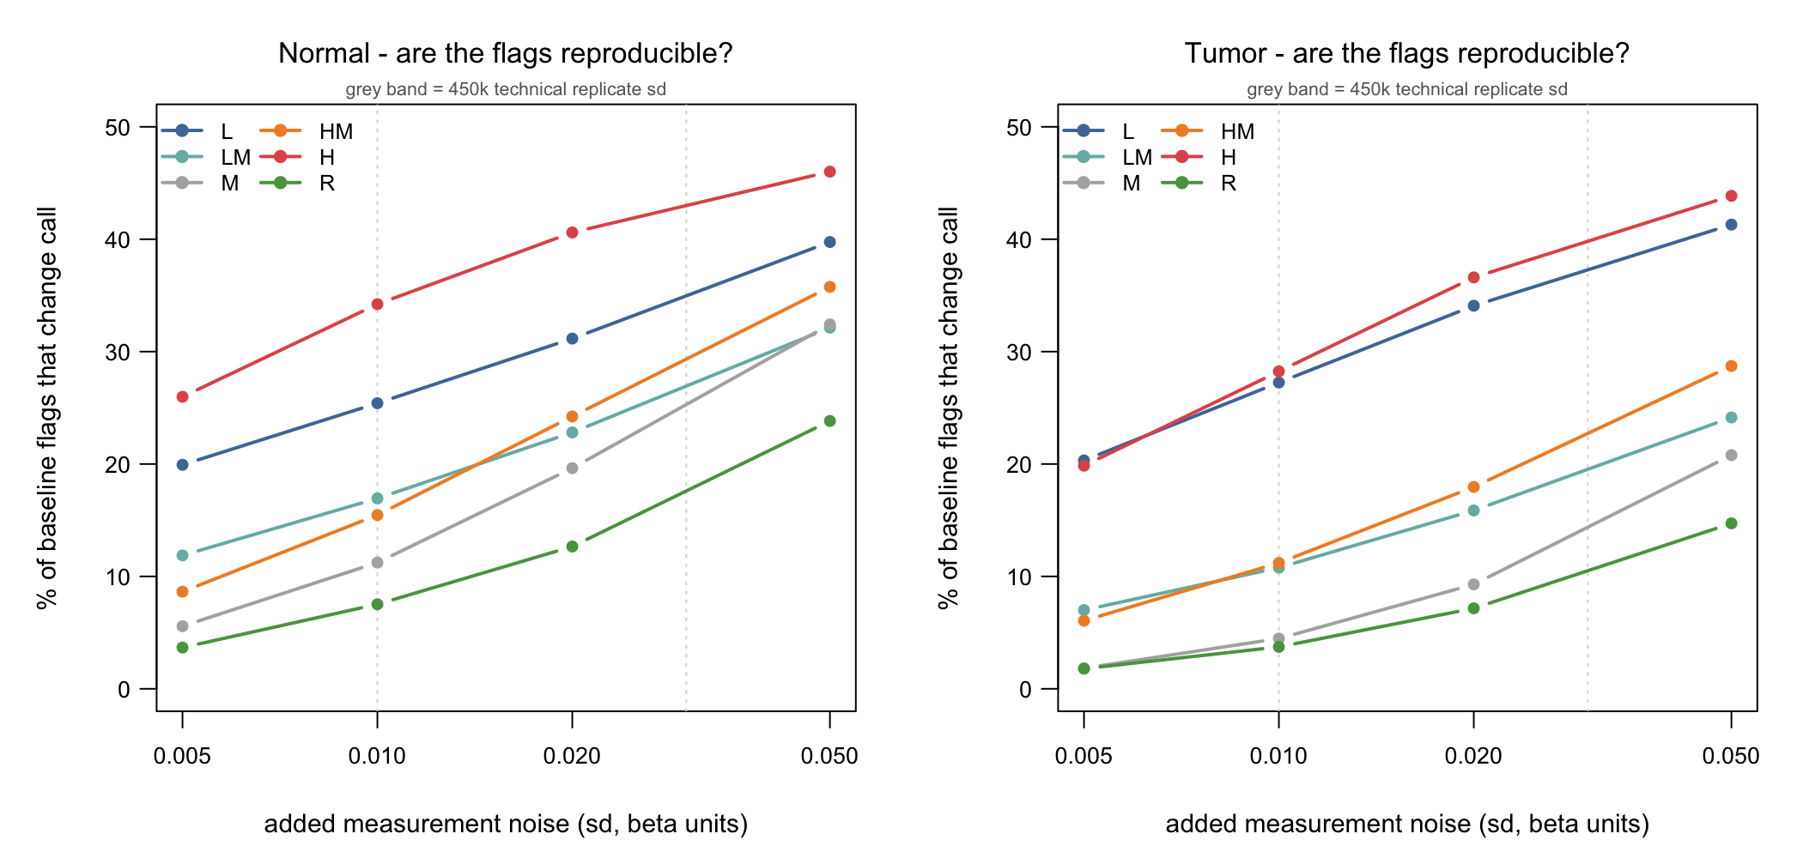
Figure 6. How many flags change when realistic measurement noise is added. Each line is one methylation state. Higher means less reproducible.

This is not a fault in one software package
Tukey's standard outlier rule — a completely different statistic, and the one already used for the outliers.coef3 column in our source files — shows a state bias too, in a different direction, and the two rules barely overlap (Jaccard 0.05–0.29).
The reason is that the spread it measures is itself state-dependent: the interquartile range is 0.008 at L sites but 0.157 at R sites. Any rule that asks “who is in the extreme tail?” without asking “by how much?” inherits this problem, because methylation values are squeezed against 0 and 1 and vary far less at the ends than in the middle.
Two alternative explanations were tested and ruled out
Was the external panel simply a poor fit for this cohort? If so, many samples would be flagged at the same site. They are not — at most 11 of 53, no site reaches half the cohort, and 0% of normal flags sit in such sites.
Was there a data-alignment error? No — zero inconsistencies across 13,618 checks.

8. A bug that changes a previously reported result
Three earlier analyses (Tasks 10, 13 and 14) contained this line:
state_order <- c("L", "LM", "M", "HM", "H", "Rc") ← the data says "R", not "Rc"
The mismatch meant every R-state site was silently dropped from those tables — no error, no warning, no change in row count to notice.
Reference | Tissue | R sites dropped | % of all sites | % of all flags lost
self | Normal | 23,455 | 6.2% | 6.2%
self | Tumour | 153,479 | 40.4% | 40.4%
ext | Normal | 23,455 | 6.2% | 7.4%
ext | Tumour | 153,479 | 40.4% | 65.0%

Source: Task23_RStateImpact.csv | Script: Task23.CorrectedStateTables.Aug28.2026.R
The last row is the important one. Task 14's tumour table — the strongest result we had — was calculated from 35% of the flags. Corrected, genome-wide:
State | Sites | % too low | % normal | % too high | % flagged
L | 76,106 | 2.08 | 95.84 | 2.08 | 4.16
LM | 40,824 | 3.41 | 89.66 | 6.93 | 10.34
M | 5,436 | 8.61 | 82.63 | 8.76 | 17.37
HM | 74,430 | 4.55 | 89.56 | 5.89 | 10.44
H | 30,080 | 0.50 | 95.71 | 3.79 | 4.29
R | 153,479 | 10.14 | 78.44 | 11.42 | 21.56%

Tumour, external reference, all 380,355 sites. Source: Task23_StateFlagTable_extref_Tumor.csv
The five original rows reproduce exactly, which confirms the correction is sound. The row that had been deleted turns out to have the highest flag rate of any state, and (from section 4) the largest effect sizes. The category being thrown away was the one carrying the signal.
All three scripts are now fixed and carry a check that stops with an error if any state in the data is missing from the list, so this cannot recur silently.

9. What to use instead
Seven different outlier definitions were run on the same data. Making that comparison fair matters more than it sounds: a method that flags fewer measurements will look more reproducible for free. So every method below was tuned until it flagged exactly the same percentage of measurements (1.03%) before being scored.
Judged on: reproducibility (does the same flag survive realistic measurement noise? higher is better), whether flags at H sites are as large as those at R sites (1.0 would be even-handed), and the share of flags too small to matter (under 0.10).
Method | Reproducibility | H vs R effect size | % of flags too small
External reference + minimum-size rule | 0.79 | 0.49 | 0%
Tukey interquartile rule | 0.47 | 0.17 | 54%
Median ± robust SD | 0.42 | 0.16 | 53%
Beta-distribution fit | 0.22 | 0.16 | 40%
Median ± robust SD on log-odds scale | 0.19 | 0.16 | 47%

Normal tissue; every method tuned to flag 1.031% of measurements. Source: Task26_RateMatchedStability_Normal.csv
Tumour behaves the same way: 0.91 for the minimum-size rule, against 0.68, 0.65, 0.54 and 0.43 for the others.
A wider sweep of seven methods, run instead at the external reference's own flag rate (Task24_MethodBenchmark_Scores.csv), ranks them in the same order and adds two more: a leave-one-out percentile (0.40) and the current external reference unmodified (0.33, with 61% of its flags too small to matter).

The recommendation, and its limits
Adding a minimum-size requirement to the existing method is the strongest option tested. It means: before a flag counts, the sample must differ from the cohort middle by at least some fixed amount. This more than doubles reproducibility (0.33 to 0.79 at matched rates) and removes the too-small flags by definition. It is one extra line of code, and the published epimutacions software already does it.
Two objections were tested rather than argued away:
Is a cut-off of 0.10 justified? No — it was chosen after seeing the data. Sweeping it across a range:
Minimum size | Flags kept | Reproducibility | H vs R effect size
0 (current) | 100% | 0.33 | 0.12
0.05 | 63% | 0.75 | 0.24
0.10 | 39% | 0.79 | 0.49
0.15 | 20% | 0.82 | 0.53
0.20 | 12% | 0.87 | not defined

Source: Task26_FloorSensitivity_Normal.csv
Reproducibility rises steadily with no peak, so this table cannot choose the value — pushed far enough it flags almost nothing and scores near-perfectly. At 0.20 no H-site flag survives at all. The cut-off has to be justified biologically, as the smallest methylation difference worth calling real on this platform. epimutacions uses 0.15; the difference between 0.10 and 0.15 here is small.
Is the advantage just because it flags less? No — this is why the table above is rate-matched. The minimum-size rule does naturally flag less (1.03% against 2.82% for the current method), so every competitor was re-tuned down to its rate before scoring. It still leads by a wide margin. The advantage belongs to the method, not to its sensitivity.
One result that reverses my earlier recommendation
In an earlier draft I recommended converting to the log-odds (M-value) scale — the textbook correction for this kind of problem. Tested, it is the worst of the seven methods (0.31 against 0.56 for the same rule on the original scale).
The reason: the log-odds transform stabilises the spread but magnifies noise at the extremes — a shift of 0.01 near 0.97 becomes a large move — and the extremes are exactly where the problem lives. Recorded as a negative result rather than dropped.

10. What is not yet established
Listed plainly, because several affect how much weight the findings above can carry.
Open question | Status
Are the 53 normal and tumour samples genuinely from the same patients? | Cannot confirm. A methylation-based identity check matches the expected pairing in only 10 of 53 cases (chance would give ~1), so the ordering probably does encode it, but this is far from proof. Nothing in this report relies on pairing.
Is the external 2,015-sample panel technically comparable to our data? | Not established. Array version, preprocessing, batch structure and the definition of “tumour-adjacent” are all unverified. This is the largest open risk to the external results. Gross mismatch is ruled out, but that is not the same as comparability.
Are the flagged sites real, or probe artifacts? | Unknown. Standard filtering for cross-reacting and variant-overlapping probes has not been applied. This blocks any biological claim, including N37's cluster.
Why do N15, N17 and N14 carry so many flags? | Untested. Candidates in order: technical batch and array quality; cell composition and tumour purity; genuine global methylation loss. Until the first two are excluded, per-sample burden cannot be interpreted.
Does the threshold-geometry finding hold genome-wide? | The effect-size result does (shown in section 4). The threshold-geometry table and the noise experiment are still chromosome-22 only.
Is the noise level used in the stability test realistic? | It comes from published figures, not from this cohort. Technical replicates, or pairs of adjacent co-methylated probes, would replace the assumption with a measurement.

11. Proposed next steps
- Apply standard probe filtering (Chen 2013; Zhou 2017). This blocks every biological claim, so it goes first.
- Test what drives the high-burden samples — batch, detection quality, cell composition, tumour purity.
- Measure this cohort's actual noise level instead of assuming it, and re-run the stability analysis.
- Extend the threshold-geometry and stability analyses genome-wide.
- Decide the minimum-size cut-off on biological grounds, then re-run the full pipeline once with it applied.

Questions for you
- Is the goal to evaluate the method, or to find real epimutations? The work supports the first; the second needs steps 1 and 2 above first.
- Should the state-aware (bio) rule be retired? As written it cannot produce a state-contradicting flag, so comparing it against the external reference measures a difference in definitions rather than a disagreement about the data. It is useful as a negative control but not as a detector.
- What minimum methylation difference should count as real on the 450k platform? This is the one number the analysis cannot supply for itself.

Appendix A — where every number comes from
Every table in this report is produced by one named script and saved as one named CSV. Each script has a matching .Rout transcript recording its inputs, parameters and console output.
Script | What it produces | Used in
Task20.Chr22.TightWindow.Concordance | State summaries, agreement measures, tight window | §2, §3, §6
Task21.Chr22.SampleBurden | Per-sample burden at three scales, effect sizes, N37 cluster | §4, §5
Task22.Chr22.FlagDefects | Threshold zones, noise stability, Tukey comparison | §7
Task23.CorrectedStateTables | Corrected state tables with R restored | §8
Task24.OutlierMethodBenchmark | Seven-method comparison | §9
Task25.Figures | Figures 3–6 | §4, §5, §7
Task26.ReviewResponse | Coverage audit, cut-off sweep, rate-matched comparison, genome-wide effect sizes | §1, §4, §9
Task27.Full100CpGSheet | The complete 100-site sheet and Figures 1–2 | §1, §2, App. B

Data protection. Tables that name both an individual sample and a genomic position are individual-level data and are excluded from the shared repository. Summary tables reporting counts per sample, with no genomic coordinates, are included. The full classification is in CLASSIFICATION.md.
Companion documents: results.md (full technical record), REVIEW.md (response to your written review, plus code findings), plan.md (ordered next steps).

Appendix B — the complete 100-CpG sheet
Every site in the window, in genomic order. Flag columns are written as too-low / too-high, counting how many of the 53 samples were flagged in each direction. N = normal tissue, T = tumour.
Reading it: self reads 1/1 on every single row — that is the arithmetic artifact. bio reads 1/0 or 0/1 or 0/0. Only ext varies with the data. The gap column shows how far the site is from the previous one; note row 7, where the gap is 3.41 million base pairs.
# | CpG probe | chr22 position | Gap (bp) | State N | State T | Median β (N) | bio N | self N | ext N | ext T
1 | cg22224202 | 11,915,060 | — | HM | HM | 0.8577 | 1/0 | 1/1 | 0/3 | 20/0
2 | cg03887676 | 12,095,366 | 180,306 | HM | M | 0.7132 | 1/0 | 1/1 | 0/1 | 23/0
3 | cg03032015 | 12,097,885 | 2,519 | M | R | 0.5655 | 0/0 | 1/1 | 0/2 | 4/4
4 | cg03312332 | 12,097,898 | 13 | HM | HM | 0.845 | 1/0 | 1/1 | 0/1 | 10/2
5 | cg26835374 | 12,097,959 | 61 | HM | R | 0.7924 | 1/0 | 1/1 | 0/3 | 5/6
6 | cg00004121 | 12,098,133 | 174 | M | R | 0.5546 | 0/0 | 1/1 | 0/3 | 4/9
7 | cg07970541 | 15,508,312 | 3,410,179 | M | M | 0.6471 | 0/0 | 1/1 | 1/0 | 28/0
8 | cg17204569 | 15,511,444 | 3,132 | H | HM | 0.9808 | 1/0 | 1/1 | 0/4 | 5/5
9 | cg05506566 | 15,554,099 | 42,655 | M | M | 0.5377 | 0/0 | 1/1 | 1/2 | 21/0
10 | cg05924543 | 15,554,962 | 863 | HM | R | 0.5539 | 1/0 | 1/1 | 0/2 | 20/0
11 | cg04778411 | 15,572,298 | 17,336 | HM | HM | 0.8642 | 1/0 | 1/1 | 0/0 | 3/4
12 | cg23921249 | 15,573,292 | 994 | HM | R | 0.8944 | 1/0 | 1/1 | 1/1 | 15/1
13 | cg20501883 | 15,603,422 | 30,130 | R | R | 0.7509 | 0/0 | 1/1 | 4/0 | 29/1
14 | cg26685726 | 15,603,441 | 19 | HM | R | 0.7203 | 1/0 | 1/1 | 4/0 | 30/1
15 | cg08711796 | 15,690,052 | 86,611 | HM | R | 0.9104 | 1/0 | 1/1 | 2/0 | 15/0
16 | cg15130204 | 15,690,964 | 912 | HM | R | 0.8859 | 1/0 | 1/1 | 2/0 | 6/0
17 | cg15668074 | 15,721,335 | 30,371 | M | LM | 0.3585 | 0/0 | 1/1 | 0/1 | 19/2
18 | cg03531177 | 15,749,399 | 28,064 | HM | R | 0.7023 | 1/0 | 1/1 | 1/2 | 17/3
19 | cg07885834 | 15,749,417 | 18 | HM | HM | 0.7348 | 1/0 | 1/1 | 0/0 | 5/7
20 | cg07917473 | 15,750,431 | 1,014 | M | R | 0.5938 | 0/0 | 1/1 | 0/1 | 16/2
21 | cg21423610 | 15,759,955 | 9,524 | HM | R | 0.705 | 1/0 | 1/1 | 1/2 | 8/5
22 | cg13472645 | 15,762,134 | 2,179 | HM | R | 0.7394 | 1/0 | 1/1 | 0/5 | 21/0
23 | cg00555036 | 15,764,181 | 2,047 | M | R | 0.5136 | 0/0 | 1/1 | 0/0 | 5/12
24 | cg12153292 | 15,775,889 | 11,708 | M | R | 0.5754 | 0/0 | 1/1 | 0/3 | 12/8
25 | cg03944122 | 15,777,580 | 1,691 | M | M | 0.4219 | 0/0 | 1/1 | 0/0 | 2/4
26 | cg10030810 | 15,778,092 | 512 | M | R | 0.5323 | 0/0 | 1/1 | 1/0 | 17/4
27 | cg04105722 | 15,784,325 | 6,233 | M | M | 0.6222 | 0/0 | 1/1 | 0/0 | 14/2
28 | cg19057994 | 15,818,890 | 34,565 | HM | R | 0.8358 | 1/0 | 1/1 | 0/0 | 4/0
29 | cg03966099 | 15,820,367 | 1,477 | H | HM | 0.9593 | 1/0 | 1/1 | 0/3 | 3/6
30 | cg26186732 | 15,821,037 | 670 | HM | HM | 0.7978 | 1/0 | 1/1 | 0/1 | 1/1
31 | cg04110531 | 15,821,249 | 212 | M | R | 0.5133 | 0/0 | 1/1 | 0/3 | 2/6
32 | cg19807306 | 15,822,202 | 953 | HM | HM | 0.8219 | 1/0 | 1/1 | 0/0 | 1/0
33 | cg11055967 | 15,822,620 | 418 | HM | R | 0.683 | 1/0 | 1/1 | 0/2 | 18/1
34 | cg24521010 | 15,822,672 | 52 | HM | R | 0.9026 | 1/0 | 1/1 | 1/2 | 13/5
35 | cg04185470 | 15,854,696 | 32,024 | H | HM | 0.9093 | 1/0 | 1/1 | 1/0 | 34/0
36 | cg18605377 | 16,387,048 | 532,352 | LM | M | 0.3193 | 0/1 | 1/1 | 0/0 | 0/15
37 | cg03389890 | 16,387,319 | 271 | R | R | 0.3271 | 0/0 | 1/1 | 0/0 | 1/9
38 | cg17036492 | 16,387,738 | 419 | M | M | 0.5752 | 0/0 | 1/1 | 0/0 | 20/1
39 | cg23557769 | 16,391,040 | 3,302 | HM | HM | 0.8066 | 1/0 | 1/1 | 0/0 | 33/0
40 | cg07443748 | 16,592,704 | 201,664 | HM | R | 0.7111 | 1/0 | 1/1 | 0/1 | 13/4
41 | cg01474260 | 16,592,994 | 290 | HM | R | 0.8034 | 1/0 | 1/1 | 0/5 | 11/3
42 | cg12888097 | 16,593,959 | 965 | HM | HM | 0.8466 | 1/0 | 1/1 | 0/2 | 10/2
43 | cg02601618 | 16,594,156 | 197 | H | R | 0.907 | 1/0 | 1/1 | 0/0 | 19/0
44 | cg13117439 | 16,600,826 | 6,670 | R | R | 0.2824 | 0/0 | 1/1 | 1/1 | 4/3
45 | cg01836687 | 16,601,097 | 271 | LM | R | 0.0523 | 0/1 | 1/1 | 2/0 | 0/1
46 | cg26822097 | 16,601,691 | 594 | LM | R | 0.0388 | 0/1 | 1/1 | 1/0 | 0/15
47 | cg12431879 | 16,601,897 | 206 | LM | R | 0.0895 | 0/1 | 1/1 | 0/0 | 0/7
48 | cg00332021 | 16,602,522 | 625 | LM | R | 0.048 | 0/1 | 1/1 | 0/1 | 0/12
49 | cg00816224 | 16,602,592 | 70 | LM | R | 0.0461 | 0/1 | 1/1 | 0/0 | 0/9
50 | cg15554678 | 16,602,673 | 81 | LM | LM | 0.0153 | 0/1 | 1/1 | 0/0 | 0/3
51 | cg23572163 | 16,602,837 | 164 | LM | LM | 0.0652 | 0/1 | 1/1 | 3/0 | 3/6
52 | cg20193183 | 16,606,997 | 4,160 | HM | HM | 0.8564 | 1/0 | 1/1 | 0/0 | 6/0
53 | cg01024141 | 16,609,246 | 2,249 | LM | LM | 0.1234 | 0/1 | 1/1 | 1/0 | 0/8
54 | cg18023096 | 16,609,696 | 450 | LM | LM | 0.0422 | 0/1 | 1/1 | 1/0 | 0/1
55 | cg26581886 | 16,609,972 | 276 | M | M | 0.4064 | 0/0 | 1/1 | 0/0 | 0/10
56 | cg04112787 | 16,610,028 | 56 | LM | R | 0.1348 | 0/1 | 1/1 | 1/0 | 0/7
57 | cg20009101 | 16,610,333 | 305 | LM | R | 0.0735 | 0/1 | 1/1 | 4/0 | 4/4
58 | cg16234298 | 16,610,407 | 74 | R | LM | 0.1396 | 0/0 | 1/1 | 0/3 | 6/3
59 | cg21220873 | 16,695,037 | 84,630 | HM | HM | 0.8471 | 1/0 | 1/1 | 0/1 | 6/1
60 | cg05695327 | 16,696,025 | 988 | HM | HM | 0.8833 | 1/0 | 1/1 | 0/0 | 11/1
61 | cg02665031 | 16,697,714 | 1,689 | HM | HM | 0.8807 | 1/0 | 1/1 | 0/2 | 18/3
62 | cg03288512 | 16,697,804 | 90 | HM | R | 0.9004 | 1/0 | 1/1 | 1/1 | 19/2
63 | cg13552315 | 16,697,861 | 57 | H | HM | 0.9865 | 1/0 | 1/1 | 0/0 | 10/0
64 | cg06842116 | 16,701,904 | 4,043 | HM | R | 0.7827 | 1/0 | 1/1 | 0/0 | 16/3
65 | cg19961720 | 16,828,959 | 127,055 | HM | R | 0.7911 | 1/0 | 1/1 | 0/2 | 9/4
66 | cg04037044 | 16,959,719 | 130,760 | HM | R | 0.8652 | 1/0 | 1/1 | 0/3 | 8/1
67 | cg07640117 | 16,959,965 | 246 | HM | R | 0.7543 | 1/0 | 1/1 | 0/0 | 16/0
68 | cg04561937 | 16,962,729 | 2,764 | HM | R | 0.8376 | 1/0 | 1/1 | 0/1 | 22/2
69 | cg20556786 | 17,007,041 | 44,312 | H | R | 0.9268 | 1/0 | 1/1 | 0/0 | 23/0
70 | cg03308092 | 17,007,385 | 344 | R | R | 0.5232 | 0/0 | 1/1 | 0/0 | 0/7
71 | cg20353484 | 17,007,985 | 600 | M | HM | 0.6044 | 0/0 | 1/1 | 1/1 | 1/10
72 | cg13652169 | 17,008,222 | 237 | H | H | 0.9704 | 1/0 | 1/1 | 1/0 | 14/0
73 | cg02432860 | 17,008,297 | 75 | HM | R | 0.9475 | 1/0 | 1/1 | 1/0 | 21/0
74 | cg19091146 | 17,008,303 | 6 | HM | R | 0.8052 | 1/0 | 1/1 | 0/1 | 21/4
75 | cg07155303 | 17,008,477 | 174 | H | R | 0.9332 | 1/0 | 1/1 | 0/1 | 15/0
76 | cg06123976 | 17,008,862 | 385 | HM | HM | 0.7569 | 1/0 | 1/1 | 0/0 | 16/0
77 | cg12370326 | 17,008,872 | 10 | HM | R | 0.8129 | 1/0 | 1/1 | 0/2 | 18/3
78 | cg17654752 | 17,010,940 | 2,068 | H | HM | 0.9174 | 1/0 | 1/1 | 0/0 | 11/1
79 | cg13751645 | 17,032,615 | 21,675 | M | R | 0.6659 | 0/0 | 1/1 | 0/3 | 3/5
80 | cg06023066 | 17,034,747 | 2,132 | M | M | 0.6012 | 0/0 | 1/1 | 0/0 | 7/0
81 | cg10277548 | 17,036,172 | 1,425 | M | R | 0.5188 | 0/0 | 1/1 | 0/0 | 2/5
82 | cg25563983 | 17,036,439 | 267 | LM | R | 0.2368 | 0/1 | 1/1 | 8/0 | 2/12
83 | cg11577174 | 17,036,483 | 44 | M | R | 0.6884 | 0/0 | 1/1 | 0/0 | 26/0
84 | cg03511692 | 17,036,528 | 45 | M | M | 0.4753 | 0/0 | 1/1 | 1/0 | 2/2
85 | cg16747643 | 17,036,957 | 429 | M | M | 0.536 | 0/0 | 1/1 | 0/0 | 14/3
86 | cg15861357 | 17,037,609 | 652 | M | M | 0.5699 | 0/0 | 1/1 | 0/0 | 34/1
87 | cg10664780 | 17,037,671 | 62 | M | M | 0.4863 | 0/0 | 1/1 | 7/0 | 13/0
88 | cg19901866 | 17,083,725 | 46,054 | H | R | 0.9083 | 1/0 | 1/1 | 0/0 | 3/1
89 | cg13595439 | 17,083,860 | 135 | H | R | 0.9371 | 1/0 | 1/1 | 0/2 | 3/1
90 | cg07191900 | 17,084,104 | 244 | HM | R | 0.9675 | 1/0 | 1/1 | 2/0 | 7/0
91 | cg20758542 | 17,084,259 | 155 | M | R | 0.5935 | 0/0 | 1/1 | 0/0 | 4/3
92 | cg01731685 | 17,084,565 | 306 | L | LM | 0.041 | 0/1 | 1/1 | 4/1 | 0/9
93 | cg21717745 | 17,084,722 | 157 | L | L | 0.0454 | 0/1 | 1/1 | 0/1 | 0/4
94 | cg02866761 | 17,084,774 | 52 | L | L | 0.0621 | 0/1 | 1/1 | 0/0 | 0/0
95 | cg05444620 | 17,084,785 | 11 | L | L | 0.0191 | 0/1 | 1/1 | 0/0 | 0/0
96 | cg03304299 | 17,084,852 | 67 | L | L | 0.017 | 0/1 | 1/1 | 2/0 | 2/0
97 | cg05824484 | 17,084,984 | 132 | L | L | 0.0126 | 0/1 | 1/1 | 0/0 | 0/0
98 | cg12642297 | 17,084,999 | 15 | L | L | 0.0105 | 0/1 | 1/1 | 1/0 | 1/0
99 | cg26298038 | 17,085,014 | 15 | LM | LM | 0.0751 | 0/1 | 1/1 | 0/2 | 1/1
100 | cg15502903 | 17,085,407 | 393 | L | L | 0.049 | 0/1 | 1/1 | 1/2 | 1/3

Source: Task27_Chr22_Full100CpG_SiteTable.csv | Script: Task27.Full100CpGSheet.Aug28.2026.R | The CSV additionally carries the 25th and 75th percentiles of beta for both tissues and the number of evaluable samples per site. Cohort minimum and maximum are deliberately excluded: with 53 samples those are single individuals’ values.

