VISVESVARAYA TECHNOLOGICAL UNIVERSITY
Jnana Sangama, Belgaum-590018


Mini Project Report
on
“GUNSHOT LOCATION DETECTOR”
Submitted in partial fulfillment of the requirements for the
Second Semester of the Bachelor of Engineering Degree, towards the completion of the Mini Project under the Interdisciplinary Project-Based Learning,
Department of Basic Sciences.
by
1. | Arnav Dhull | I-19
2. | Aruna Sarangamath | I-20
3. | Anagha B K | M-19
4. | Anamika A | M-20

Under the Guidance of
Mr. Manjunatha Babu B
Associate Professor



CMR INSTITUTE OF TECHNOLOGY
#132, AECS LAYOUT, IT PARK ROAD, KUNDALAHALLI,
BANGALORE-560037
DEPARTMENT OF BASIC SCIENCES


CERTIFICATE
This is to certify that the File Structures mini project entitled “Gunshot Location Detector” has been successfully carried out by Arnav Dhull (I-19), Aruna Sarangamath (I-20), Anagha B K (M-19) and Anamika A (M-20), bonafide students of CMR Institute of Technology.
The project is submitted in partial fulfillment of the requirements for the Second Semester of the Bachelor of Engineering Degree, towards the completion of the Mini Project under the Interdisciplinary Project-Based Learning, Department of Basic Sciences.
It is further certified that all corrections and suggestions indicated during the Internal Assessment have been duly incorporated in the project report submitted to the departmental library. This File Structures mini project report has been reviewed and approved as it satisfies the academic requirements prescribed for the said degree.
----------------------- ----------------------
Signature of Guide Signature of HOD
MR. Manjunatha Babu B Dr. Raveesha K
HoD,
Dept. of Physics, CMRIT

External Viva
Name of the examiners Signature with date
1.
2.

ACKNOWLEDGEMENT

I sincerely express my gratitude to Dr. Sanjay Jain, Principal, CMR Institute of Technology, Bangalore, for providing a supportive academic environment.
I extend my thanks to Dr. Raveesha K H, HoD, Dept. of Physics, CMRIT for his valuable guidance and support.
I am especially grateful to my internal guide, Mr. Manjunatha Babu B for his constant encouragement and guidance throughout this project.
I also thank all the faculty members, non-teaching staff, and others who contributed directly or indirectly to the successful completion of this work.

Arnav Dhull (I-19),
Aruna Sarangamath (I-20),
Anagha B K (M-19) and
Anamika A (M-20)

Table of Contents
- Introduction
1.1 Brief History of Gunshot Detection Systems
1.2 Modern Sound-Based Detection Systems
- Problem Statement
2.1 Description
2.2 Challenge Statement
- Design Thinking Process and Methodology
3.1 Design Thinking Process
3.2 Methodology
3.3 Prototype Description
3.3.1 Materials Used
- Implementation
4.1 Hardware Setup
4.2 Working Principle
- Results and Analysis
- Conclusion and Future Work
6.1 Conclusion
6.2 Future Enhancements

Chapter 1
INTRODUCTION
Public safety and rapid emergency response are major concerns in urban and sensitive areas such as schools, public gatherings, military zones, and smart cities. Traditional gunshot reporting depends on eyewitnesses or emergency calls, which may cause delays in locating the exact source of gunfire. These delays can reduce the effectiveness of law enforcement response and increase risks to public safety.
The objective of this project is to design a Gunshot Location Detection System using sound sensors and triangulation techniques. The system detects loud impulsive sounds such as gunshots through multiple sound sensors placed at different locations. By measuring the difference in arrival time of the sound at each sensor node, the system estimates the location of the gunshot using triangulation principles.
This project aims to provide a low-cost, real-time detection and localization system that can improve emergency response time and enhance public safety.

1.1 Brief History of Gunshot Detection Systems
Early gunshot detection methods relied mainly on human observation and manual reporting. Security personnel or civilians had to identify the direction of gunfire based on sound, which was often inaccurate and unreliable, especially in crowded or noisy environments.
Later, military applications introduced acoustic detection systems using microphone arrays to estimate enemy firing positions. These systems were expensive and limited to defence applications.

1.2 Modern Sound-Based Detection Systems
Modern gunshot detection systems use microphones, acoustic sensors, embedded processors, GPS modules, and wireless communication technologies to automatically detect and locate gunfire. Advanced systems apply triangulation algorithms and digital signal processing to improve accuracy and reduce false alarms.
Today, smart city surveillance and IoT technologies make it possible to build compact and affordable gunshot localization systems for public safety applications.

Chapter 2
Problem Statement
2.1 Description
In many public and sensitive areas, identifying the exact location of gunfire quickly is difficult. Manual reporting methods are slow and often inaccurate. Security personnel may not immediately determine where the gunshot originated, especially in large areas or crowded urban environments.
A real-time automated system is needed to detect gunshots and estimate their source location accurately with minimal delay.

2.2 Challenge Statement
To design a sound-based gunshot detection system that can:
- Detect impulsive gunshot sounds using multiple sound sensors.
- Measure the time difference of arrival (TDOA) of the sound signal between sensors.
- Estimate the approximate location of the gunshot using triangulation methods.
- Display or transmit the detected coordinates for rapid response and monitoring.
- Operate with low-cost hardware and minimal power consumption.

Chapter 3
Design Thinking Process and Methodology
3.1 Design Thinking Process
a) Empathize
Discussions with security personnel and analysis of public safety issues highlighted the importance of rapid gunshot localization. Delays in identifying firing locations can increase panic and reduce response efficiency.
b) Define
The key requirements identified were:
- Fast detection of gunshots
- Accurate location estimation
- Low-cost implementation
- Real-time alert generation
- Easy deployment in public areas
c) Ideate
Different approaches were considered, including camera-based monitoring and vibration detection systems. The final solution chosen was an acoustic detection system using sound sensors and triangulation because of its simplicity, affordability, and fast response.

d) Prototype
A prototype was developed using:
- ESP32/Arduino microcontroller
- Multiple sound sensors or microphones
- Wireless communication modules
- LCD/serial monitoring system
e) Test
The prototype was tested using loud impulsive sounds to simulate gunshots. Sensor readings and timing differences were analysed to verify the accuracy of the triangulation calculations.

3.2 Methodology
The methodology follows these steps:
- Place multiple sound sensors at known positions.
- Detect loud impulsive sound events simultaneously.
- Record the arrival time of the sound at each sensor.
- Calculate the time difference between sensor detections.
- Apply triangulation algorithms to estimate the gunshot source location.
- Display the estimated coordinates on a monitoring interface.

3.3 Prototype Description
The prototype consists of multiple sound sensor nodes connected to a microcontroller system. When a gunshot-like sound is detected, each sensor records the detection time. The controller compares these timing differences and estimates the source location using triangulation mathematics.

3.3.1 Materials Used
- ESP32 / Arduino UNO microcontroller board for processing sensor data.
- Sound sensors / microphones to detect gunshot sounds.
- GPS module (optional) for synchronizing sensor node locations.
- Wireless communication module for transmitting alerts.
- LCD display / Serial monitor for displaying detection status and coordinates.
- Power supply / battery for portable operation.
- Connecting wires and breadboard for circuit assembly.

Chapter 4
Implementation
4.1 Hardware Setup
The hardware setup includes multiple sound sensors connected to ESP32 or Arduino boards positioned at fixed locations. Each sensor continuously monitors sound intensity levels.
When a loud impulsive sound exceeds a predefined threshold, the sensor sends a signal to the controller. The controller records the precise detection time from each sensor.

4.2 Working Principle
The system works on the principle of Time Difference of Arrival (TDOA) and triangulation.
If a gunshot occurs closer to one sensor, the sound reaches that sensor slightly earlier than the others.
The distance travelled by sound is calculated using:
$$d=v×t$$
where:
- $d$= distance travelled by sound
- $v$= speed of sound in air
- $t$= time taken
The location of the sound source is estimated by comparing the arrival times at different sensors and applying triangulation calculations.

4.3 Implementation
// Gunshot Direction Detection Prototype
// Using 3 KY-038 Sound Sensors

// Sensor connections
int sensor1 = A0;
int sensor2 = A1;
int sensor3 = A3;

// Buzzer pin
int buzzer = 8;

// Sound threshold
int threshold = 99;

void setup()
{
Serial.begin(9600);

pinMode(buzzer, OUTPUT);

digitalWrite(buzzer, LOW);
}

void loop()
{
// Read sensor values
int s1 = analogRead(sensor1);
int s2 = analogRead(sensor2);
int s3 = analogRead(sensor3);

// Print values on Serial Monitor
Serial.print("S1: ");
Serial.print(s1);

Serial.print(" S2: ");
Serial.print(s2);

Serial.print(" S3: ");
Serial.println(s3);

// Check for loud sound
if (s1 > threshold || s2 > threshold || s3 > threshold)
{
digitalWrite(buzzer, HIGH);

// Find direction
if (s1 > s2 && s1 > s3)
{
Serial.println("Gunshot Detected from LEFT");
}
else if (s2 > s1 && s2 > s3)
{
Serial.println("Gunshot Detected from FRONT");
}
else if (s3 > s1 && s3 > s2)
{
Serial.println("Gunshot Detected from RIGHT");

delay(500);
}
else
{
digitalWrite(buzzer, LOW);
}
delay(50);
}

4.4 Virtual Circuit Design
https://app.cirkitdesigner.com/project/7d090b39-4bfc-435d-8bbb-945ac7ed4d9d

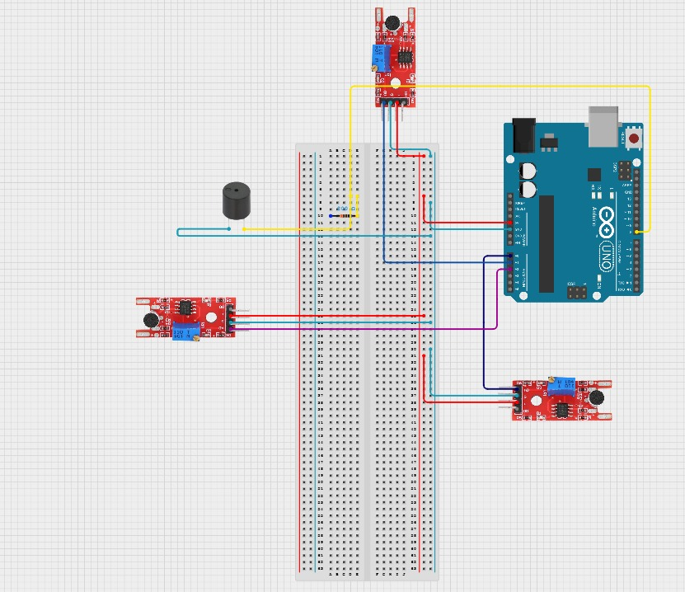

Chapter 5
Results and Analysis
During testing, the prototype successfully detected loud impulsive sounds and estimated their approximate source location using triangulation methods.
The system demonstrated:
- Real-time sound detection
- Successful synchronization between sensors
- Accurate relative location estimation in small test environments
- Low-cost and reliable operation using embedded hardware
Some minor errors were observed due to environmental noise, echo, and sensor sensitivity differences. However, the overall system performance proved that acoustic triangulation can effectively estimate gunshot locations.

Chapter 6
Conclusion & Future Work
6.1 Conclusion
The Gunshot Location Detection System using sound sensors and triangulation provides an efficient and affordable solution for detecting and locating gunfire events in real time.
By combining multiple sound sensors, microcontrollers, and triangulation algorithms, the system can estimate the direction and approximate coordinates of gunshots.
The project demonstrates the practical application of IoT, embedded systems, and acoustic signal processing in smart surveillance systems.

6.2 Future Enhancements
Future improvements may include:
- AI-based sound classification to distinguish gunshots from fireworks or vehicle noises.
- Mobile application support for instant notifications.
- GPS synchronization for large-scale deployment.
- Improved triangulation algorithms for higher localization accuracy.
- Integration with CCTV systems for automatic camera targeting after gunshot detection.

