PROJECT PROPOSAL
Student Management System with Role-Based Access Control

1. Title
Student Management System (SMS) – A Role-Based Web Application for University Administration

2. Introduction
In today’s academic landscape, universities increasingly rely on digital systems to manage and organize student-related data efficiently. Manual recordkeeping methods are not only time-consuming but also prone to errors and inconsistencies that can compromise data integrity and hinder timely decision-making. As institutions grow, the complexity of managing large volumes of student records—including attendance, grades, course registration, and fees—demands a more scalable and reliable solution. This project addresses these challenges by introducing a web-based Student Management System (SMS) designed to enhance administrative efficiency while maintaining a secure and structured digital environment.
The proposed SMS incorporates role-based access control (RBAC), ensuring that administrators have full control over data entry and updates, while students can securely access their own academic records in a read-only format. Built using Python (Flask) for the backend and MySQL for data storage, the system also features a clean user interface. Through automation and centralized data handling, the system aims to streamline university processes, reduce administrative workload, and promote transparency across academic operations. This initiative ultimately contributes to improved data accuracy, enhanced user experience, and stronger institutional management.

3. Problem Statement
Universities face numerous challenges when it comes to record keeping. In 21st century there are still some colleges that uses traditional record keeping system or semi-automated system which is tedious and inconvenient. With the traditional way, there is high potential for errors in data entry and retrieval. There is difficulty in maintaining secure and consistent access to academic records. In semi-automated system, the absence of role-based access has led to data breaches.
The proposed SMS addresses these concerns with automation, role-based access control, and secure data management capabilities.

4. Objectives
The objectives of this proposed system are that the student can read their details. The admin can update, delete, create and search for the student.

5. Literature Review
The development of student management systems (SMS) has evolved over the past decade to meet institutional needs such as scalability, accuracy, and security. Several existing implementations were studied to understand current limitations and inform the design of the proposed system.

- University Management System (Java + MySQL)
Kumar and Singh [1] describe a system developed to automate attendance and grading tasks. While effective in reducing manual effort, it lacks fine-grained access control, making it less secure in multi-user environments. This limitation highlights the need for role-based access as proposed in our system.

- Student Information System (Python + SQLite)
Patel and Sharma [2] present a lightweight Python-based SIS suitable for small colleges. Despite its simplicity, it lacks role management and robust database backends like MySQL. Our system builds upon this by offering multi-role support (admin/student), enhanced GUI, and secure MySQL integration.

6. Methodology
- Development Model: Agile (iterative and incremental model).
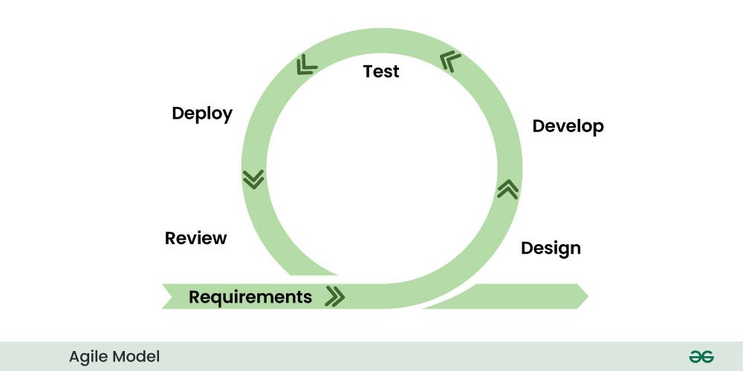
The proposed project will follow the Agile development model, known for its flexibility and ability to quickly and effectively adapt to change. This model supports an iterative and incremental approach, allowing continuous improvement and regular delivery of functional product versions. Within this framework, the Scrum framework will be implemented. Sprints will be planned and executed by team members Anshika Pant, Anamika Aryal, and Anjana Chaudhary. The Scrum Master, Suraj Kumar Jha, will oversee the sprint process and facilitate coordination during Scrum meetings.
In the first iteration, the product will include essential features of the Student Management System (SMS), such as viewing student statistics and providing basic admin controls. In later increments, additional functionalities like data validation and real-time access will be introduced to enhance the system.
The frontend development will be handled by Anshika Pant and Anjana Chaudhary, utilizing HTML, CSS, and JavaScript. The backend will be developed by Anamika Aryal and Suraj Kumar Jha using Python and MySQL.

8. Use Case & ER Diagrams
Use Case Diagram:
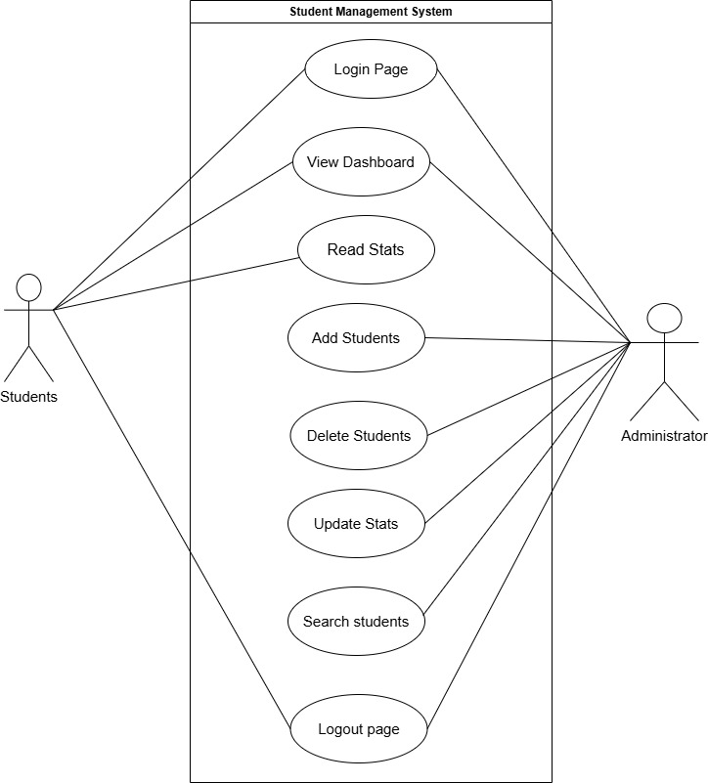

ER Diagram:
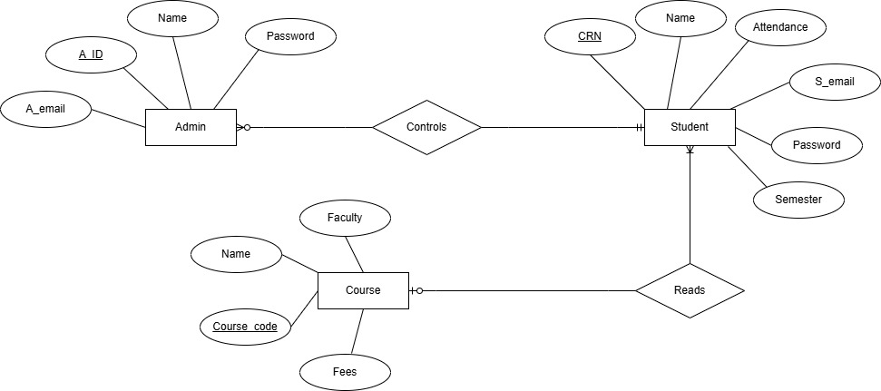

9. Tools & Technologies
Frontend: Figma, HTML, CSS, JS
Backend: MySQL
IDE: PyCharm, VS Code
Version Control: Git, GitHub
GUI Design: Flask
Diagram Tools: draw.io

10. Projected Output
Desktop application supporting two roles:
- Admin Panel: Full data control.
- Student Panel: Read-only access to academic records.
Other Features:
- Role-based login
- Secure local storage of data

11. Additional Considerations
Data Validation: Input restrictions (e.g., marks must be 0–100).
Routing: (visitor can surf to any specific location page with URL)
User Documentation: User guide and system manual.

12. References
[1] A. Kumar and B. Singh, "Design and Implementation of a University Management System," Int. J. Comput. Appl., vol. 120, no. 10, pp. 12–18, 2015.
[2] C. Patel and D. Sharma, "Student Information System Using Python and SQLite," Proc. IEEE Conf. Edu. Tech., pp. 45–50, 2020.
[3] E. Smith, "Database Design for School ERP Systems," J. Database Manag., vol. 25, no. 3, pp. 112–125, 2018.

