Lab-12

sol1:
1.) speed at t=1.2 using forward difference with h=0.4 : -142.5
2.) speed at t=1.2 using forward difference with h=0.2 : -145
3.) speed at t=1.2 using richard_extrapolation : -147.5
4.) absolute error of forward_difference with h=0.4 wrt extrapolation result is: 5
absolute error of forward_difference with h=0.2 wrt extrapolation result is: 2.5
5.)sources of error:
1. air resistance
2. sensor noise
3. error in recording time intervals
6.) altitude at 1.4 is :11793.5
absolute error in calculating altitude at t=1.4 is: 34.5

sol2:
1.) Temperature at t=0 using forward difference with h=1: 2.1999999999999993
2.) Temperature at t=0 using 3-point forward difference with h=1: 1.8499999999999979
3.) 3 point is better as it's order of accuracy is high and using more data points
4.) based on data and graph the temperature rise is exponential as plotting the logarithm value getting a straight line.
5.) if only first 4 values are available we can use 4point- central difference , backaward difference

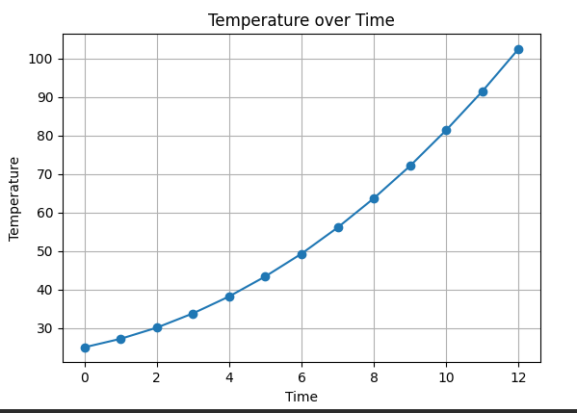

sol3:
Truck's speed at t=50 using forward difference: 0.4799999999999997
Truck's speed at t=50 using 3-point forward difference: 0.4099999999999994
stopping distance is 2.6265624999999675
Truck's speed at t=20 0.9899999999999997
Truck's speed at t=30 0.8500000000000011
Truck's speed at t=40 0.6700000000000006
#as speed is decreasing so truck is slowing
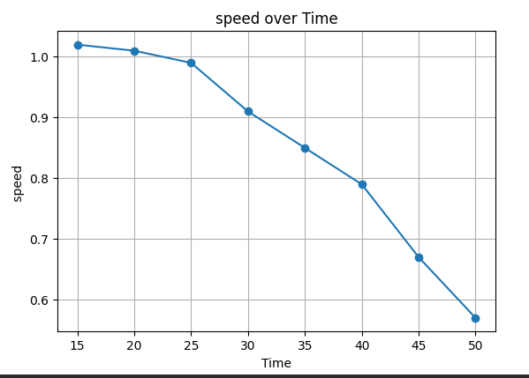
sol4:
rate of pressure drop at altitude=600 using central difference : -0.09
rate of pressure drop at altitude=600 using 3-point central difference : -0.09

#4.3)based on data pressure is decreasing
#4.4)yes there is exponential decrease in the pressure
#4.5)bcoz of higher order of accuracy
#4.6)a.)incorrect weather prediction
#b.) risk of ballon brust
