Network Troubleshooting and Enhancement Assignment 1
NETW(Networking)
Prof: Dr. Eoin OConnell
Anamika Guha
ID: 24086991

- Fix DHCP Issues:
1.1 DHCP is basically a protocol which automatically assign IP address and other network configuration details to devices on a network. In our packet tracer to fix the DHCP issue need assign all the end devices as DHCP so that the PCs and Printer assign their IP address automatically.
To fix DHCP issue we need to go Dektop>IP config>DHCP
  - Then need to configure the router so that it can connect with switch port and end devices.
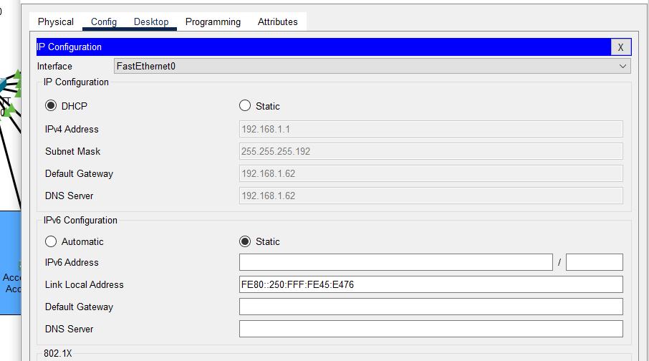
2. Add additional users:
Here I added new 3 Pcs in SOHO network but PCs can’t communicate because of segmented switch port which we can resolve by configure switch and VLAN.
2.1 Here I configured the VLAN according to my student ID which is VLAN 111 and again converted it to DHCP for all 3 PCs so that IP address will assign automatically.
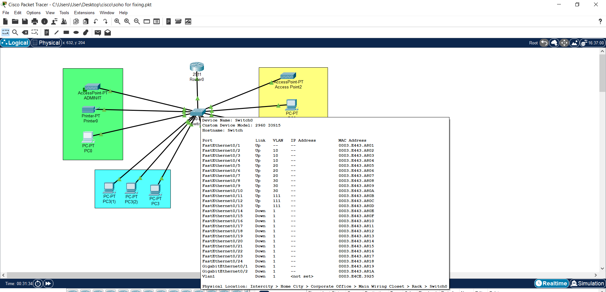
3. Implement Basic Security:
In this network the security was already implemented but port security was applied to the trunk port which caused connectivity issues.
3.1 So I reconfigured the router and switch settings.
3.2 Router Security: I assigned password and configured access control and privacy measures to protect it from unauthorized access.
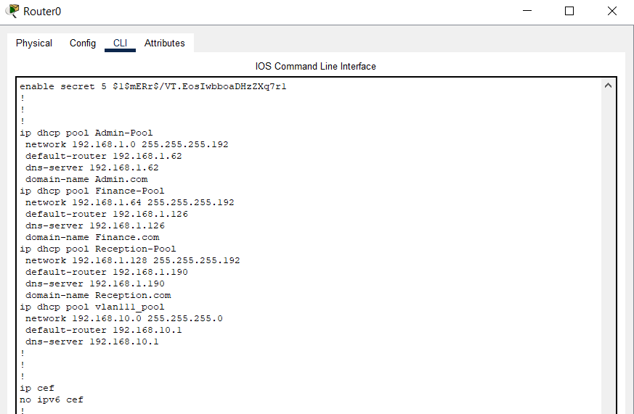
3.3 Switch Security: For switch, set up a port security and allow only trusted MAC address which will help to ensure a secure network environment.
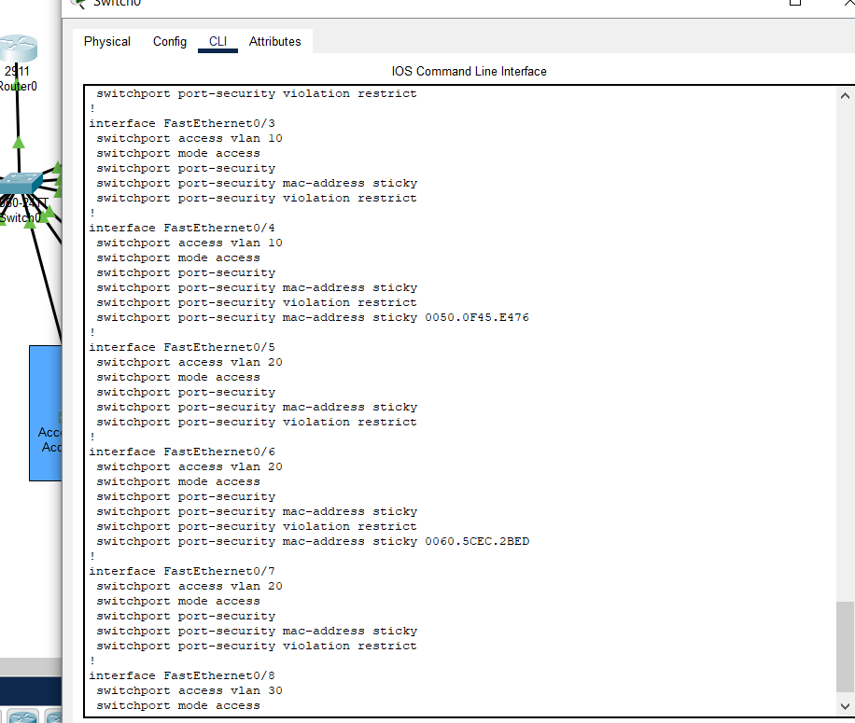
Final Output:
