WEEK 2 TASK
Data Visualization and Reporting in Agribusiness
Step-by-Step Visualization Project Plan

Domain focus: Crop production • Yield • Rainfall • Market prices • Market arrivals
Estimated effort: 30–35 hours
Prepared as a practical and reproducible visualization plan

1. Executive Summary
This Week 2 plan describes how cleaned agribusiness data will be converted into clear, informative, and decision-oriented visual reports. The visualization strategy continues the Week 1 data plan, which focuses on crop production and yield, rainfall and weather indicators, agricultural market prices, and market arrivals. The main purpose is to transform quantitative data into graphics that make trends, comparisons, relationships, seasonality, and unusual observations easy to understand.
The project will use a combination of tables, KPI cards, bar charts, line graphs, scatter plots, heatmaps, and maps where geographic data are available. Each chart will be selected according to the question it answers rather than simply for visual appeal. The report will follow a consistent layout, limited visual clutter, readable labels, meaningful units, and clear source notes. Conceptual charts included in this document demonstrate the intended approach; they are illustrative only and do not represent actual agricultural measurements.

2. Objectives and Scope
- Identify the key agribusiness metrics and decision questions that the visual report should answer.
- Match each metric to the most suitable visualization technique.
- Design a report structure that allows users to move from a high-level overview to detailed evidence.
- Use consistent titles, units, scales, labels, legends, and source notes across all visualizations.
- Make complex agricultural relationships understandable without removing important context.
- Develop conceptual sample charts and layout sketches before final implementation.
- Define a validation process to check numerical accuracy, readability, and interpretation.
- Produce a final visualization report/dashboard that is suitable for agribusiness decision-making.

3. Agribusiness Metrics to Visualize
The following metrics will form the core of the visualization project:
Metric | Unit | Main dimensions | Decision question | Preferred visual
Crop production | tonnes | year, crop, region | Which crops/regions contribute most? | Bar / line
Crop yield | kg/ha or t/ha | year, crop, region | Where is productivity improving? | Line / bar
Cultivated area | hectares | year, crop, region | How is cultivation changing? | Line / bar
Rainfall | mm | month, season, region | Are rainfall patterns seasonal or abnormal? | Line / heatmap
Market price | ₹/kg or source unit | date, crop, market | How volatile are prices? | Line
Market arrivals | tonnes/quintals | date, crop, market | How do supply volumes change? | Line / bar
Price vs. arrivals | paired measures | date, market | Is supply associated with price movement? | Scatter / dual view
Rainfall vs. yield | paired measures | season, region | Is there an observable relationship? | Scatter

4. Key Questions the Visual Report Should Answer
- How has crop production changed over time?
- Which crops or regions have the highest production and yield?
- Are there clear seasonal patterns in rainfall, market prices, or arrivals?
- How large are year-to-year or month-to-month changes?
- Are rainfall conditions associated with crop yield differences?
- Do market arrivals and prices show an observable relationship?
- Which regions or commodities show unusual increases or decreases?
- What are the most important findings that could support production, marketing, or procurement decisions?

5. Visualization Strategy and Technique Selection
The project will use an evidence-first approach. A visualization will be created only when it helps answer a specific question. The selection rules below will guide the design.
Technique | Purpose and justification
Bar charts | Best for comparing discrete categories such as crops, regions, or markets. Horizontal bars will be used when category names are long.
Line graphs | Best for time-series data such as annual production, monthly prices, rainfall, and market arrivals. Multiple lines will be limited to a small number of meaningful series.
Scatter plots | Best for investigating relationships between two numerical variables, such as rainfall and yield or arrivals and price. A trend line may be added when appropriate.
Heatmaps | Useful for showing seasonal intensity across regions, months, or commodities, especially when patterns are difficult to see in a table.
Tables | Used when exact values are important or when decision-makers need a ranked list rather than a visual pattern.
KPI cards | Used at the top of the report for a small number of headline indicators such as total production, average yield, price change, or rainfall deviation.
Maps | Used when geographic differences are central to the question and reliable geographic boundaries/codes are available.
Small multiples | Used when many crops or regions must be compared without placing too many series in a single chart.

6. Step-by-Step Design and Execution Process
Step 1 – Confirm the analytical questions: Translate the agribusiness objectives into a short list of questions that can be answered visually.
Step 2 – Prepare visualization-ready data: Use the cleaned Week 1 data; verify dates, units, geographic names, crop names, and aggregation levels before plotting.
Step 3 – Select the chart type: Choose the simplest chart that communicates the intended comparison, trend, distribution, or relationship.
Step 4 – Calculate derived indicators: Create measures such as year-over-year growth, percentage share, moving averages, price change, rainfall anomaly, and yield change where justified.
Step 5 – Build a rough prototype: Create a basic chart with titles, axes, units, and source notes before applying final formatting.
Step 6 – Check accuracy: Compare chart values against the underlying table or source data; check aggregation and filtering logic.
Step 7 – Improve readability: Remove unnecessary gridlines, decorations, labels, or duplicated information. Keep titles descriptive and axes explicit.
Step 8 – Apply consistent design: Use the same terminology, number formats, units, spacing, typography, and visual hierarchy throughout the report.
Step 9 – Add interpretation: Write a short evidence-based insight below or beside each major chart, avoiding unsupported causal claims.
Step 10 – Validate with a reader test: Ask whether a reader can identify the main message, units, time period, geography, and source without additional explanation.
Step 11 – Assemble the report/dashboard: Arrange the visuals according to the storyboard and create a logical flow from overview to detail.
Step 12 – Final quality review: Check spelling, legends, scales, filters, source notes, accessibility, file integrity, and reproducibility.

7. Design Principles for Clarity, Scalability, and Aesthetic Quality
- Clarity: Every chart must have a clear title, meaningful axis labels, units, and a visible time/geographic context.
- Consistency: Use common naming conventions for crops, markets, regions, seasons, and measures throughout the report.
- Comparability: Keep scales and units consistent when charts are intended to be compared.
- Hierarchy: Place the most important KPIs and findings near the top, followed by supporting evidence.
- Minimalism: Avoid decorative 3D effects, excessive legends, crowded labels, and unnecessary chart elements.
- Context: Include source, period, geography, and relevant methodological notes so that the chart is not misleading when viewed alone.
- Scalability: Design charts to remain readable when exported to DOC, PDF, presentation slides, or dashboard screens.
- Accessibility: Use sufficient text size, clear labels, patterns or direct labeling where color alone might create ambiguity, and avoid relying on color as the only encoding.
- Integrity: Do not distort axes or selectively omit observations simply to make a trend appear stronger.
- Interpretability: Add concise insight statements that explain what the visual shows without claiming causation unless supported by analysis.

8. Conceptual Sample Charts
The following sample charts use invented values solely to demonstrate the intended visualization techniques. They must not be interpreted as actual crop, rainfall, yield, or market statistics.
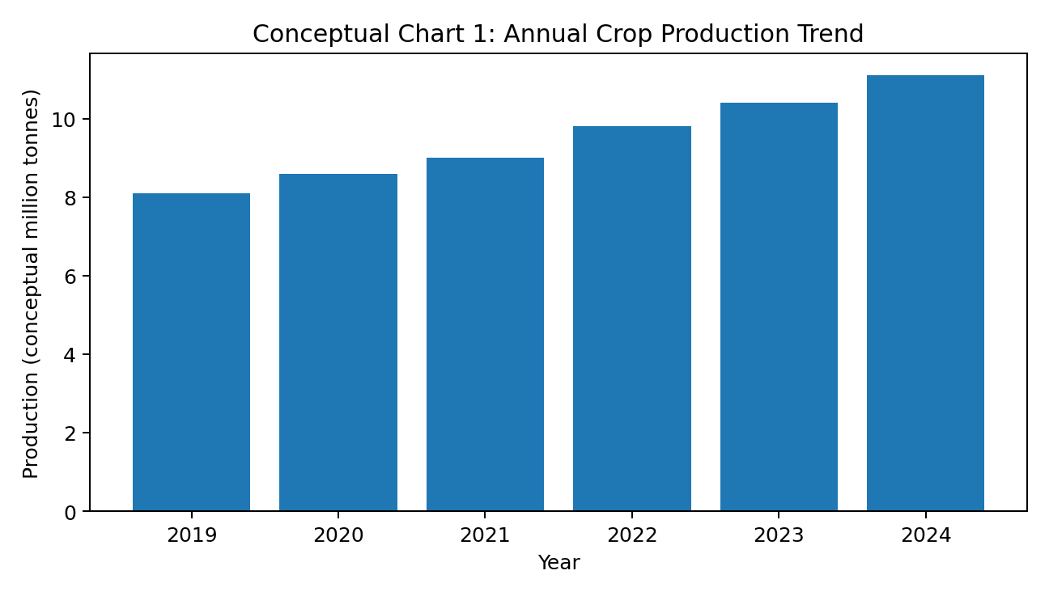
Figure 1. Conceptual annual production bar chart — illustrative values only.
Use case: compare production across years or categories. The final chart will use validated production data and clearly state the unit.
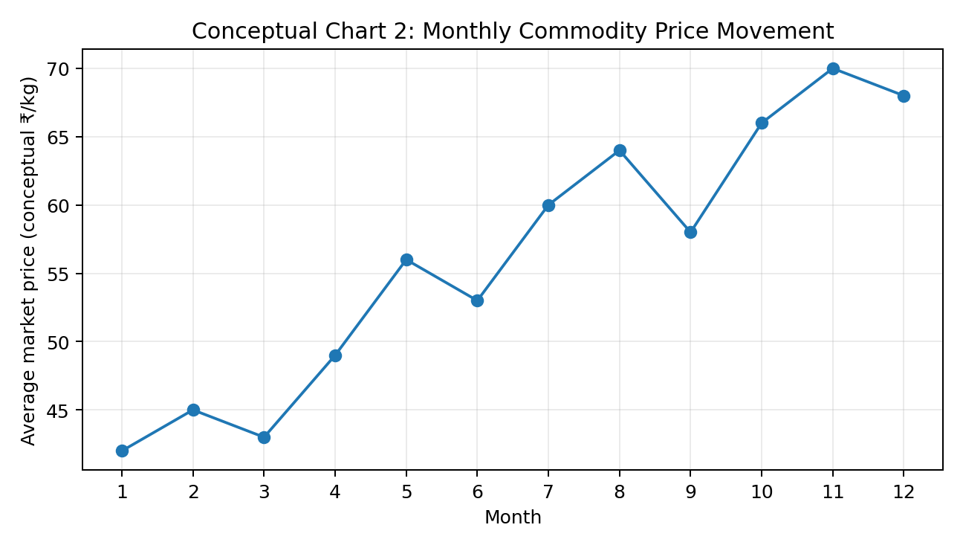
Figure 2. Conceptual monthly market-price line graph — illustrative values only.
Use case: identify seasonality, volatility, peaks, troughs, and sudden price changes over time.
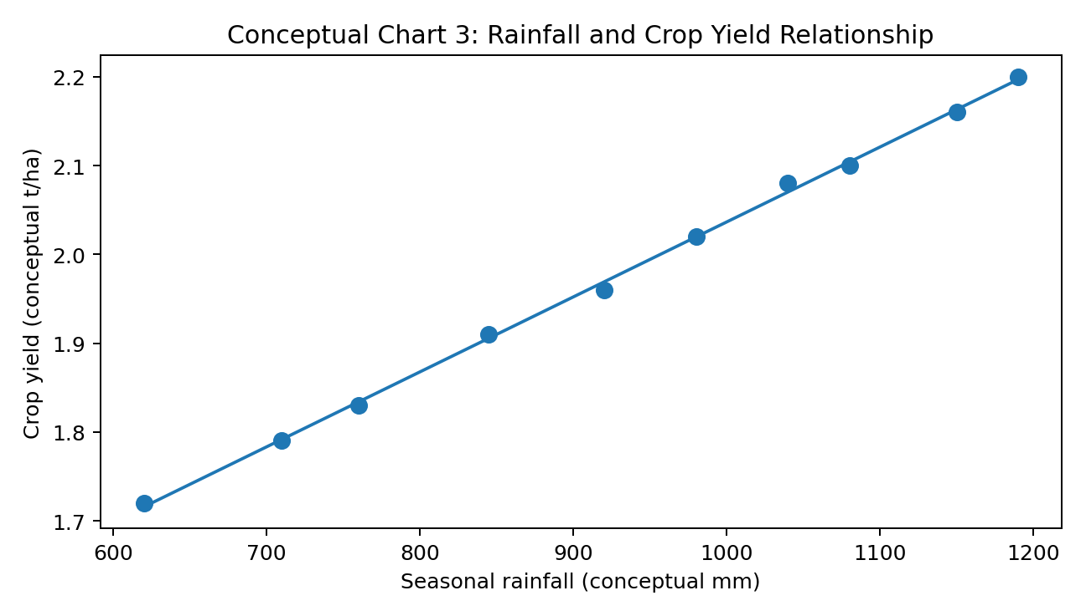
Figure 3. Conceptual rainfall-versus-yield scatter plot — illustrative values only.
Use case: explore whether rainfall and yield move together. The final report will distinguish association from causation.
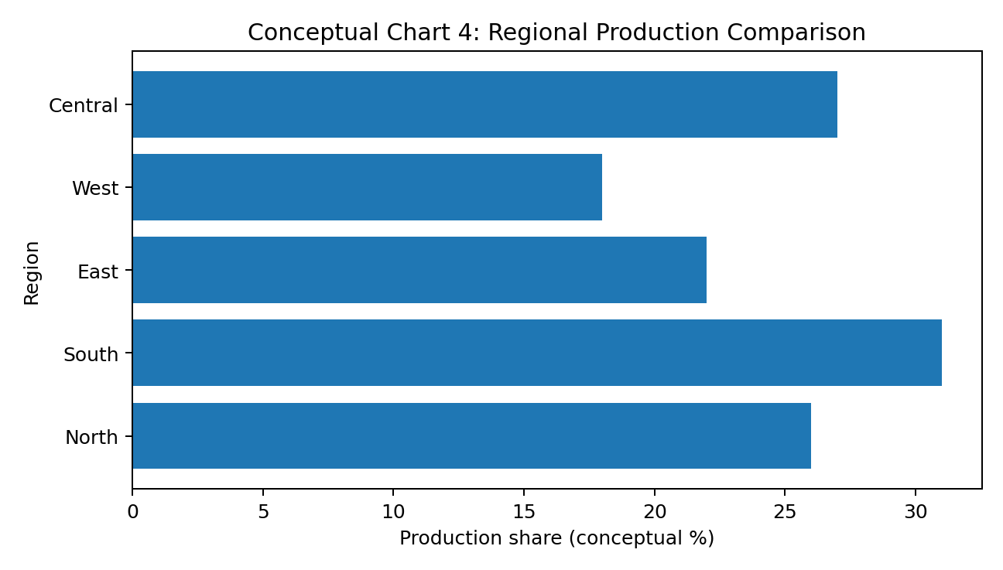
Figure 4. Conceptual regional production comparison — illustrative values only.
Use case: compare contribution or production share across regions while keeping category labels easy to read.

9. Report Layout Sketches
The following wireframes show the planned placement of information. They are structural sketches, not final graphics.
Page 1 – Executive Dashboard / Overview
TITLE + PERIOD | Agribusiness Performance Overview | Selected crop / region / period
KPI 1 | KPI 2 | KPI 3 | KPI 4 | Total production | Avg. yield | Price change | Rainfall indicator
LEFT: LINE CHART | RIGHT: BAR CHART
Production / yield trend | Top crops / regions
KEY FINDING | One or two evidence-based decision insights + source note

Page 2 – Drivers and Relationships
LEFT: RAINFALL LINE / HEATMAP | RIGHT: YIELD TREND
Seasonal rainfall pattern | Yield by year / region
LEFT: SCATTER PLOT | RIGHT: PRICE + ARRIVALS TREND
Rainfall vs. yield relationship | Market behavior and possible seasonal links

Page 3 – Detailed Comparison and Data Table
FILTERS / SELECTIONS: crop | region | market | season | year
RANKED BAR CHART: highest/lowest production, yield, or price
DETAILED TABLE: exact values, changes, and quality flags
CONCLUSION + LIMITATIONS + DATA SOURCES

10. Storyboard / Visual Sequence
Storyboard scene | Visual content | Communication purpose
Scene 1 – Context | Title, scope, period, filters | Introduce the crop, geography, period, and purpose of the report.
Scene 2 – Headline KPIs | KPI cards and short table | Show the most important current or selected-period indicators.
Scene 3 – Production trend | Line/bar chart | Explain how production and/or yield changed over time.
Scene 4 – Regional comparison | Ranked bar chart or map | Identify high- and low-performing regions or markets.
Scene 5 – Weather context | Rainfall line/heatmap | Show rainfall seasonality, deviations, or regional differences.
Scene 6 – Market behavior | Price/arrivals line charts | Show commodity price and market-arrival trends.
Scene 7 – Relationships | Scatter plot and supporting table | Use scatter plots or paired views to investigate rainfall-yield or arrivals-price relationships.
Scene 8 – Key findings | Insight callouts | Summarize the strongest evidence-based insights and practical implications.
Scene 9 – Limitations | Notes and quality flags | State data gaps, differences in definitions, missing values, and any interpretation constraints.
Scene 10 – Sources | Source and methodology panel | Provide source names, coverage, units, access/update information, and methodological notes.

11. Recommended Visualization Tools
Tool | Primary use | Role in project
Microsoft Excel | Rapid exploratory charts, pivot tables, basic dashboards, and tables. | Beginner-friendly; suitable for prototypes and simple reports.
Power BI | Interactive dashboards, filters, geographic views, KPI cards, and drill-down reporting. | Recommended for scalable business-facing dashboards.
Python (Pandas + Matplotlib) | Reproducible data preparation and custom statistical visualizations. | Recommended when repeatability and programmatic control are priorities.
Python (Seaborn) | Statistical exploration and quick relationship/distribution plots. | Useful for exploratory analysis; final styling should remain consistent with the report.
Tableau | Interactive visual analytics and dashboards. | Useful when strong drag-and-drop exploration is required.
Microsoft Word | Final narrative report, layout, captions, tables, and documentation. | Recommended submission format for this assignment.

12. Potential Challenges and Mitigation Strategies
Challenge | Potential impact | Mitigation
Too many variables | Crowded charts and poor comprehension | Prioritize decision-relevant metrics; use small multiples or separate pages.
Different units | Incorrect comparisons | Standardize units before visualization and show units on every relevant axis.
Different time frequencies | Misleading joins or trends | Define explicit aggregation rules before combining daily, monthly, seasonal, and annual data.
Missing values | Broken lines or biased summaries | Show missingness transparently; do not silently treat missing as zero.
Outliers | Extreme points may dominate the visual | Investigate with source and domain checks; annotate genuine events rather than deleting them automatically.
Geographic inconsistencies | Maps and regional comparisons may be wrong | Use standardized geographic codes and reference tables from the cleaning stage.
Overplotting | Too many lines or points hide patterns | Filter, aggregate, facet, or use small multiples.
Misleading scales | Differences may appear larger/smaller than they are | Use honest axes, consistent baselines, and clear scale notes.
Color/accessibility issues | Some readers may not distinguish categories | Use direct labels, patterns, line styles, and accessible contrast; never rely on color alone.
Source revisions | Figures may change after publication | Record source version/access date and keep the visualization linked to the documented dataset.

13. Visualization Quality-Control Checklist
- All plotted values match the cleaned source data.
- Filters and aggregation levels produce the expected totals.
- Titles describe the metric, population, and period accurately.
- Axes contain units and readable scales.
- No accidental truncation or misleading axis manipulation is present.
- Legends and category labels are understandable without excessive effort.
- Missing values and outliers are handled consistently with the Week 1 cleaning policy.
- Source notes identify the dataset and relevant period.
- Charts remain legible after export to DOC/PDF or presentation format.
- The main insight can be identified quickly from each major visual.
- Interpretive statements distinguish association from causation.
- The final report has a consistent visual hierarchy and spacing.

14. Week 2 Timeline and Action Points
Time | Activity | Checkpoint/output
Hours 1–3 | Review Week 1 cleaned dataset and finalize visualization questions. | Question list + metric dictionary
Hours 4–7 | Select chart types, tools, measures, filters, and report structure. | Visualization specification
Hours 8–12 | Create prototypes for production, yield, rainfall, and market indicators. | Prototype chart set
Hours 13–17 | Build relationship views, comparisons, tables, and optional geographic views. | Analytical visual set
Hours 18–21 | Apply formatting, labels, hierarchy, and accessibility checks. | Styled visual set
Hours 22–25 | Assemble dashboard/report pages and write evidence-based insights. | Draft report
Hours 26–29 | Validate numbers, filters, units, sources, and visual interpretation. | QA checklist + corrections
Hours 30–32 | Finalize storyboard, captions, methodology, limitations, and references. | Final report package
Hours 33–35 | Final proofread, export test, reproducibility check, and submission preparation. | Submission-ready DOC

15. Planned Deliverables
- Visualization metric dictionary and chart-selection matrix.
- Conceptual layout sketches and storyboard.
- Prototype charts for production, yield, rainfall, prices, arrivals, and selected relationships.
- Final charts/tables with source notes and explanatory captions.
- A structured agribusiness report/dashboard with an executive overview and detailed analysis pages.
- Visualization quality-control checklist and documented corrections.
- Final DOC/DOCX submission containing the complete step-by-step visualization plan.

16. Definition of Done
- Every major visualization answers a clearly stated agribusiness question.
- Chart types are justified according to the data and intended comparison.
- The report moves logically from overview to evidence to conclusions.
- All figures use documented units, time periods, and geographic scope.
- No chart contains unexplained calculations, filters, or transformations.
- The visual design is consistent, readable, scalable, and accessible.
- Potential limitations and data-quality issues are clearly disclosed.
- The final report can be reproduced from the cleaned Week 1 data and documented transformation steps.

17. Data Sources and References
- FAOSTAT — Food and agriculture statistics: global agricultural statistics including crop production, yield, prices, trade, and related domains. https://www.fao.org/faostat/en/
- FAOSTAT Crop Production, Yield and Harvested Area dataset: https://data.fao.org/catalog/iso/d24a448b-3b62-4c09-8c1d-4a39bb599876
- Open Government Data Platform India — Agriculture: https://data.gov.in/sector/agriculture
- District-wise, season-wise crop production statistics: https://www.data.gov.in/catalog/district-wise-season-wise-crop-production-statistics-0
- India Meteorological Department — Rainfall Information: https://mausam.imd.gov.in/responsive/rainfallinformation_swd.php
- Agmarknet — Agricultural market information: https://agmarknet.gov.in/
- Week 1 project plan: Data Collection, Exploration, and Cleaning in Agribusiness. The Week 2 visualization plan is designed to continue from the cleaned and validated dataset produced in Week 1.

18. Final Note
Effective agribusiness visualization is not simply the process of making attractive charts. It is a structured communication process that connects reliable data to a decision question. The proposed approach therefore prioritizes accuracy, context, simplicity, and traceability. By combining trend analysis, category comparison, relationship analysis, and concise narrative interpretation, the final report will help readers understand agricultural performance and market behavior without being overwhelmed by raw numbers.

