Memory Game for Kids in JavaScript

## Content :

**1.Creating the structure of the game board.**

I started with creating a 4 x 4 grid game board to hold 16 cards using the html <table> element. I created a table with 4 rows and 4 columns.

Then I set the images visibility to hidden which turned the game board into a grid with 16 black cells.

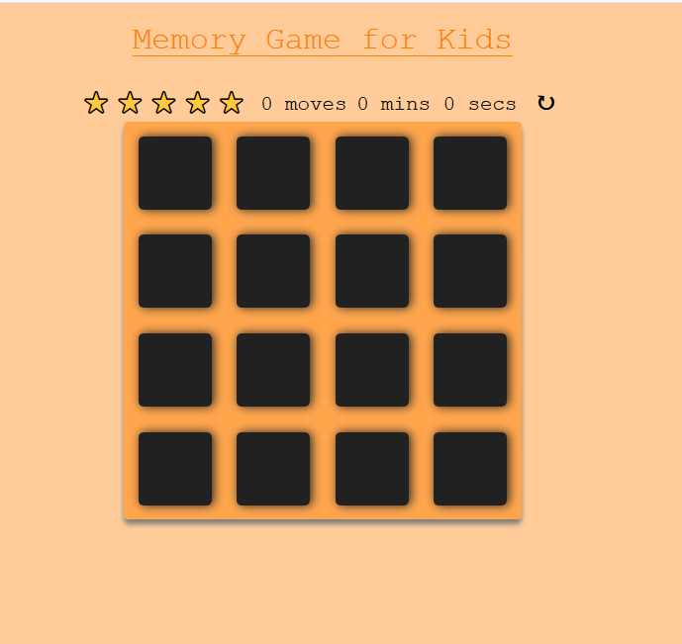

## 2. Displaying the cards images on click of each card

it looks like the images are behind the card and will flip to display the images when clicked.

I collected all the cards i.e all the <td class=”game-card”> and stored them in a variable thus: let cardElements = document.getElementByClassName(‘game-card’). Then I used a for loop to loop through them and add a click event listener.

for(let i = 0; i < cardElements.length; i++) {

cardElements[i].addEventListener('click', displayCard)

}

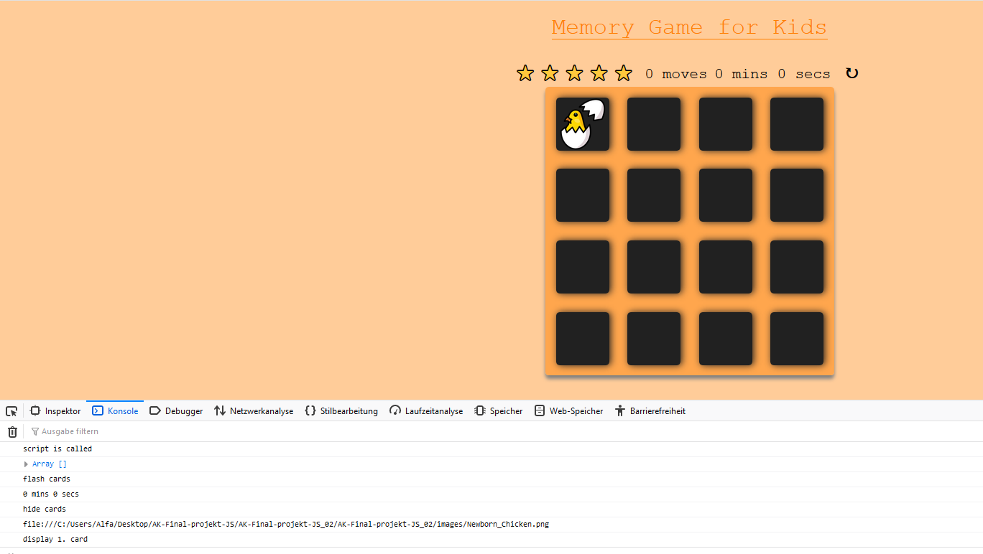

## 3. Shuffling Cards

The game requires that cards had to be shuffled on page load (when the game starts) or on restart. A shuffle function called the Fisher-Yates ([https://en.wikipedia.org/wiki/Fisher-Yates_shuffle](https://en.wikipedia.org/wiki/Fisher%E2%80%93Yates_shuffle))

Shuffle was provided already.

Next, I call the startGame() function on page load

window.addEventListener('load',startGame);

## 4. Matching Cards

Here we have three option

1.when there is no card open ,open a card as actual card.

2. when another card open, push the actual card value to first card

3. then again compare both the card

For matching

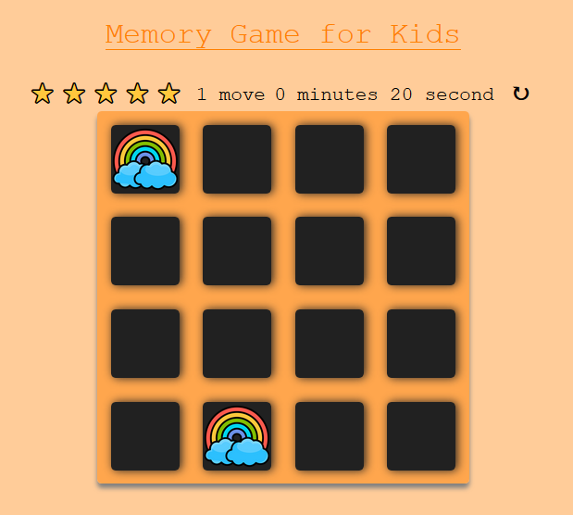

Or not matching

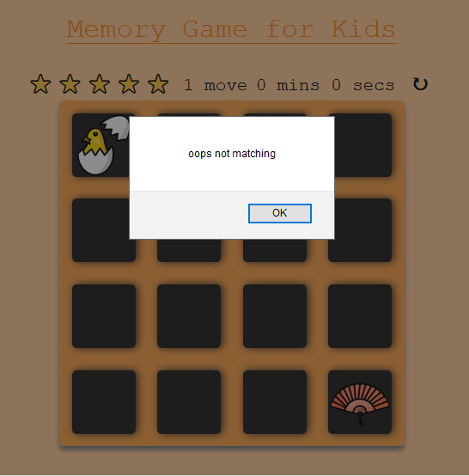

## 5. Counting and Displaying How Many Moves Player Has Made

call a moveCounter() function which increments the number of moves a player has done when two cards have been selected, then sets the innerHTML of my counter element to that value.

## 6. Displaying Star Rating that Reflects Player’s Performance Based on the Number of Moves Made.

I collected all .star elements in an array called starElementsArray

Then modified  moveCounter() function; reducing opacity

## 7.Display a Modal When The Game Ends

When all cards have been correctly matched; the game ends and a modal should appear to alert the user.

