**Introduction:**

We are given a mission on creating an entire version of the complex community by means of coming across the interconnectivity of the systems and subnetworks, on the way to mirror the INTERNATIONAL APEX University’s shape and facilities supplied. On this assignment, we are able to configure DHCP with a purpose to routinely assign IPv4 addresses to any host from the assigned IPv4 address block of our design. Also the HTTP protocol with advocated packet tracer. (Cisco Packet Tracer)

**Overview:**

In our assignment’s community model, we've used Cisco Packet Tracer for the implementation. There are major service, one is Dynamic Host Configuration Protocol (DHCP) and another is Hypertext transfer Protocol (HTTP).

Dynamic Host Configuration Protocol (DHCP) is a network protocol that permits a server to robotically assign an IP to a computer from a described variety of numbers configured for a given network. DHCP permits to move a pc, which include a pc, among diverse locations without reconfiguring the TCP/IP placing. For example, if a college member had a laptop which he desired to take from his office to a networked school room to give in magnificence, DHCP will allow the laptop to hook to the community in both locations without reconfiguring the pc. Or if a pupil has a computer she desires to use to get right of entry to the network in numerous places round campus, DHCP will take care of the TCP/IP configuration.

In our undertaking’s network model, there's one server (DHCP) that is related to a transfer. That transfer is connected to many other switches that refers to library server, faculty server, classroom server, staff server, admin server and lab. Each server is a sub-community. Within the DHCP server there are few numbers of ports wherein we've got used handiest one port to attach a switch that creates a sub-network. From that transfer port we've got linked many other switches. Consequently, the number of ports have increased exponentially. In future which can be multiplied creating subnets from them. These are the stressed community connections. Alongside of those, we've used 1 Wi-Fi community routers in order that you possibly can join there pill or cellular cellphone and use internet service.

HTTP is designed to permit intermediate community factors to improve or allow communications among clients and servers. Excessive-site visitor’s websites regularly gain from internet cache servers that deliver content on behalf of upstream servers to enhance reaction time. Web browsers cache previously accessed web sources and reuse them whilst viable to reduce network traffic. HTTP proxy servers at private community limitations can facilitate communique for customers without a globally routable deal with, by using relaying messages with external servers.

The usage of these two configuration, we have attempted to create that entire version of complex community that reflects the INTERNATIONAL APEX University’s shape and centers.

**components:**

1. Switches
2. PC
3. Wireless Routers
4. Server
5. Laptop
6. Mobile phone
7. Tablet PC
8. Connectors

**Network Diagram:**

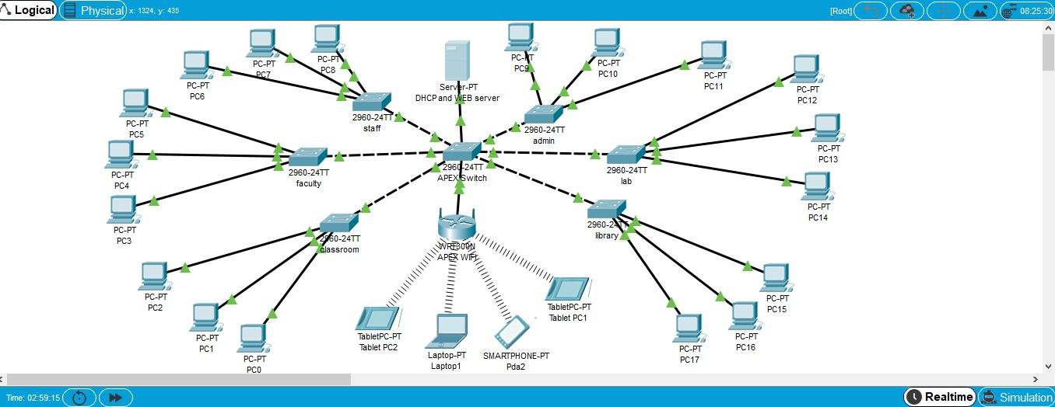

Figure-1: Network Model created in Cisco Packet Tracer

**Implementation of DHCP:**

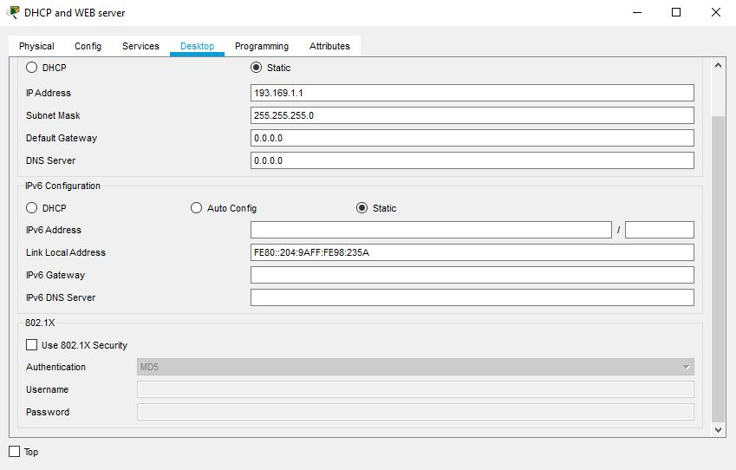

Fig-2: IP configuration of DHCP server

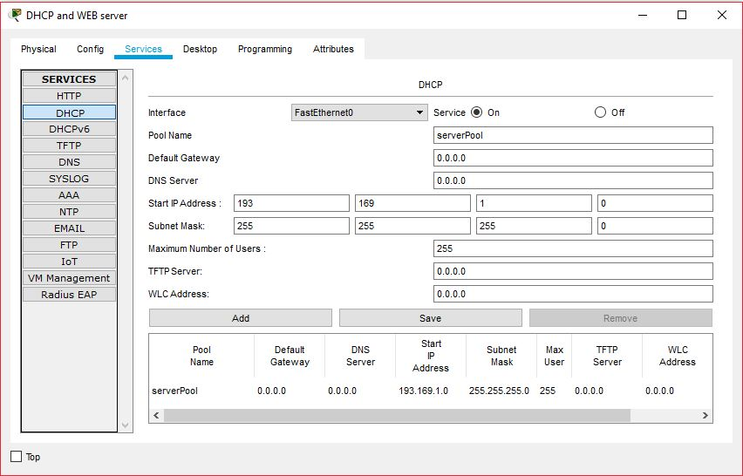

Fig-3: Create serverpool

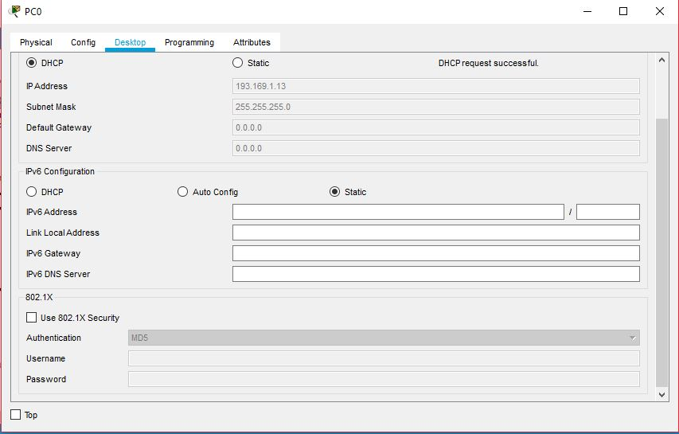

Fig-4: DHCP auto IP config for PC

**Implementation of HTTP:**

**Web Server:**

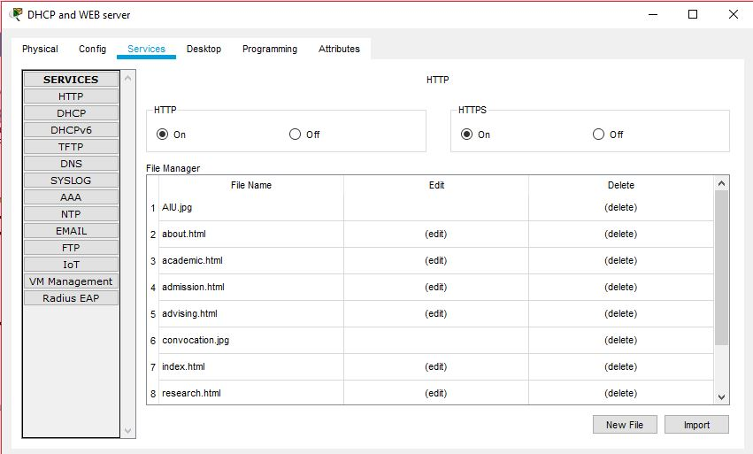

Fig-5: HTTP Web Server

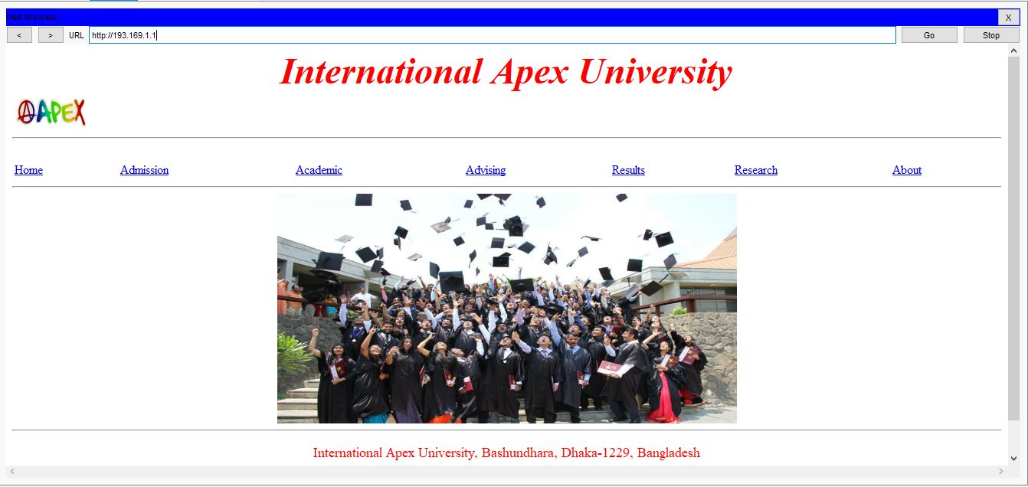

Fig-6: Home Page of Apex Web-Server

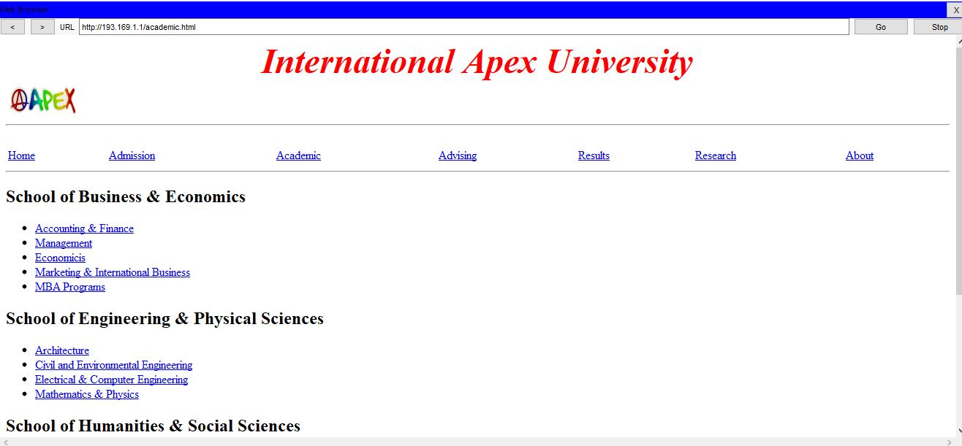

Fig-7: Academic Page

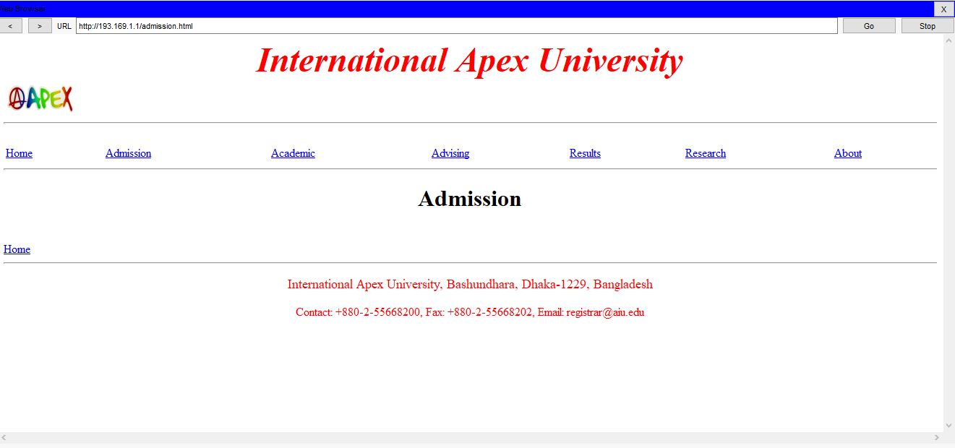

Fig-8: Admission Page

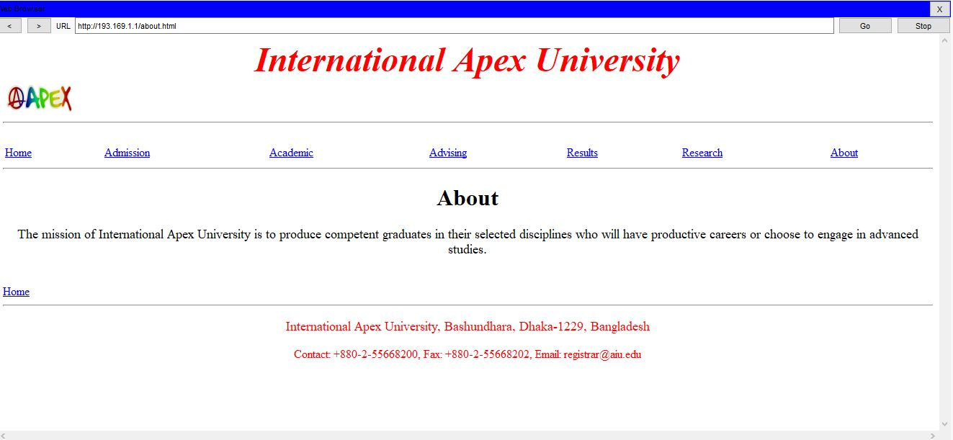

Fig-9: About Page

**Conclusion:**

In this project, we have carried out DHCP and HTTP in Cisco Packet Tracer, wherein the configuration of DHCP is routinely assign IPv4 address to any other host from the assigned IPv4 address block of our design. Also our net-server generates website which reflects the business enterprise profile.

**References:**

1. <https://ipcisco.com>
2. <https://en.wikipedia.org/wiki/Hypertext_Transfer_Protocol>
3. <https://docs.oracle.com/cd/E23824_01/html/821-1453/dhcp-overview-12a.html>
4. <https://kb.iu.edu/d/adov>
5. <https://www.youtube.com/watch?v=eydKbWgA6f0>