Retail Intelligence
  - Sales Analytics and AI-Assisted Customer Segmentation
Anamika Negi
AICTE | IBM SkillsBuild Data Analytics with AI Internship 2026
BharatCares

1. Abstract
This project transforms 541,909 retail invoice lines into a decision-ready business-intelligence application. After documented cleaning, 497,379 eligible product-sales rows produce £9,615,927.75 in historical product sales across 18,955 orders. The application combines complete-month trends, product and country analysis, K-means customer segmentation, and explicit action hypotheses.

2. Problem statement and objectives
Retail managers need to identify demand patterns, geographic dependence and customer purchasing behavior without mistaking descriptive patterns for causal evidence. This project asks: which inventory, market-development and retention experiments should management investigate next?
- Define a small, clear set of reconciled sales KPIs.
- Expose trends and concentration without partial-month comparisons.
- Use unsupervised machine learning to describe customer behavior.
- Translate verified facts into actions with measurable validation plans.

3. Scope and design
The complete backend and Streamlit frontend are contained in one Python file. Four navigation views separate executive, sales, customer and data-quality questions. The AI component is unsupervised customer segmentation; a prediction model is not required to produce actionable insights. The report includes screenshots from the executed application, not mockups.
This is an AI-assisted educational project. It is not an official IBM product, and the report does not claim real-world deployment or business impact.

4. Dataset and data preparation
Source: UCI Online Retail, contributed by Daqing Chen. The source covers a UK-based non-store gift retailer from 1 December 2010 to 9 December 2011; many customers are wholesalers. One row is an invoice line, not an order or a customer.
Dataset: https://archive.ics.uci.edu/dataset/352/online+retail
Reporting window: 1 December 2010–30 November 2011. The incomplete final month is excluded from all headline KPIs and customer features.
Sequential cleaning step | Rows left | Removed
Raw source rows | 541,909 | 0
Remove exact duplicate rows | 536,641 | 5,268
Keep December 2010–November 2011 (complete-month window) | 511,395 | 25,246
Exclude cancellations, returns and non-positive quantities | 501,197 | 10,198
Exclude missing, free and non-positive unit prices | 500,045 | 1,152
Keep product codes; exclude postage/manual/non-product codes | 497,379 | 2,666

Data-quality decisions
InvoiceNo and CustomerID are identifiers, not dates or additive quantities. StockCode is converted to text. InvoiceDate is parsed as a timestamp. A profiler's identifier/date hints were rejected after checking the source schema. Missing descriptions receive a neutral label. Missing customer IDs remain in sales totals but are excluded from RFM.
Product codes are defined as five digits plus an optional letter. Non-product codes, such as postage/manual adjustments, are excluded. Exact duplicate lines are treated as duplicate records and removed; this is an explicit assumption. Large positive transactions are retained rather than trimmed without evidence.

KPI definitions
Measure | Definition
Product sales (GBP) | Sum of Quantity × UnitPrice for eligible product lines.
Orders | Distinct eligible InvoiceNo values.
Average order value | Product sales ÷ eligible orders.
Identified customers | Distinct non-missing CustomerID values in eligible sales.
Product sales exclude returns, fees and adjustments; they are not net revenue or profit. No cost or margin measure is available.

5. Executive overview and monthly results
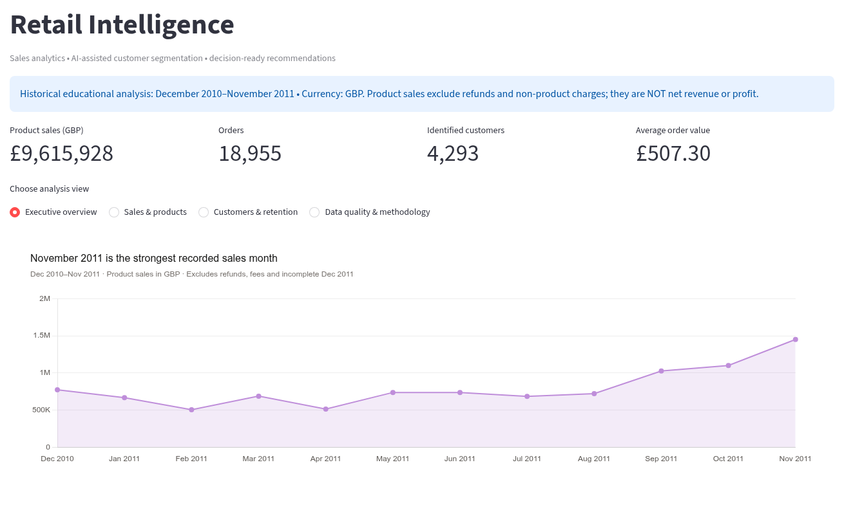
Figure 1. Actual executive-view output from the executed Streamlit application.
The peak month is November 2011. Product sales increased 87.4% from December 2010 to November 2011, but the path is not steadily rising. February and April are lower-sales months. Endpoint change is not annual growth or a forecast.
Month | Product sales (GBP) | Orders | Change vs prior month
2010-12 | £774,247.85 | 1,549 | Not applicable
2011-01 | £669,276.73 | 1,080 | -13.6%
2011-02 | £506,999.49 | 1,093 | -24.2%
2011-03 | £688,945.21 | 1,440 | +35.9%
2011-04 | £514,744.52 | 1,235 | -25.3%
2011-05 | £738,724.58 | 1,668 | +43.5%
2011-06 | £736,609.59 | 1,525 | -0.3%
2011-07 | £685,419.31 | 1,452 | -6.9%
2011-08 | £722,844.15 | 1,339 | +5.5%
2011-09 | £1,026,718.35 | 1,818 | +42.0%
2011-10 | £1,100,356.09 | 2,005 | +7.2%
2011-11 | £1,451,041.88 | 2,751 | +31.9%
Action hypothesis: test stock and staffing plans before the late-year selling period. This dataset alone cannot establish whether seasonality, promotions or stock availability caused the observed pattern.

6. Geographic concentration and products
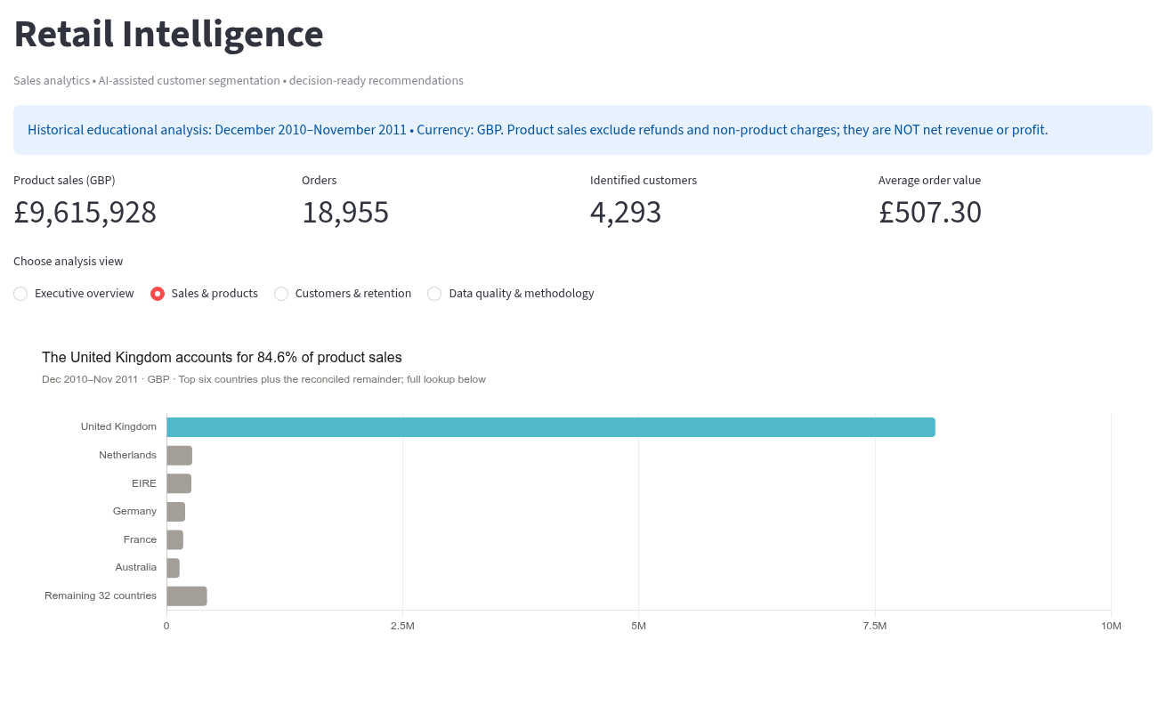
Figure 2. Actual sales-view output; the chart includes the reconciled country remainder.
The UK accounts for 84.6% of eligible product sales across 38 country labels. This indicates geographic dependence. The chart shows the top six countries and all remaining countries together; the application also provides the full country table.

Five leading products by product sales
Stock code / product | Sales (GBP) | Units
22423 — REGENCY CAKESTAND 3 TIER | £168,162.42 | 13,402
85123A — WHITE HANGING HEART T-LIGHT HOLDER | £102,236.34 | 36,826
47566 — PARTY BUNTING | £98,526.75 | 18,147
85099B — JUMBO BAG RED RETROSPOT | £91,932.91 | 47,266
23166 — MEDIUM CERAMIC TOP STORAGE JAR | £81,448.21 | 77,826
The app includes all product rows, a description/stock-code search field and a full CSV download. Product sales are not profitability: a high-selling product may have high fulfilment or acquisition costs.
Action hypothesis: examine stockouts and margins for leading products; test small-market expansion only after evaluating delivery cost and contribution margin.

7. Customer segmentation and retention review
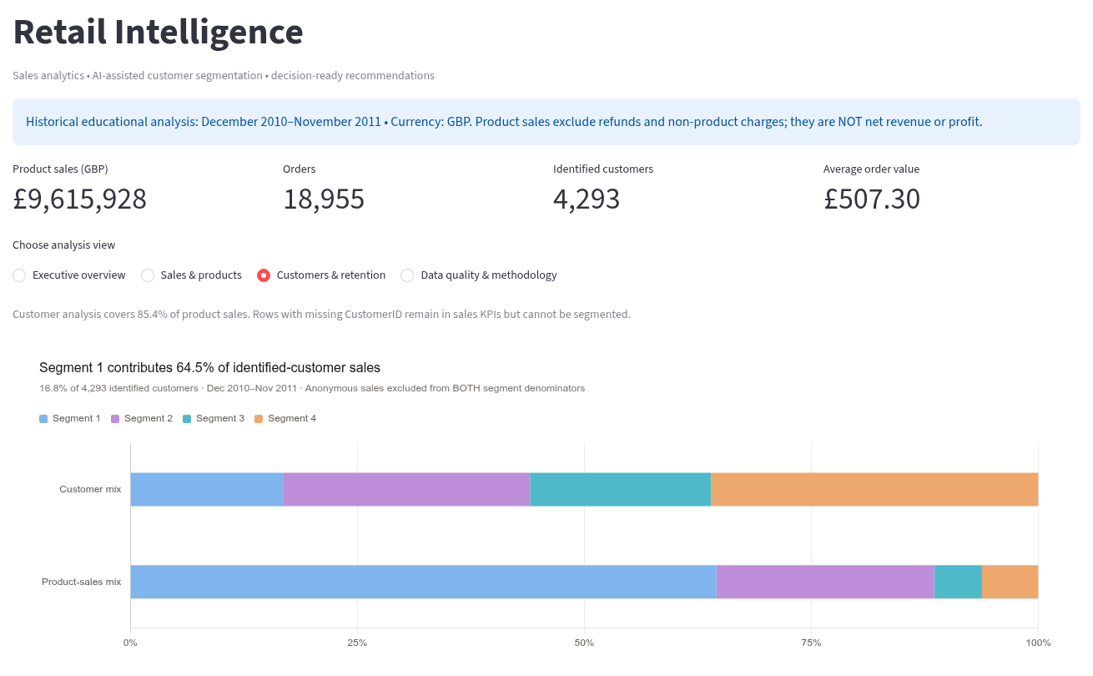
Figure 3. Actual customer-view output. Both mix rows refer only to identified customers.
Identified customers account for 85.4% of product sales. Segment 1 combines recent, frequent, higher-spend behavior. Segment 4 has a much older median last-purchase date. These are descriptive segment profiles, not individual customer forecasts.
Segment | Customers | Median recency | Median orders | Sales share
Segment 1 | 721 | 9 days | 9 | 64.5%
Segment 2 | 1,168 | 55.5 days | 4 | 24.0%
Segment 3 | 856 | 15 days | 2 | 5.3%
Segment 4 | 1,548 | 179 days | 1 | 6.2%

RFM and machine-learning method
Recency is days since last purchase at 1 December 2011; frequency is unique eligible invoices; monetary is historical product sales. log1p reduces skew, then StandardScaler makes the three features comparable. KMeans uses four clusters, seed 42 and 20 initializations. Segment display names follow descending median spend.
Sample silhouette score: 0.340 on up to 1,000 customers. Four clusters are an exploratory choice, not a demonstrated optimum. Silhouette is not prediction accuracy.
Retention-review rule: recency >90 days and spend ≥£1,568.23 (75th percentile). It flags 106 customers. The rule is a heuristic; actual churn and future revenue loss are unknown.

8. Fact → insight → action plan

Inventory readiness
Fact: November is the highest-sales reporting month.
Insight: Recorded demand varies by season; the cause is not established.
Action: Test advance replenishment and staffing for a comparable late-year window.
Validation: Monitor stockouts, fulfilment times and incremental sales against a comparison plan.

Customer concentration
Fact: Segment 1 contributes 64.5% of identified-customer sales from 16.8% of those customers.
Insight: A relatively small customer group represents a large share of historical demand.
Action: Review service levels and loyalty experiments for this group without indiscriminate discounts.
Validation: Compare repeat-order rate and net contribution using a randomized holdout.

Reactivation opportunity
Fact: 106 high-spend customers have no purchase in more than 90 days.
Insight: They merit review, but non-purchase is not confirmed churn.
Action: Run a small, consent-aware reactivation experiment with a holdout group.
Validation: Measure incremental 30-day purchase rate, unsubscribe rate and contribution after offer cost.

Risks and limitations
- This is a historical retailer dataset, not evidence of current demand or present-day customer status.
- No cost, inventory, promotional-exposure or actual churn labels are supplied; causal drivers, profitability and forecast accuracy cannot be evaluated.
- Anonymous sales cannot be segmented; wholesalers and large orders can influence clusters. Validate product-code exclusions and duplicate treatment with a domain expert.
- Customer segmentation is fitted to the analysis population for description. There is no supervised target, train/test accuracy claim or demonstrated campaign uplift.
- A real deployment must protect customer identifiers, use appropriate consent and evaluate interventions before automating them.

9. Reproducibility, testing and references

Run instructions
Use Python 3.13 (tested). Save the code and requirements.txt together, create a virtual environment, install dependencies and start the dashboard:
python -m pip install -r requirements.txt
python -m streamlit run AnamikaNegi_RetailIntelligence.py
python AnamikaNegi_RetailIntelligence.py --analyze
The first run downloads the UCI workbook into .cache/. It can also be downloaded manually. The analysis command exports metrics, validation results and CSV lookup tables into outputs/. Full setup and offline fallback instructions are in README.md.

Validation performed
Check | Outcome
Complete-file syntax / CLI execution | Passed; actual analysis executed.
Independent revenue computation | Passed; £9,615,927.75.
Monthly, country and product reconciliation | Passed; all equal the product-sales KPI.
Segment totals / customer counts | Passed; identified-customer totals reconcile.
Sequential row accounting | Passed; retained + removed equals raw rows.
UI views / product search | Four views captured; search interaction exercised.
Chart audit | Canonical chart preflight and browser checks passed.
Three verified chart snapshots are embedded inside the Python file; a results fingerprint prevents stale charts from being displayed. Tables and KPIs are recomputed from the source on every uncached analysis. If charts fail to load from the CDN or the fingerprint differs, use the newly computed tables and exports.

AI use and submission integrity
AI assisted project design, code and documentation; numerical findings were executed and checked in Python. IBM Bob is not claimed to have been used. The student should review, understand and personalize the work before submission. The supplied Q&A transcript permits alternative tools and requires a dataset different from the masterclass learning dataset. Confirm that this source meets that rule.

References
UCI Online Retail, Daqing Chen:
https://archive.ics.uci.edu/dataset/352/online+retail
Dataset DOI: https://doi.org/10.24432/C5BW33
KMeans documentation: https://scikit-learn.org/stable/modules/generated/sklearn.cluster.KMeans.html
Streamlit documentation: https://docs.streamlit.io/
Submission: upload the four individual files to the form and the same files to GitHub. Supply the actual GitHub repository URL. Do not upload a ZIP or substitute a Drive link. No repository or form submission has been performed by this project.

