🧪 📦 LAB: Mastering tar
🎯 Goal
Work like a DevOps engineer:
- Backup logs
- Compress files
- Restore data

⚙️ Step 1: Create sample files
mkdir tar_lab
cd tar_lab
Create files:
echo "Log file 1" > app.log
echo "Error file" > error.log
echo "User data" > user.txt
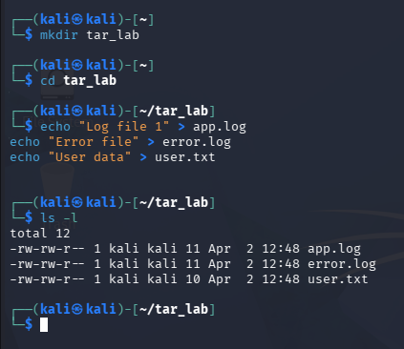

📦 Step 2: Create a tar archive
tar -cvf backup.tar app.log error.log user.txt
👉 Meaning:
- c → create
- v → verbose (show progress)
- f → file name
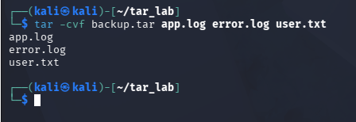

🔍 Step 3: View archive contents
tar -tvf backup.tar
👉 Meaning:
- t → "list" or "table of contents
- v → verbose (show progress)
- f → file name
👉 See what’s inside without extracting
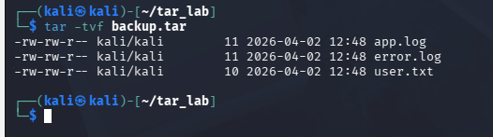

📂 Step 4: Extract archive
tar -xvf backup.tar
👉 Extract all files
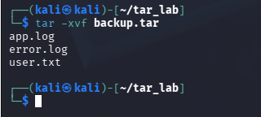

🗜️ Step 5: Create compressed archive (gzip)
tar -czvf backup.tar.gz app.log error.log user.txt
👉 Adds compression → smaller size
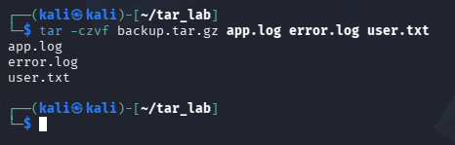

📤 Step 6: Extract compressed archive
tar -xzvf backup.tar.gz
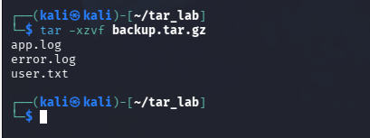

🎯 Step 7: Extract specific file
tar -xvf backup.tar app.log
👉 Only extract app.log
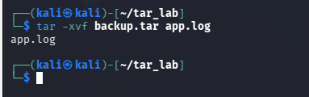

🔥 Step 8: Real-world scenario (Log backup)
tar -czvf logs_backup.tar.gz *.log
👉 Compress all .log files
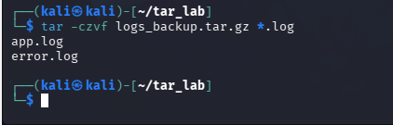

📁 Step 9: Extract to different location
mkdir restore
tar -xvf backup.tar -C restore/
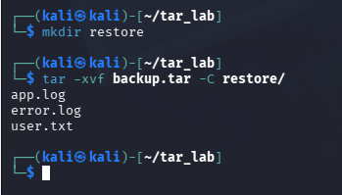

🧠 Step 10: Verify backup
ls restore/
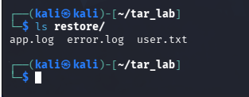

💡 Bonus (Advanced 🔥)
Exclude files:
tar -czvf backup.tar.gz --exclude="*.txt" *
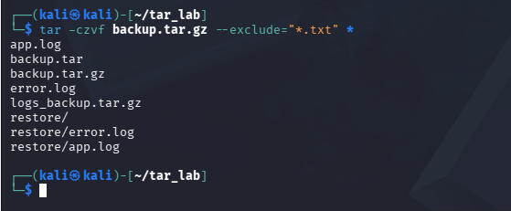

Append file to archive:
tar -rvf backup.tar newfile.txt

🎤 Interview-ready answer
Say this:
“I use tar to create backups, compress logs using gzip, and restore files when needed. I also verify contents before extraction using tar -tvf.”

🚀 One-line memory trick
👉 Create → -c | Extract → -x | Compress → -z

💥 Mini Challenge
👉 Backup only .log files and extract to new folder

🔥 Real-world usage
- Backup configs
- Archive logs
- Deploy applications
- Transfer data

If you want next 🔥
I can give you:
👉 Real production scenario: backup + restore failure lab (very interview-focused)

