Introduction
Welcome to TechCorp. You have just been onboarded as a Junior DevOps Engineer, and you are already facing your first incident.
The monitoring system has triggered a "DISK FULL" alert on the main application server. Upon investigation, you discover that the app_logs directory is overflowing with old log files. If the disk fills up completely, the web application will crash.
Your manager has assigned you a critical maintenance task: Log Rotation.
Your mission is to free up disk space without destroying data. You must execute a safe "Archive and Purge" workflow:
- Identify the relevant log files.
- Archive them into a compressed backup.
- Verify the backup is valid (Safety First!).
- Delete the original files to reclaim space.
This is a standard procedure in system administration. Let's save the server!
Target Identification
The first phase of the operation is Scouting. We need to precisely identify which files are consuming the space. The application directory contains various files, but we are only interested in those with the .log extension.

Tasks
Navigate: Go to ~/project/app_logs.
List: Find all files ending in .log.
Save: Write this list to log_list.txt.
Requirements
Working directory: ~/project/app_logs.
Output file: log_list.txt.
log_list.txt must contain only the .log filenames from ~/project/app_logs.
Do not include non-log files such as config.xml or README.md.
Examples
To list text files and save:
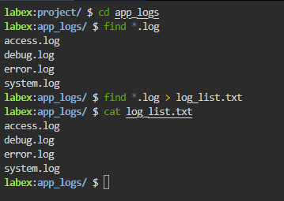
Compressed Backup
Now that we have identified the targets, we proceed to Packing. To maximize disk space savings, we will bundle all the log files into a single compressed archive.

Tasks
Archive: Create a gzip-compressed archive named logs_archive.tar.gz.
Content: Include all .log files.
Requirements
Output: logs_archive.tar.gz.
Format: Use the correct compression flag for gzip.
Include all .log files from ~/project/app_logs.
Do not include non-log files in the archive.
Examples
Creating a tarball:
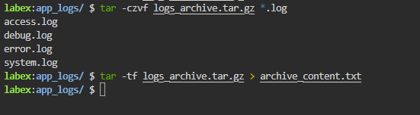

Integrity Check
STOP! Before we delete anything, we must perform Verification. A corrupt backup is worse than no backup at all. We need to confirm that our new archive actually contains the log files we intended to save.

Tasks
List: Show contents of logs_archive.tar.gz without extracting.
Save: Redirect the list to archive_content.txt.
Requirements
Save the archive listing to archive_content.txt.
The saved listing must include the .log files stored in logs_archive.tar.gz.
Examples
List tar contents:

Space Reclamation
We have reached the final phase: Purge. You have confirmed that the backup logs_archive.tar.gz exists and contains the correct data. It is now safe to remove the original clutter.

Tasks
Delete: Remove all original .log files.
Preserve: Keep the .tar.gz file and other config files.
Requirements
Use the command to remove files matching the log pattern.
Be careful not to delete *.
Examples
Remove text files:
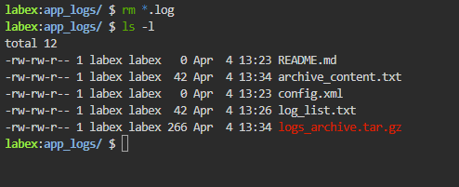

Summary
Challenge Complete!

You have successfully performed a critical system maintenance task. The disk space is reclaimed, and the data is safely archived.

In this challenge, you simulated a real-world System Administrator task:

Analyzed disk usage to identify targets.
Archived logs using compressed backups.
Verified data integrity before deletion.
Reclaimed space safely.
You learned that meticulous verification ("Trust but Verify") is what separates a professional Admin from one who loses data. Great job!

