🧪 🚑 LAB: Fix a Broken Service (SSH Down Scenario)
🎯 Goal
You will learn how to:
- Identify a failed service
- Debug using logs
- Fix and recover the service

⚙️ Step 1: Check SSH service status
sudo systemctl status ssh
👉 You should see:
- active (running) ✅ OR
- failed ❌
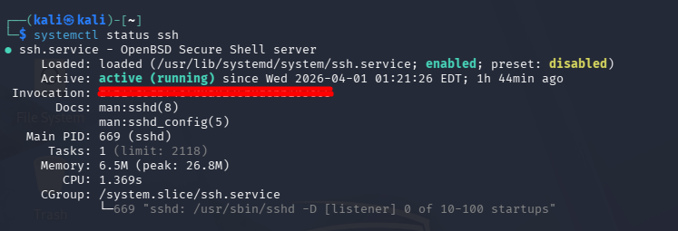

💥 Step 2: BREAK the service intentionally
We’ll simulate a real issue (wrong config)
Open SSH config:
sudo nano /etc/ssh/sshd_config
Find this line:
#Port 22
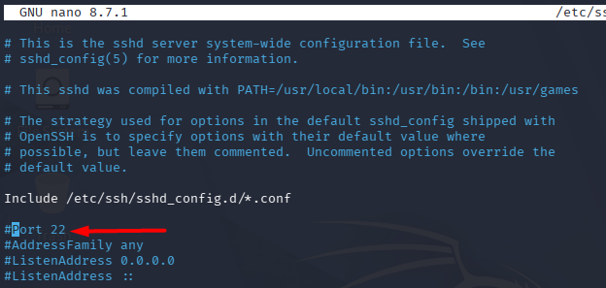
Change it to:
Port 99999
⚠️ Invalid port (max is 65535) → will break SSH
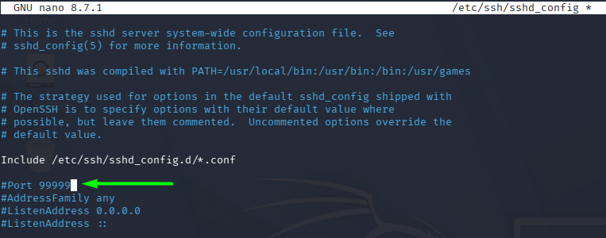
Save:
- CTRL + O → Enter
- CTRL + X

❌ Step 3: Restart SSH (it will FAIL)
sudo systemctl restart ssh
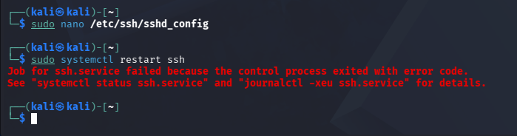
Now check:
sudo systemctl status ssh
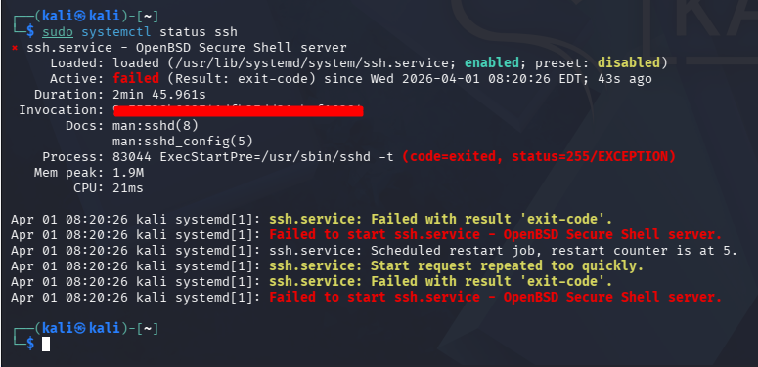
👉 You should see:
- failed state
- Error messages

🔍 Step 4: Investigate logs (THIS IS KEY 🔥)
Use journalctl:
journalctl -u ssh -xe
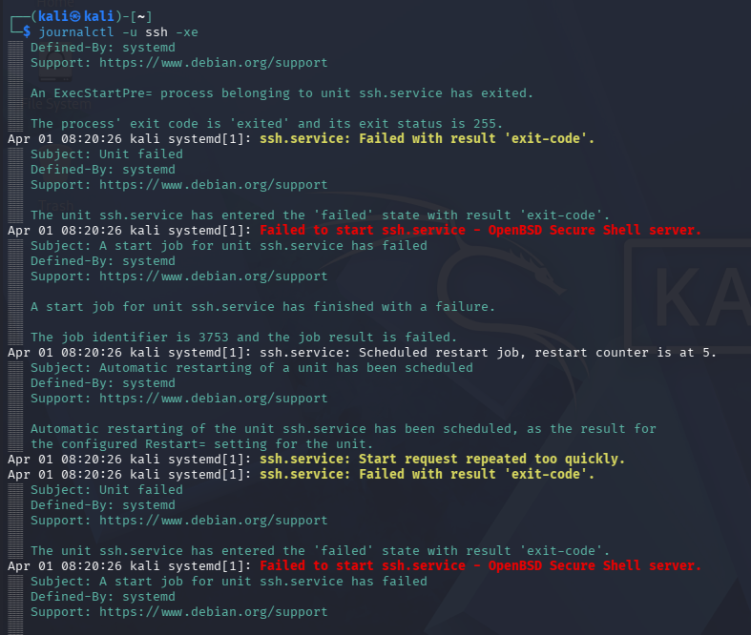

👉 Look for error like:
Badly formatted port number

🧠 Step 5: Root cause analysis (what you say in interview)
“SSH failed due to invalid configuration — incorrect port number.”

🔧 Step 6: FIX the issue
Edit config again:
sudo nano /etc/ssh/sshd_config
Fix:
Port 22

✅ Step 7: Test config before restarting (PRO TIP ⭐)
sudo sshd -t
👉 If no output → config is valid ✅

🔁 Step 8: Restart service
sudo systemctl restart ssh
Check:
sudo systemctl status ssh
👉 Now should be:
active (running)

📡 Step 9: Verify service is working
ssh localhost

💡 BONUS (Advanced Debugging)
If service still fails:
Check full logs:
journalctl -xe
Check port usage:
sudo ss -tulnp | grep ssh

🎯 Interview Answer (Golden Response)
If asked:
👉 “How do you fix a failed service?”
Say:
“I check service status using systemctl, analyze logs using journalctl, identify root cause, fix configuration, validate using sshd -t, and restart the service.”

🚀 Real Skills You Just Learned
- Service troubleshooting
- Log analysis
- Root cause identification
- Safe restart practices
ervice

