Monitoring
🔐 LAB: Monitor SSH Login Activity
🎯 Goal
You will:
- Generate SSH login logs
- Detect success & failure
- Monitor logs LIVE

⚙️ Step 0: Understand your system
Kali uses systemd-journald, so we’ll use journalctl.

🧱 Step 1: Ensure SSH is running
Check SSH service:
sudo systemctl status ssh
If not running:
sudo systemctl start ssh

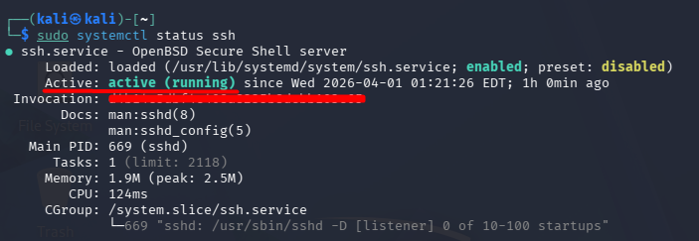

🔑 Step 2: Create a test user (for login attempts)
sudo adduser testuser
Set password when asked.
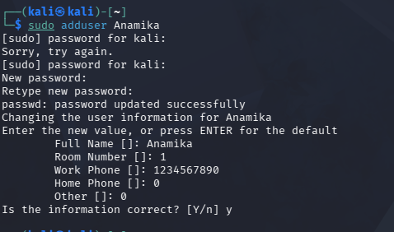

💥 Step 3: Generate FAILED login attempts
Now simulate attack (wrong password):
ssh testuser@localhost
👉 Enter WRONG password 2–3 times
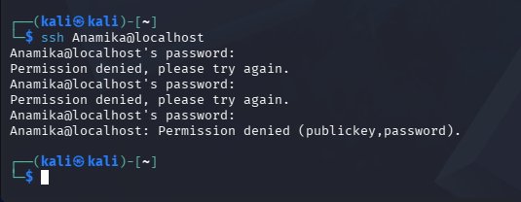

🔍 Check failed logs
journalctl -u ssh | grep Failed
👉 You should see:
- “Failed password”
- Username
- IP (localhost)
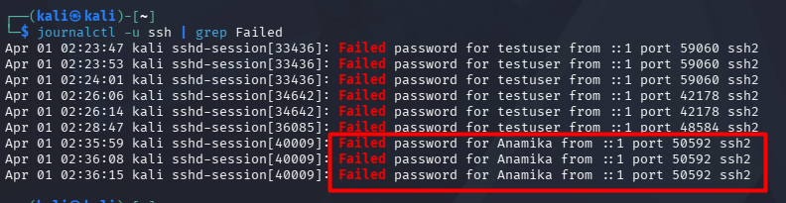

✅ Step 4: Generate SUCCESS login
Now login correctly:
ssh testuser@localhost
Enter correct password.
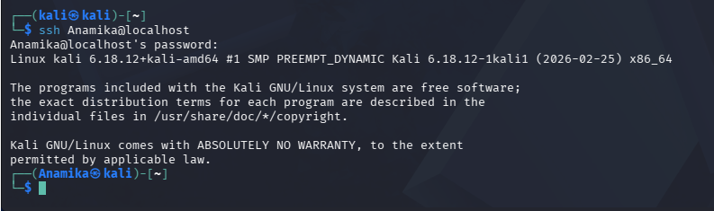

🔍 Check success logs
journalctl -u ssh | grep Accepted
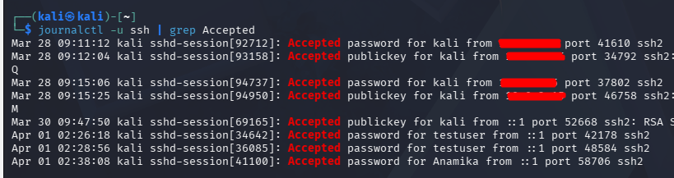
👉 Output shows:
- “Accepted password”
- User + IP

📡 Step 5: REAL-TIME monitoring (IMPORTANT)
Open 2 terminals
Terminal 1:
journalctl -u ssh -f
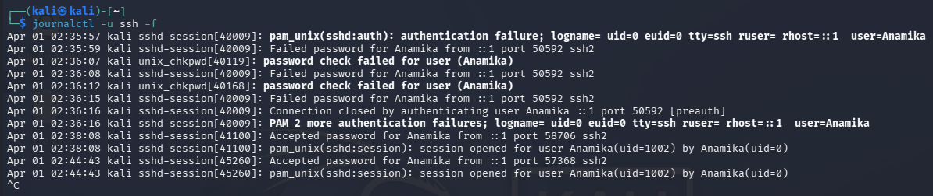
Terminal 2:
ssh testuser@localhost
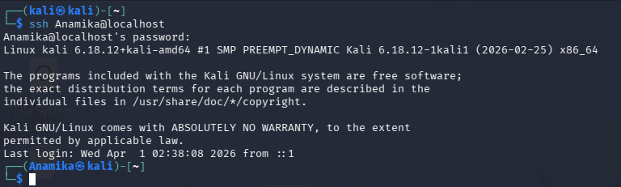
👉 Watch logs appear LIVE 🔥

🧾 Step 6: Check login history
Last
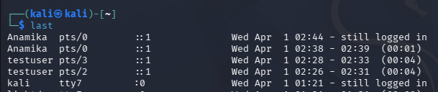
👉 Shows:
- Login sessions
- Time
- Duration

⚡ Step 7: Filter logs by time
journalctl -u ssh --since "10 minutes ago"
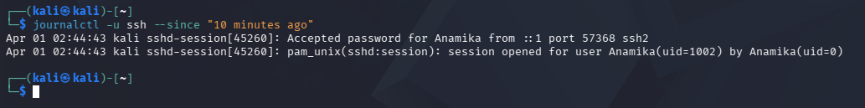

You can now confidently say:
I can monitor SSH logs using journalctl, identify failed attempts for security analysis, and track real-time login activity.

