Introduction
Use awk to process text field by field. awk is one of the classic Unix text-processing tools.While grep is mainly for finding matching lines, awk is better when you want to work with the internal structure of each line.
- Lines are Rows.
- Words are Columns ($1, $2, ...).
In this lab, you will extract data from logs:
- Months from auth.log (Column 1).
- Process Names from syslog (Column 5).
- IPs from access.log (Column 1).

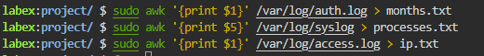
Cat of all .txt file
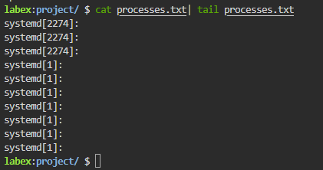

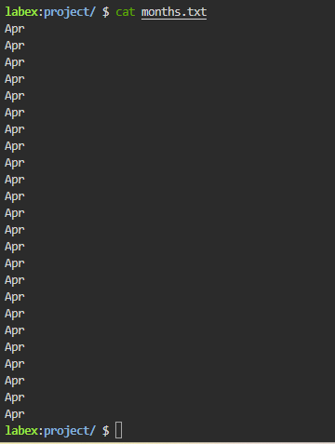
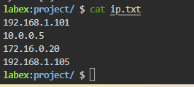

Summary
In this lab, you learned how to slice and dice text files using awk.
- awk '{print $1}': Grab the first column.
- awk '{print $5}': Grab the fifth column.
- Concept: Linux treats text files like spreadsheets where spaces are the column dividers.
You have now mastered the basics of Log Management: finding files, watching them in real-time (tail), searching them (grep), and extracting data (awk). You are well on your way to becoming a Linux Pro!

