🧪 📦 LAB: TAR (Backup & Restore Like a DevOps Engineer)
🎯 Scenario
You are a DevOps engineer.
You need to:
- Backup logs
- Compress data
- Restore files when needed

⚙️ Step 1: Setup lab environment
mkdir tar_lab
cd tar_lab
Create sample files:echo "Application log data" > app.log
echo "System error log" > error.log
echo "User information" > user.txt
👉 Check:
ls
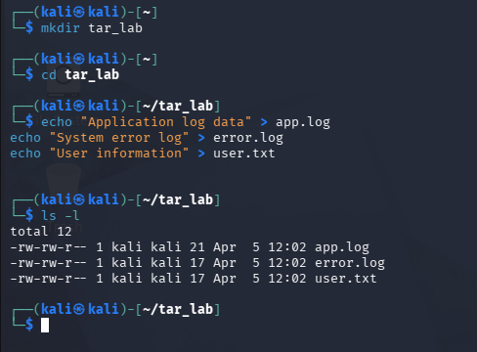

📦 Step 2: Create a basic archive
tar -cvf backup.tar app.log error.log user.txt
👉 What happens:
- Creates backup.tar
- Stores all files inside
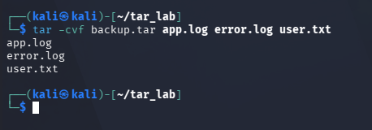

🔍 Step 3: Verify archive (VERY IMPORTANT)
tar -tvf backup.tar
👉 Always verify before using backups
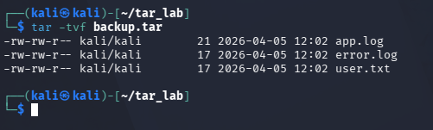

🧪 Step 4: Simulate data loss
rm *.log *.txt
ls
👉 Files are gone ❌
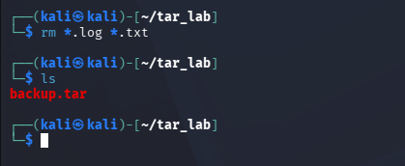

🔄 Step 5: Restore from backup
tar -xvf backup.tar
👉 Files are back ✅
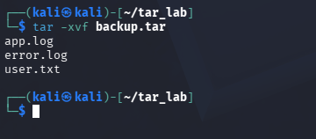

🗜️ Step 6: Create compressed backup (gzip)
tar -czvf backup.tar.gz app.log error.log user.txt
👉 Smaller size + faster transfer
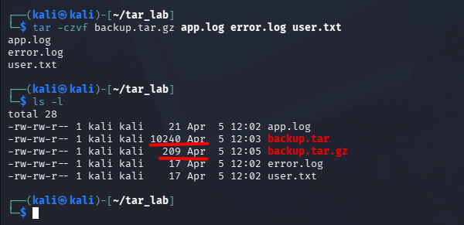

🔍 Step 7: Check compressed archive
tar -tzvf backup.tar.gz
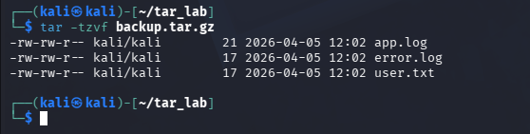

📂 Step 8: Extract compressed archive
tar -xzvf backup.tar.gz
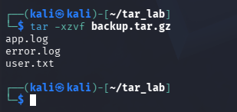

🎯 Step 9: Backup only log files (real scenario)
tar -czvf logs_backup.tar.gz *.log
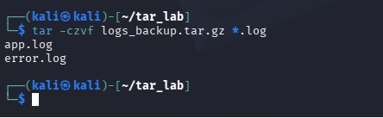

📁 Step 10: Restore to another folder
mkdir restore_folder
tar -xvf backup.tar -C restore_folder/
👉 Files extracted into new location
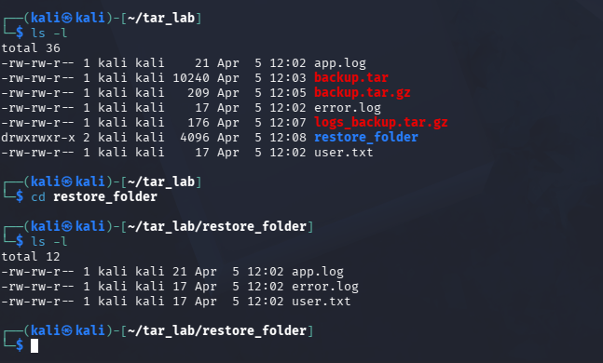

💡 Step 11: Exclude unnecessary files
tar -czvf backup.tar.gz --exclude="*.txt" *
👉 Skips .txt files
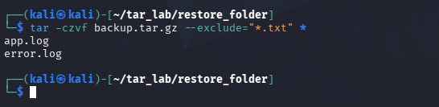

🔥 Step 12: Add new file to archive
echo "New log" > new.log
tar -rvf backup.tar new.log
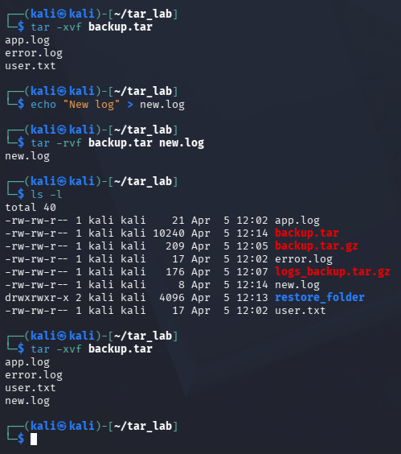

🧠 What you learned
You can now:
- Create backups
- Compress files
- Restore data
- Handle real-world scenarios

🎤 Interview-ready answer
“I use tar to create and compress backups, verify archives before use, and restore files when needed. I also handle selective backups and exclusions.”

⚡ Memory shortcut
👉 -c create
👉 -x extract
👉 -v verbose
👉 -f file
👉 -z gzip

💥 Mini Challenge
👉 Create backup of only .log files
👉 Delete them
👉 Restore into new folder

🚀 Real-world usage
- Server backups
- Log archiving
- Deployment packaging
- Data migration

If you want next 🔥
I can give you:
👉 Production-level backup failure troubleshooting lab (very powerful for interviews)

