🧪 Lab 1: New Employee Onboarding (Production Scenario)
Scenario
A new DevOps engineer, Anamika, joins the company.
Your task is to:
- Create her user account
- Create a devops group
- Add Alice to the group
- Create her home directory
- Verify access
Commands
sudo groupadd devops
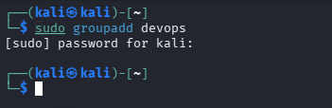
sudo useradd -m -g devops Anamika
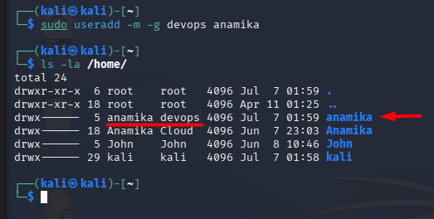
sudo passwd Anamika
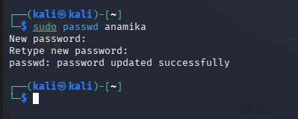
id alice
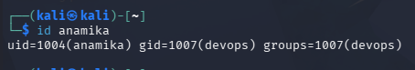
groups anamika
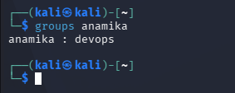
Learning
- User creation
- Group management
- Access verification

🧪 Lab 2: Project Team Access
Scenario
Three engineers need access to the same project.
Users:
- anamika
- bob
- charlie
Group:
- project-team
Tasks
- Create the group
- Add all users
- Create /projects/webapp
- Assign ownership to the project group
Commands:
sudo groupadd project-team
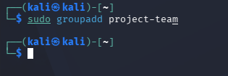
sudo usermod -aG project-team anamika
sudo usermod -aG project-team John
sudo usermod -aG project-team Anamika
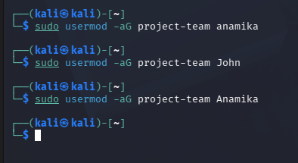
sudo mkdir -p /projects/webapp
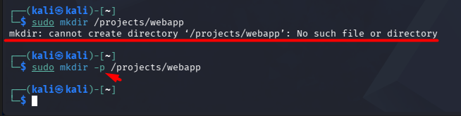
sudo chown root:project-team /projects/webapp
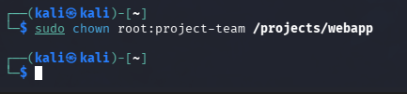
Production Use
Shared project folders.

🧪 Lab 3: Employee Exit Process
Scenario
Employee John resigns.
Tasks:
- Lock account
- Remove from groups
- Archive home directory
- Delete account
Commands
sudo passwd -l John
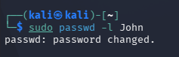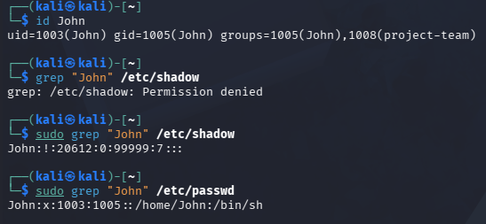
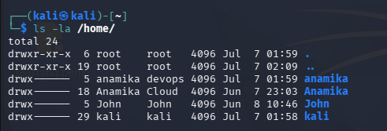
sudo tar -czvf John_backup.tar.gz /home/John

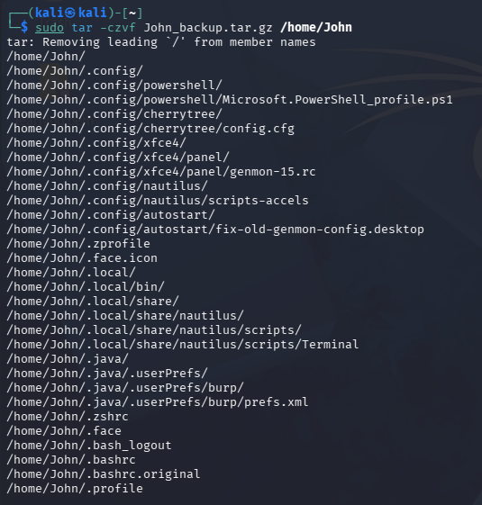
sudo userdel -r John
Production Use
HR offboarding.

🧪 Lab 4: Permission Denied Investigation
Scenario
Application cannot write logs.
Check ownership.
ls -l /opt/app/logs
Fix
sudo chown appuser:appgroup /opt/app/logs
Verify
ls -l /opt/app/logs

🧪 Lab 5: Audit User Accounts
Scenario
Security team requests all users with login shells.
Commands
cat /etc/passwd

grep "/bin/bash" /etc/passwd
Bonus
List only usernames
cut -d: -f1 /etc/passwd

🧪 Lab 6: Shared Backup Folder
Scenario
Operations and Backup teams need common access.
sudo groupadd backup

sudo mkdir /backup

sudo chown root:backup /backup

sudo chmod 770 /backup

🧪 Lab 7: Temporary Contractor Access
Scenario
Contractor works for one week.
Tasks
- Create user
- Force password change
- Set account expiry
sudo useradd -m contractor

sudo passwd contractor

sudo chage -d 0 contractor

sudo chage -E 2026-08-25 contractor
Production use:
Temporary vendor accounts.

🧪 Lab 8: File Ownership Recovery
Scenario
Application migration changed ownership.
Everything became:
root root
Restore
sudo chown -R appuser:appgroup /opt/application

🧪 Lab 9: User Activity Investigation
Find
last

lastlog

who

w
Questions
- Who logged in?
- When?
- Is anyone currently connected?

🧪 Lab 10: Password Policy
View
sudo chage -l alice
Modify
sudo chage -M 90 alice
Meaning
Password expires after 90 days.

⭐ These labs look great on LinkedIn and GitHub
Instead of saying:
"Created a Linux user."
You can say:
"Simulated a production onboarding process by creating user accounts, assigning groups, validating access permissions, and verifying user configuration."
That sounds much closer to real-world system administration.
💡 My recommendation for your GitHub
Create a repository named:
Linux-System-Administration-Labs
Structure it like:
Linux-System-Administration-Labs/
│
├── 01-User-Onboarding
├── 02-Project-Team-Access
├── 03-Employee-Offboarding
├── 04-Permission-Denied-Troubleshooting
├── 05-User-Audit
├── 06-Shared-Backup-Directory
├── 07-Temporary-Contractor-Account
├── 08-Ownership-Recovery
├── 09-User-Activity-Audit
└── 10-Password-Policy
This repository will look far more professional than a collection of isolated Linux commands and demonstrates that you understand production-style user management workflows.

