🧪 🚀 LAB: Advanced Log Analysis (grep + awk + sed)
🎯 Goal
You will:
- Simulate real logs
- Extract useful data
- Analyze like a DevOps engineer

⚙️ Step 1: Create a realistic SSH log file
nano ssh.log
Paste this:
Apr 10 10:00:01 kali sshd[1234]: Failed password for invalid user admin from 192.168.1.10 port 22
Apr 10 10:01:15 kali sshd[1235]: Accepted password for testuser from 192.168.1.20 port 22
Apr 10 10:02:30 kali sshd[1236]: Failed password for root from 192.168.1.10 port 22
Apr 10 10:03:45 kali sshd[1237]: Failed password for testuser from 192.168.1.30 port 22
Apr 10 10:05:00 kali sshd[1238]: Accepted password for admin from 192.168.1.40 port 22
Save & exit.
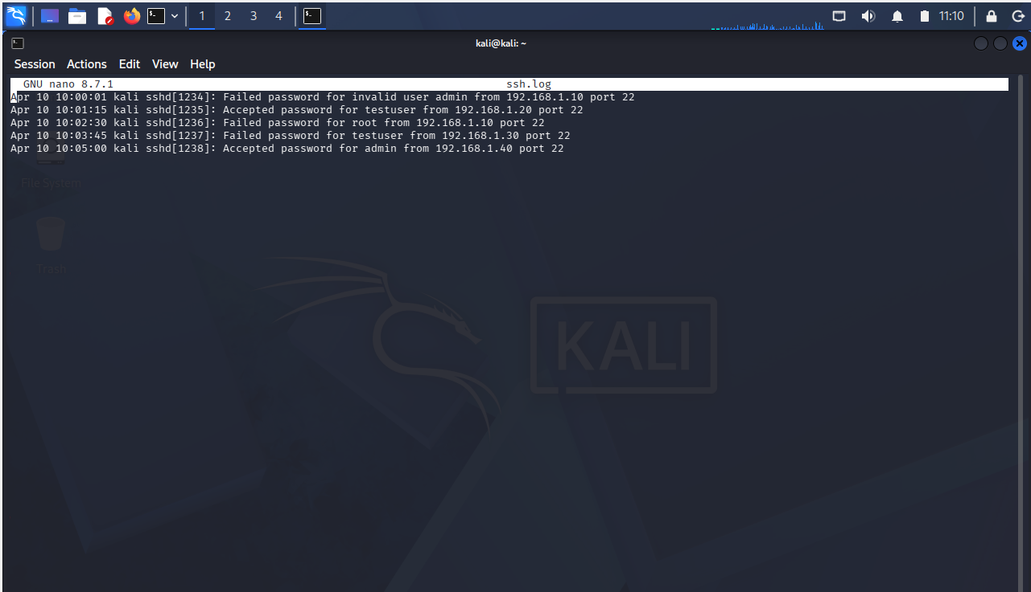

🔍 Step 2: Find failed login attempts (grep)
grep Failed ssh.log
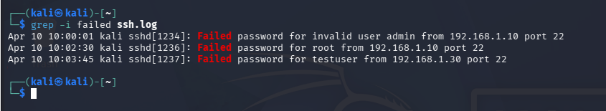
👉 You’ll see only failed attempts

📊 Step 3: Extract usernames (awk)
grep Failed ssh.log | awk '{print $11}'
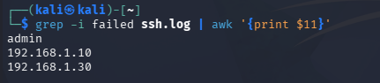
It did not gave me the output as suggested by ChatGPT so I dug deeper to get the below output.
👉 Output:
admin
root
testuser
It suggested me to use: grep Failed ssh.log | awk '{for(i=1;i<=NF;i++) if($i=="for") print $(i+1)}'
Explanation of the loop:
🔹 for(i=1; i<=NF;i++)
👉 Loop through all words in the line
- i=1 → start from first word
- NF → total number of words
- So it checks every word

🔹 if($i=="for")
👉 “If the current word is for”
Example line:
Failed password for admin from 192.168.1.10
↑
this word

🔹 print $(i+1)
👉 Print the next word after for
So:
for admin
↑
printed

🎯 Final Output
admin
root
testuser
Tried it but it gave me different output. I learned that the logic can break sometimes depending upon how the logs are been presented. Some logs contain “for admin” some “for invalid user admin” so we must create the logic keeping all the scenarios in mind but we learn by making mistakes as I did Finally we got the desired output.
🎯 Final Output
admin
root
testuser
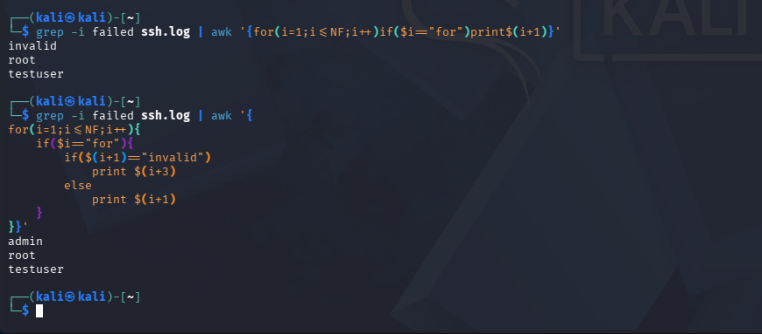

🌐 Step 4: Extract IP addresses
grep Failed ssh.log | awk '{for(i=1;i<=NF;i++) if($i==”from”) print $(i+1) }'
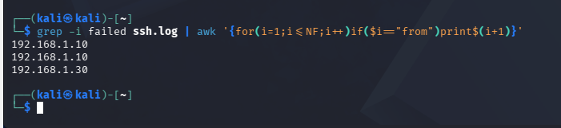
👉 Output:
192.168.1.10
192.168.1.10
192.168.1.30

🔢 Step 5: Count failed attempts per IP (REAL USE CASE 🔥)
grep Failed ssh.log | awk '{for(i=1;i<=NF;i++) if($i==”from”) print $(i+1) }'
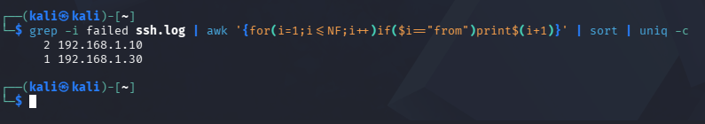
👉 Output:
2 192.168.1.10
1 192.168.1.30
👉 This shows possible brute-force attack 🚨

🧹 Step 6: Clean output using sed
Original : 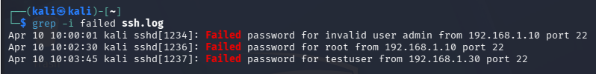
After command: grep Failed ssh.log | sed 's/Failed password for //'
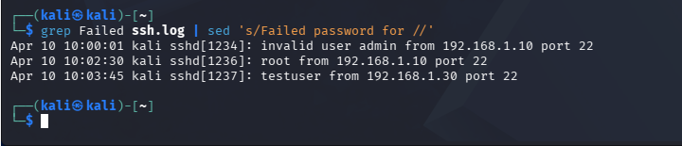
👉 Removes unwanted text → cleaner logs

⚡ Step 7: Real system logs (optional)
If SSH is running:
journalctl -u ssh | grep Failed
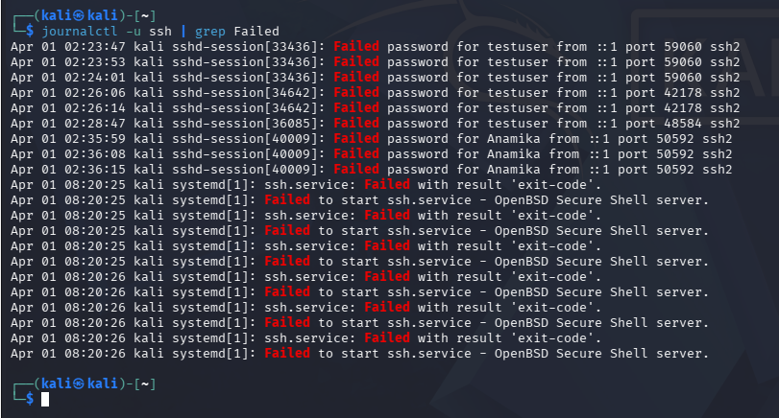

🧠 What you just learned
You can now:
- Detect suspicious activity
- Extract users & IPs
- Identify attack patterns
- Clean and transform logs

🎤 Interview-ready explanation
Say this:
“I use grep to filter logs, awk to extract fields like usernames and IPs, and sed to clean data. I combine them to detect patterns like repeated failed login attempts.”

🚀 Real-world relevance
This exact skill is used in:
- 🔐 Security monitoring
- 🛠️ Incident troubleshooting
- 📊 Log analysis in production

