DATA MINING –II: Mini Project Report
Clustering of BBC News Articles Using Machine Learning

Mini Project Report

Clustering of BBC News Articles Using Machine Learning

Abstract
This project investigates the clustering of BBC news articles using unsupervised machine learning techniques. The BBC dataset contains news stories from five primary domains—business, entertainment, politics, sport, and technology. The study applies multiple clustering methods including K-Means, Agglomerative Clustering, and DBSCAN to identify natural groupings in text data. A complete pipeline involving text preprocessing, TF-IDF feature engineering, dimensionality reduction, and model evaluation was implemented. Experimental results demonstrate that the K-Means algorithm provides the most effective cluster separation, making it suitable for automated news classification and information retrieval applications.

1. Introduction

1.1 Problem Statement
With the rapid surge of digital publishing, thousands of news articles are produced daily across various platforms. Manually organizing or categorizing such massive textual content becomes extremely inefficient and susceptible to human error. Traditional rule-based categorization lacks scalability and struggles with linguistic variability. Therefore, there is a clear need for robust, automated clustering systems that can group similar articles together based on their underlying themes.

1.2 Purpose of Study
The purpose of this project is to design an automated, unsupervised learning system capable of identifying thematic clusters in BBC news articles. The objectives include:
- Preprocessing raw news articles into structured representations
- Extracting meaningful features using TF-IDF
- Applying and comparing different clustering algorithms
- Evaluating cluster quality using standard metrics
- Visualizing high-dimensional text data using PCA and t-SNE

1.3 Significance of Research
This research has direct implications in the fields of:

Information Retrieval
Improves browsing efficiency through topic-based grouping.

News Personalization
Forms the foundation for recommender systems (e.g., “More Like This”).

Content Management
Helps media organizations automatically organize, archive, and tag news articles.

Machine Learning Applications
Demonstrates real-world use of text mining and unsupervised learning methods.

1.4 Dataset Description
The dataset used for this project is the BBC News Text Dataset, a widely used benchmark for text clustering and topic modeling tasks. It contains 2,225 news articles collected from the BBC News website and categorized into five major topics:
- Business
- Entertainment
- Politics
- Sport
- Tech

Key Characteristics
- Total documents: 2,225
- Number of classes: 5
- Document type: Raw text news articles
- Average text length: ~300–400 words
- Language: English
- Source: BBC News (2004–2005)
- Provided labels: Class labels (used only for evaluation, not during clustering)

2. Methodology

2.1 Data Preprocessing
Textual data must be normalized before feature extraction. Steps include:
- Lowercasing: Ensures uniformity.
- Punctuation Removal: Eliminates characters that do not contribute to meaning.
- Tokenization: Splits articles into individual words.
- Stop word Removal: Removes frequently used but semantically weak words.
- Lemmatization: Reduces words to their base form to reduce vocabulary size.
- Whitespace Normalization: Eliminates redundant spacing artifacts.
This preprocessing pipeline substantially improves the accuracy of clustering.
CODE SNIPPET:
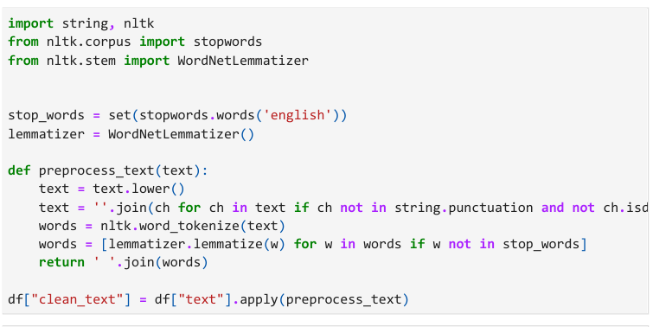

2.2 Feature Extraction
To convert text into numerical form, two methods were explored:

Bag of Words (BoW)
- Captures word occurrence frequency
- Limited to top 4,000 most frequent words
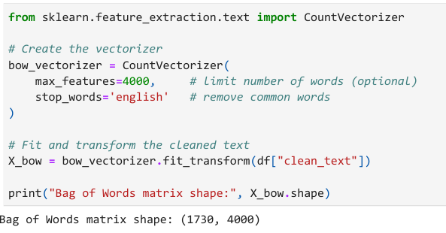

TF-IDF (Term Frequency–Inverse Document Frequency)
- Assigns higher weight to important but less frequent terms
- Produces a sparse, high-dimensional vector representation
- Works well for text clustering due to emphasis on distinguishing words
TF-IDF was used in final experiments for its superior accuracy.
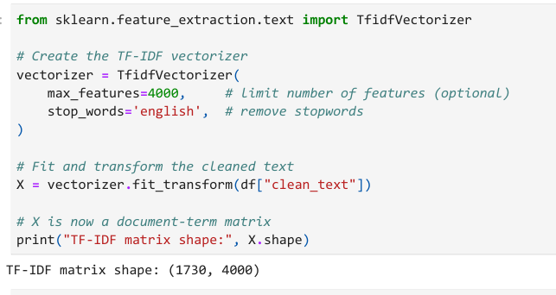

2.3 Dimensionality Reduction
High-dimensional TF-IDF vectors (4000+ dimensions) are difficult to visualize. Therefore:

Principal Component Analysis (PCA)
- Linear transformation
- Reduces dimensionality while preserving maximum variance
- Useful for initial visualization

t-Distributed Stochastic Neighbor Embedding (t-SNE)
- Non-linear dimensionality reduction
- Better separation of non-linear clusters
- Produces more interpretable 2D visualizations of natural groupings

2.4 Clustering Algorithms

K-Means
- Partitions data into k clusters using distance minimization
- Fast and scalable
- Performs best when clusters are spherical and well separated
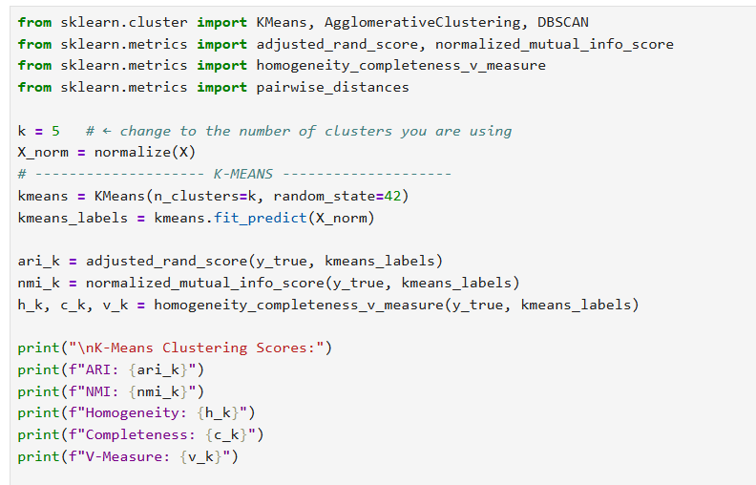

Agglomerative Clustering
- Hierarchical bottom-up approach
- Uses cosine similarity or Euclidean distance
- Produces a dendogram representing document linkage
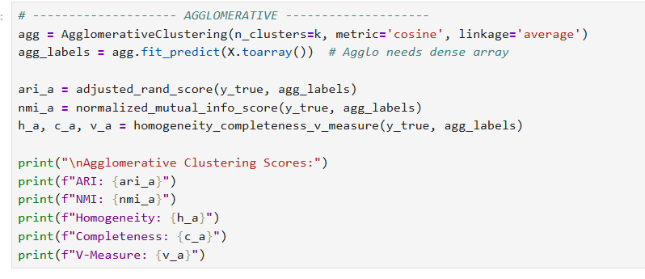

DBSCAN
- Groups points based on density
- Can detect noise/outliers
- Performance depends heavily on ε and MinPts parameters
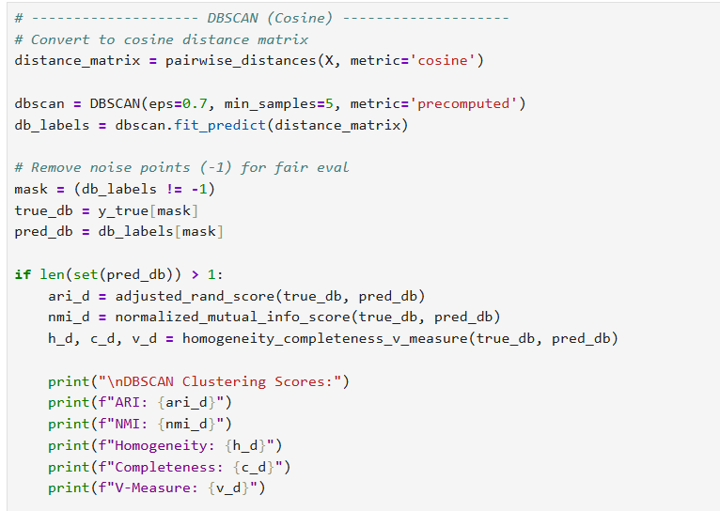

2.5 Evaluation Metrics
The following metrics were used to validate cluster quality:
- Adjusted Rand Index (ARI): Measures similarity between predicted and true labels.
- Normalized Mutual Information (NMI): Captures mutual dependence between clusters.
- Homogeneity: Ensures each cluster contains only one class.
- Completeness: Ensures all documents of a class are assigned to the same cluster.
- V-Measure: Harmonic mean of homogeneity and completeness.
- Precision, Recall, F1-Score: Standard classification-oriented clustering evaluation.

3. Results

3.1 Quantitative Comparison
The performance of different clustering algorithms is summarized below:
Method | ARI | NMI | Homogeneity | Completeness | V-Measure | Precision | Recall | F1-Score
K-Means | 0.639 | 0.689 | 0.667 | 0.713 | 0.689 | 0.731 | 0.731 | 0.731
Agglomerative | 0.530 | 0.607 | 0.513 | 0.743 | 0.607 | 0.608 | 0.608 | 0.608
DBSCAN | 0.446 | 0.616 | 0.646 | 0.588 | 0.616 | 0.493 | 0.493 | 0.493

Interpretation
- K-Means outperforms all other algorithms.
- Agglomerative clustering shows high completeness but poor homogeneity.
- DBSCAN detects noise effectively but fails to form distinct clusters due to sparse high-dimensional text data.

3.2 Cluster Interpretation
Cluster themes were identified using top words:

Business:
Company, market, bank, profit, economic

Politics:
Government, election, party, policy, minister

Sport:
Match, team, win, player, league

Entertainment:
Film, award, music, television, actor

Technology:
Software, device, internet, security, technology
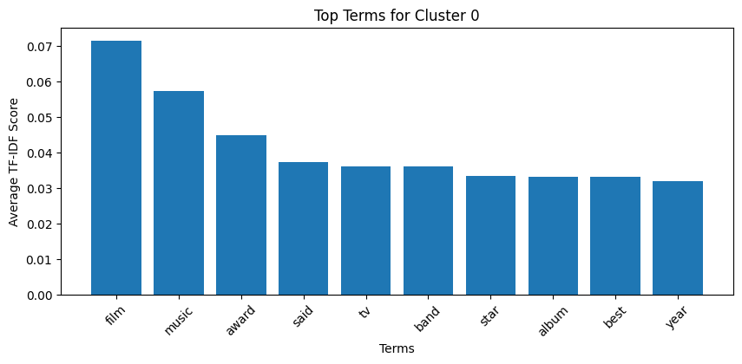

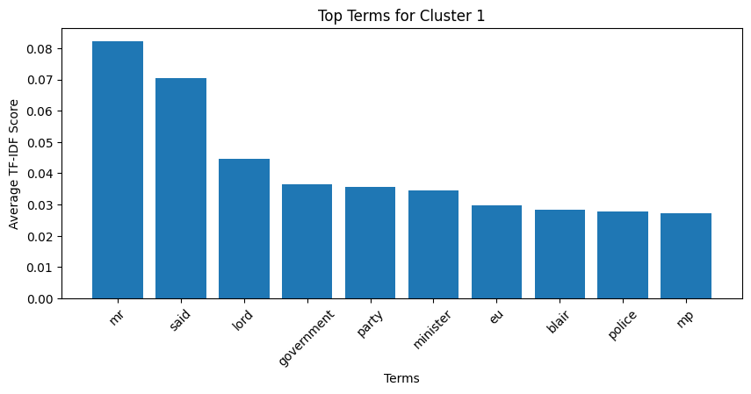
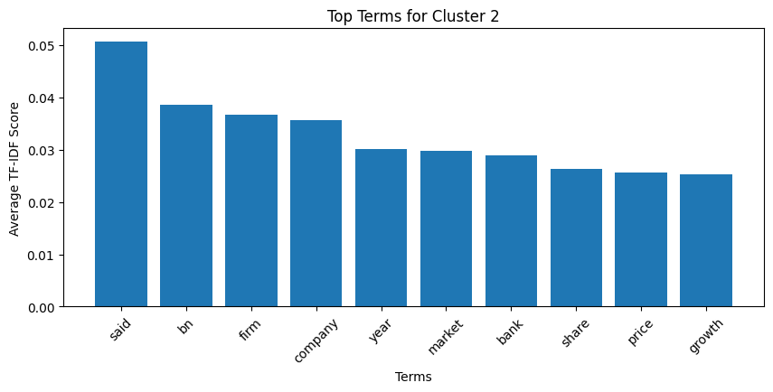
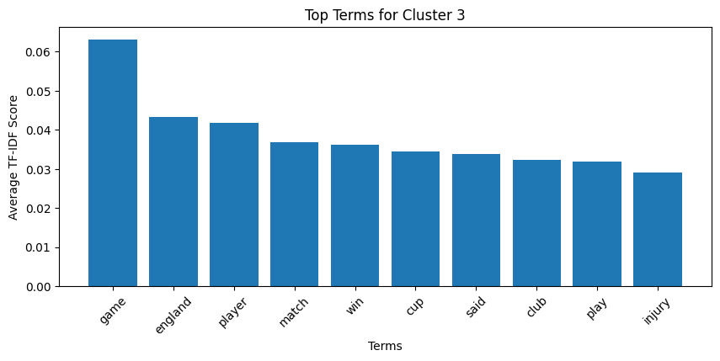

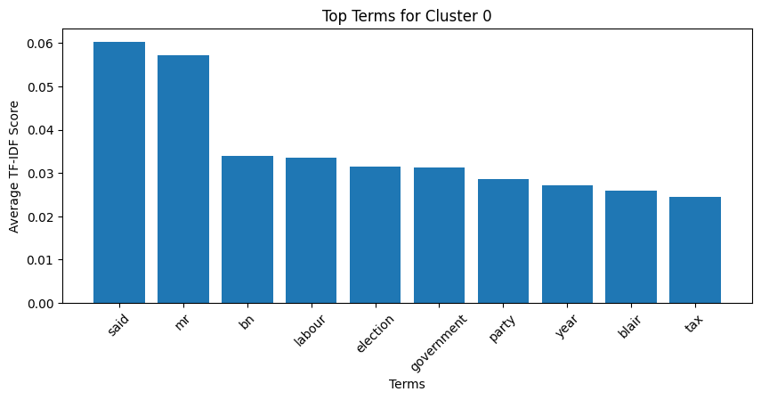

3.3 Visual Insights
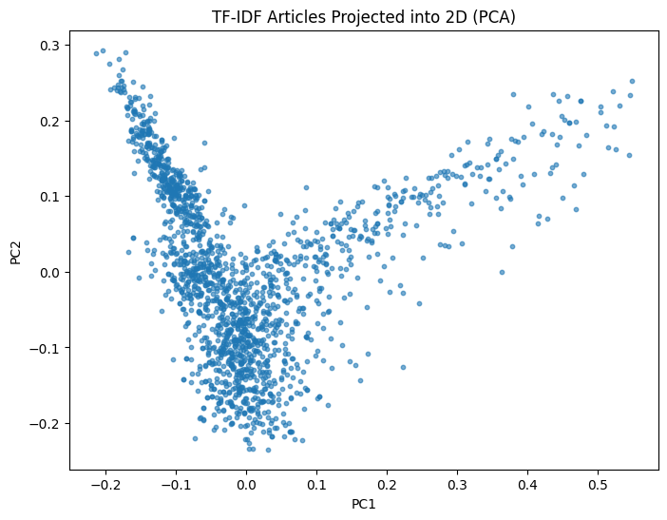
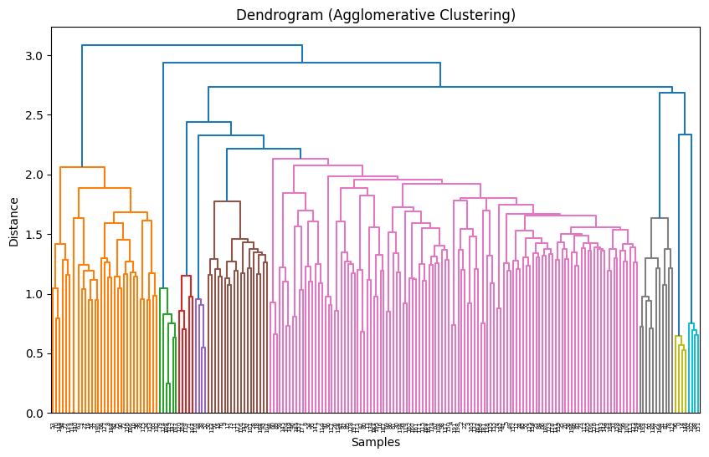
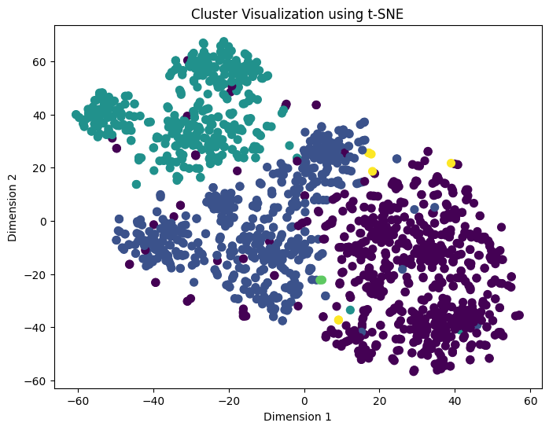

4. Conclusion
The study demonstrates that efficient text preprocessing combined with TF-IDF feature engineering produces meaningful document representations. Among the tested algorithms, K-Means achieved the best clustering accuracy, stability, and interpretability. The results confirm that unsupervised learning is highly effective for automated topic discovery in news corpora. This system can serve as a foundation for recommendation engines, search optimization, and intelligent content management systems.

References
REFERENCE PAPER:

[1] R. G. García, B. Beltrán, D. Vilaríno, C. Zepeda, and R. Martínez, “Comparison of Clustering Algorithms in Text Clustering Tasks,” Faculty of Computer Science, Benemérita Universidad Autónoma de Puebla, Mexico.
- BBC News Summary Dataset
- Scikit-learn Documentation
- Tan P.N., Steinbach M, Karpatne A. and Kumar V. Introduction to Data Mining, Second edition, Sixth Impression, Pearson, 2023.
- Aggarwal C. C. Data Mining: The Textbook, Springer, 2015
- McKinney W. Python for Data Analysis: Data Wrangling with Pandas, NumPy and IPython. 2nd edition. O’Reilly Media, 2018.

