FML Assignment-1

2024-02-05

setwd("C:/Users/anred/Desktop")  
kaggle_dataset <- read.csv("fmlA.csv")  
summary(kaggle_dataset[c("km_driven", "year", "selling_price")])

## km_driven year selling_price   
## Min. : 1000 Min. :2000 Min. : 45957   
## 1st Qu.: 35000 1st Qu.:2012 1st Qu.: 250000   
## Median : 60000 Median :2014 Median : 390000   
## Mean : 67414 Mean :2014 Mean : 427280   
## 3rd Qu.: 90000 3rd Qu.:2017 3rd Qu.: 555500   
## Max. :270000 Max. :2020 Max. :1594000

kaggle_dataset$year_Squared <- kaggle_dataset$year^2  
hist(kaggle_dataset$year, main = "year Histogram", xlab = "year")

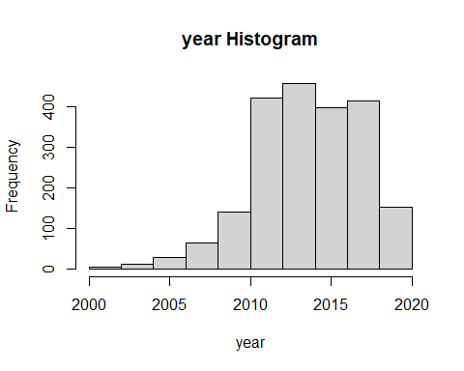

plot(kaggle_dataset$year, kaggle_dataset$selling_price,  
main = "year vs selling price",  
xlab = "year", ylab = "selling price",   
col = kaggle_dataset$km_driven)

