Climate Monitoring Brief: Dry Tortugas National Park

Atlantic Oceanographic & Meteorological Laboratory National Oceanic Atmospheric Administration

N. Besemer, G. Kolodziej, M. Jankulak, A. Palacio, I. Enochs - July 2021

### About this summary brief

The NOAA Atlantic Oceanographic and Metorolgical Laboratory condunts the long-term National Coral Reef Monitoring Program (NCRMP) to track the status and trends of coral reef ecosystems of the US atlantic and Caribbean Reef jurisdictions.This summer brief provides an overview of the most recent survey efforts.

### Sampling effort

* The most recent climate monitoring took place at Dry Tortugas National park from June 24th to June 29th 2021
* Data were collected at 4 different sites to collect and deploy instruments that monitor temperature, current, pH, light, bioerosion and calcification
* At the Bird Key Reef site, landscape mosaics(n=6) and carbonate budget surveys(n=6) were completed to monitor changes in benthic cover and carbonate production

### Spatial sample design

Survey site locations were selected to represent temporal‐resolution monitoring with moored instruments at fixed time‐series. These sites were placed on depth gradient to see how virtical structure affects reef status and trends. Pulaski Shoal (1m),

### Sampling methods

Subsurface Temperature Recorder(STR)s are placed at at all 4 sites and collect temperature measurments for at 5 minute intervals for 3 years. Bird Key Reef was selected as the Class 2 sampling site where additional instruments are deployed for a 72 hour diurnal suite. SeaFET pH logger, Tiltmeter and EcoPAR collect measurments at 5 minute intervals. Subsurface Automatic Samplers (SAS) collect discrete water samples at three hour intervals (n=24).

### Overview of data collected

temporary map - working on something else

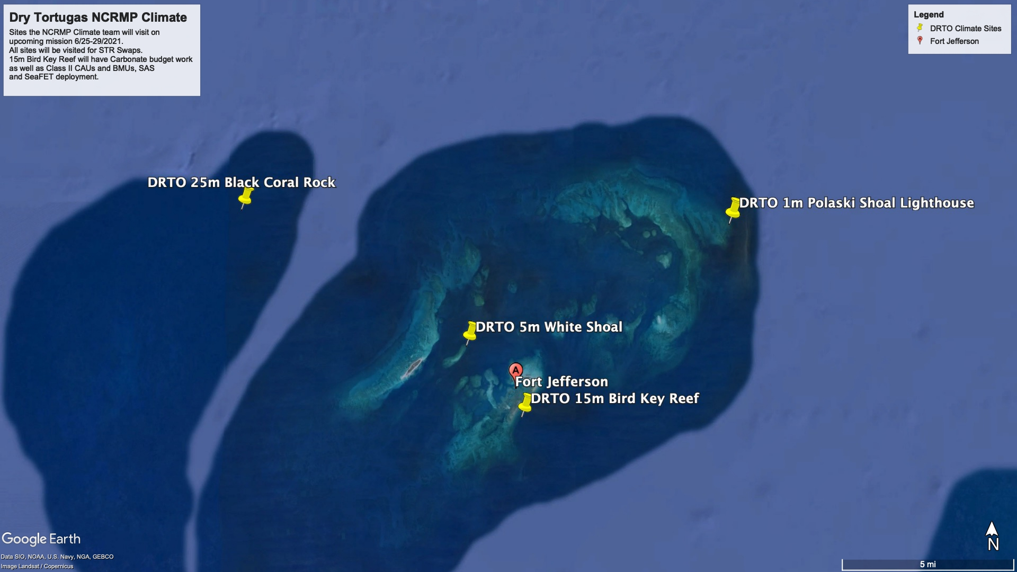

Map of Study locations in Dry Tortugas National Park

This is a map made with R

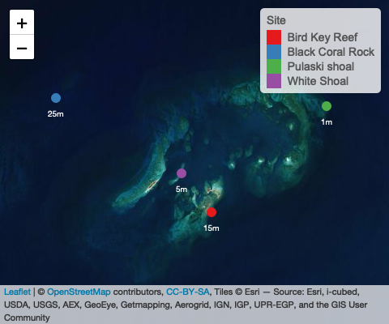

#### Temperature Data

Plot option 1:

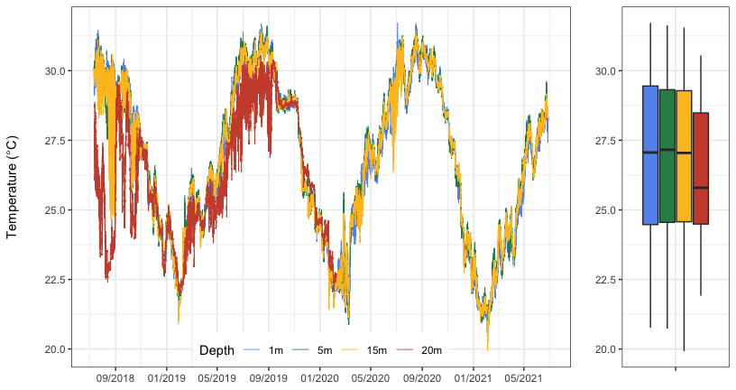

Plot 1 option 2

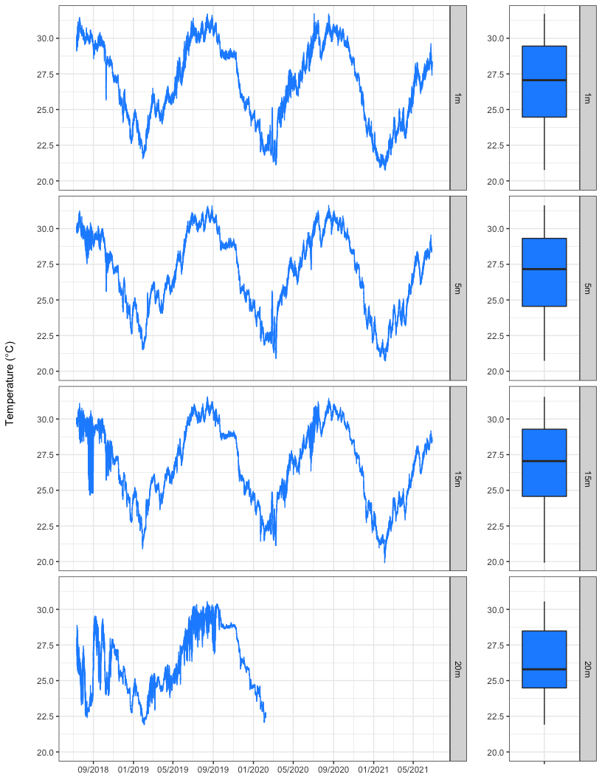

**Figure 1:** Temperature data collected for 3 years at four sites in the Dry Tortugas at 1 m (Pulaski Shoal Lighthouse), 5m (white-shoal), 15m (Bird Key Reef) and 25 m (Black Coral Rock).The 1m, 5m, and 15m collected data for the full deployment. The 25m STR stopped collecting on Febuary 7th 2020.

#### Diurnal Suite Deployment

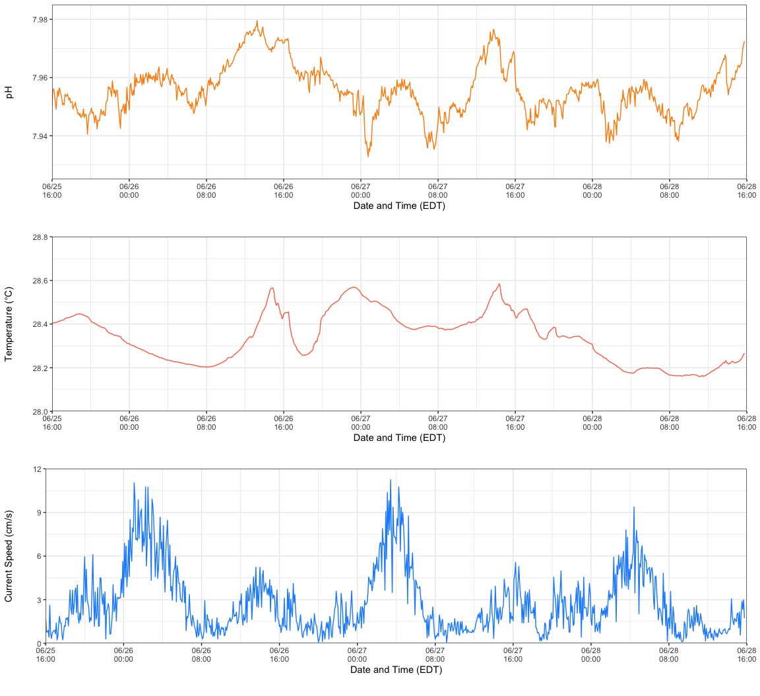

**Figure 2:** Summary plots of pH, Temperature and current speed collected from instrument deployment at Bird Key Reef site around 45 feet from June 25th to June 28th. Instruments measured parameters ever 5 minutes.

#### Light Data

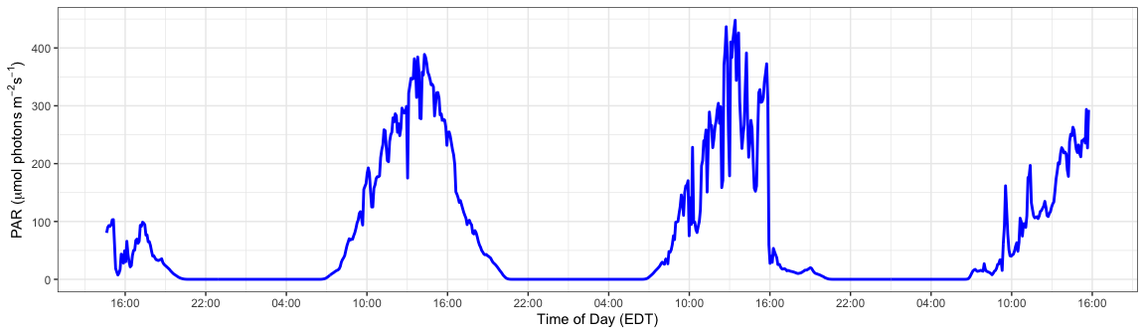

**Figure 3:** EcoPar light intensity data collected in PAR from the 72 hour deployment at Bird Key Reef

#### Current Data

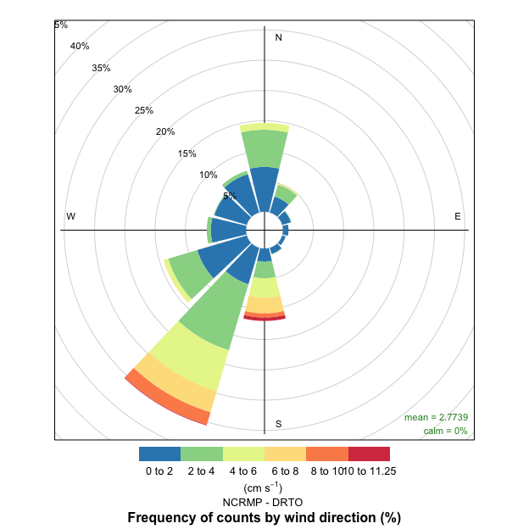

**Figure 4:** Measurements of current direction from the tiltmeter collected every 5 minutes.

### About the monitoring program

The Atlantic climate monitoring forms a key part of the National Coral Reef Monitoring Program of NOAA’s Coral Reef Conservation Program (CRCP), providing integrated, consistement and comparable data across U.S. Managed coral reef ecosystems. CRCP monitoring efforts aim to:

* Document the status of reef species of ecologicaland economic importance.
* Track and assess changes in reef communities inresponse to environmental stressors or humanactivities.
* Evaluate the effectiveness of specific managementstrategies and identify actions for future andadaptive responses.

### For more information

Coral Reef Conservation Program: <http://coralreef.noaa.gov>

NOAA Atlantic Oceanographic and Meteorological Laboratory: <http://www.aoml.noaa.gov/>

Atlantic Climate team lead: [nicole.besemer@noaa.gov](mailto:nicole.besemer@noaa.gov)