Here’s a quick report to QA/QC the negative grazing erosion values in the New Caledonia BMUs.

There are 7 BMUs that have negative erosionGrazing values: 4511, 4515, 4518, 4519, 4533, 4534, 4550

In all but 4515, the BMUs displayed an increase in volume from the prescan to the postscan. I’ve been working on Identifying where the excess volume in the postscans is coming from. So far, I’m not seeing anything obvious. I have included screenshots of the Amira projects from the 3 bmus that apparently had the most negative grazing erosion.

When you all get back from the field, we can figure out a time to look it over.

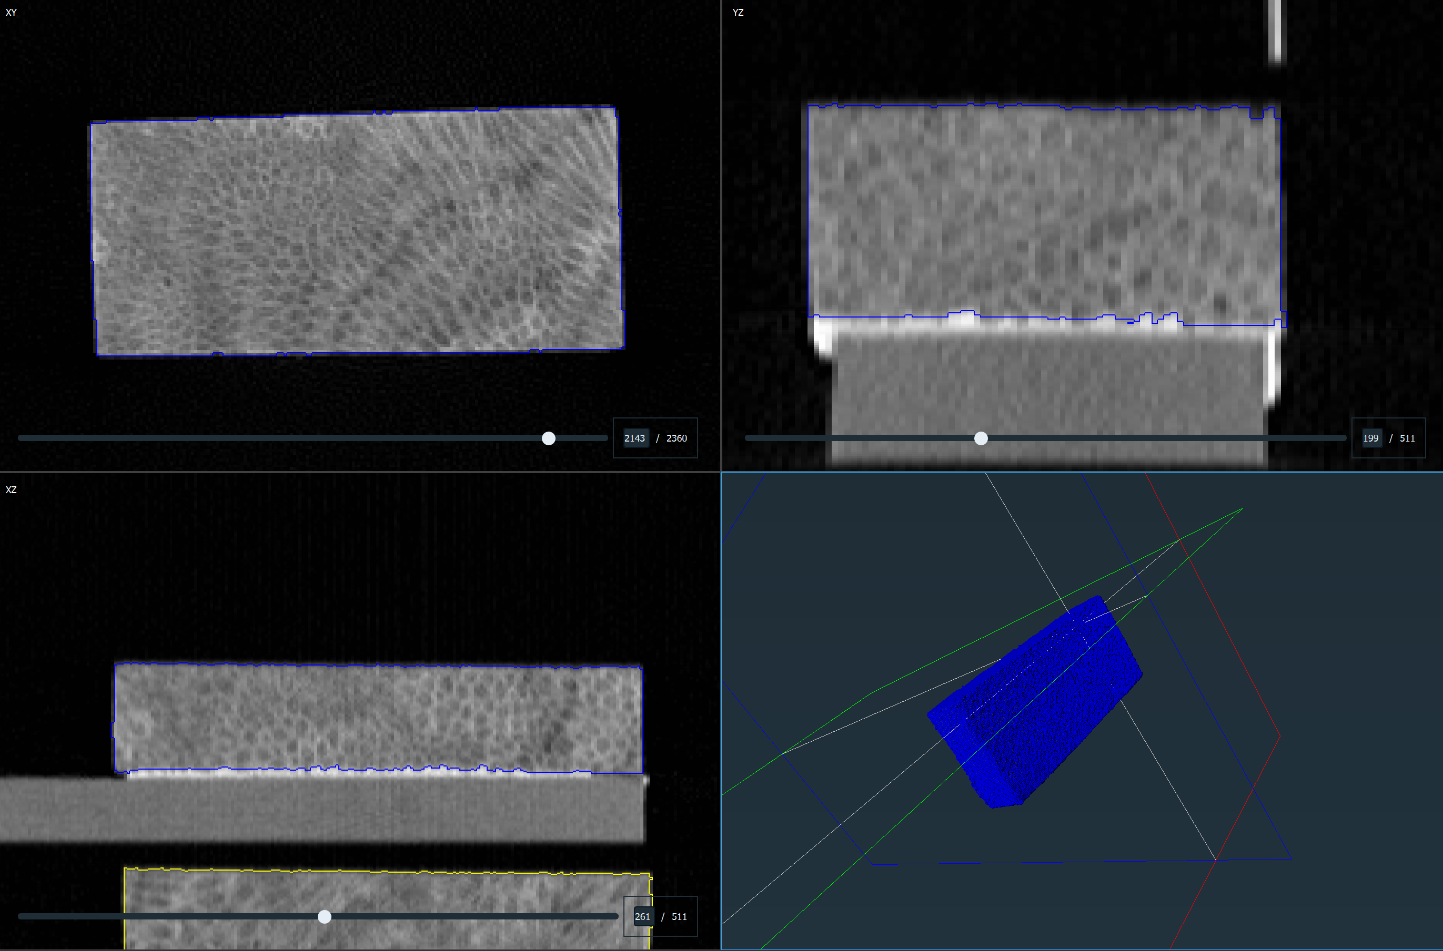

BMU4511 prescan.

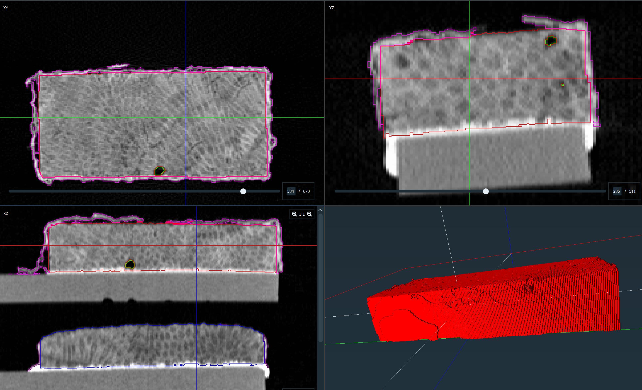

BMU4511 postscan. Nothing unusual here except potentially too little epoxy removed. After removing the excess epoxy in a separate Amira project, the resulting volume was negligibly different. Not different enough to make the erosion value positive.

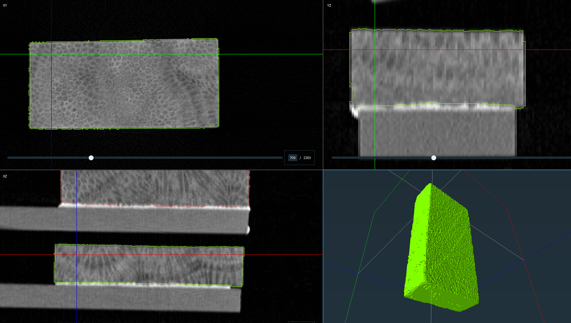

BMU4518 prescan

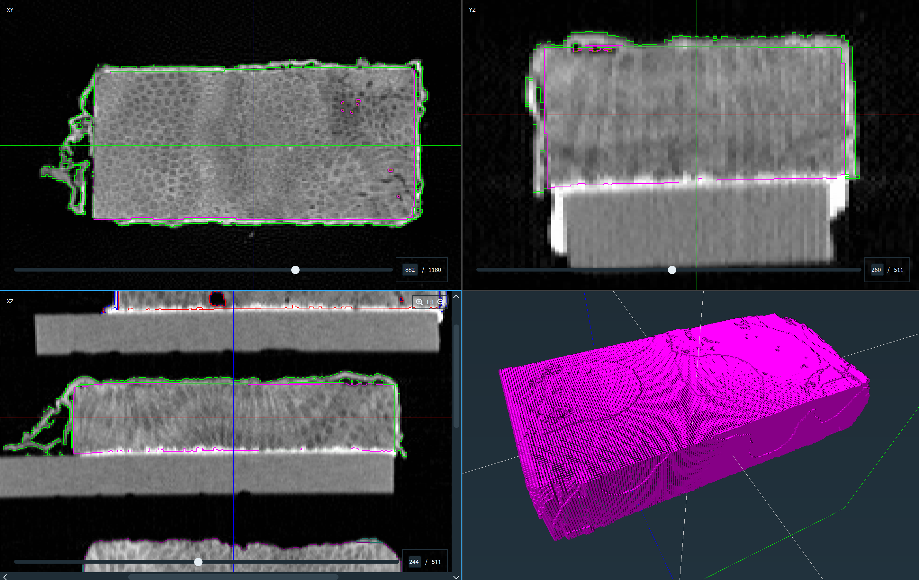

BMU4518 postscan

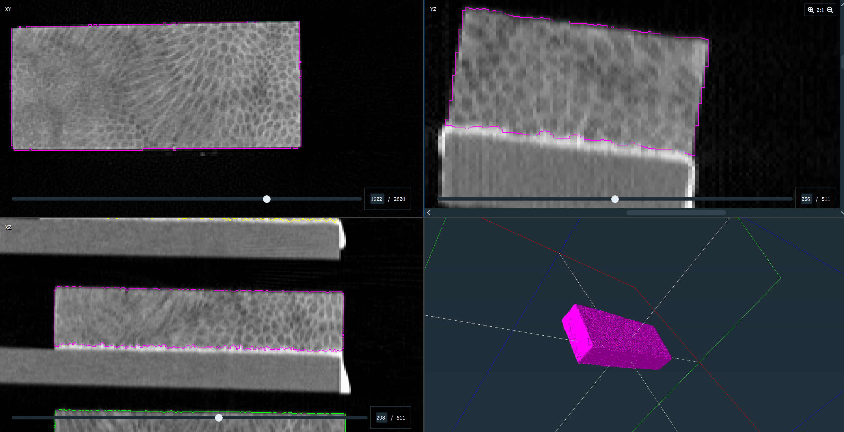

BMU4533 Prescan

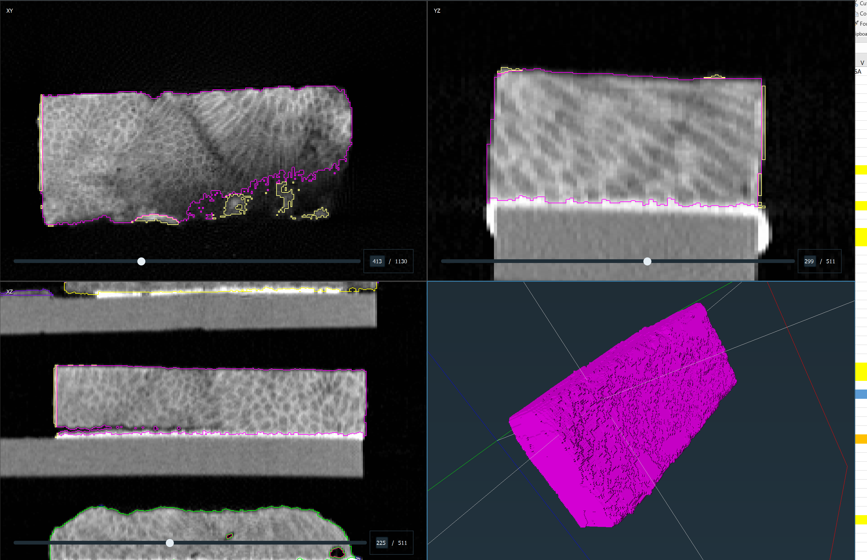

BMU4533 postscan. There is very little accretion on this BMU and the carbonate has separated a bit from the base. That should not increase the postscan volume, but it is different from the other BMUs with that feature.