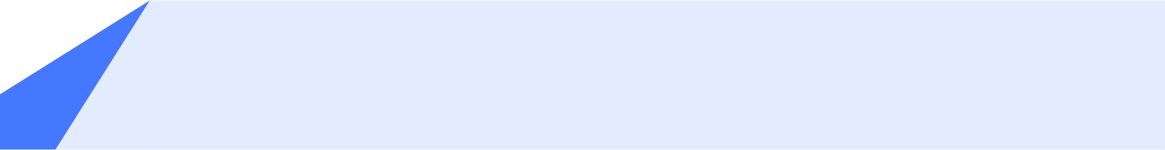

+++IMAGE injectPhoto(photoRaw)+++
Summary
+++ summary +++

Areas of expertise
+++ expertise.join(', ') +++

Industry Know-How
+++ industryKnowHow.join(', ') +++

IT Skills
+++ itSkills.join(', ') +++

IT Tools
+++ itTools.join(', ') +++

+++ name +++
Education
+++ education.join('\n') +++

Methods
+++ methods.join('\n') +++

Languages
+++ languages.join('\n') +++

+++ FOR project in projects +++

+++ $project.name +++ (+++ $project.from +++ - +++ $project.to +++)
Industry: +++$project.industry +++
Role: +++$project.role +++
Core Business Topics: +++$project.coreBusinessTopics.join(', ')+++
Methods: +++$project.projectMethods.join(', ')+++
Technologies/Tools: +++$project.tools.join(', ')+++
Achievements:
+++ FOR achievement in $project.achievements+++
- +++ $achievement +++
+++ END-FOR achievement +++

+++ END-FOR project+++

+++ name +++

