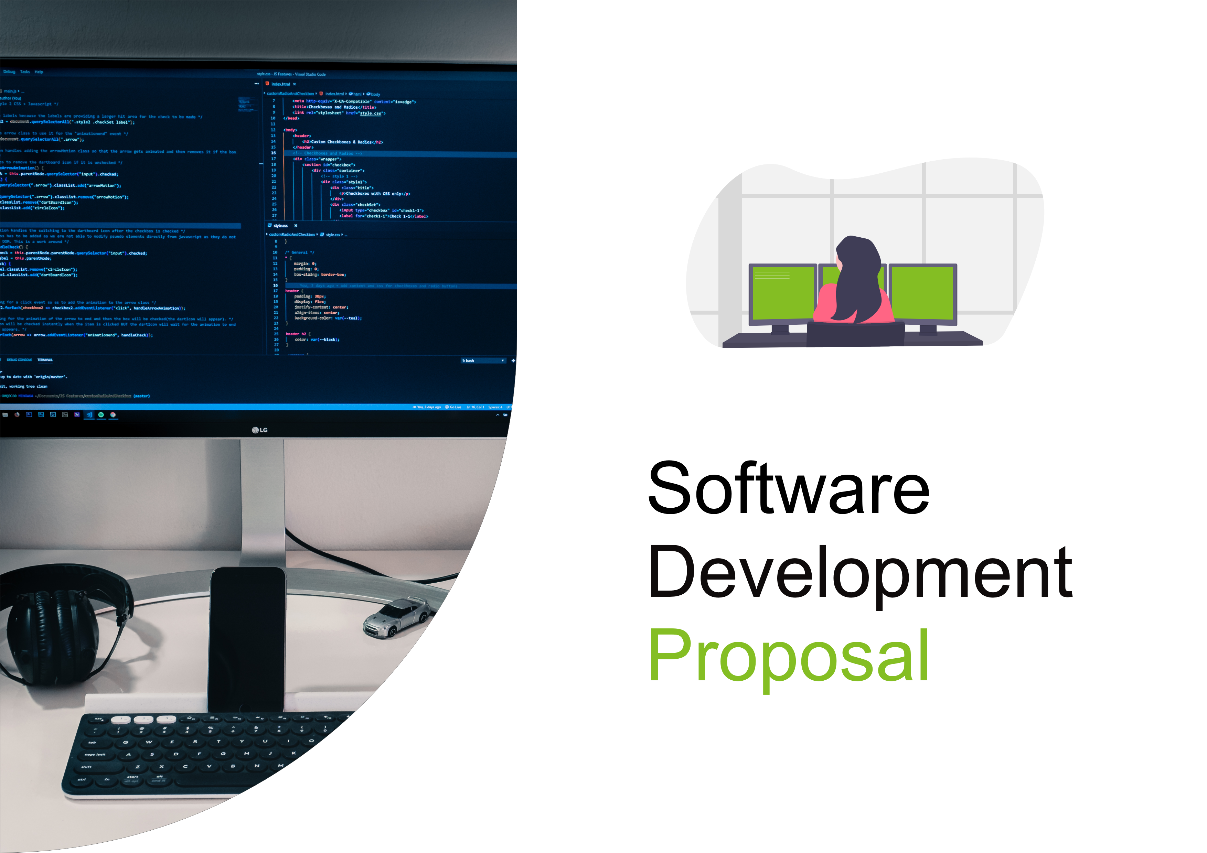
1. Overview

This proposal outlines the development of a private real-time manufacturing status dashboard for Daikibo Industrials.
The objective of the project is to provide a centralized and secure view of the operational health of machines across Daikibo’s factories. The dashboard will display the real-time status of monitored devices and enable factory managers and technical staff to quickly identify and respond to potential issues

The solution will be deployed within the client’s internal network (intranet) and will integrate with existing authentication systems to ensure secure access. The system will improve operational visibility, reduce downtime, and support data-driven decision-making.

2. Scope

The project will deliver a web-based dashboard with the following functionality:
- A single-page interface displaying the health status of 9 machines in each of Daikibo’s 4 factories.
- Secure access restricted to the client’s intranet environment.
- User authentication integrated with the company’s internal authentication server, allowing employees to log in using existing corporate credentials.
- A hierarchical view of machine data:
  - Factory-level view showing overall machine health.
  - Expandable and collapsible device-level view displaying the current status of each machine.
  - Historical status information available when expanding individual machines.
- Visual indicators (as shown in the referenced graphics in the template) to represent machine states such as operational, warning, or failure.

Out of scope: advanced analytics, predictive maintenance, and external internet access.
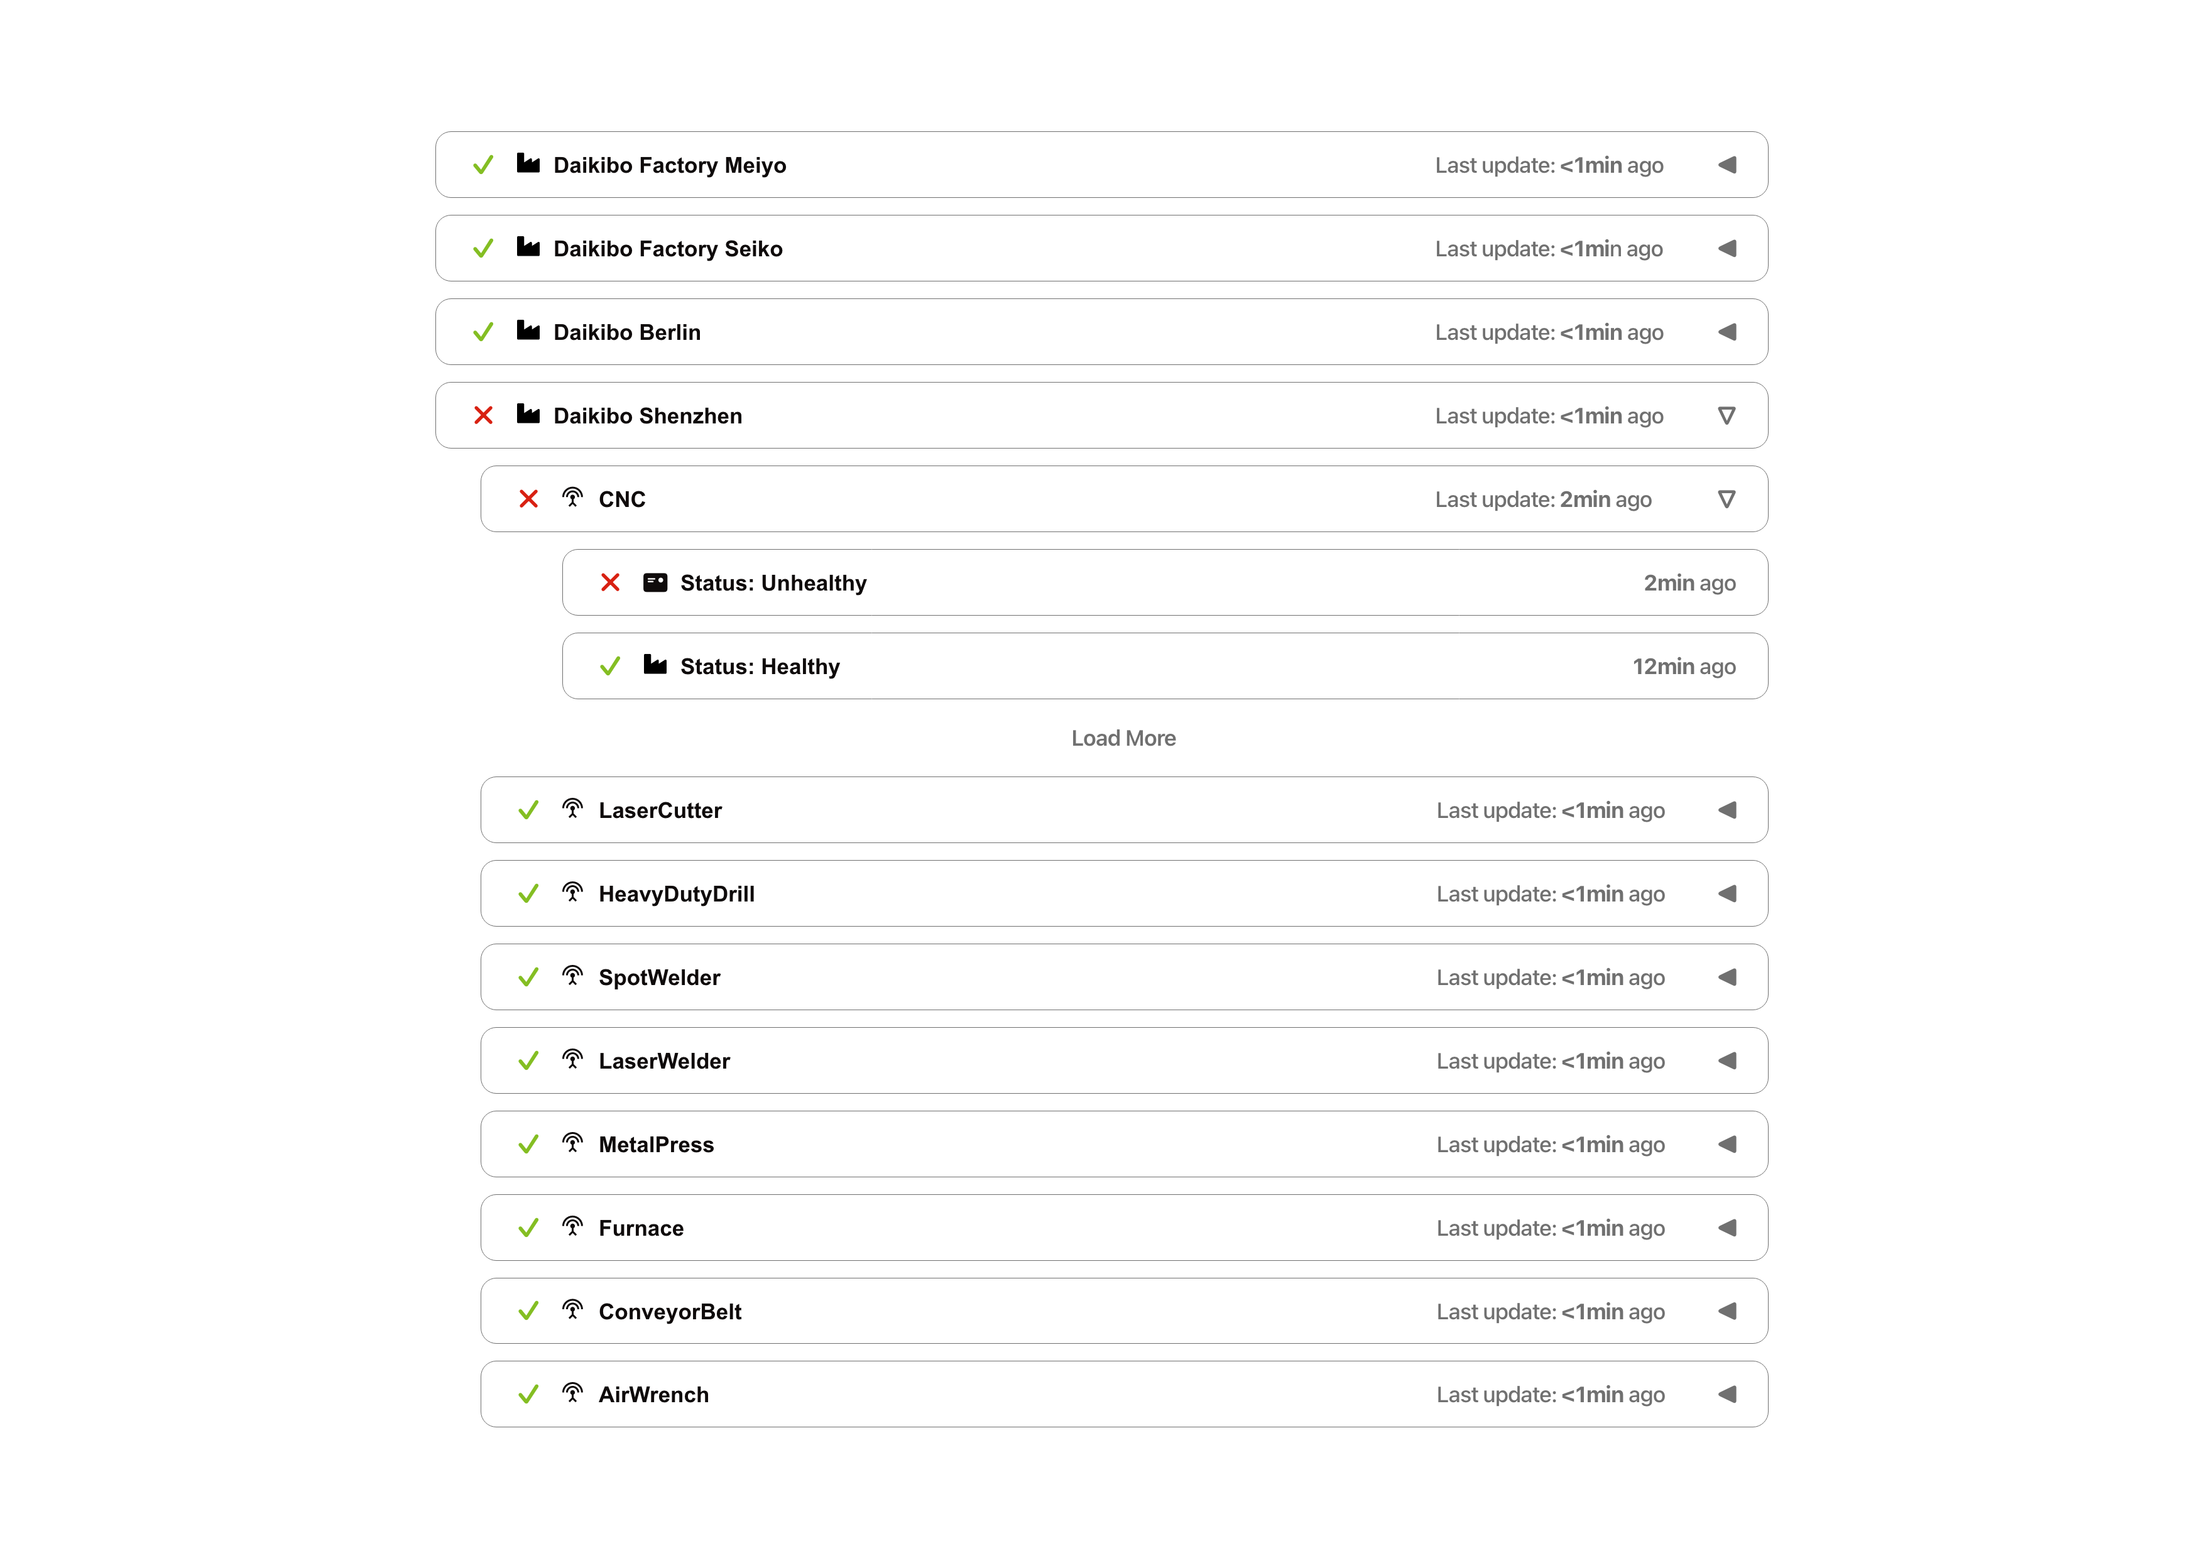
3. Estimate

The total estimated effort for the project is 120 man-hours, broken down as follows:
- Development: 70 hours
(Frontend dashboard development, backend integration, authentication integration)
- Testing: 30 hours
(Unit testing, system testing, and user acceptance testing)
- Integration: 20 hours
(Deployment within intranet, authentication server synchronization, data stream integration)

This estimate assumes stable telemetry input formats and access to the client’s authentication system during development.
4. Timeline

The project is expected to be completed within 4 weeks, with the following milestones:

- Week 1:
Requirements confirmation and dashboard design based on provided templates and graphics.
- Week 2:
Backend development and authentication system integration.
- Week 3:
Frontend development and implementation of collapsible views for factories and machines.
- Week 4:
Testing, deployment within intranet environment, and client review.
5. Support

Deloitte will provide continuous product support following deployment. This includes:
- Bug fixes and system maintenance
- Support ticket handling
- Assistance with future enhancements such as additional factories, devices, or new dashboard features

Ongoing support ensures long-term reliability and adaptability of the dashboard as business needs evolve.

