1.0 Introduction
To address the challenge of inefficient manual literature reviews, this proposal outlines a Multi-Agent System based on the Belief-Desire-Intention model to automate the retrieval and organisation of academic research. This document serves as a comprehensive design proposal, detailing the system's requirements, architecture, development methodology, and evaluation plan.

2.0 System Requirements & Methodology
This multi-agent system for academic literature retrieval utilises the Belief-Desire-Intention (BDI) model, a robust architecture for practical reasoning systems in dynamic environments (Wooldridge, 2009). The methodology enables decomposition of complex literature reviews into specialised autonomous agents, each with distinct beliefs, goals, and execution plans. The system's requirements derive from this agent-centric architecture, addressing the need for automation in systematic reviews (Wohlin et al., 2012).

2.1. Functional & Technical Requirements

2.1.1. Functional Requirements
The functional requirements specify system capabilities from an end-user perspective. FR-1 enables search initiation through query input and source selection. FR-2 ensures autonomous navigation and retrieval from academic sources while respecting ethical scraping guidelines (Zimmer, 2010). FR-3 covers comprehensive metadata extraction from paper detail pages. FR-4 handles data cleaning and automated reference formatting. FR-5 compiles all data into an organised research digest for offline analysis.

2.1.2. Technical Requirements
Technical requirements implement the functional specifications using Python's ecosystem for web scraping, HTTP requests, and data handling. The system employs HTTP/S protocols for external communication and Python-native structures for internal messaging. HTML parsing libraries extract data through CSS selectors and pattern matching. Output is stored in CSV/JSON formats for universal compatibility. Error handling ensures faultless flows of the system, while ethical compliance measures include respecting robots.txt and implementing request delays (Zimmer, 2010).

2.2 Development Methodology
This system implementation will follow an agent-oriented methodology aligned with the BDI framework (Wooldridge, 2009). Development will proceed iteratively, with independent design and testing of each agent before integration. We will apply Python's ecosystem for implementation while incorporating ethical web scraping practices, including robots.txt compliance and request throttling (Zimmer, 2010).

3.0 System Design & Architecture

3.1 Architectural Overview
The system employs a Multi-Agent System (MAS) architecture chosen for the modularity and autonomy it provides. This design breaks the complex literature retrieval task into discrete functions handled by specialised, independent agents, which enhances system efficiency and adaptability. (Nemati, Montaner and Sun, 2000)

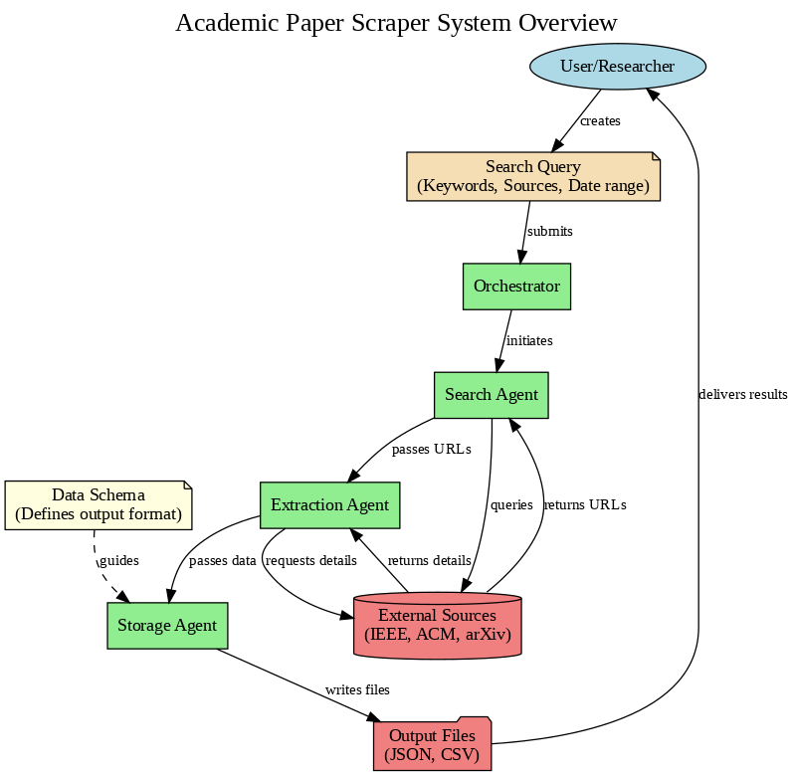
Figure 1. Architectural overview of the MAS

3.2 Agent Design (BDI Model)
The system architecture uses the Belief-Desire-Intention (BDI) model, a robust framework for rational agents in dynamic environments (Wooldridge, 2009). Each agent has distinct cognitive states: beliefs about its environment , desires as primary objectives, and intentions as plans to achieve them . This model enables agents to adapt their behaviour to environmental feedback while focusing on core objectives, suiting the unpredictable nature of web-based academic retrieval.

3.3 Agent Interaction & Data Flow

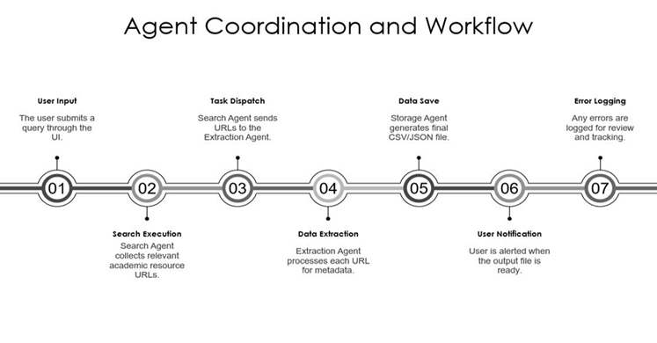

Figure 2: The agent coordination and workflow
Agent interaction follows a sequential workflow (see Figure 2 above) where output from one agent becomes input for the next, creating a streamlined data processing pipeline. The Search Agent initiates the process by querying academic databases and returning a curated list of paper URLs. This list is passed to the Extraction Agent, which visits each URL to retrieve and structure metadata. The structured data is subsequently forwarded to the Storage Agent for compilation and persistence.
3.4 Data & Knowledge Representation
Data representation employs a hierarchical structure where raw HTML content is progressively transformed into structured knowledge, refer Figure 1 in Section 3.1. . Initially, the Search Agent processes unstructured HTML search results to extract paper URLs. The Extraction Agent then converts article page content into structured metadata fields (title, authors, abstract, etc.). Finally, the Storage Agent organises this metadata into standardised formats (CSV/JSON) featuring consistent field organisation and formatting.
4.0 Evaluation & Test Plan
4.1 Data Design Schema
The schema in Figure 3 below is designed to ensure correctness, consistency, and completeness of metadata generated by the Extraction Agent, aligned with FR-3. Each field is checked for proper data types, constraints, and limits. The validation we will explore uses sample comparison with original papers, DOI hash checks for duplicates, and metrics such as field coverage, missing values, and error rates.
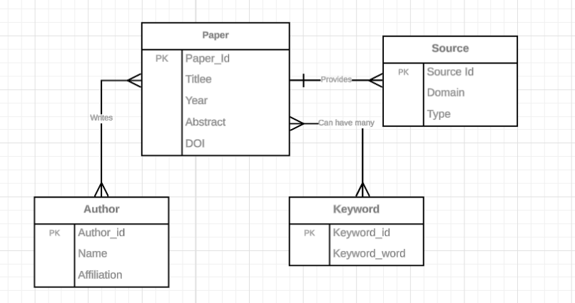

Figure 3: Data Schema

4.2 Plan Processing Logic
- Input Acquisition – Search Agent collects URLs, fetches HTML via HTTP, validates responses, and stores temporarily.
- Preprocessing – Removes ads, scripts, and irrelevant tags; isolates content containers using DOM.
- Extraction – Identifies fields (title, authors, abstract, year, DOI, keywords) through CSS/XPath and ensures values validated for completeness and DOI format.
- Transformation – Ensures mandatory fields, formats author names, assigns unique IDs to remove duplicates.
- Storage – Converts metadata into CSV/JSON with consistent field order; stores in database or file system with indexing.
- Validation – Checks for duplicates, missing fields, and logs anomalies for review.
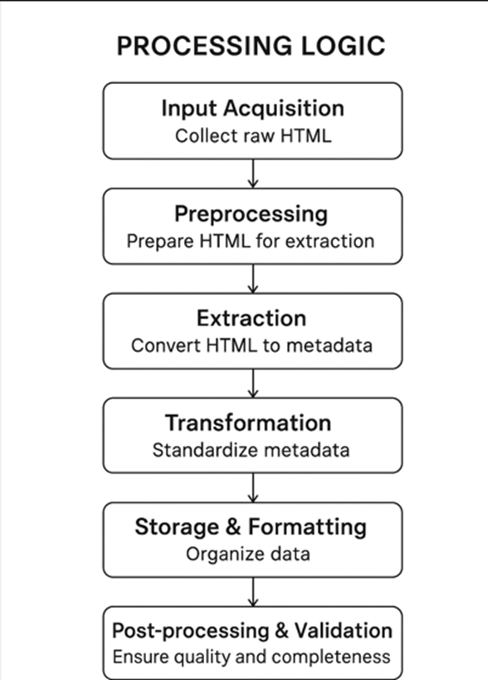
Figure 4: Processing Logic

4.3 Design Offline Storage:
Offline storage supports FR-5 by persisting structured data in CSV/JSON to a document database, which can be MySQL, MongDB etc. System tests involve writing/reading large datasets, checking recovery after interruptions, and measuring latency, utilization, and recovery success.

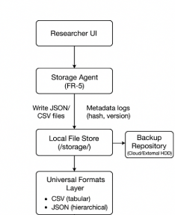
Figure 5: Offline Storage Design

4.4 Test Plan
The table below outlines the test plan of the system.
Requirement ID | Description | Test Category | Test Case Description | Expected Result
FR-1 | System should accept and process user queries. | Functional / Integration | Submit a valid academic query. | Relevant papers retrieved.
 | Exception |  | Submit empty/invalid query. | System logs error, no crash.
FR - 2 | System should respect robots.txt & throttling. | Compliance | Attempt access to restricted pages. | Access blocked.
FR-3 | Extract structured metadata (title, author, abstract, DOI, link). | Unit | Parse raw HTML metadata. | ≥ 95% accuracy in extracted fields.
FR-4 | Avoid duplicates & malformed entries removed. | Unit | Run deduplication logic. | Duplicate suppression ≥99%.
 |  | Exception | Malformed HTML input. | Error Logged
FR-5 | Output validated, consolidated dataset. | Functional / Integration | End-to-end run (Search → Extract → Clean → Store). | Dataset produced
 |  | Performance | Process 10 papers at once | Latency <60s

5.0 Conclusion
In summary, this project introduces a Multi-Agent System (MAS) using the Belief-Desire-Intention (BDI) model to automate the complex process of academic literature review. The system uses specialised, autonomous agents with distinct beliefs and goals that adapt to environmental feedback. This results in a scalable, architecturally sound solution that provides automation without compromising ethical principles, enabling faster and more reliable academic reviews.

6.0 References
Nemati, H., Montaner, M.B. and Sun, M. (2000) 'A Multi-Agent Framework for Web Based Information Retrieval and Filtering', in Proceedings of the Americas Conference on Information Systems (AMCIS). Long Beach, CA. Available at: http://aisel.aisnet.org/amcis2000/10.
Russell, S. J. and Norvig, P. (2020) Artificial intelligence: a modern approach. 4th edn. Harlow: Pearson.
Wohlin, C., Runeson, P., Höst, M., Ohlsson, M. C., Regnell, B. and Wesslén, A. (2012) Experimentation in Software Engineering. Berlin, Heidelberg: Springer Berlin Heidelberg.
Wooldridge, M. (2009) An introduction to multiagent systems. 2nd edn. Chichester, U.K.: John Wiley & Sons.
Zimmer, M. (2010) ʻ“But the data is already public”: on the ethics of research in Facebook’, Ethics and Information Technology, 12(4), pp. 313–325.

