Object Oriented Programming Project
STUDY ANXIETY CALCULATOR

Subject: Object Oriented Programming (C++)
Project Type: Console-Based Application
Concept: Study Anxiety Assessment

Submitted By:
Anamta Khurram (SP25-BSSE-0033)

Submitted To:
Miss Aiman Fatima
Department:
Software Engineering

1. INTRODUCTION
The Study Anxiety Calculator is a console-based application developed in C++ using Object Oriented Programming (OOP) principles. The goal of this project is to assess a student’s anxiety related to studies, exams, and academic pressure through a quiz-based system.
The program collects user responses, calculates an anxiety score, categorizes the anxiety level, provides personalized study suggestions, and gathers user feedback. This project demonstrates real-world implementation of OOP concepts including encapsulation, inheritance, abstraction, polymorphism, and composition.
2. CORE CONCEPT OF THE PROJECT
The system works as an interactive console program where:
- Users create an account and log in
- A quiz related to study anxiety is conducted
- Each answer carries a predefined score
- Total anxiety score is calculated
- Anxiety level is classified as Low, Moderate, or High
- Study suggestions are displayed
- User feedback is collected

3. UML DIAGRAM
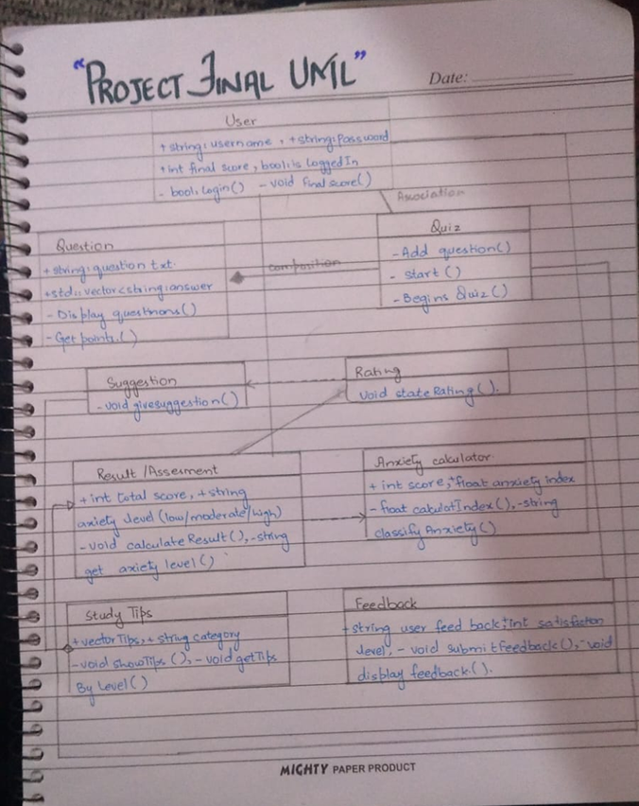

Classes Included:
- User
- Question
- Quiz
- Assessment (Abstract)
- Result
- Suggestion
- Feedback
The UML diagram shows inheritance, association, and composition relationships among classes, ensuring modular and reusable code.

4. CLASSES:
User Class
Handles user registration and authentication.
Attributes:
- Username
- Password
Functions:
- signUp()
- signIn()
This class ensures secure access to the system.

Question Class
Represents a single quiz question.
Attributes:
- Question text
- Options (vector)
- Scores (vector)
Functions:
- display()
- getScore()
Encapsulation ensures data safety.

Quiz Class
Manages the entire quiz process.
Attributes:
- Vector of Question objects
- Total score
Functions:
- addQuestion()
- start()
- getTotalScore()
- getMaxScore()
Demonstrates composition.

Assessment Class (Abstract)
Defines a base structure for result evaluation.
Function:
- calculateResult() (pure virtual)
Implements abstraction.

Result Class
Inherits from Assessment and calculates anxiety percentage.
Functions:
- calculateResult()
Demonstrates inheritance and polymorphism.

Suggestion Class
Provides study and stress-management advice based on anxiety level.

Feedback Class
Collects user satisfaction rating and comments.
Includes:
- Input validation
- Exception handling

5. OOP CONCEPTS USED:
Encapsulation
Data members are kept private and accessed through public methods.
Abstraction
Implemented using an abstract class (Assessment).
Inheritance
Result class inherits from Assessment.
Polymorphism
Overridden calculateResult() function.
Composition
Quiz class contains multiple Question objects.

6. USE OF VECTORS:
Vectors are used to:
- Store questions
- Store answer options
- Store scores dynamically
Advantages:
- Automatic resizing
- Efficient memory management
- Easy access and modification

7. EXCEPTION HANDLING:
Exception handling ensures:
- Valid input for feedback ratings (1-5)
- Program stability
- Error-free execution
Implemented using try-catch blocks.

8. CONCLUSION
The Study Anxiety Calculator is a well-structured OOP-based C++ project that applies OOP principles. The system is modular, user-friendly, and demonstrates real-world problem-solving using programming concepts. The project provides a practical solution for assessing study-related anxiety by using a structured quiz system, calculating anxiety levels, and offering personalized study and stress-management suggestions.
CODE:
#include <iostream>
#include <vector>
#include <string>
#include <stdexcept>
using namespace std;
//creating first main class
class User {
private:
string username;
string password;
//function to sign up
public:
void signUp() {
cout << "SIGN UP TO ENTER THE PROGRAM";
cout << "\nCreate Username:";
cin >> username;
cout << "Create Password:";
cin >> password;
cout << "Your account has been created successfully!";
}
//sign in function
bool signIn() {
string u, p;
//entering your personal details according to your signup details
cout << "\nSIGN IN:";
cout << "Username:";
cin >> u;
cout << "Password:";
cin >> p;
if (u == username && p == password) {
cout << "\nLogin Successful!";
return true;
}
else {
cout << "Invalid Username or Password!";
return false;
}
}
};
//Second main class blue print of the program
class Question {
private: //private members of variables cant be accessible without any encapsulation outside of class
string text;
vector<string> options;
vector<int> scores;
public:
Question(string t, vector<string> o, vector<int> s) { //creating constructor to get an access to the private values of the class
text = t;
options = o;
scores = s;
}
void display() {
cout << "\nEnter your question" << text << endl;
for (int i = 0;i < options.size();i++) {
cout << i + 1 << ". " << options[i] << endl;
}
}
int getScore(int choice) {
return scores[choice - 1];
}
};
//Third class to manage the quiz
class Quiz {
private:
vector<Question>questions;
int totalScore;
//we used vector values because vector is used to store multiple values for one answers
public:
Quiz() { //constructor
totalScore = 0;
}
//creating a function to add questions in the quiz
void addQuestion(Question q) {
questions.push_back(q);
}
//creating a function to start the quiz
void start() {
int choice;
//for loop for questions
for (int i = 0; i < questions.size(); i++) {
questions[i].display();
//do-while loop for choices
do {
cout << " Choose (1-4): ";
cin >> choice;
} while (choice < 1 || choice>4);
totalScore += questions[i].getScore(choice);
}
}
//function to get totalscore
int getTotalScore() {
return totalScore;
}
//function to get maximum score
int getMaxScore() {
return questions.size() * 4;
}
};
//creating assesment class
class Assessment {
protected: //protecting values of this class
int score;
int maxScore;

public:
Assessment(int s, int m) { //constructor
score = s;
maxScore = m;
}
virtual void calculateResult() = 0;
};

//Result class
class Result :public Assessment { //Inheritance
public:
Result(int s, int m) :Assessment(s, m) {}
//creating function to calculate result
void calculateResult() {
float percentage = (float)score / maxScore * 100;
//output for the result
cout << "\nRESULT:";
cout << "\nScore:" << score << "/" << maxScore;
cout << "\nAnxiety Percentage:" << percentage << "%";
//condition for anxiety level
if (percentage <= 40)
cout << "\nAnxiety Level: LOW";
else if (percentage <= 70)
cout << "\nAnxiety Level: MODERATE";
else
cout << "\nAnxiety Level: HIGH\n";
}
};
//Suggestion class according to anxiety level
class Suggestion {
public:
void showSuggestion(int score, int maxScore) {
float percent = (float)score / maxScore * 100;
//Study Suggestion According to calculator
cout << "\nSTUDY SUGGESTIONS:";
//Suggestion According to your level
if (percent >= 70) {
cout << "\nReduce study time this is creating more panic" << endl;
cout << "Practice mind relaxation techniques" << endl;
cout << "Eat Dark chocolate" << endl;
}
else if (percent >= 40) {
cout << "Improve time management" << endl;
cout << "Take short breaks" << endl;
cout << "Avoid last-minute study" << endl;
}
else {
cout << "Keep following your routine" << endl;
cout << "\nStay consistent" << endl;
}
}
};
//class for feedback collecting from user
class Feedback {
private:
int satisfactionLevel;
string comment;
//function to collect feedback
public:
void collectFeedback() {
cout << "\nFEEDBACK:";

while (true) {
try {
cout << "\nRate your satisfaction (1-5): ";
cin >> satisfactionLevel;
if (cin.fail()) {
throw runtime_error("Invalid input! Please enter a number between 1 and 5.");
}

if (satisfactionLevel < 1 || satisfactionLevel > 5) {
throw out_of_range("Satisfaction level must be between 1 and 5.");
}

break; // valid input, exit loop
}
catch (exception& e) {
cout << e.what() << endl;
cin.clear(); // clear error flag
cin.ignore(1000, '\n'); // discard invalid input
}
}

cout << "Any comments (words only): ";
cin.ignore(); // clear leftover newline
getline(cin, comment);

// Ensure comment is not just digits
bool onlyDigits = true;
for (char c : comment) {
if (!isdigit(c) && !isspace(c)) {
onlyDigits = false;
break;
}
}

if (onlyDigits) {
cout << "Comment must contain words, not just numbers. Setting comment as 'No valid comment'.";
comment = "No valid comment";
}

cout << "Thank you for your feedback!" << endl;
}

void displayFeedback() {
cout << "\nUSER FEEDBACK: ";
cout << "\nSatisfaction Level:" << satisfactionLevel << "/5";
cout << "\nComment: " << comment;
}
};
//MAIN FUNCTION
int main() {
cout << "STUDY ANXIETY CALCULATOR" << endl;
User student;
student.signUp();
//condition
if (!student.signIn())
return 0;
//object for quiz
Quiz quiz;
vector<string> options;
vector<int> scores;
//choice
options.push_back("Never");
options.push_back("Rarely");
options.push_back("Often");
options.push_back("Always");
//scores
scores.push_back(1);
scores.push_back(2);
scores.push_back(3);
scores.push_back(4);
//Added Questions
quiz.addQuestion(Question("\nDo you feel stressed during studies?", options, scores));
quiz.addQuestion(Question("\nDo exams disturb your sleep?", options, scores));
quiz.addQuestion(Question("\nDo deadlines make you anxious?", options, scores));
quiz.addQuestion(Question("\nDo you feel tired while studying?", options, scores));
quiz.addQuestion(Question("\nDo you fear failure in exams?", options, scores));
quiz.addQuestion(Question("\nDo you feel pressure to complete syllabus on time?", options, scores));
quiz.addQuestion(Question("\nDo you compare your performance with others?", options, scores));
quiz.addQuestion(Question("\nDo assignments increase your stress level?", options, scores));
quiz.start();
//getting result for the quiz
Result result(quiz.getTotalScore(), quiz.getMaxScore());
result.calculateResult();
//give suggestions
Suggestion s;
s.showSuggestion(quiz.getTotalScore(), quiz.getMaxScore());
//give feedback
Feedback f;
f.collectFeedback();
f.displayFeedback();
//end
cout << "\nThank you for using Study Anxiety Calculator!" << endl;
return 0;
}

