Model_Supplement

Ana Miller-ter Kuile

6/26/2020

# Diet Measure Models

## 1. Prey Detection

### A. Mesocosm

For mesocosm consumers, the full model is of the form:

**presence ~ Sterilized, family = binomial**

where **presence** is the binary 0-1 detection of the offered prey item (*Oxya japonica*) in the sample and **Sterilized** is a two-level factor of either *surface sterilized* or *not surface sterilized*.

and the null model is:

**presence ~ 1, family = binomial**

####Model comparison with AICc

AICc(lab_detect_mod, lab_null_model)

## df AICc  
## lab_detect_mod 2 22.54235  
## lab_null_model 1 24.13599

#### Model summary

p-value of the surface sterilization fixed effect as marginally significant:

summary(lab_detect_mod)

## Family: binomial ( logit )  
## Formula: presence ~ Sterilized  
## Data: lab_detect  
##   
## AIC BIC logLik deviance df.resid   
## 21.8 23.7 -8.9 17.8 17   
##   
##   
## Conditional model:  
## Estimate Std. Error z value Pr(>|z|)   
## (Intercept) 2.303 1.049 2.195 0.0281 *  
## SterilizedSS -2.303 1.265 -1.820 0.0687 .  
## ---  
## Signif. codes: 0 '***' 0.001 '**' 0.01 '*' 0.05 '.' 0.1 ' ' 1

#### Marginal means graph

A marginal means graph shows a decreased in detection with surface steriliation:

plot(allEffects(lab_detect_mod))

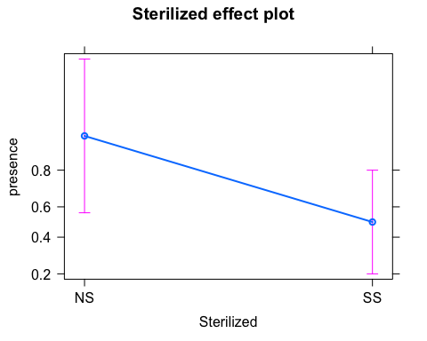

#### Model diagnostics

simulationOutput_lab <- simulateResiduals(fittedModel = lab_detect_mod)   
fit_lab <- plot(simulationOutput_lab, asFactor=TRUE)

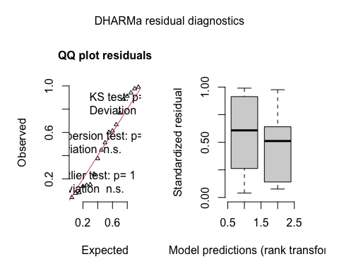

binned_residuals(lab_detect_mod)

## Ok: About 100% of the residuals are inside the error bounds.

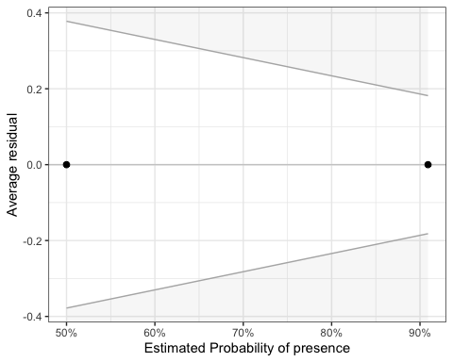

### B. Natural

For natural consumers, the full model is of the form:

**presence ~ Sterilized, family = binomial**

where **presence** is the binary 0-1 detection of any potential prey in the sample and **Sterilized** is a two-level factor of either *surface sterilized* or *not surface sterilized*.

and the null model is:

**presence ~ 1, family = binomial**

#### Model comparison with AICc

AICc(fld_detect_mod, fld_null_model)

## df AICc  
## fld_detect_mod 2 29.69774  
## fld_null_model 1 27.46236

#### Model summary

The sterilized term is non-significant:

summary(fld_detect_mod)

## Family: binomial ( logit )  
## Formula: presence ~ Sterilized  
## Data: field_detect  
##   
## AIC BIC logLik deviance df.resid   
## 29.3 32.6 -12.7 25.3 35   
##   
##   
## Conditional model:  
## Estimate Std. Error z value Pr(>|z|)   
## (Intercept) 2.14007 0.74755 2.863 0.0042 **  
## SterilizedSS -0.06063 1.05893 -0.057 0.9543   
## ---  
## Signif. codes: 0 '***' 0.001 '**' 0.01 '*' 0.05 '.' 0.1 ' ' 1

summary(fld_null_model)

## Family: binomial ( logit )  
## Formula: presence ~ 1  
## Data: field_detect  
##   
## AIC BIC logLik deviance df.resid   
## 27.3 29.0 -12.7 25.3 36   
##   
##   
## Conditional model:  
## Estimate Std. Error z value Pr(>|z|)   
## (Intercept) 2.1102 0.5294 3.986 6.73e-05 ***  
## ---  
## Signif. codes: 0 '***' 0.001 '**' 0.01 '*' 0.05 '.' 0.1 ' ' 1

#### Model diagnostics

simulationOutput_fld <- simulateResiduals(fittedModel = fld_null_model)   
fit_fld <- plot(simulationOutput_fld, asFactor=TRUE)

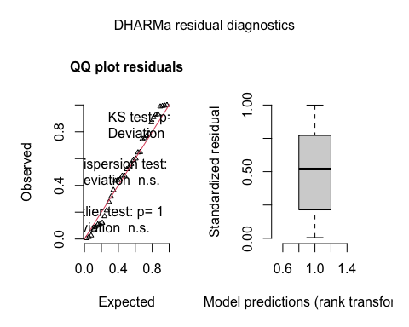

binned_residuals(fld_null_model)

## Ok: About 100% of the residuals are inside the error bounds.

## geom_path: Each group consists of only one observation. Do you need to adjust  
## the group aesthetic?  
## geom_path: Each group consists of only one observation. Do you need to adjust  
## the group aesthetic?

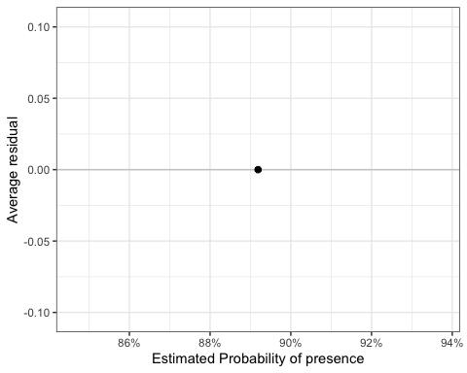

### C. Summary

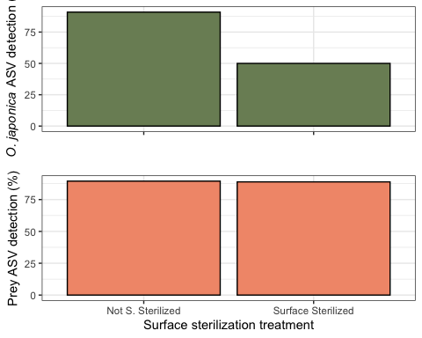

## 2. Prey DNA Abundance

### A. Mesocosm

For mesocosm consumers, the full model is of the form:

**offered prey ~ Sterilized, offset = log(total), family = “genpois”)**

where **offered prey** is the abundance of DNA from the offered prey item (*Oxya japonica*) in the sample, **Sterilized** is a two-level factor of either *surface sterilized* or *not surface sterilized*, and the offset term of **total** offset transforms the abundance value by the total DNA read abundance in the sample, since there is a huge spread in the raw DNA abundances.

and the null model is:

**offered prey ~ 1, offset = log(total), family = “genpois”)**

#### Model comparison with AICc

AICc(lab_mod, lab_null)

## df AICc  
## lab_mod 3 180.2187  
## lab_null 2 177.9251

#### Model summary

summary(lab_mod)

## Family: genpois ( log )  
## Formula: known ~ Sterilized  
## Data: lab_all_nz  
## Offset: log(total)  
##   
## AIC BIC logLik deviance df.resid   
## 177.8 179.7 -85.9 171.8 11   
##   
##   
## Overdispersion parameter for genpois family (): 5.66e+03   
##   
## Conditional model:  
## Estimate Std. Error z value Pr(>|z|)   
## (Intercept) -4.6549 0.9358 -4.974 6.55e-07 ***  
## SterilizedSS -0.4906 0.5111 -0.960 0.337   
## ---  
## Signif. codes: 0 '***' 0.001 '**' 0.01 '*' 0.05 '.' 0.1 ' ' 1

summary(lab_null)

## Family: genpois ( log )  
## Formula: known ~ 1  
## Data: lab_all_nz  
## Offset: log(total)  
##   
## AIC BIC logLik deviance df.resid   
## 176.8 178.1 -86.4 172.8 12   
##   
##   
## Overdispersion parameter for genpois family (): 5.92e+03   
##   
## Conditional model:  
## Estimate Std. Error z value Pr(>|z|)   
## (Intercept) -4.7723 0.9512 -5.017 5.24e-07 ***  
## ---  
## Signif. codes: 0 '***' 0.001 '**' 0.01 '*' 0.05 '.' 0.1 ' ' 1

#### Model diagnostics

plot(residuals(lab_null))

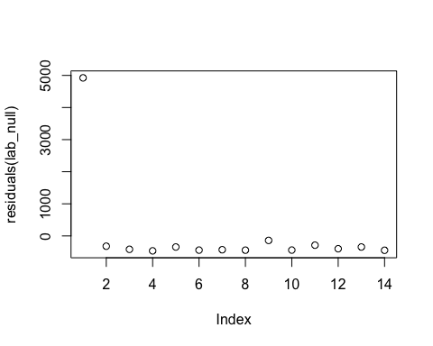

simulationOutput <- simulateResiduals(fittedModel = lab_null)   
fit <- plot(simulationOutput, asFactor=TRUE)

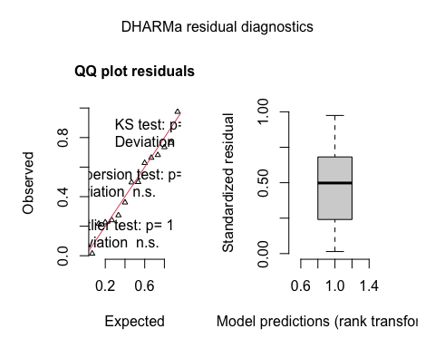

zi <- testZeroInflation(simulationOutput)

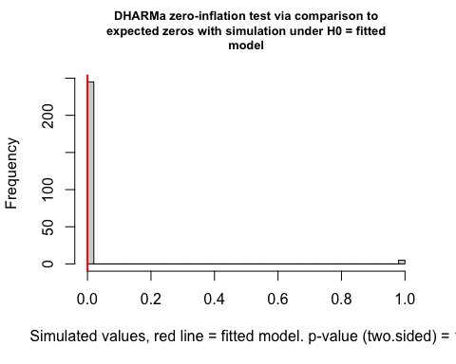

od <- testDispersion(simulationOutput)

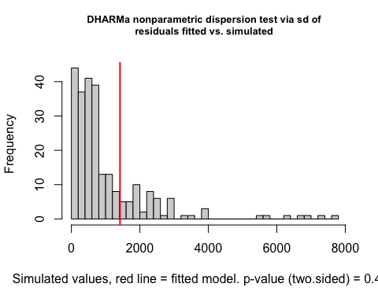

### B. Natural

For natural consumers, the full model is of the form:

**prey ~ Sterilized, offset = log(total), family = “genpois”)**

where **prey** is the abundance of potential prey DNA in the sample, **Sterilized** is a two-level factor of either *surface sterilized* or *not surface sterilized*, and the offset term of **total** offset transforms the abundance value by the total DNA read abundance in the sample, since there is a huge spread in the raw DNA abundances.

and the null model is:

**offered prey ~ 1, offset = log(total), family = “genpois”)**

#### Model comparison with AICc

AIC(fld_mod, fld_null)

## df AIC  
## fld_mod 3 355.8463  
## fld_null 2 353.8582

#### Model summary

summary(fld_mod)

## Family: genpois ( log )  
## Formula: prey ~ Sterilized  
## Data: fld_all_nz  
## Offset: log(total)  
##   
## AIC BIC logLik deviance df.resid   
## 355.8 360.3 -174.9 349.8 30   
##   
##   
## Overdispersion parameter for genpois family (): 1.37e+04   
##   
## Conditional model:  
## Estimate Std. Error z value Pr(>|z|)   
## (Intercept) -3.8924 1.1468 -3.394 0.000688 ***  
## SterilizedSS -0.0346 0.3178 -0.109 0.913303   
## ---  
## Signif. codes: 0 '***' 0.001 '**' 0.01 '*' 0.05 '.' 0.1 ' ' 1

summary(fld_null)

## Family: genpois ( log )  
## Formula: prey ~ 1  
## Data: fld_all_nz  
## Offset: log(total)  
##   
## AIC BIC logLik deviance df.resid   
## 353.9 356.9 -174.9 349.9 31   
##   
##   
## Overdispersion parameter for genpois family (): 1.37e+04   
##   
## Conditional model:  
## Estimate Std. Error z value Pr(>|z|)   
## (Intercept) -3.909 1.137 -3.438 0.000586 ***  
## ---  
## Signif. codes: 0 '***' 0.001 '**' 0.01 '*' 0.05 '.' 0.1 ' ' 1

#### Model diagnostics

plot(residuals(fld_null))

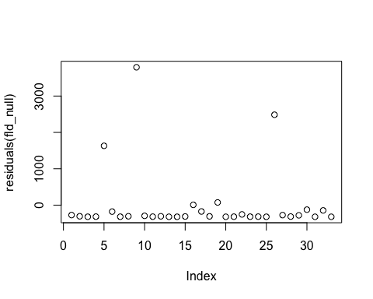

simulationOutput <- simulateResiduals(fittedModel = fld_null)   
fit <- plot(simulationOutput, asFactor=TRUE)

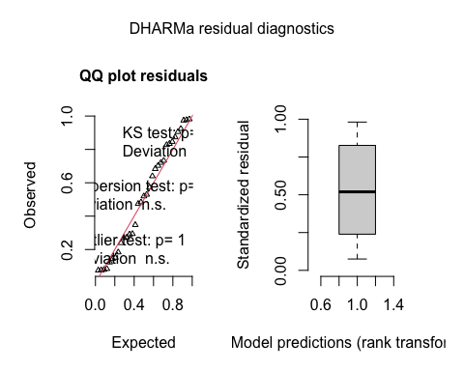

zi <- testZeroInflation(simulationOutput)

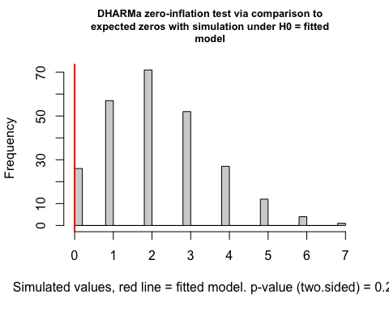

od <- testDispersion(simulationOutput)

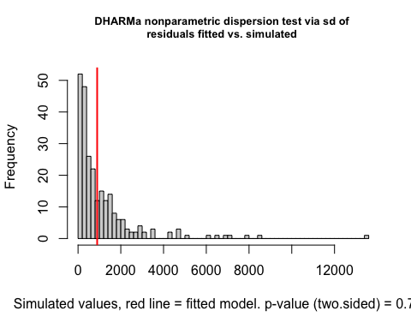

### C. Summary

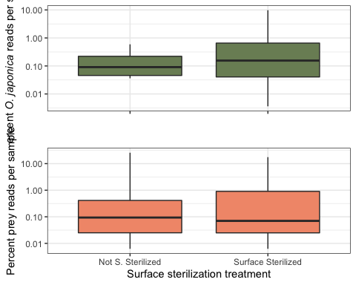

## 3. Natural: Prey DNA Richness and Composition

### A. Richness

We looked at richness of diet within each natural predator diet, with richness being the richness of family-level taxonomic assignments in each sample. The full model for richness is:

**SR ~ Sterilized, family = poisson**

where **SR** is taxonomic richness in a sample (concatenated at the family level) and **Sterilized** is a two-level factor of either *surface sterilized* or *not surface sterilized*.

and the null model is:

**SR ~ Sterilized, family = poisson**

#### Model comparison with AICc

AICc(rich_mod, rich_null)

## df AICc  
## rich_mod 2 135.8017  
## rich_null 1 133.5740

#### Model summary

#based on this summary, surface sterilizatoin treatment is   
#non-significant.   
summary(rich_mod)

## Family: poisson ( log )  
## Formula: SR ~ Sterilized  
## Data: richness  
##   
## AIC BIC logLik deviance df.resid   
## 135.4 138.7 -65.7 131.4 35   
##   
##   
## Conditional model:  
## Estimate Std. Error z value Pr(>|z|)   
## (Intercept) 0.74444 0.15811 4.708 2.5e-06 ***  
## SterilizedSS -0.02389 0.22809 -0.105 0.917   
## ---  
## Signif. codes: 0 '***' 0.001 '**' 0.01 '*' 0.05 '.' 0.1 ' ' 1

summary(rich_null)

## Family: poisson ( log )  
## Formula: SR ~ 1  
## Data: richness  
##   
## AIC BIC logLik deviance df.resid   
## 133.5 135.1 -65.7 131.5 36   
##   
##   
## Conditional model:  
## Estimate Std. Error z value Pr(>|z|)   
## (Intercept) 0.7329 0.1140 6.431 1.27e-10 ***  
## ---  
## Signif. codes: 0 '***' 0.001 '**' 0.01 '*' 0.05 '.' 0.1 ' ' 1

#### Model diagnostics

plot(residuals(rich_null))

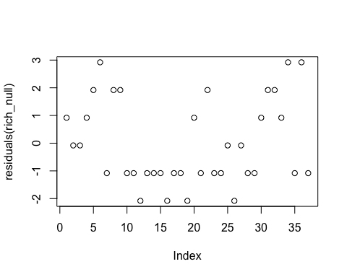

simulationOutput <- simulateResiduals(fittedModel = rich_null)   
fit <- plot(simulationOutput, asFactor=TRUE)

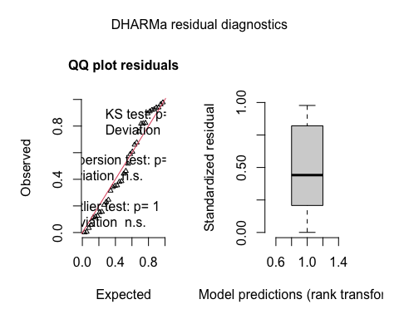

zi <- testZeroInflation(simulationOutput)

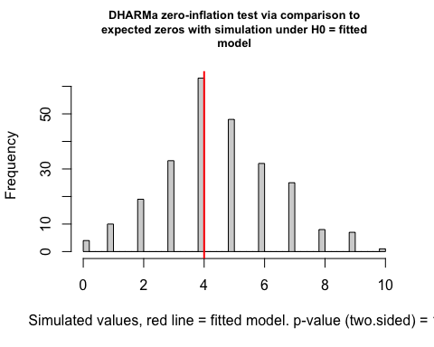

od <- testDispersion(simulationOutput)

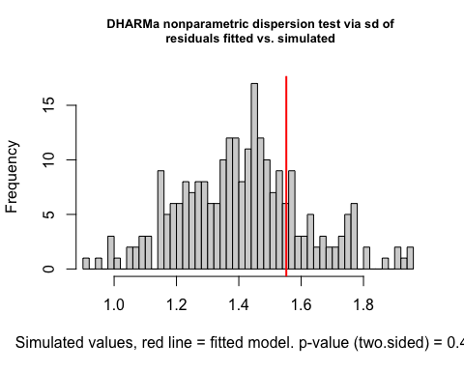

### B. Composition

We looked at presence-absence taxonomic composition of prey DNA using a GLMM-based PERMANOVA approach. Specifically, this GLMM is run by saying, how does the fixed effect of sterilization impact presence, with a random effects structure with both a random interept term for Family_ncbi (let each family have a different intercept) and a random slopes term for surface sterilization treatment (let each family’s relationship with with surface sterilization differ, ie let some families increase with surface sterilization, and others decrease)

The full model looks like:

**presence ~ Sterilized + (1+Sterilized|Family_ncbi), family = “binomial”**

And the null looks like:

**presence ~ 1 + (1|Family_ncbi), family = “binomial”**

#### Model comparison with AICc

AICc(comp_mod, comp_null)

## df AICc  
## comp_mod 5 468.1095  
## comp_null 2 462.0452

#### Model summary

summary(comp_null)

## Family: binomial ( logit )  
## Formula: presence ~ 1 + (1 | Family_ncbi)  
## Data: comp  
##   
## AIC BIC logLik deviance df.resid   
## 462 471 -229 458 658   
##   
## Random effects:  
##   
## Conditional model:  
## Groups Name Variance Std.Dev.  
## Family_ncbi (Intercept) 0.5887 0.7673   
## Number of obs: 660, groups: Family_ncbi, 20  
##   
## Conditional model:  
## Estimate Std. Error z value Pr(>|z|)   
## (Intercept) -2.2451 0.2282 -9.837 <2e-16 ***  
## ---  
## Signif. codes: 0 '***' 0.001 '**' 0.01 '*' 0.05 '.' 0.1 ' ' 1

summary(comp_mod) #sterilization term not significant

## Family: binomial ( logit )  
## Formula: presence ~ Sterilized + (1 + Sterilized | Family_ncbi)  
## Data: comp  
##   
## AIC BIC logLik deviance df.resid   
## 468.0 490.5 -229.0 458.0 655   
##   
## Random effects:  
##   
## Conditional model:  
## Groups Name Variance Std.Dev. Corr   
## Family_ncbi (Intercept) 0.5985723 0.77367   
## SterilizedSS 0.0001757 0.01326 -1.00   
## Number of obs: 660, groups: Family_ncbi, 20  
##   
## Conditional model:  
## Estimate Std. Error z value Pr(>|z|)   
## (Intercept) -2.23856 0.27016 -8.286 <2e-16 ***  
## SterilizedSS -0.01357 0.29549 -0.046 0.963   
## ---  
## Signif. codes: 0 '***' 0.001 '**' 0.01 '*' 0.05 '.' 0.1 ' ' 1

#### Model diagnostics

binned_residuals(comp_null)

## Warning: About 90% of the residuals are inside the error bounds (~95% or higher would be good).

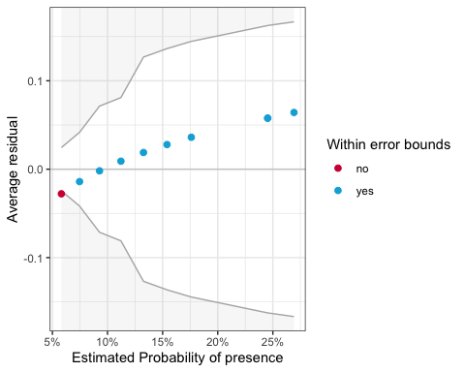

simulationOutput <- simulateResiduals(fittedModel = comp_null)  
fit <- plot(simulationOutput, asFactor=TRUE)

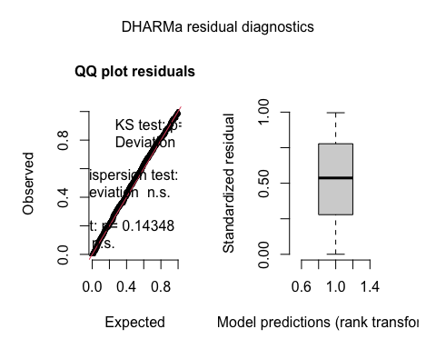

#### Supplementary: Compare to adonis()

The results are similar with an adonis() call from vegan, with the structure:

**comp1 ~ Sterilized, data = meta_field, dist = “jaccard”, binary = TRUE**

Where **comp1** is a matrix of interactions by individual, **Sterilized** is a binary fixed effect. We selected the Jaccard dissimilarlity index (indicating that data are presence-absence with binary=TRUE) since the Jaccard dissimilarity index is functionally Bray-Curtis dissimilarity, but better suited for presence-absence data

adonis(comp1 ~ Sterilized, data = meta_field, dist = "jaccard", binary = TRUE)

##   
## Call:  
## adonis(formula = comp1 ~ Sterilized, data = meta_field, dist = "jaccard", binary = TRUE)   
##   
## Permutation: free  
## Number of permutations: 999  
##   
## Terms added sequentially (first to last)  
##   
## Df SumsOfSqs MeanSqs F.Model R2 Pr(>F)  
## Sterilized 1 0.0462 0.04625 0.113 0.00363 0.999  
## Residuals 31 12.6870 0.40926 0.99637   
## Total 32 12.7333 1.00000

### C. Summary

