Title: Predator-prey interaction outcomes in terrestrial invertebrates are determined by predator body size and species identity, but not hunting traits inferred from diet DNA metabarcoding data

Authors: Ana Miller-ter Kuile1, Austen Apigo1, An Bui1, Bart DiFiore1, Elizabeth Forbes1, Michelle Lee1, Devyn Orr1, Daniel L. Preston2, Rachel Behm1, Taylor Bogar1, Jasmine Childress1, Rodolfo Dirzo3, Maggie Klope1, Kevin Lafferty4, John McLaughlin1, Marisa Morse1, Carina Motta1, Kevin Park1, Katherine Plummer3, David Weber3, Ronny Young1, Hillary Young1

1 Department of Ecology, Evolution, and Marine Biology, University of California, Santa Barbara, Santa Barbara, CA 93106

2 Department of Fish, Wildlife, and Conservation Biology, Colorado State University, Fort Collins CO 80523

3 Department of Biology, Stanford University, Gilbert Biology Building, 371 Jane Stanford Way, Stanford, CA 94305

4 Western Ecological Research Center, US Geological Survey, at Marine Science Institute, University of California, Santa Barbara 93106

Corresponding Author: Ana Miller-ter Kuile, ana.miller.ter.kuile@lifesci.ucsb.edu,

Department of Ecology, Evolution, and Marine Biology

University of California, Santa Barbara,

Santa Barbara, CA 93106

**Acknowledgements**

This project was funded by the National Science Foundation (DEB #1457371), National Geographic Society, and a Faculty Research Grant from the UC Santa Barbara Academic Senate. We would like to thank J. Smith, M. Espinoza, C. Johnston, C. Steel, E. Lutz, and T. Chou for help with field and lab work. We would like to thank the U.S. Fish and Wildlife Service and The Nature Conservancy on Palmyra Atoll for supporting field work for this project. R. Oono provided laboratory space and equipment and we acknowledge the use of the Biological Nanostructures Laboratory within the California NanoSystems Institute, supported by the University of California (UC) Santa Barbara and the University of California Office of the President. We acknowledge the use of computational facilities at the Center for Scientific Computing (CSC), which was purchased with funds from the National Science Foundation (CNS-1725797) and is supported by the California NanoSystems Institute and the Materials Research Science and Engineering Center (MRSEC; NSF DMR 1720256) at UC Santa Barbara. We thank C. Owens, R. Harris-Gavin, S. Copeland, G. Titcomb, H. Lowman, C. Jerde, M. Lee, and R. Ramiro for help in aspects of editing this manuscript. We thank XX anonymous reviewers for help revising this manuscript. This is publication number PARC-XXX from the Palmyra Atoll Research Consortium.

**Author Contributions**

AM-tK, AA, and HY conceived the ideas of this study. AMtK, AB, EF, DO, ML, TB, JC, RD, MK, KL, JM, CM, KP, and DW conducted field work for this study. AM-tK, AA, AB, RB, TB, MK, ML, MM, JM, KP, and RY conducted laboratory work for this study. AMtK led the writing of this manuscript with conceptual contributions from AA, AB, BD, EF, ML, DO, DP, RD, KL, and HY and all authors provided editorial and intellectual feedback on aspects of the manuscript. All authors have read and agree to the content of this manuscript.

**Data Availability**

Raw DNA sequencing data for this project can be found on GenBank (BioProject: PRJNA715709). Processed data, code, and analyses can be found on GitHub (https://github.com/anamtk/DNA_predators) and will be published on Dryad upon article acceptance. Additional data were drawn from Sohlström, Lucas, et al., 2018; Sohlström, Marian, et al., 2018; Su et al., 2020; and Yaninek & Gnanvossou, 1993.

**Abstract**

1. Predator-prey interactions are shaped by a combination of predator traits, including body size and hunting strategy. However, applying a traits-based approach is challenging for most invertebrate taxa because predator-prey interactions are difficult or impossible to observe directly with traditional approaches.
2. In this study, we combined diet DNA metabarcoding data of 173 individual invertebrate predators from nine species with community body size data to explore how predator traits and identity shape interactions. This dataset includes a total of 305 predator-prey interactions.
3. We found that 1) prey size scales with predator size, with species-specific variation to a general size scaling relationship. We also found that 2) while predator hunting traits, including web and venom use, are thought to shape predator prey interaction outcomes, predator species identity more strongly influences relative size of predators and prey (predator:prey size ratios) than either of these hunting traits.
4. Our findings indicate that predator body size and species identity are important in shaping trophic interactions in invertebrate food webs and could help predict how anthropogenic biodiversity change will influence terrestrial invertebrates, the earth’s most diverse and biomass-dominant animal taxonomic group.

**Keywords**

Allometry, arthropod, centipede, consumptive, food web, functional role, insect, spider

**Introduction**

Predator-prey interactions shape the structure and function of ecosystems and their responses to external influences, including anthropogenic global change (Brodie et al., 2014; McCann, 2000). Traditionally, predator-prey interactions have been approached from a species-specific framework; specifically, emphasis is placed on how species identity or phylogenetic relatedness shape feeding interactions (Ings et al., 2009). However, more generalizable predictions of feeding interactions can be made using non-specific traits. Body size, for example, is a key trait that determines feeding interactions between predators and prey across ecosystems (Woodward et al., 2005). Because body size is integral to feeding interactions, both dictating the rate and range of prey a predator can consume, it is one of the primary approaches for predicting the structure of feeding interactions for biological communities, or food webs (Gravel, Poisot, Albouy, Velez, & Mouillot, 2013; Nakazawa, 2017; Stouffer, Camacho, Guimera, Ng, & Nunes Amaral, 2005; Woodward et al., 2005). Whereas body size alone predicts general patterns across food webs in multiple contexts, combining body size with more species-specific characteristics, including species identity, and more broadly, species traits such as locomotion or metabolic group, creates food web models that look even more similar to empirically-observed patterns (Brose et al., 2019; Gray et al., 2015; Pomeranz, Thompson, Poisot, & Harding, 2019; Rudolf, Rasmussen, Dibble, & Allen, 2014). Using general traits to describe food web patterns across ecosystems is not only important for the development of generalizable rules describing patterns in biological communities but could also be integral to predicting and mitigating species extinctions given the rate of anthropogenic species loss (Valiente-Banuet et al., 2015).

Although a few general rules sometimes predict patterns in empirical food webs, we have a dearth of observed interaction data from many predators, in particular small-bodied invertebrate predator species for which empirical diet methods (e.g. gut dissections) are impossible or unfeasible to conduct (Gravel et al., 2013; McLaughlin, Jonsson, & Emmerson, 2010; Sheppard & Harwood, 2005). Without these data, we cannot validate extrapolated approaches to predicting interactions based on general rules. For these consumers, species interactions are often inferred from literature reports of observed interactions from phylogenetically-related species (Laigle et al., 2018; Piechnik, Lawler, & Martinez, 2008; Simberloff & Wilson, 1969), based on body size feeding constraints (Digel, Curtsdotter, Riede, Klarner, & Brose, 2014; Hines et al., 2019; Laigle et al., 2018), or derived from mesocosms or feeding trials which include only pre-defined predator-prey identity pairs (Digel et al., 2014; Rall, Kalinkat, Ott, Vucic-Prestic, & Brose, 2011; Rudolf et al., 2014). Thus, because these interactions are not empirically observed in natural environments, we do not know whether patterns that emerge for these interactions are real broad ecological patterns or artefacts of the rule-based diet assignment methods used to compile them. The lack of empirical interaction data for small-bodied invertebrate taxa is not inconsequential; these taxa represent over 50% of the earth’s animal biomass and a majority of animal species diversity (Bar-On, Phillips, & Milo, 2018; Costello, May, & Stork, 2013; Mora, Tittensor, Adl, Simpson, & Worm, 2011; Stork, 2018).

In this study, we employ novel diet DNA metabarcoding data from 173 samples of nine terrestrial invertebrate predator species to document predator-prey interactions between these predators and their prey in field conditions. We combined these data, which included 305 unique predator-prey interactions, with an extensive dataset of body sizes for both predator individuals and the prey groups identified in their diets. To understand how predator size, species identity, and hunting traits may drive empirical predator-prey interactions, we asked: 1) do larger predator individuals eat larger prey and does this vary by predator species identity? and 2) do predator species traits related to hunting strategy explain variations in prey size selection, or is prey size selection based on predator phylogeny?

**Materials and methods:**

*Field site and collections*

We conducted this work on Palmyra Atoll National Wildlife Refuge, Northern Line Islands (5º53’ N, 162º05’W). Palmyra Atoll has a well-characterized species list, and like many atolls, is relatively species poor, allowing for detailed characterization of potential diet items (Handler, Gruner, Haines, Lange, & Kaneshiro, 2007). Predator individuals were collected across habitat types, including different forest types and microhabitats (e.g., understory vegetation, canopy vegetation, and soil types). For each of these habitat types, we used a combination of methods, including individual collection during visual surveys for understory, and soil collections and canopy fogging with insecticide onto collection sheets for canopy individuals. All individuals were collected individually with sterilized implements (ethanol-burned forceps) in sterilized collection containers containing 95% EtOH to avoid contamination (Greenstone, Weber, Coudron, & Payton, 2011). All individuals were stored in 95% EtOH at -20ºC before DNA extraction.

We identified all predators to morphospecies using a species list for Palmyra Atoll (Handler et al., 2007) and later validated unique species by DNA metabarcoding sequence data. The predators sampled represent the most common predator species found in each habitat location and span a body size range of 0.2 – 998 mg (wet mass, Figure 1). These predators included five arachnid species (*Opopaea sp*., *Neoscona theisi*, *Heteropoda venatoria*, *Smeringopus pallidus*, and *Scytodes longipes*), one dragonfly (*Pantala flavescens*), one predatory katydid (*Phisis holdhausi*), one earwig (*Euborellia annulipes*), and one soil-dwelling centipede species (*Mecistocephalus sp*.). These predators use various hunting tools, including webs and venom and employ several different hunting strategies, including active hunting and non-active hunting (e.g., sit-and-wait or ambush, SI Table 2).

*DNA extraction, PCR amplification, library preparation, sequencing, and denoising*

Our full DNA extraction, PCR amplification, library preparation, sequencing, and denoising methods can be found in the Supplementary Information. Here we provide an abridged version.

To determine the identity of prey DNA in predator diets, we extracted and sequenced DNA from samples consisting of one or several predator individuals using high throughput sequencing methods. Multiple predator individuals were combined due to small body size (thus, inability to extract ample DNA) based on shared size (mean length difference ± 0.5 mm), species, and sampling period (70%, or 121/173 samples consisted of one predator individual, and 52/173 consisted of two or more individuals, Supplementary Methods and SI Figures 6 & 7). We extracted DNA from predator samples using a modified CTAB protocol and following methods outlined in (Krehenwinkel, Kennedy, Pekár, & Gillespie, 2017). We amplified the CO1 gene with general metazoan primers (mlCOIintf/Fol-degen-rev; (Krehenwinkel et al., 2017; Leray et al., 2013; Yu et al., 2012)) and sequenced samples on the Illumina MiSeq platform with 250 paired-end reads. We merged, filtered, and denoised our sequences to amplicon sequence variants (ASVs) using the DADA2 package in R (v1.1.14.0; (Callahan et al., 2016), SI Figures 2 & 3). We removed samples from analysis with incomplete sequencing depth using interpolation and extrapolation methods (Hsieh & Chao, 2017) and then rarefied all sequencing depths to the lowest sequencing depth of remaining samples (15, 954 reads). We performed these steps in R (version 4.0.2) with the iNEXT (version 2.0.20, (Hsieh, Ma, & Chao, 2016)) and vegan (version 2.5.6) packages.

*ASV taxonomic assignment*

To determine the identity of the sequenced DNA, we compared sequencing data to the GenBank and BOLD taxonomic databases. GenBank searches were run using the computing cluster at UC Santa Barbara. We chose to combine prey taxonomies at the family level, similar to diet resolution in both metabarcoding and histological methods in this field (Brose et al., 2019; Eitzinger et al., 2019; Kartzinel et al., 2015) summing the cumulative rarefied read abundances across the ASVs that corresponded to each diet family in each sample. Family-level data provides information comparable to previous studies; additionally, on Palmyra, each family corresponds to an average of 1.9 (± 0.13 SE) species, so a family-level taxonomic assignment may closely mirror species-level assignments. We corrected for potential sequence jumping (‘cross-talk’) across samples by removing reads across samples that emerged in negative controls (Oono et al., 2020) and all DNA matching any predator family present on an individual sequencing run was removed as a conservative method to account for potential sequence jumping (‘cross-talk’) (van der Valk, Vezzi, Ormestad, Dalén, & Guschanski, 2020). We verified ASV specificity based on positive control samples (SI Figure 8)

*Predator and prey size determination*

We measured the length of each predator individual from the front of the head to the end of the abdomen prior to DNA extraction. We converted predator lengths to wet mass using mass-length scaling relationships for each predator species from existing datasets ((Sohlström, Marian, et al., 2018; Su et al., 2020; Yaninek & Gnanvossou, 1993). Prey masses were taken as the average mass for individuals across species within each family (SI Figures 10 & 11).

*Data analyses*

To determine whether individual predator size, species, or both predicted prey size, we fit a linear mixed effects model with the response variable of log10 prey mass (in mg) and predictor variables of log10 predator mass (in mg), species identity, and their interaction, with a random effect of predator individual. Then, to explore whether predator hunting traits or predator phylogeny influences predator-prey size ratios, we divided predators based on whether or not the predator species uses webs to capture prey or uses venom to subdue prey. We determined the ratio of predator to prey size for each of these interactions (raw predator mass/prey mass) and then built a set of linear mixed models of this ratio (log transformed for data normality) as the response variable, and each type of predator trait as a predictor variable (one model with web-building and one with venom use). We compared these to two predator phylogeny models – choosing to compare the ratio of predator to prey size based on predator species and predator class, with the aim to determine whether, if hunting traits did not influence size selection, individuals within shared taxonomic groups had conserved size ratios. In each of these models except the predator species model, predator individual and predator species identity were considered random effects. For the predator species model, only predator individual was considered as a random effect.

*Statistical model selection*

For the linear mixed effects models examining how predator size and species identity shape prey size, we performed model selection using the dredge() function in the MuMIn package in R (package version 1.43.17, (Barton, 2020)) to compare nested models (n = 5 models) and chose the model with the lowest AICc value. To compare the predator trait and phylogeny models, we performed model selection by comparing AICc values for these models (along with a null model with no predictor variables (n = 5 total models). For all models, we verified model assumptions for best-fitting using the DHARMa package in R (version 0.3.3.0, (Hartig, 2020)). The color palette in our figures is from the calecopal package (version 0.1.0, (Bui, Lowman, Guerra, & Miller-ter Kuile, 2020)).

**Results**

*DNA extraction, PCR amplification, library preparation, sequencing, denoising, and ASV taxonomy*

Complete results and QC for each step of the DNA sequencing protocol can be found in the Supplementary Information. Raw data are available on GenBank and our code and analyses are currently hosted in a GitHub repository. Neither of these sources is anonymous, and because of double-blind peer review, we do not provide links to them here. Code and analyses will be published on Dryad prior to publication.

Our final analyses were performed on a total of 173 predator samples of nine species. Each predator sample contained 1–7 (average 1.76 ± 1.08 SD) prey families. Thirty percent (n = 524 of 1,738 total ASVs) of the total ASVs found in samples received taxonomic assignments from GenBank and BOLD, corresponding to prey items at the family level or lower (n = 48 prey families, 14 orders; Figure 3, SI Table 3). Although the predators used in this study represent species at the larger end of the community size spectrum (Figure 1), prey item size distribution resembled the community-wide size distribution (Figure 2). Predator diet items varied by predator species with the widest diversity of prey items in the order Diptera and the most frequently consumed prey items in the orders Hymenoptera, Lepidoptera, and Orthoptera (Figure 3).

*Prey size and predator:prey ratio predictors, and predation strategy*

The best performing model predicting prey size included the terms of predator mass and predator species identity, but not their interaction (log10(prey mass) = 0.32*log10(predator mass), with variation in by-species intercepts (Figure 4, SI Table 5) (β = 0.32, p-value = 0.001). The predator trait or phylogeny model that most explained variation in predator:prey size ratio was the phylogeny model that included predator species as a predictor, with statistically significant post-hoc differences between Arachnida and Chilopoda predators and no others (Figure 5, SI Table 6).

**Discussion**

For terrestrial invertebrate predators like the ones in our study, comprehensive field-based diet analyses have been nearly impossible or time-prohibitive without genetic methods (McLaughlin et al., 2010; Polis, 1991). By combining diet DNA metabarcoding data with community body size data, our study addresses such limitation and provides important empirical examination of interaction patterns for these consumers. We found that predator size and species identity are important drivers of prey size selection and resulting interaction patterns. Specifically, we 1) found that larger predator individuals do eat larger prey, however, individuals of some predator species eat proportionally smaller or larger prey than would be expected by one general cross-species relationship. Then, we 2) demonstrate that predator phylogeny, specifically predator species, is a strong driver of predator:prey size ratios; no hunting strategies related to hunting activity or tools (e.g. webs and venom) relaxed size constraints consistently across species that possessed those traits. Rather, our data suggest that phylogenetic similarity is important for determining predator-prey interaction outcomes. These results highlight that many food web patterns in small, terrestrial invertebrate predator-prey interactions may be explained by a combination of predator species characteristics and that not one predator attribute alone predicts all interactions (Pomeranz et al., 2019).

Our results highlight the need for combining multiple predator traits, including body size and species identity for explaining and predicting food web patterns (Raffaelli, 2007; Rall et al., 2011; Rudolf et al., 2014). In our results, samples from predator species that may be more limited in prey sizes they can attack or handle (e.g., *Pantala flavescens* and *Mecistocephalus sp*.) have smaller prey items on average compared to predators of similar or even smaller size that may be able to attack or handle larger prey (e.g. the spider predators, order Araneae). Whereas both sets of feeding interactions are still constrained by predator and prey size, these constraints vary depending on predator identity, or, more broadly, potentially to predator traits related to prey handling and attack efficiency. Although these traits (body size and handling efficiency) may vary across individuals within a species over life stages, our dataset demonstrates that some traits that limit prey size selection may be conserved across life stages, lending credence to phylogenetic approaches to inferring feeding interactions (Gray et al., 2015). While we did not see evidence that these phylogenetically constrained traits were specifically related to tools such as webs or venom, determining what allows predators to relax size constraints is a fruitful area of future study.

Traits related to predator hunting strategies, such as web and venom use, have gained attention as important drivers of interactions in invertebrate food webs (Laigle et al., 2018; Schmitz, 2008, 2009) and are often a primary way in which interactions are inferred (Digel et al., 2014; Hines et al., 2019). In our dataset, individual species deviated from a general predator-prey body size scaling relationship, and the traits that have previously gained traction for increasing relative prey size (e.g. venom or web use) do not consistently seem to do so across species; this suggests an evaluation of what other traits of predator species may shape the size constraints of predation interactions. It may be that particular invertebrate predators rely on scavenging as opposed to active predation, a phenomenon which may explain why the presumed predator earwig in our dataset (*E. annulipes*), which uses neither venom or webs, fed on relatively large prey (mean ± standard error of predator-prey mass ratio = 4.35 ± 1.99:1) (Wilson & Wolkovich, 2011). Or it may be that these interactions are more dictated by prey as opposed to predator traits (e.g. predator-prey matching, Gravel et al., 2013; Pomeranz et al., 2019). While it may be unclear which traits or species attributes mediate prey size selection in invertebrate predators, almost a quarter (24% or 72/305) of the interactions in our dataset occurred with larger prey than predators, violating assumptions that predators generally eat prey smaller than themselves (Nakazawa, Ohba, & Ushio, 2013). These patterns may highlight distinct rules governing predator-prey interactions of small-bodied consumers with implications for biomass cycling and food web dynamics (Schmitz, 2008).

Diet DNA metabarcoding will continue to be an important tool in understanding the biology of small-bodied invertebrate consumers because it allows us to examine invertebrate diets at the individual level, with the same resolution as that of the diets of larger-bodied species (Baker, Buckland, & Sheaves, 2014; Duffy & Jackson, 1986; Hyslop, 1980). As DNA sequence databases continue to grow (Porter & Hajibabaei, 2018), these analyses will likely get more specific and potentially surpass the resolution of other methods (e.g. gut dissection) even for non-invertebrate consumers (McElroy et al., 2020). For example, rather than being confined to family-level taxonomic assignments, future studies, or re-evaluations of past data could reveal a greater depth of species-level data. Although individual body size data had high resolution for the predators included in this study, we are still limited in knowing the abundance or realized size of prey items consumed by these predators because read abundance may not accurately correspond to prey biomass (Elbrecht & Leese, 2015; Elbrecht, Peinert, & Leese, 2017). Combining these field-based empirical observations with future experimental feeding trials could help to constrain prey sizes or determine preferences for live versus dead prey (Wilson & Wolkovich, 2011). Concurrently, combining multiple genetic methods, such as the use of age-based biomarkers in RNA and DNA sequencing to determine diet age, or amino acid racemization to determine time since prey death, could help determine the age or size of prey and the degree to which predators rely on scavenged food sources, though these methods remain untested in predation interactions (Jarman et al., 2015; Macías-Hernández et al., 2018; Nielsen, Clare, Hayden, Brett, & Kratina, 2018).

Small-bodied invertebrate predators are the most diverse and abundant predators on earth (Bar-On et al., 2018; Costello et al., 2013; Mora et al., 2011) and until now, the predation interactions of these consumers in the wild have been largely unknown. Like other predators in multiple other ecosystem contexts (Brose et al., 2019), the predation interactions of small-bodied predators are driven by a combination of measurable and generalizable predator attributes, including body size and species identity. Using empirical datasets, such as those built by diet DNA metabarcoding data, will be key to determining which traits shape and mediate species interactions. Not only will this build a deeper understanding of the generality of feeding interactions and food webs across environmental contexts and consumer groups, but could be key to predicting and mitigating ongoing biodiversity loss (Borrvall & Ebenman, 2006; Donohue et al., 2017; Valiente-Banuet et al., 2015). Given the growing evidence of global terrestrial invertebrate declines (Desquilbet et al., 2020; van Klink et al., 2020), studies like the present, conducted in multiple localities, are warranted.

**Literature Cited**

Baker, R., Buckland, A., & Sheaves, M. (2014). Fish gut content analysis: Robust measures of diet composition. *Fish and Fisheries*, *15*(1), 170–177. doi: 10.1111/faf.12026

Bar-On, Y. M., Phillips, R., & Milo, R. (2018). The biomass distribution on Earth. *Proceedings of the National Academy of Sciences of the United States of America*, *115*(25), 6506–6511. doi: 10.1073/pnas.1711842115

Barton, K. (2020). *MuMIn: Multi-Model Inference*.

Borrvall, C., & Ebenman, B. (2006). Early onset of secondary extinctions in ecological communities following the loss of top predators. *Ecology Letters*, *9*(4), 435–442. doi: 10.1111/j.1461-0248.2006.00893.x

Brodie, J. F., Aslan, C. E., Rogers, H. S., Redford, K. H., Maron, J. L., Bronstein, J. L., & Groves, C. R. (2014). Secondary extinctions of biodiversity. *Trends in Ecology and Evolution*, *29*(12), 664–672. doi: 10.1016/j.tree.2014.09.012

Brose, U., Archambault, P., Barnes, A. D., Bersier, L. F., Boy, T., Canning-Clode, J., … Iles, A. C. (2019). Predator traits determine food-web architecture across ecosystems. *Nature Ecology and Evolution*, *3*(6), 919–927. doi: 10.1038/s41559-019-0899-x

Bui, A., Lowman, H., Guerra, A. S., & Miller-ter Kuile, A. (2020). *calecopal: A California-inspired Package of Color Palettes*.

Callahan, B. J., McMurdie, P. J., Rosen, M. J., Han, A. W., Johnson, A. J. A., & Holmes, S. P. (2016). DADA2: High-resolution sample inference from Illumina amplicon data. *Nature Methods*, *13*(7), 581–583. doi: 10.1038/nmeth.3869

Costello, M. J., May, R. M., & Stork, N. E. (2013). Can we name earth’s species before they go extinct? *Science*, *339*(6118), 413–416. doi: 10.1126/science.1230318

Desquilbet, M., Gaume, L., Grippa, M., Cereghino, R., Humbert, J.-F., Bonmatin, J.-M., … Goulson, D. (2020). Comment on “Meta-analysis reveals declines in terrestrial but increases in freshwater insect abundances.” *Science*, *370*, 1–6. doi: 10.1038/304586a0

Digel, C., Curtsdotter, A., Riede, J., Klarner, B., & Brose, U. (2014). Unravelling the complex structure of forest soil food webs: Higher omnivory and more trophic levels. *Oikos*, *123*(10), 1157–1172. doi: 10.1111/oik.00865

Donohue, I., Petchey, O. L., Kéfi, S., Génin, A., Jackson, A. L., Yang, Q., & O’Connor, N. E. (2017). Loss of predator species, not intermediate consumers, triggers rapid and dramatic extinction cascades. *Global Change Biology*, *23*(8), 2962–2972. doi: 10.1111/gcb.13703

Duffy, D. C., & Jackson, S. (1986). Diet Studies of Seabirds: A Review of Methods. *Colonial Waterbirds*, *9*(1), 1–17.

Eitzinger, B., Abrego, N., Gravel, D., Huotari, T., Vesterinen, E. J., & Roslin, T. (2019). Assessing changes in arthropod predator–prey interactions through DNA-based gut content analysis—variable environment, stable diet. *Molecular Ecology*, *28*(2), 266–280. doi: 10.1111/mec.14872

Elbrecht, V., & Leese, F. (2015). Can DNA-based ecosystem assessments quantify species abundance? Testing primer bias and biomass-sequence relationships with an innovative metabarcoding protocol. *PLoS ONE*, *10*(7), 1–16. doi: 10.1371/journal.pone.0130324

Elbrecht, V., Peinert, B., & Leese, F. (2017). Sorting things out: Assessing effects of unequal specimen biomass on DNA metabarcoding. *Ecology and Evolution*, *7*(17), 6918–6926. doi: 10.1002/ece3.3192

Gravel, D., Poisot, T., Albouy, C., Velez, L., & Mouillot, D. (2013). Inferring food web structure from predator-prey body size relationships. *Methods in Ecology and Evolution*, *4*(11), 1083–1090. doi: 10.1111/2041-210X.12103

Gray, C., Figueroa, D. H., Hudson, L. N., Ma, A., Perkins, D., & Woodward, G. (2015). Joining the dots: An automated method for constructing food webs from compendia of published interactions. *Food Webs*, *5*, 11–20. doi: 10.1016/j.fooweb.2015.09.001

Greenstone, M. H., Weber, D. C., Coudron, T. C., & Payton, M. E. (2011). Unnecessary roughness? Testing the hypothesis that predators destined for molecular gut-content analysis must be hand-collected to avoid cross-contamination. *Molecular Ecology Resources*, *11*(2), 286–293. doi: 10.1111/j.1755-0998.2010.02922.x

Handler, A., Gruner, D., Haines, W., Lange, M., & Kaneshiro, K. (2007). Arthropod surveys on Palmyra Atoll, Line Islands, and insights into the decline of the native tree Pisonia grandis (Nyctaginaceae). *Pacific Science*, *61*(4), 485–502. doi: 10.2984/1534-6188(2007)61

Hartig, F. (2020). *DHARMa*.

Hines, J., Giling, D. P., Rzanny, M., Voigt, W., Meyer, S. T., Weisser, W. W., … Ebeling, A. (2019). A meta food web for invertebrate species collected in a European grassland. *Ecology*, *100*(6), 2679. doi: 10.1002/ecy.2679

Hsieh, T. C., & Chao, A. (2017). Rarefaction and extrapolation: Making fair comparison of abundance-sensitive phylogenetic diversity among multiple assemblages. *Systematic Biology*, *66*(1), 100–111. doi: 10.1093/sysbio/syw073

Hsieh, T. C., Ma, K. H., & Chao, A. (2016). iNEXT: an R package for rarefaction and extrapolation of species diversity (Hill numbers). *Methods in Ecology and Evolution*, *7*(12), 1451–1456. doi: 10.1111/2041-210X.12613

Hyslop, E. J. (1980). Stomach contents analysis - a review of methods and their application. *Journal of Fish Biology*, *17*(4), 411–429. doi: 10.1111/j.1095-8649.1980.tb02775.x

Ings, T. C., Montoya, J. M., Bascompte, J., Bluthgren, N., Brown, L., Dormann, C., … Woodward, G. (2009). Ecological networks - Beyond food webs. *Journal of Animal Ecology*, *78*(1), 253–269. doi: 10.1111/j.1365-2656.2008.01460.x

Jarman, S. N., Polanowski, A. M., Faux, C. E., Robbins, J., De Paoli-Iseppi, R., Bravington, M., & Deagle, B. E. (2015). Molecular biomarkers for chronological age in animal ecology. *Molecular Ecology*, *24*(19), 4826–4847. doi: 10.1111/mec.13357

Kartzinel, T. R., Chen, P. A., Coverdale, T. C., Erickson, D. L., Kress, W. J., Kuzmina, M. L., … Pringle, R. M. (2015). DNA metabarcoding illuminates dietary niche partitioning by African large herbivores. *Proceedings of the National Academy of Sciences*, *112*(26), 8019–8024. doi: 10.1073/pnas.1503283112

Krehenwinkel, H., Kennedy, S., Pekár, S., & Gillespie, R. G. (2017). A cost‐efficient and simple protocol to enrich prey DNA from extractions of predatory arthropods for large‐scale gut content analysis by Illumina sequencing. *Methods in Ecology and Evolution*, *8*(1), 126–134. doi: 10.1111/2041-210X.12647

Laigle, I., Aubin, I., Digel, C., Brose, U., Boulangeat, I., & Gravel, D. (2018). Species traits as drivers of food web structure. *Oikos*, *127*(2), 316–326. doi: 10.1111/oik.04712

Leray, M., Yang, J. Y., Meyer, C. P., Mills, S. C., Agudelo, N., Ranwez, V., … Machida, R. J. (2013). A new versatile primer set targeting a short fragment of the mitochondrial COI region for metabarcoding metazoan diversity: Application for characterizing coral reef fish gut contents. *Frontiers in Zoology*, *10*(34), 1–14. doi: 10.1186/1742-9994-10-34

Macías-Hernández, N., Athey, K., Tonzo, V., Wangensteen, O. S., Arnedo, M., & Harwood, J. (2018). Molecular gut content analysis of different spider body parts. *PLoS ONE*, *13*(5), 1–16. doi: 10.1371/journal.pone.0196589

McCann, K. (2000). The diversity–stability debate. *Nature*, *405*.

McElroy, M. E., Dressler, T. L., Titcomb, G. C., Wilson, E. A., Deiner, K., Dudley, T. L., … Jerde, C. L. (2020). Calibrating Environmental DNA Metabarcoding to Conventional Surveys for Measuring Fish Species Richness. *Frontiers in Ecology and Evolution*, *8*, 0–12. doi: 10.3389/fevo.2020.00276

McLaughlin, Ó. B., Jonsson, T., & Emmerson, M. C. (2010). Temporal Variability in Predator-Prey Relationships of a Forest Floor Food Web. In *Advances in Ecological Research* (Vol. 42). doi: 10.1016/B978-0-12-381363-3.00004-6

Mora, C., Tittensor, D. P., Adl, S., Simpson, A. G. B., & Worm, B. (2011). How many species are there on earth and in the ocean? *PLoS Biology*, *9*(8), 1–8. doi: 10.1371/journal.pbio.1001127

Nakazawa, T. (2017). Individual interaction data are required in community ecology: a conceptual review of the predator–prey mass ratio and more. *Ecological Research*, *32*(1), 5–12. doi: 10.1007/s11284-016-1408-1

Nakazawa, T., Ohba, S. Y., & Ushio, M. (2013). Predator-prey body size relationships when predators can consume prey larger than themselves. *Biology Letters*, *9*, 20121193. doi: 10.1098/rsbl.2012.1193

Nielsen, J. M., Clare, E. L., Hayden, B., Brett, M. T., & Kratina, P. (2018). Diet tracing in ecology: Method comparison and selection. *Methods in Ecology and Evolution*, *9*(2), 278–291. doi: 10.1111/2041-210X.12869

Oono, R., Black, D., Slessarev, E., Sickler, B., Strom, A., & Apigo, A. (2020). Species diversity of fungal endophytes across a stress gradient for plants. *New Phytologist*, *228*(1), 210–225. doi: 10.1111/nph.16709

Piechnik, D. A., Lawler, S. P., & Martinez, N. D. (2008). Food-web assembly during a classic biogeographic study: species’ “trophic breadth.” *Oikos*, *117*(5), 665–674.

Polis, G. A. (1991). Complex Trophic Interactions in Deserts: An Empirical Critique of Food-Web Theory. *The American Naturalist*, *138*(1), 123–155.

Pomeranz, J. P. F., Thompson, R. M., Poisot, T., & Harding, J. S. (2019). Inferring predator–prey interactions in food webs. *Methods in Ecology and Evolution*, *10*(3), 356–367. doi: 10.1111/2041-210X.13125

Porter, T. M., & Hajibabaei, M. (2018). Over 2.5 million COI sequences in GenBank and growing. *PLoS ONE*, *13*(9), 1–16. doi: 10.1371/journal.pone.0200177

Raffaelli, D. (2007). Food webs, body size and the curse of the latin binomial. *From Energetics to Ecosystems: The Dynamics and Structure of Ecological Systems*, 53–64. doi: 10.1007/978-1-4020-5337-5_3

Rall, B. C., Kalinkat, G., Ott, D., Vucic-Prestic, O., & Brose, U. (2011). Taxonomic versus allometric constraints on non-linear interaction strengths. *Oikos*, *120*, 483–492.

Rudolf, V. H. W., Rasmussen, N. L., Dibble, C. J., & Allen, B. G. Van. (2014). Resolving the roles of body size and species identity in driving functional diversity. *Proceedings of the Royal Society B*, *281*, 20133203.

Schmitz, O. J. (2008). Effects of predator hunting mode on grassland ecosystem function. *Science*, *319*(5865), 952–954. doi: 10.1126/science.1152355

Schmitz, O. J. (2009). Effects of predator functional diversity on grassland ecosystem function. *Ecology*, *90*(9), 2339–2345.

Sheppard, S. K., & Harwood, J. D. (2005). Advances in molecular ecology: Tracking trophic links through predator-prey food-webs. *Functional Ecology*, *19*(5), 751–762. doi: 10.1111/j.1365-2435.2005.01041.x

Simberloff, D. S., & Wilson, E. O. (1969). Experimental Zoogeography of Islands : The Colonization of Empty Islands. *Ecology*, *50*(2), 278–296.

Sohlström, E. H., Lucas, M., Barnes, A. D., Haneda, N. F., Scheu, S., Rall, B. C., … Jochum, M. (2018). Data from: Applying generalised allometric regressions to predict live body mass of tropical and temperate arthropods. *Dryad*. doi: https://doi.org/10.5061/dryad.vk24fr1

Sohlström, E. H., Marian, L., Barnes, A. D., Haneda, N. F., Scheu, S., Rall, B. C., … Jochum, M. (2018). Applying generalized allometric regressions to predict live body mass of tropical and temperate arthropods. *Ecology and Evolution*, *8*(24), 12737–12749. doi: 10.1002/ece3.4702

Stork, N. E. (2018). How Many Species of Insects and Other Terrestrial Arthropods Are There on Earth? *Annual Review of Entomology*, *63*, 31–45. doi: 10.1146/annurev-ento-020117-043348

Stouffer, D. B., Camacho, J., Guimera, R., Ng, C. A., & Nunes Amaral, L. A. (2005). Quantitative patterns in the structure of model and empirical food webs. *Ecology*, *86*(5), 1301–1311.

Su, G., Dudley, R., Pan, T., Zheng, M., Peng, L., & Li, Q. (2020). Maximum aerodynamic force production by the wandering glider dragonfly (Pantala flavescens, Libellulidae). *The Journal of Experimental Biology*, *223*(May). doi: 10.1242/jeb.218552

Valiente-Banuet, A., Aizen, M. A., Alcántara, J. M., Arroyo, J., Cocucci, A., Galetti, M., … Zamora, R. (2015). Beyond species loss: The extinction of ecological interactions in a changing world. *Functional Ecology*, *29*(3), 299–307. doi: 10.1111/1365-2435.12356

van der Valk, T., Vezzi, F., Ormestad, M., Dalén, L., & Guschanski, K. (2020). Index hopping on the Illumina HiseqX platform and its consequences for ancient DNA studies. *Molecular Ecology Resources*, *20*(5), 1171–1181. doi: 10.1111/1755-0998.13009

van Klink, R., Bowler, D. E., Gongalsky, K. B., Swengel, A. B., Gentile, A., & Chase, J. M. (2020). Meta-analysis reveals declines in terrestrial but increases in freshwater insect abundances. *Science*, *368*, 417–420. doi: 10.1126/science.abd8947

Wilson, E. E., & Wolkovich, E. M. (2011). Scavenging: How carnivores and carrion structure communities. *Trends in Ecology and Evolution*, *26*(3), 129–135. doi: 10.1016/j.tree.2010.12.011

Woodward, G., Ebenman, B., Emmerson, M., Montoya, J. M., Olesen, J. M., Valido, A., & Warren, P. H. (2005). Body size in ecological networks. *Trends in Ecology and Evolution*, *20*(7), 402–409. doi: 10.1016/j.tree.2005.04.005

Yaninek, J. S., & Gnanvossou, D. (1993). Fresh and dry wei ghts of Mononychellus tanajoa (Acari: Tetranychidae): A functional description of biomass accumulation. *Experimental and Applied Acarology*, *17*(10), 775–779. doi: 10.1007/BF00051836

Yu, D. W., Ji, Y., Emerson, B. C., Wang, X., Ye, C., Yang, C., & Ding, Z. (2012). Biodiversity soup: Metabarcoding of arthropods for rapid biodiversity assessment and biomonitoring. *Methods in Ecology and Evolution*, *3*(4), 613–623. doi: 10.1111/j.2041-210X.2012.00198.x

**Figures**

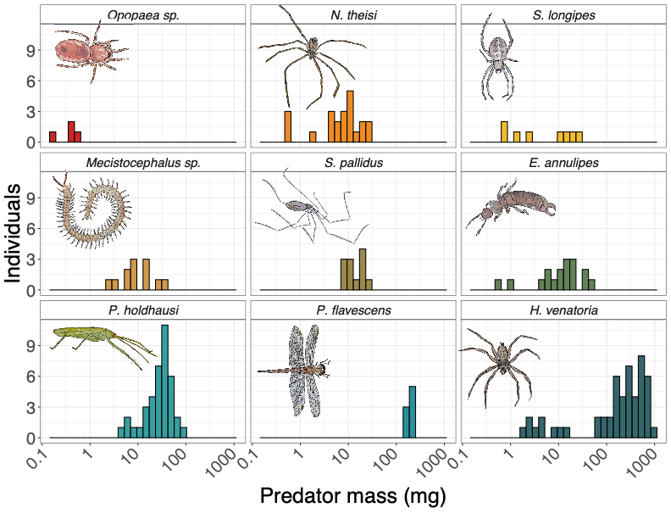

Figure 1: Predator size distributions of predator individuals across the nine predator species. The x-axis scale depicts absolute values but has been log10 transformed. Predator individuals span from 2x10-1 mg (*Opopaea sp*.) to 9.9x102 mg (*H. venatoria*) in wet weight. The facets in this figure have been ordered by increasing predator species mean size.



Figure 2: While the predator species in this study skew toward the larger side of the size spectrum of the Palmyra community (dark grey: predator species, light grey: community), the prey species detected in DNA data (medium grey) represent species across much of the range of the community size spectrum.

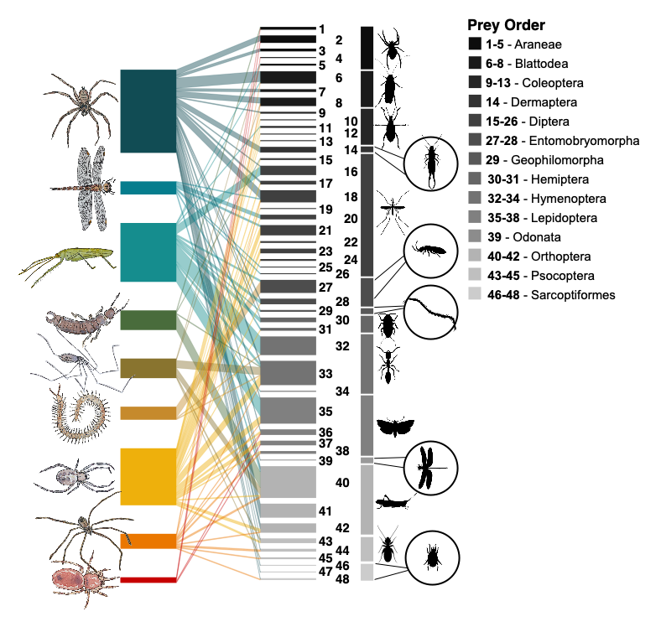

Figure 3: Prey community (right bars) detected in the DNA of predator samples (left bars). The width of the predator bars vary due to sample size, the width of the line (interaction) connecting each predator to each prey represents the frequency of that prey item in that predator species sample, and the width of the prey bar corresponds to the number of times that prey item occurs in any predator’s diet. Prey items correspond to 48 families of 14 orders of arthropods, including arachnids, collembola, and insects.



Figure 4: A log10-log10 transformed relationship shows that larger predators eat larger prey (panel (a), log10 prey size = 0.32*log10 predator size), though the effect is mediated by predator species identity (b). The dashed line in panel (a) represents the 1:1 relationship between predator and prey size. Continuous axis labels represent absolute values but the scale between them has been log10 transformed. In panel (b), “+” and “-“ symbols indicate species that either have significantly higher (“+”) or lower (“-“) prey sizes relative to predator body size and the general predator-prey body size patterns.

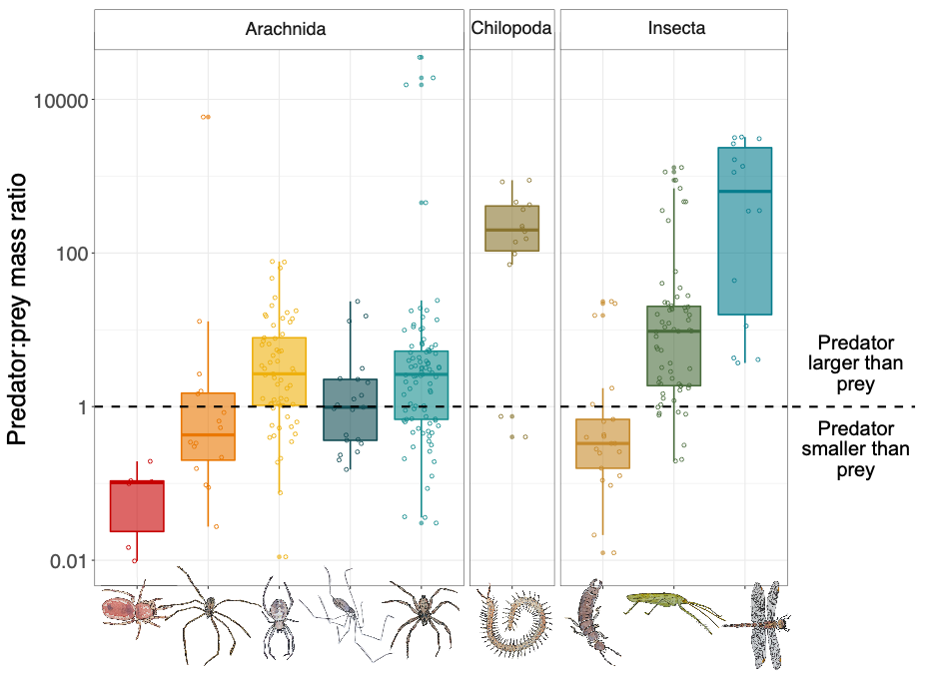

Figure 5: Predator species identity was a stronger predictor of predator:prey size ratios than specific hunting traits (e.g. web or venom use) or broader predator taxonomies (e.g. Class). In this figure, the dashed line indicates interactions where predators are the same size as prey. Any interactions below that line indicates that predators are smaller than prey, while any interactions above that line are when predators are larger than prey. The y-axis is presented with absolute values but displayed on a log10-transformed scale to demonstrate the spread in the data. While arachnids (all spiders in the order Aranea, lightest grey boxes) tend to eat relatively larger prey items relative to their own body size than non-spider predators (medium and dark grey boxes), patterns across species vary, emphasizing a need for phylogenetic information in predator-prey interactions along with traits such as body size and hunting strategies. Twenty-four percent (72/305) of the interactions in our dataset corresponded to predators eating prey items larger than themselves (interactions below the dashed line), contrary to assumptions about size-based predation interactions.