Untitled

Ana Miller-ter Kuile

3/18/2020

## Warning: Removed 2 rows containing non-finite values (stat_bin).

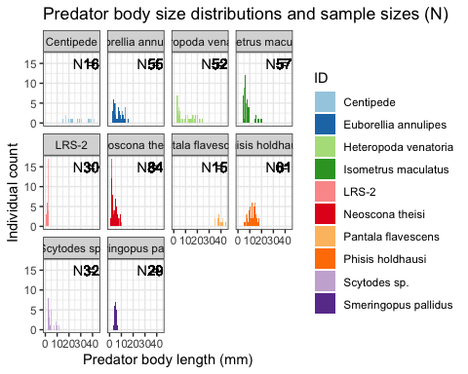

## `stat_bin()` using `bins = 30`. Pick better value with `binwidth`.

## Warning: Removed 1 rows containing non-finite values (stat_bin).

