**Title:** If you’re rare, should I care? How imperfect detection changes relationships between biodiversity and global change drivers

**Author List:** Ana Miller-ter Kuile1,2, An Bui3, Austen Apigo4, Shelby Lamm1, Megan Swan5, Jamie S. Sanderlin2, Kiona Ogle1

**Author Emails:**

ana.miller-ter-kuile@nau.edu (ORCID: 0000-0003-2599-5158)

an_bui@ucsb.edu (ORCID: 0000-0002-9548-7776)

aaapigo@uci.edu (ORCID: 0000-0002-2525-0394)

shelby.lamm@nau.edu (ORCID: 0000-0002-9710-9023)

megan_swan@nps.gov (ORCID: 0009-0000-3467-022X)

jamie.l.sanderlin@usda.gov (ORCID: 0000-0001-8651-9804)

kiona.ogle@nau.edu (ORCID: 0000-0002-0652-8397)

**Author Affiliations:**

1 Northern Arizona University, School of Informatics, Computing and Cyber Systems, Flagstaff, Arizona, USA

2 USDA Forest Service Rocky Mountain Research Station, Flagstaff, Arizona, USA

3 University of California, Santa Barbara, Department of Ecology, Evolution, and Marine Biology, Santa Barbara, California, USA

4 University of California, Irvine, Department of Ecology and Evolutionary Biology, Irvine, California, USA

5 National Park Service Southern Colorado Plateau Inventory and Monitoring Network, Flagstaff, Arizona, USA

**Data availability:** Code for data preparation, analysis, and visualization can be found on Zenodo (<https://doi.org/10.5281/zenodo.13737499>).

**Running Head (45 characters):** Rarity alters drivers of biodiversity change

**Keywords (6-10):** multi-species occupancy model, multi-species abundance model, Bray-Curtis dissimilarity, functional richness, stability, species turnover, extinction, passerine birds, grasshoppers, understory plants

Journal aim: GCB Mini Reviews (3000 words abstract-acknowledgements, no figure limits specified)

**Abstract**

Across ecosystems and biomes, the majority of species in a biological community are rare. Many biodiversity studies discount rare species when examining biodiversity patterns because common species often most influence ecosystem functioning. There is a growing amount of evidence that rare species contribute unique functions in many ecosystems; thus, discounting them could lead to misleading conclusions about how biodiversity is changing in the face of natural and anthropogenic forces. However, rare species are more likely to be missed by multi-species sampling designs and are thus sensitive to detection error. In this piece, we argue that biodiversity assessments should include rare species and account for error in the detection process. We provide a general approach researchers can take to account for detection error in sampling designs using multi-species occupancy and abundance models (MSOM/MSAM). We then show how estimates of mean and variance in alpha and beta diversity metrics derived from MSOM and MSAM model results can be incorporated into regression models to evaluate relationships with global change covariates. Using three case studies across diverse taxa (birds, insects, and plants), we demonstrate how accounting for the detection process alters the relationships between biodiversity and global change drivers in ways that are important for understanding and predicting ongoing and future change in these communities. Our aim in this mini review is to provide a generalizable analysis approach for biodiversity studies and show how it impacts our understanding of global biodiversity.

**Introduction**

Most species in ecosystems across the globe are rare ((Rabinowitz, 2014) Figure 1). Historically, rare species have often been excluded from analyses of biodiversity metrics under the assumption that more abundant or common species contribute most to ecosystem functioning (Poos & Jackson, 2012; Sasaki & Lauenroth, 2011). We’re increasingly realizing that rare species are important for understanding relationships between biodiversity and ecosystem function and services (Dee et al., 2019; Mouillot et al., 2013). For example, rare species disproportionately influence functional diversity (Jain et al., 2014; Leitão et al., 2016; Roth et al., 2018) since these species often have unique trait combinations (e.g., large-bodied long-distance seed dispersing birds in Australia, Leitão et al., 2016). Thus, including rare species in considerations of biodiversity change may matter for our understanding of how ongoing and future global change will shape ecosystems (Jaureguiberry et al., 2022).

Incorporating rare species into biodiversity metrics may alter predictions about many facets of biodiversity (e.g., species richness; (Tingley et al., 2020). However, many multi-species observational datasets, even ones with long temporal or spatial coverage, do not incorporate survey designs to capture rare or patchy species distributions well (Devarajan et al., 2020; Jeliazkov et al., 2022; Sanderlin et al., 2014; Zipkin et al., 2010). As a result, many multi-species sampling methods are likely to systematically miss rare species. Thus, if we want to incorporate rare species into our estimates of biodiversity change but take observational data at face value, we are likely to come across instances of “false negatives” (Zipkin et al., 2010). Specifically, that many species and individuals, especially rare species, are present in the ecosystem but not detected. Thus, when we examine how biodiversity is changing and which factors are shaping these biodiversity changes, we may be observing relics of sampling design as opposed to real biological patterns. Given that rare species have unique responses to environmental perturbations (e.g., (Säterberg et al., 2019), not accounting for these species may alter our predictions of the direction, magnitude, and time scales of influence of global change drivers on biodiversity.

In this piece, we argue that biodiversity assessments across ecosystems can benefit from accounting for imperfect detection of species, especially those that are rare. We outline a general approach researchers can take using established modeling methods that account for imperfect detection (Bayesian multi-species occupancy and abundance models; (Dorazio et al., 2006; Iknayan et al., 2014) to generate latent abundance and occupancy estimates. We then show how researchers can generate mean and variance in a variety of biodiversity metrics (including both alpha and beta diversity) from these latent values. Then, these estimates can be incorporated into regression models that incorporate both mean and variance of biodiversity metrics, thus propagating uncertainty. These regression models can include a variety of covariates for global change drivers and we show how researchers can also quantify lagged effects in these covariate effects using a stochastic antecedent modeling framework ((Ogle et al., 2015); Figure 2). We demonstrate how accounting for imperfect detection of all species (especially rare ones) alters estimates of global change driver effect direction, magnitude, and time scales using three examples from large, long-term community datasets from a variety of taxa (plants, invertebrates, and vertebrates).

**1 Accounting for detection error**

Accounting for detection error in observational datasets is not a new concept (e.g., (Dorazio et al., 2006; Kéry & Schmidt, 2008; MacKenzie et al., 2002; Royle et al., 2005). Within multiple fields, researchers have realized that there are undetected parts of their ecosystem and have come up with a suite of approaches for dealing with this issue. For multi-species datasets, it is common to use multi-species occupancy and abundance models (MSOM/MSAM), which “correct” observed data to estimate latent “true” values of abundance or occupancy. These models include two parts. First, the observational process describes observed data in relation to a set of covariates that could alter detection probabilities. Second, this information is fed into a biological process model in which latent (unmeasured) “true” occupancy or abundance can be based on a variety of biological covariates. These models allow rarer species in a community to “borrow strength” by allowing species-level parameters to be centered around community- or group-level values (Iknayan et al., 2014; Ogle et al., 2013). These models account for “false negatives” and generally shift species abundance and frequency distributions to the right (Figure 3). While the concept isn’t new, it has been applied much more often in studies of vertebrate communities (Kellner & Swihart, 2014), but is not common practice in community ecology writ large, especially for invertebrates and plants (but see (Chen et al., 2013) and for biodiversity metrics other than species richness (e.g., (Dorazio et al., 2006; Tingley et al., 2020), but see (Broms et al., 2015; Cannon et al., 2019; Si et al., 2018).

**2 Generating values of alpha and beta diversity**

Once detection error has been accounted for, modeled “true” latent occupancy and abundance of species in a community can be used to generate all biodiversity metrics common in community ecology, including measures of alpha and beta diversity based both on occurrence and abundance data (e.g., species richness, Shannon’s diversity, Berger-Parker dominance, Bray-Curtis dissimilarity, and Jaccard dissimilarity; (Baselga, 2013; Hallett et al., 2016; Morris et al., 2014; Oksanen et al., 2020), Figure 3). Further, occupancy probabilities can be used instead of estimated latent presence-absence values as a proxy for relative abundances (e.g., Broms et al., 2015). In the Bayesian statistical framework in which these models are commonly run, models generate a set of independent samples for all parameters, including these “true” values of abundance or occupancy. Due to the nature of this type of modeling, resulting biodiversity metrics can be described in terms of both their central tendency (mean or median) and their variance (e.g., standard deviation, Bayesian credible intervals; (Ellison, 2004).

**3 Evaluating drivers of biodiversity patterns**

The uncertainty in estimates of biodiversity generated from multi-species models can be propagated into downstream analyses. Many values for functional diversity and for beta diversity have values between 0 and 1 (Oksanen et al., 2020). Thus, we describe a general Bayesian model using a beta distribution (Ferrari & Cribari-Neto, 2004; Irvine et al., 2016). However, any other potential data distribution (e.g., Poisson for species richness, gaussian for Shannon diversity) can be applied in this modeling framework by incorporating measured and unmeasured variance into equations for the expected variance of these distributions. Because biodiversity responses to any environmental driver or perturbation stem from the combined and complex population and community interaction dynamics of a system, including extinction debts (Figueiredo et al., 2019), variation in species-specific population rate responses (Thompson & Ollason, 2001), or reconfiguration of multi-trophic species interactions (Essl et al., 2015a), it is likely that biodiversity could have a lagged response to change drivers (Essl et al., 2015b). We can explicitly test for these lagged responses to global change drivers using stochastic antecedent modeling, which provides estimates of covariate effects as the weighted average value across a range of user-defined temporal lags. Each lag gets an estimated importance weight from the model describing its relative influence on the biodiversity response (e.g., Ogle et al., 2015).

**4 Applying a combined modeling framework**

Combining multi-species models with general regressions provides a powerful framework for accounting for detection error of rare species. For this paper, we have derived values of biodiversity for three examples in two ways: 1. Using the above modeling framework and 2. Using observational data without accounting for detection error. These examples are meant to illustrate that accounting for imperfect detection alters our predictions of the direction, magnitude, and temporal scale of effects of many environmental covariates on multiple biodiversity metrics across a diverse range of environments and biological communities. These differences stem largely from the inclusion of more rare species. Our aim was not to provide comprehensive ecological analyses of these communities, but rather, we aim to provide them as examples of the utility of our modeling process. For these examples, we chose gold standard long-term ecological survey and monitoring data that meet the assumptions for multi-species models (e.g., multiple surveys within “closed” timeframes) and which have long enough temporal coverage (15-20+ years) to examine long-term variability in climate drivers. Further, all datasets represent surveys that have captured >95% of total species likely present in each meta-community, based on rarefaction (SI Figure 1), thus allowing us to calculate diversity metrics with a known total species pool for each dataset (Tingley et al., 2020). More information on the data processing for all three examples and results from additional diversity metrics (SI Figure 2-4) can be found in our Supporting Information.

**5 Example 1: Functional richness of bird communities at Konza Prairie LTER**

Functional diversity metrics describe communities in terms of how the organisms in that community contribute to ecosystem functions such as nutrient cycling and storage (Mammola et al., 2021). These are also metrics where multiple studies have shown the importance of rare species (Leitão et al., 2016; Mouillot et al., 2013), since rare species can often represent unique trait combinations (e.g., larger animals are more rare and disperse larger seeds (Donoso et al., 2020).

In this example, we examined Rao’s quadratic entropy, an abundance-based metric of functional richness of grassland passerine bird communities at Konza Prairie LTER (Boyle, 2023; Bruckerhoff et al., 2020; Nippert, 2023; Tobias et al., 2022). Rao’s quadratic entropy increased slightly when accounting for detection error (Figure 3). Rather than there being only a slow positive effect of precipitation on Rao’s quadratic entropy, accounting for imperfect detection of species demonstrates that, in fact, the precipitation effect is likely to act on a faster timescale. Further, temperature has a much stronger effect on functional diversity of grassland birds and has a cyclical pattern (Figure 4). These new outcomes shift the ecological interpretation of patterns in this system from being a smaller set of simpler potential mechanisms, such as increases in abundance or diversity of breeding and young-rearing season resources that trigger increased nest success or earlier migration (Marra et al., 2005; McKinnon et al., 2012) to a complex potential suite of mechanisms. These could include early emergence of diverse or abundant food resources triggered by precipitation prior to the nesting season, changes or mismatches in the phenology of birds and resources (e.g., migration and emergence/germination) in warmer springs or falls, or increased competition among birds when warm conditions lead to more limited food options (Illán et al., 2014; Kokko, 1999; Studds & Marra, 2011).

**6 Example 2: Occurrence-based stability of plant communities in Petrified Forest National Park**

Community stability quantifies how much biodiversity changes through time (Loreau & de Mazancourt, 2013). One way of quantifying stability is by examining how species occurrence changes over time (e.g., turnover, which can be partitioned into local extinction and colonization; (Hallett et al., 2016). Rare species are more likely to go locally extinct due to small population sizes and relative isolation from other isolated conspecific patches (e.g., (Matthies et al., 2004), and so better estimating their presence helps to better represent these local extinction events.

In this example, we examined temporal patterns of species losses based on occurrence data for understory plants in Petrified Forest National Park. These data come from the National Park Service Inventory & Monitoring program (Swan & Ploughe, 2023). Accounting for imperfect detection increased estimates of losses (Figure 3), likely because we better accounted for rare species in the community. When we do not account for imperfect detection, neither precipitation nor vapor pressure deficit (VPD) shape species losses (Figure 5). Conversely, when accounting for imperfect detection, both VPD and precipitation have positive effects on species loss. These both have cyclical effects on plant loss with great importance for summer VPD and summer and winter precipitation (Figure 5). High precipitation in the summer and winter can shape competitive dynamics. High-abundance annual plants may take advantage of good growing conditions, potentially driving local extinction of more rare plants (Kadmon, 1995). The temporal signals for both VPD and precipitation extended through two summers, suggesting that dynamics of reproduction, growth, competition, and thermal or drought stress can have relatively long “memories”, even in communities with shorter-lived plants (Fernández‐Pascual et al., 2019; Walter et al., 2011).

**7 Example 3: Abundance-based stability of grasshopper communities in Sevilleta LTER**

Another way that temporal stability is examined is through abundance-based metrics like beta diversity (e.g., Bray-Curtis dissimilarity between time points at a site, Oksanen et al., 2020). While abundance-based metrics are shaped mostly by common species (Brasil et al., 2020), better accounting for all species is likely to alter these estimates.

In this example, we explored relationships with temporal abundance-based beta diversity and grasshopper communities at Sevilleta LTER from 1992-2019 (Baur et al., 2022; Lightfoot, 2021; Moore & Hall, 2023). We observed greater abundance-based stability (smaller values of Bray-Curtis dissimilarity) when accounting for detection error (Figure 3). Potentially because of this reduction in change, we saw a weaker effect of all three covariates (precipitation, temperature, and plant biomass) on community stability (Figure 6). Further, we saw shifts in the temporal signals of all covariates, including a shift to a slower plant biomass effect, a change to dry season precipitation signal (versus wet season), and a shorter temperature signal. Grasshopper community dynamics are driven by complex interactions among environmental drivers that vary across species with different foods and life histories (Branson, 2008; Guo et al., 2009; Jonas et al., 2015). For example, a shift from wet to dry-season precipitation effects shifts our interpretation of the ecological drivers in this system from responses to greater plant biomass due to high wet-season precipitation to a story of the importance of dry season precipitation on grasshopper abundance through alterations in plant nutritional quality (Branson, 2017). That community stability increased when accounting for missed species and individuals suggest that rare species may have important stabilizing effects in grasshopper communities. Further exploration of this community examining how Bray-Curtis temporal stability is shaped by the effects of abundance compensation across species and abundance gradients (e.g., (Baselga, 2013) may further reveal the importance of more rare species in patterns of stability.

**8 Conclusion: the future of tracking biodiversity change**

The examples in our review highlight that across communities and environments, better accounting for both the presence and abundance of rare species changes the direction, magnitude, and time scales of effects of global change drivers on biodiversity change. These results change our interpretation of potential mechanisms that shape biodiversity change, which can lead to more focused experimental work across ecosystems on the impacts of climate change on biodiversity (Urban et al., 2016). We also have a better sense of how biodiversity will change in the future if we know we are better accounting for the species and individuals present in a community (Tingley et al., 2020). Importantly, responses were nuanced depending on community and biodiversity metric, highlighting that responses are shaped by the complex ecological composition and interactions unique to every community and also that different biodiversity metrics describe different aspects of biological communities (Carroll et al., 2025).

We are likely in the world’s sixth mass extinction (Cowie et al., 2022) and the spatial scale and pace of biodiversity loss and change means it is imperative to understand how this biodiversity re-wiring is shaping ecosystems across the globe. Not only are rare species more likely to go extinct (Harnik et al., 2012), but growing evidence from studies we have highlighted here and through our worked examples illustrate how these rare species shape multiple facets of biodiversity (Mouillot et al., 2013; White et al., 2023), including those that shape ecosystem functioning. In order to best understand and predict how ongoing and future global change drivers will continue to shape biodiversity, we suggest that we need to examine multiple facets of biodiversity and not exclude subsets of communities from analyses based on faulty assumptions about their roles (or lack thereof) in shaping ecosystems. Building on growing literature on the importance of rare species to biodiversity and uniting modeling approaches already employed across disparate fields of ecology, we can better understand the relationships between biodiversity and our ever-changing planet.

**Acknowledgements**

We would like to thank the data managers at the Konza Prairie and Sevilleta LTERs for providing data for this study. This research was supported by the U.S. Department of Agriculture, Forest Service. AMtK was funded for this work under USDA Forest Service Agreement Challenge Cost Share 21-CS-11221635-194. Computational analyses were run on Northern Arizona University’s Monsoon computing cluster, funded by Arizona’s Technology and Research Initiative Fund. The views expressed in this piece are those of the authors and do not represent official views of the USDA or Forest Service. We would like to thank XX reviewers and editors for improving this manuscript.

**References**

Baselga, A. (2013). Separating the two components of abundance-based dissimilarity: Balanced changes in abundance vs. abundance gradients. *Methods in Ecology and Evolution*, *4*(6), 552–557. https://doi.org/10.1111/2041-210X.12029

Baur, L., Collins, S., Muldavin, E., Rudgers, J. A., & Pockman, W. T. (2022). *SEV-LTER quadrat plant species biomass all sites and experiments* [Dataset]. Environmental Data Initiative. https://doi.org/10.6073/PASTA/90F40FE4A7AB5ED5BCAB35272D6E9D84

Boyle, A. (2023). *CBP01 Variable distance line-transect sampling of bird population numbers in different habitats on Konza Prairie* [Dataset]. Environmental Data Initiative. https://doi.org/10.6073/PASTA/17B63F19967D13BA55ACB5ED4D9601DE

Branson, D. H. (2008). Influence of a Large Late Summer Precipitation Event on Food Limitation and Grasshopper Population Dynamics in a Northern Great Plains Grassland. *Environmental Entomology*, *37*(3), 686–695. https://doi.org/10.1603/0046-225X(2008)37[686:IOALLS]2.0.CO;2

Branson, D. H. (2017). Effects of Altered Seasonality of Precipitation on Grass Production and Grasshopper Performance in a Northern Mixed Prairie. *Environmental Entomology*, *46*(3), 589–594. https://doi.org/10.1093/ee/nvx053

Brasil, L. S., Vieira, T. B., Andrade, A. F. A., Bastos, R. C., Montag, L. F. D. A., & Juen, L. (2020). The importance of common and the irrelevance of rare species for partition the variation of community matrix: Implications for sampling and conservation. *Scientific Reports*, *10*(1), 19777. https://doi.org/10.1038/s41598-020-76833-5

Broms, K. M., Hooten, M. B., & Fitzpatrick, R. M. (2015). Accounting for imperfect detection in Hill numbers for biodiversity studies. *Methods in Ecology and Evolution*, *6*(1), 99–108. https://doi.org/10.1111/2041-210X.12296

Bruckerhoff, L. A., Connell, R. K., Guinnip, J. P., Adhikari, E., Godar, A., Gido, K. B., Boyle, A. W., Hope, A. G., Joern, A., & Welti, E. (2020). Harmony on the prairie? Grassland plant and animal community responses to variation in climate across land‐use gradients. *Ecology*, *101*(5), e02986. https://doi.org/10.1002/ecy.2986

Cannon, P. G., Gilroy, J. J., Tobias, J. A., Anderson, A., Haugaasen, T., & Edwards, D. P. (2019). Land‐sparing agriculture sustains higher levels of avian functional diversity than land sharing. *Global Change Biology*, *25*(5), 1576–1590. https://doi.org/10.1111/gcb.14601

Carroll, K. A., Pidgeon, A. M., Elsen, P., Farwell, L., & Radeloff, V. C. (2025). Biodiversity Metric Selection and Their Applications for Spatial Conservation Planning. *Diversity and Distributions*, *31*(1), e13952. https://doi.org/10.1111/ddi.13952

Chen, G., Kéry, M., Plattner, M., Ma, K., & Gardner, B. (2013). Imperfect detection is the rule rather than the exception in plant distribution studies. *Journal of Ecology*, *101*(1), 183–191. https://doi.org/10.1111/1365-2745.12021

Cowie, R. H., Bouchet, P., & Fontaine, B. (2022). The Sixth Mass Extinction: Fact, fiction or speculation? *Biological Reviews*, *97*(2), 640–663. https://doi.org/10.1111/brv.12816

Dee, L. E., Cowles, J., Isbell, F., Pau, S., Gaines, S. D., & Reich, P. B. (2019). When Do Ecosystem Services Depend on Rare Species? *Trends in Ecology & Evolution*, *34*(8), 746–758. https://doi.org/10.1016/j.tree.2019.03.010

Devarajan, K., Morelli, T. L., & Tenan, S. (2020). Multi‐species occupancy models: Review, roadmap, and recommendations. *Ecography*, *43*(11), 1612–1624. https://doi.org/10.1111/ecog.04957

Donoso, I., Sorensen, M. C., Blendinger, P. G., Kissling, W. D., Neuschulz, E. L., Mueller, T., & Schleuning, M. (2020). Downsizing of animal communities triggers stronger functional than structural decay in seed-dispersal networks. *Nature Communications*, *11*(1), 1582. https://doi.org/10.1038/s41467-020-15438-y

Dorazio, R. M., Royle, J. A., Söderström, B., & Glimskär, A. (2006). ESTIMATING SPECIES RICHNESS AND ACCUMULATION BY MODELING SPECIES OCCURRENCE AND DETECTABILITY. *Ecology*, *87*(4), 842–854. https://doi.org/10.1890/0012-9658(2006)87[842:ESRAAB]2.0.CO;2

Ellison, A. M. (2004). Bayesian inference in ecology. *Ecology Letters*, *7*(6), 509–520. https://doi.org/10.1111/j.1461-0248.2004.00603.x

Essl, F., Dullinger, S., Rabitsch, W., Hulme, P. E., Pyšek, P., Wilson, J. R. U., & Richardson, D. M. (2015a). Delayed biodiversity change: No time to waste. *Trends in Ecology & Evolution*, *30*(7), 375–378. https://doi.org/10.1016/j.tree.2015.05.002

Essl, F., Dullinger, S., Rabitsch, W., Hulme, P. E., Pyšek, P., Wilson, J. R. U., & Richardson, D. M. (2015b). Historical legacies accumulate to shape future biodiversity in an era of rapid global change. *Diversity and Distributions*, *21*(5), 534–547. https://doi.org/10.1111/ddi.12312

Fernández‐Pascual, E., Mattana, E., & Pritchard, H. W. (2019). Seeds of future past: Climate change and the thermal memory of plant reproductive traits. *Biological Reviews*, *94*(2), 439–456. https://doi.org/10.1111/brv.12461

Ferrari, S., & Cribari-Neto, F. (2004). Beta Regression for Modelling Rates and Proportions. *Journal of Applied Statistics*, *31*(7), 799–815. https://doi.org/10.1080/0266476042000214501

Guo, K., Hao, S., Sun, O. J., & Kang, L. (2009). Differential responses to warming and increased precipitation among three contrasting grasshopper species. *Global Change Biology*, *15*(10), 2539–2548. https://doi.org/10.1111/j.1365-2486.2009.01861.x

Hallett, L. M., Jones, S. K., MacDonald, A. A. M., Jones, M. B., Flynn, D. F. B., Ripplinger, J., Slaughter, P., Gries, C., & Collins, S. L. (2016). codyn: An r package of community dynamics metrics. *Methods in Ecology and Evolution*, *7*(10), 1146–1151. https://doi.org/10.1111/2041-210X.12569

Harnik, P. G., Simpson, C., & Payne, J. L. (2012). Long-term differences in extinction risk among the seven forms of rarity. *Proceedings of the Royal Society B: Biological Sciences*, *279*(1749), 4969–4976. https://doi.org/10.1098/rspb.2012.1902

Iknayan, K. J., Tingley, M. W., Furnas, B. J., & Beissinger, S. R. (2014). Detecting diversity: Emerging methods to estimate species diversity. *Trends in Ecology & Evolution*, *29*(2), 97–106. https://doi.org/10.1016/j.tree.2013.10.012

Illán, J. G., Thomas, C. D., Jones, J. A., Wong, W., Shirley, S. M., & Betts, M. G. (2014). Precipitation and winter temperature predict long‐term range‐scale abundance changes in Western North American birds. *Global Change Biology*, *20*(11), 3351–3364. https://doi.org/10.1111/gcb.12642

Irvine, K. M., Rodhouse, T. J., & Keren, I. N. (2016). Extending Ordinal Regression with a Latent Zero-Augmented Beta Distribution. *Journal of Agricultural, Biological and Environmental Statistics*, *21*(4), 619–640. https://doi.org/10.1007/s13253-016-0265-2

Jain, M., Flynn, D. F. B., Prager, C. M., Hart, G. M., DeVan, C. M., Ahrestani, F. S., Palmer, M. I., Bunker, D. E., Knops, J. M. H., Jouseau, C. F., & Naeem, S. (2014). The importance of rare species: A trait-based assessment of rare species contributions to functional diversity and possible ecosystem function in tall-grass prairies. *Ecology and Evolution*, *4*(1), 104–112. https://doi.org/10.1002/ece3.915

Jaureguiberry, P., Titeux, N., Wiemers, M., Bowler, D. E., Coscieme, L., Golden, A. S., Guerra, C. A., Jacob, U., Takahashi, Y., Settele, J., Díaz, S., Molnár, Z., & Purvis, A. (2022). The direct drivers of recent global anthropogenic biodiversity loss. *Science Advances*, *8*(45), eabm9982. https://doi.org/10.1126/sciadv.abm9982

Jeliazkov, A., Gavish, Y., Marsh, C. J., Geschke, J., Brummitt, N., Rocchini, D., Haase, P., Kunin, W. E., & Henle, K. (2022). Sampling and modelling rare species: Conceptual guidelines for the neglected majority. *Global Change Biology*, *28*(12), 3754–3777. https://doi.org/10.1111/gcb.16114

Jonas, J. L., Wolesensky, W., & Joern, A. (2015). Weather Affects Grasshopper Population Dynamics in Continental Grassland Over Annual and Decadal Periods. *Rangeland Ecology & Management*, *68*(1), 29–39. https://doi.org/10.1016/j.rama.2014.12.011

Kadmon, R. (1995). Plant Competition along Soil Moisture Gradients: A Field Experiment with the Desert Annual Stipa Capensis. *The Journal of Ecology*, *83*(2), 253. https://doi.org/10.2307/2261564

Kellner, K. F., & Swihart, R. K. (2014). Accounting for Imperfect Detection in Ecology: A Quantitative Review. *PLoS ONE*, *9*(10), e111436. https://doi.org/10.1371/journal.pone.0111436

Kéry, M., & Schmidt, B. (2008). Imperfect detection and its consequences for monitoring for conservation. *Community Ecology*, *9*(2), 207–216. https://doi.org/10.1556/comec.9.2008.2.10

Kokko, H. (1999). Competition for early arrival in migratory birds. *Journal of Animal Ecology*, *68*(5), 940–950. https://doi.org/10.1046/j.1365-2656.1999.00343.x

Leitão, R. P., Zuanon, J., Villéger, S., Williams, S. E., Baraloto, C., Fortunel, C., Mendonça, F. P., & Mouillot, D. (2016). Rare species contribute disproportionately to the functional structure of species assemblages. *Proceedings of the Royal Society B: Biological Sciences*, *283*(1828), 20160084. https://doi.org/10.1098/rspb.2016.0084

Lightfoot, D. (2021). *Long-Term Core Site Grasshopper Dynamics for the Sevilleta National Wildlife Refuge, New Mexico* [Dataset]. Environmental Data Initiative. https://doi.org/10.6073/PASTA/8DA81E91177DC6029D147990D1181BE3

Loreau, M., & de Mazancourt, C. (2013). Biodiversity and ecosystem stability: A synthesis of underlying mechanisms. *Ecology Letters*, *16*(s1), 106–115. https://doi.org/10.1111/ele.12073

MacKenzie, D. I., Nichols, J. D., Lachman, G. B., Droege, S., Andrew Royle, J., & Langtimm, C. A. (2002). ESTIMATING SITE OCCUPANCY RATES WHEN DETECTION PROBABILITIES ARE LESS THAN ONE. *Ecology*, *83*(8), 2248–2255. https://doi.org/10.1890/0012-9658(2002)083[2248:ESORWD]2.0.CO;2

Mammola, S., Carmona, C. P., Guillerme, T., & Cardoso, P. (2021). Concepts and applications in functional diversity. *Functional Ecology*, *35*(9), 1869–1885. https://doi.org/10.1111/1365-2435.13882

Marra, P. P., Francis, C. M., Mulvihill, R. S., & Moore, F. R. (2005). The influence of climate on the timing and rate of spring bird migration. *Oecologia*, *142*(2), 307–315. https://doi.org/10.1007/s00442-004-1725-x

Matthies, D., Bräuer, I., Maibom, W., & Tscharntke, T. (2004). Population size and the risk of local extinction: Empirical evidence from rare plants. *Oikos*, *105*(3), 481–488. https://doi.org/10.1111/j.0030-1299.2004.12800.x

McKinnon, L., Picotin, M., Bolduc, E., Juillet, C., & Bêty, J. (2012). Timing of breeding, peak food availability, and effects of mismatch on chick growth in birds nesting in the High Arctic. *Canadian Journal of Zoology*, *90*(8), 961–971. https://doi.org/10.1139/z2012-064

Moore, D. I., & Hall, K. M. (2023). *Meteorology Data from the Sevilleta National Wildlife Refuge, New Mexico* [Dataset]. Environmental Data Initiative. https://doi.org/10.6073/PASTA/DECDAA0C695CB2070C73F5B684A32E73

Morris, E. K., Caruso, T., Buscot, F., Fischer, M., Hancock, C., Maier, T. S., Meiners, T., Müller, C., Obermaier, E., Prati, D., Socher, S. A., Sonnemann, I., Wäschke, N., Wubet, T., Wurst, S., & Rillig, M. C. (2014). Choosing and using diversity indices: Insights for ecological applications from the German Biodiversity Exploratories. *Ecology and Evolution*, *4*(18), 3514–3524. https://doi.org/10.1002/ece3.1155

Mouillot, D., Bellwood, D. R., Baraloto, C., Chave, J., Galzin, R., Harmelin-Vivien, M., Kulbicki, M., Lavergne, S., Lavorel, S., Mouquet, N., Paine, C. E. T., Renaud, J., & Thuiller, W. (2013). Rare Species Support Vulnerable Functions in High-Diversity Ecosystems. *PLoS Biology*, *11*(5), e1001569. https://doi.org/10.1371/journal.pbio.1001569

Nippert, J. (2023). *AWE01 Meteorological data from the konza prairie headquarters weather station* [Dataset]. Environmental Data Initiative. https://doi.org/10.6073/PASTA/743C6B205E38A087BC54925ED258F549

Ogle, K., Barber, J. J., Barron‐Gafford, G. A., Bentley, L. P., Young, J. M., Huxman, T. E., Loik, M. E., & Tissue, D. T. (2015). Quantifying ecological memory in plant and ecosystem processes. *Ecology Letters*, *18*(3), 221–235. https://doi.org/10.1111/ele.12399

Ogle, K., Barber, J., & Sartor, K. (2013). Feedback and Modularization in a Bayesian Meta–analysis of Tree Traits Affecting Forest Dynamics. *Bayesian Analysis*, *8*(1). https://doi.org/10.1214/13-BA806

Oksanen, J., Guillaume Blanchet, F., Friendly, M., Kindt, R., Legendre, P., McGlinn, D., Minchin, P. R., O’Hara, R. B., Simpson, G. L., Solymos, P., Stevens, M. H. H., Szoecs, E., & Wagner, H. (2020). *vegan: Community ecology package* (Version 2.5-7) [R]. https://CRAN.R-project.org/package=vegan

Poos, M. S., & Jackson, D. A. (2012). Addressing the removal of rare species in multivariate bioassessments: The impact of methodological choices. *Ecological Indicators*, *18*, 82–90. https://doi.org/10.1016/j.ecolind.2011.10.008

Rabinowitz, D. (2014). Seven forms of rarity. In *Foundations in Macroecology* (p. 480). University of Chicago Press.

Roth, T., Allan, E., Pearman, P. B., & Amrhein, V. (2018). Functional ecology and imperfect detection of species. *Methods in Ecology and Evolution*, *9*(4), 917–928. https://doi.org/10.1111/2041-210X.12950

Royle, J. A., Nichols, J. D., & Kéry, M. (2005). Modelling occurrence and abundance of species when detection is imperfect. *Oikos*, *110*(2), 353–359. https://doi.org/10.1111/j.0030-1299.2005.13534.x

Sanderlin, J. S., Block, W. M., & Ganey, J. L. (2014). Optimizing study design for multi‐species avian monitoring programmes. *Journal of Applied Ecology*, *51*(4), 860–870. https://doi.org/10.1111/1365-2664.12252

Sasaki, T., & Lauenroth, W. K. (2011). Dominant species, rather than diversity, regulates temporal stability of plant communities. *Oecologia*, *166*(3), 761–768. https://doi.org/10.1007/s00442-011-1916-1

Säterberg, T., Jonsson, T., Yearsley, J., Berg, S., & Ebenman, B. (2019). A potential role for rare species in ecosystem dynamics. *Scientific Reports*, *9*(1), 11107. https://doi.org/10.1038/s41598-019-47541-6

Si, X., Cadotte, M. W., Zhao, Y., Zhou, H., Zeng, D., Li, J., Jin, T., Ren, P., Wang, Y., Ding, P., & Tingley, M. W. (2018). The importance of accounting for imperfect detection when estimating functional and phylogenetic community structure. *Ecology*, *99*(9), 2103–2112. https://doi.org/10.1002/ecy.2438

Studds, C. E., & Marra, P. P. (2011). Rainfall-induced changes in food availability modify the spring departure programme of a migratory bird. *Proceedings of the Royal Society B: Biological Sciences*, *278*(1723), 3437–3443. https://doi.org/10.1098/rspb.2011.0332

Swan, M., & Ploughe, L. (2023). *SCPN UplandVegetation herbaceous and shrub vegetation and soils 2007-2022 Data Package* [Dataset]. National Park Service. https://doi.org/10.57830/2300890

Thompson, P. M., & Ollason, J. C. (2001). Lagged effects of ocean climate change on fulmar population dynamics. *Nature*, *413*(6854), 417–420. https://doi.org/10.1038/35096558

Tingley, M. W., Nadeau, C. P., & Sandor, M. E. (2020). Multi‐species occupancy models as robust estimators of community richness. *Methods in Ecology and Evolution*, *11*(5), 633–642. https://doi.org/10.1111/2041-210X.13378

Tobias, J. A., Sheard, C., Pigot, A. L., Devenish, A. J. M., Yang, J., Sayol, F., Neate‐Clegg, M. H. C., Alioravainen, N., Weeks, T. L., Barber, R. A., Walkden, P. A., MacGregor, H. E. A., Jones, S. E. I., Vincent, C., Phillips, A. G., Marples, N. M., Montaño‐Centellas, F. A., Leandro‐Silva, V., Claramunt, S., … Schleuning, M. (2022). AVONET: Morphological, ecological and geographical data for all birds. *Ecology Letters*, *25*(3), 581–597. https://doi.org/10.1111/ele.13898

Urban, M. C., Bocedi, G., Hendry, A. P., Mihoub, J.-B., Pe’er, G., Singer, A., Bridle, J. R., Crozier, L. G., De Meester, L., Godsoe, W., Gonzalez, A., Hellmann, J. J., Holt, R. D., Huth, A., Johst, K., Krug, C. B., Leadley, P. W., Palmer, S. C. F., Pantel, J. H., … Travis, J. M. J. (2016). Improving the forecast for biodiversity under climate change. *Science*, *353*(6304), aad8466. https://doi.org/10.1126/science.aad8466

Walter, J., Nagy, L., Hein, R., Rascher, U., Beierkuhnlein, C., Willner, E., & Jentsch, A. (2011). Do plants remember drought? Hints towards a drought-memory in grasses. *Environmental and Experimental Botany*, *71*(1), 34–40. https://doi.org/10.1016/j.envexpbot.2010.10.020

White, H. J., McKeon, C. M., Pakeman, R. J., & Buckley, Y. M. (2023). The contribution of geographically common and rare species to the spatial distribution of biodiversity. *Global Ecology and Biogeography*, *32*(10), 1730–1747. https://doi.org/10.1111/geb.13734

Zipkin, E. F., Andrew Royle, J., Dawson, D. K., & Bates, S. (2010). Multi-species occurrence models to evaluate the effects of conservation and management actions. *Biological Conservation*, *143*(2), 479–484. https://doi.org/10.1016/j.biocon.2009.11.016

**Figures**

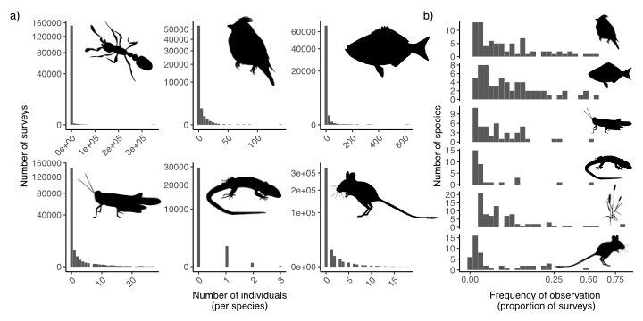

Figure 1: Two dimensions of rarity that highlight that rarity is the norm in ecosystems across the globe, Here, we show that most species are a) rare in abundance across sites and sampling sessions and b) detected in relatively few sampling sessions. We’ve demonstrated this general pattern for a diversity of taxa across systems, including terrestrial and marine animals and plants.

Figure 2: Distributions of abundances and occurrence across three datasets when excluding (blue) and including (yellow) detection error (a: birds, b: plants, and c: grasshoppers) and how accounting for imperfect detection alters estimates of a variety of biodiversity metrics (d-f). Across abundance (a and c) and occurrence (b) datasets, accounting for imperfect detection shifts species abundance and occurrence distributions to the right as models account for false negatives. Accounting for rare species leads to increases in bird functional diversity (a), increases in the number of plant species lost over time (b), and decreases abundance-based dissimilarity for grasshopers (c).

## 

Figure 3: A general modeling approach for accounting for imperfect detection of rare species. Data are represented as brown circles; models as teal squares.

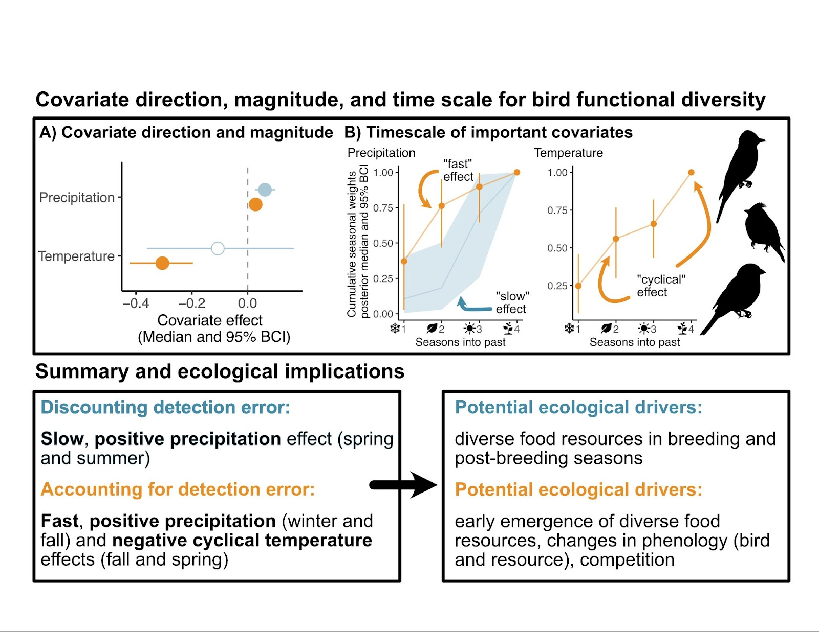

Figure 4: How accounting for imperfect detection alters estimates of covariate effects and time scales on bird functional diversity measured as Rao’s quadratic entropy.

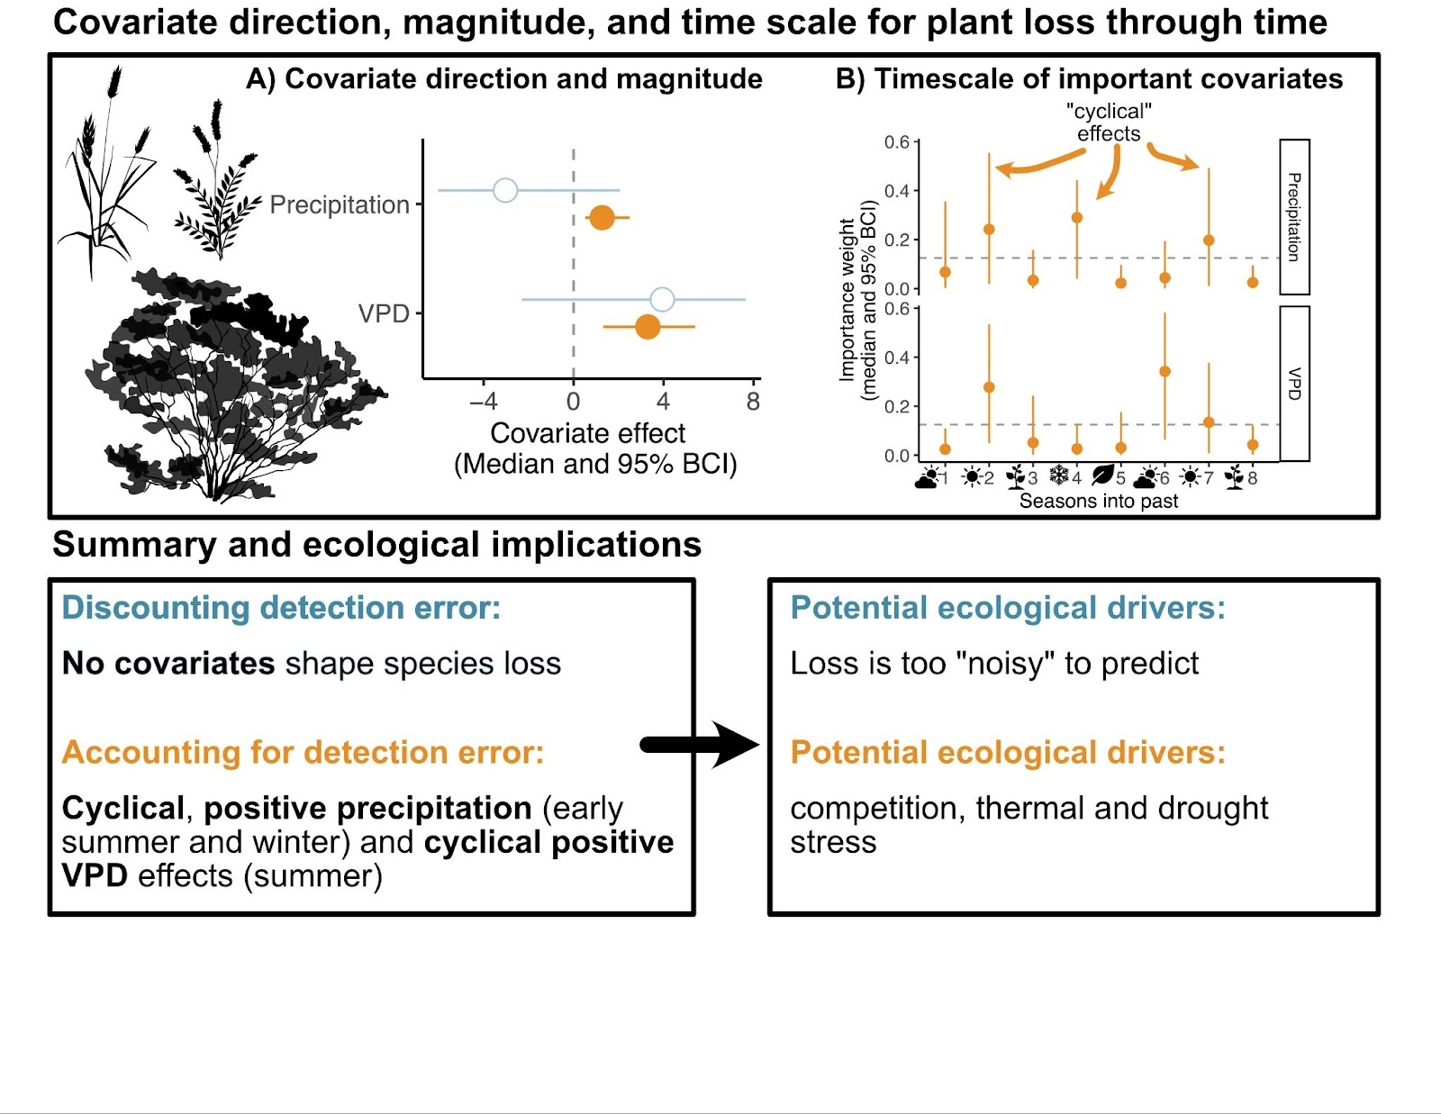

Figure 5: How accounting for imperfect detection alters estimates of covariate effects and time scales on plant species loss.

Figure 6: How accounting for imperfect detection alters estimates of covariate effects and time scales on temporal stability of grasshopper communities based on Bray-Curtis dissimilarity.