**Title:**

Functionalizing ecological integrity: using functional ecology to monitor animal communities across taxa and environments

**Author list:** Ana Miller-ter Kuile1,2, Jamie S. Sanderlin1, Jessalyn Ayars3, Helen Chmura4, Melissa Dressen5, Jessie D. Golding6, Gavin M. Jones3, Rebecca Kirby7, Kari E. A. Norman3, Sarah Sawyer8, Donna Shorrock9, Cara Staab10, Zachary L. Steel11, Valerie Stein Foster12

1 USDA Forest Service Rocky Mountain Research Station, Flagstaff, Arizona, USA

2 Northern Arizona University School of Informatics, Computing, and Cyber Systems, Flagstaff, Arizona, USA

3 USDA Forest Service Rocky Mountain Research Station, Albuquerque, New Mexico, USA

4 USDA Forest Service Rocky Mountain Research Station, Missoula, Montana, USA

5 USDA Forest Service Rocky Mountain Region, Lakewood, Colorado, USA

6 University of Arizona, School of Natural Resources and the Environment, Tucson, AZ USA

7 USDA Forest Service Southwestern Region, Albuquerque, New Mexico, USA

8 USDA Forest Service, Vallejo, California, USA

9

10

11 USDA Forest Service Rocky Mountain Research Station, Fort Collins, Colorado, USA

12 USDA Forest Service, Flagstaff, Arizona, USA

**Target journal:** Frontiers in Ecology and the Environment Concepts and Questions (2800 words from Introduction-Conclusion, including panel text; <= 40 references, 4-5 total figures, tables, and panels)

**Abstract**

Ecological integrity, or the ability of an ecosystem to support the structure, composition, diversity, function, and connectivity within its natural range, has been a guiding principle in ecosystem monitoring across the globe. However, in terrestrial ecosystems, ecological integrity monitoring efforts often exclude animal communities, even though they are critical drivers of integrity. We are at a moment when methodological advances in monitoring and data science have made it easier to monitor and describe animal communities. We highlight examples of these advances and how they can remove barriers to adopting animal-specific integrity metrics. We then illustrate how describing animal communities in terms of functional ecology can provide a generalizable approach to incorporating animal community metrics into integrity-based monitoring across taxa and ecosystems. Incorporating animal communities into ecological integrity monitoring is a vital step in understanding how human-driven change, restoration, and conservation shape ecosystems worldwide.

**In a nutshell**

* Ecological integrity, which encompasses the structure, composition, diversity, function, and connectivity of an ecosystem, is an important guiding principle for ecosystem monitoring
* Ecological integrity monitoring for land management has historically excluded animal communities
* New advances in monitoring technology, data availability, statistical methods, and computation power have removed historic barriers to monitoring animal communities
* Using functional traits, such as diet, habitat, behavior, and body size, provides a generalizable way to incorporate animal communities in ecological integrity monitoring

**Monitoring ecological integrity: where we are and where we could go**

Ecological integrity is an important guiding concept for ecosystem assessment and monitoring globally. In both conservation and management contexts, ecological integrity provides a cohesive framework for assessing whether ecosystems support diversity, structure, and function within a natural or expected range (Parrish *et al.* 2003). The concept has and continues to be applied across agencies and environments worldwide, sometimes as one cohesive “integrity score” for an ecosystem (Faber-Langendoen *et al.* 2006; Woodley 2010) and sometimes to describe a set of desirable or target conditions (e.g., a combination of metrics depending on management or conservation goals, such as forest stand structure, size, and species composition, and amount of coarse woody debris, (Carter *et al.* 2019; Nordman *et al.* 2021). At its core, the concept of ecological integrity aims to describe how an ecosystem looks and functions relative to a goal condition or range of conditions.

Because of its broad definition, monitoring ecological integrity has looked different across environments and agencies using the concept to guide monitoring. For example, in land management, the emphasis of ecological integrity monitoring has been on the structure and composition of vegetation (e.g., trees, Nordman *et al.* 2021); in aquatic ecosystems, the emphasis of monitoring is on indicator species (e.g., macroinvertebrates and fish) of pollution and land use (Karr 1981; Carter *et al.* 2019). The variety of applications is based on a variety of factors, from historical or current agency-specific mandates for monitoring to historical establishment of standardized protocols (e.g., Karr 1981). Due to the variety of applications, it has been challenging to create generalizable metrics across ecosystems, taxa, and agencies.

One of the key gaps in applying ecological integrity to monitoring is the inclusion of animal communities in terrestrial monitoring (Figures 1 & 2A). Animal communities provide additive information about ecological integrity not revealed by common indices based on abiotic factors and vegetation structure. For example, animal communities comprise multiple trophic levels, so including them in assessments of ecological integrity can help decipher top-down influences on ecosystem states (Karr 1981). When animals are considered in terrestrial systems, they are often evaluated with a habitat-proxy approach (Palmer *et al.* 1997) or through focal species monitoring (Runge *et al.* 2019). Although the habitat-proxy approach captures abiotic and vegetation structure metrics of ecological integrity well, both approaches are generally poor predictors of animal community response to change (Schwartz *et al.* 2015; Van Lanen *et al.* 2023). It is well established that animal communities are not only influenced by the ecosystems they occupy, but that they also shape these ecosystems (Russo *et al.* 2023). Thus, the structure and composition of the animal community shapes ecological integrity directly.

We propose that we are at a pivotal moment for adopting animal community metrics of ecological integrity into terrestrial monitoring efforts for two reasons. First, current and growing technological advances in monitoring and data analysis have alleviated many real or perceived barriers to monitoring animal communities. Second, because ecological integrity is essentially a metric describing how functional an ecosystem is, we can adopt metrics for animal communities using functional ecology and functional traits (e.g., feeding, habitat, behavioral, and morphology traits) as a guiding principle because functional traits are generalizable and comparable across taxa and environments. We highlight methodological and technological advances we find to be most promising in this endeavor and highlight literature demonstrating how using a functional ecology approach allows for building general protocols, baselines, and understanding of ecological integrity of animal communities across systems, taxa, and monitoring schema.

**Growth in monitoring, data, and computation capacity**

Historically, animal communities have been difficult to integrate into ecological integrity monitoring because animal communities are challenging to monitor. For example, animals can move, are cryptic, and/or are rare on the landscape relative to stationary ecosystem components. However, new methods of data collection are making these barriers a relic of the past. New technology, such as acoustic recording units (ARUs), camera traps, environmental DNA (eDNA), and drones are allowing us to collect data on animal communities at much broader spatial and temporal scales (Rees *et al.* 2014; Steenweg *et al.* 2017; Wood *et al.* 2019). These and traditional data collection methods are contributing to a growing number of long-term monitoring programs (e.g. Breeding Bird Survey: (Ziolkowski Jr. *et al.* 2023), NABat: (Benjamin Gotthold *et al.*), LTER network) and databases (i.e., AVONET bird trait database; (Tobias *et al.* 2022) for diverse taxa across many ecosystems.

Technological advances and a growing amount of data, combined with advanced modeling and computational ability, further erode barriers to monitoring animal communities, and thus, incorporating animal communities into ecological integrity metrics. Modeling approaches such as multi-species occupancy models (Iknayan *et al.* 2014) and data integration (combining multiple data sources, including those collected by community scientists, e.g., eBIRD) (Sullivan *et al.* 2009; Miller *et al.* 2019), can accommodate large datasets and help account for deficiencies in historical data collection (e.g., imperfect detection, biased sampling design, lack of temporal or spatial coverage). Advancements in methods have been paired with increased computational power for efficient analyses of community data (Yackulic *et al.* 2020). Thus, with analytical and technological advances, the time has never been better to integrate animals into ecological integrity monitoring (Figure 3).

Nevertheless, proposed changes to monitoring programs can be met with skepticism, and challenges will certainly confront efforts to integrate animals into ecological integrity monitoring. For example, many emerging sampling technologies (i.e., ARUs, camera traps, eDNA) are designed as multi-species sampling approaches that passively or non-invasively sample large areas. These methods may be more expensive or require more quantitative expertise during sampling design and data analysis than established single-species approaches. Where concerns exist about the additional cost of multi-species sampling, community-level monitoring could be simplified over time as part of goal-efficient monitoring approaches (Golding et al, in review) and optimal sampling approaches (i.e., (Sanderlin *et al.* 2014). And, as we highlight in our next point, these decisions could be based on information about the species functional groups that most shape ecosystem integrity.

**Functional ecology as a general framework for ecological integrity and animal communities**

The functional ecology of an animal community describes the traits that underpin the maintenance of ecological processes, making functional ecology a clear and simple approach to ecological integrity for animal communities. Functional traits, such as those related to diet, morphology, and habitat use, can be generalized across systems, taxa, and data collection methodologies (Carter *et al.* 2019). Animal communities perform processes such as nutrient cycling (Schmitz *et al.* 2014; Schneider *et al.* 2016) seed and pollen dispersal (González‐Robles *et al.* 2021; Fricke *et al.* 2022). composition of species within functional groups in an animal community determines how these processes shape ecosystems (e.g., (Bello *et al.* 2015; Donoso *et al.* 2020). of these functions and the animal traits that govern them are general across ecosystems, thus, they provide a way to describe animal communities and ecological integrity across systems and taxa and to build predictions about the mechanisms that may shape ecosystems and ecological integrity (Mcgill *et al.* 2006).

Ecological integrity is often divided into four common components: 1) structure (e.g., canopy cover), 2) composition/diversity (e.g., species richness), 3) function (e.g., nutrient cycling), and 4) connectivity (e.g., corridors). Ideally, monitoring targets all of these through a combination of metrics. We can extend these and other aspects of ecological integrity to animal community monitoring using functional ecology and functional traits. These traits include trophic (e.g., trophic composition and diet breadth), habitat (e.g., feeding and nesting sites and geographic range), morphological (e.g., body size), and behavioral traits (e.g., migratory behavior, dispersal distances, and range size; (Gonçalves‐Souza *et al.* 2023); Figure 2B). These traits describe animals in communities across taxa and environments and could be used to build a general set of ecological integrity metrics (e.g., Karr 1981). Below we highlight studies that demonstrate the benefit of using functional ecology for monitoring animal communities for ecological integrity (Figure 4).

*Structure*

The *structure* of animal communities includes the networks of biological interactions that shape all communities. Thus, monitoring animal community structure could include monitoring these networks or the components of these networks (e.g., key network components, such as primary producers, predators, or keystone species). (Johnson and Ringler 2014) show that stream macroinvertebrate and fish assemblages in New York, USA respond to human-driven environmental change. Specifically, this study highlights that functional traits related to network *structure* (trophic composition, feeding guild, and diet breadth) are all influenced by human-driven environmental change, with key implications for ecosystem function. For example, the macroinvertebrate community is less even (more dominated by the three most common taxa) with increased urbanization, a shift that coincides with a dominance of a particular feeding guild (more ’collector-gatherers’ that focus on gathering filtered particles once they’ve fallen out of the water column versus filtering them out of suspension). Further, streams with lower dissolved oxygen are dominated by fish with a more generalized diet. Importantly, fish and macroinvertebrates respond differently to human-driven change, highlighting the importance of monitoring multiple groups of taxa as indicators of ecological integrity.

*Composition and diversity*

(Alexandrino *et al.* 2017) developed a metric of ecological integrity based on the functional *composition* and *diversity* of the bird communities in the Brazilian Atlantic Forest. They computed and compared multiple abundance and richness-based metrics of species composition, splitting species up into a set of functional trait groups, including traits related to habitat associations (e.g., forest-dwelling), foraging habits (e.g., ground versus canopy), endemism, and threat level. From a set of candidate metrics, they selected just seven that categorized functional community composition well along a human disturbance gradient, including richness and abundance of species in specific habitat associations and foraging guilds. They combined these into one ecological integrity index that better detected a gradient of human disturbance than taxonomic diversity metrics, including total species richness or Shannon diversity.

*Function*

(Gómez *et al.* 2021) demonstrated that functional trait space (a measure of the breadth of many different traits represented in a community) decreased for a bird assemblage in the Andes of Colombia over a century of increased human use. Most of this change in functional diversity was caused by traits related to body size, dispersal ability, and habitat breadth. Specifically, average body size and diet specialization of birds in the community decreased over time while dispersal ability increased. These changes have implications for ecosystem *functions* such as seed dispersal, carbon storage, and habitat connectivity (Bello *et al.* 2015; Donoso *et al.* 2020; González‐Robles *et al.* 2021; Fricke *et al.* 2022).

*Connectivity*

(Rocha-Ortega *et al.* 2019) demonstrated that the average body size of dragonfly and damselfly communities (together referred to as “Odonates”) tracked past and current land use in Mexico. Specifically, large-bodied species, which can fly over greater distances to more disparate patches, do better with land use intensification. Communities with greater dispersal abilities overall alter the *connectivity* of patches across the landscape and increase the potential for biotic homogenization (Olden *et al.* 2004) and loss of patches with distinct biodiversity (Juen and De Marco 2011). Importantly, in this study, single species’ abundances and total species richness did not track land use intensification.

**The future of ecological integrity monitoring includes animal communities**

We are in a new era of methodological and computational advances that can allow us to better monitor how land management, restoration, and conservation efforts shape ecosystems. In these contexts, there is a growing awareness that even actions that are meant to improve the resiliency and integrity of an ecosystem have a ripple effect that lead to positive, negative, and neutral outcomes for a variety of interconnected ecosystem components (Miller‐ter Kuile *et al.* 2021; Pearson *et al.* 2022). Expanding ecological integrity monitoring to include animal community metrics will help us better understand how communities are structured and how conservation and management actions shape ecosystems, without disregarding crucial players in ecosystems. Tracking communities in terms of their functional traits is a unifying way in which we can document the ecological integrity of animal communities.

**References:**

Alexandrino ER, Buechley ER, Karr JR, *et al.* 2017. Bird based Index of Biotic Integrity: Assessing the ecological condition of Atlantic Forest patches in human-modified landscape. *Ecological Indicators* **73**: 662–75.

Bello C, Galetti M, Pizo MA, *et al.* 2015. Defaunation affects carbon storage in tropical forests. *Sci Adv* **1**: e1501105.

Benjamin Gotthold, Ali Khalighifar, Joseph P Chabarek, *et al.* North American Bat Monitoring Program: NABat Acoustic ML (version 2.0.0).

Carter SK, Fleishman E, Leinwand IIF, *et al.* 2019. Quantifying Ecological Integrity of Terrestrial Systems to Inform Management of Multiple-Use Public Lands in the United States. *Environmental Management* **64**: 1–19.

Donoso I, Sorensen MC, Blendinger PG, *et al.* 2020. Downsizing of animal communities triggers stronger functional than structural decay in seed-dispersal networks. *Nat Commun* **11**: 1582.

Faber-Langendoen D, Tierney G, Shriver G, and Lombard P. 2006. Monitoring Ecological Resources within U.S. National Parks: Developing “Vital Signs” of Ecological Integrity for the Northeast Temperate Network. *USDA Forest Service Prodeedings* **RMRS-P-42CD**: 614–22.

Fricke EC, Ordonez A, Rogers HS, and Svenning J-C. 2022. The effects of defaunation on plants’ capacity to track climate change. *Science* **375**: 210–4.

Gómez C, Tenorio EA, and Cadena CD. 2021. Change in avian functional fingerprints of a Neotropical montane forest over 100 years as an indicator of ecosystem integrity. *Conservation Biology* **35**: 1552–63.

Gonçalves‐Souza T, Chaves LS, Boldorini GX, *et al.* 2023. Bringing light onto the Raunkiæran shortfall: A comprehensive review of traits used in functional animal ecology. *Ecology and Evolution* **13**: e10016.

González‐Robles A, García C, Salido T, *et al.* 2021. Extensive pollen‐mediated gene flow across intensively managed landscapes in an insect‐pollinated shrub native to semiarid habitats. *Mol Ecol* **30**: 3408–21.

Iknayan KJ, Tingley MW, Furnas BJ, and Beissinger SR. 2014. Detecting diversity: emerging methods to estimate species diversity. *Trends in Ecology & Evolution* **29**: 97–106.

Johnson SL and Ringler NH. 2014. The response of fish and macroinvertebrate assemblages to multiple stressors: A comparative analysis of aquatic communities in a perturbed watershed (Onondaga Lake, NY). *Ecological Indicators* **41**: 198–208.

Juen L and De Marco P. 2011. Odonate biodiversity in terra-firme forest streamlets in Central Amazonia: on the relative effects of neutral and niche drivers at small geographical extents: Odonate biodiversity in terra-firme forest streamlets. *Insect Conservation and Diversity* **4**: 265–74.

Karr JR. 1981. Assessment of Biotic Integrity Using Fish Communities. *Fisheries Magazine* **6**: 21–7.

Mcgill B, Enquist B, Weiher E, and Westoby M. 2006. Rebuilding community ecology from functional traits. *Trends in Ecology & Evolution* **21**: 178–85.

Miller DAW, Pacifici K, Sanderlin JS, and Reich BJ. 2019. The recent past and promising future for data integration methods to estimate species’ distributions. *Methods Ecol Evol* **10**: 22–37.

Miller‐ter Kuile A, Orr D, Bui A, *et al.* 2021. Impacts of rodent eradication on seed predation and plant community biomass on a tropical atoll. *Biotropica* **53**: 232–42.

Nordman C, Faber-Langendoen D, and Baggs J. 2021. Rapid Ecological Integrity Assessment Metrics to Restore Wildlife Habitat and Biodiversity for Shortleaf Pine–Oak Ecosystems. *Forests* **12**: 1739.

Olden JD, LeRoy Poff N, Douglas MR, *et al.* 2004. Ecological and evolutionary consequences of biotic homogenization. *Trends in Ecology & Evolution* **19**: 18–24.

Palmer MA, Ambrose RF, and Poff NL. 1997. Ecological Theory and Community Restoration Ecology. *Restor Ecology* **5**: 291–300.

Parrish JD, Braun DP, and Unnasch RS. 2003. Are We Conserving What We Say We Are? Measuring Ecological Integrity within Protected Areas. *BioScience* **53**: 851.

Pearson DE, Clark TJ, and Hahn PG. 2022. Evaluating unintended consequences of intentional species introductions and eradications for improved conservation management. *Conservation Biology* **36**: e13734.

Rees HC, Maddison BC, Middleditch DJ, *et al.* 2014. REVIEW: The detection of aquatic animal species using environmental DNA – a review of eDNA as a survey tool in ecology. *Journal of Applied Ecology* **51**: 1450–9.

Rocha-Ortega M, Rodríguez P, and Córdoba-Aguilar A. 2019. Can dragonfly and damselfly communities be used as bioindicators of land use intensification? *Ecological Indicators* **107**: 105553.

Runge CA, Withey JC, Naugle DE, *et al.* 2019. Single species conservation as an umbrella for management of landscape threats. *PLoS ONE* **14**: e0209619.

Russo NJ, Davies AB, Blakey RV, *et al.* 2023. Feedback loops between 3D vegetation structure and ecological functions of animals. *Ecology Letters* **26**: 1597–613.

Sanderlin JS, Block WM, and Ganey JL. 2014. Optimizing study design for multi‐species avian monitoring programmes. *Journal of Applied Ecology* **51**: 860–70.

Schmitz OJ, Raymond PA, Estes JA, *et al.* 2014. Animating the Carbon Cycle. *Ecosystems* **17**: 344–59.

Schneider FD, Brose U, Rall BC, and Guill C. 2016. Animal diversity and ecosystem functioning in dynamic food webs. *Nat Commun* **7**: 12718.

Schwartz MK, Sanderlin JS, and Block WM. 2015. Manage habitat, monitor species. Wildlife Habitat Conservation: Concepts, Challenges, and Solutions. Baltimore, MD: Johns Hopkins University Press.

Steenweg R, Hebblewhite M, Kays R, *et al.* 2017. Scaling‐up camera traps: monitoring the planet’s biodiversity with networks of remote sensors. *Frontiers in Ecol & Environ* **15**: 26–34.

Sullivan BL, Wood CL, Iliff MJ, *et al.* 2009. eBird: A citizen-based bird observation network in the biological sciences. *Biological Conservation* **142**: 2282–92.

Tobias JA, Sheard C, Pigot AL, *et al.* 2022. AVONET: morphological, ecological and geographical data for all birds. *Ecology Letters* **25**: 581–97.

Van Lanen NJ, Monroe AP, and Aldridge CL. 2023. A hidden cost of single species management: Habitat-relationships reveal potential negative effects of conifer removal on a non-target species. *Biological Conservation* **280**: 109959.

Wood CM, Gutiérrez RJ, and Peery MZ. 2019. Acoustic monitoring reveals a diverse forest owl community, illustrating its potential for basic and applied ecology. *Ecology* **100**: e02764.

Woodley S. 2010. Ecological Integrity and Canada’s National Parks. *The George Wright Forum* **27**: 151–60.

Yackulic CB, Dodrill M, Dzul M, *et al.* 2020. A need for speed in Bayesian population models: a practical guide to marginalizing and recovering discrete latent states. *Ecol Appl* **30**.

Ziolkowski Jr. D, Lutmerding M, English WB, *et al.* 2023. 2023 Release - North American Breeding Bird Survey Dataset (1966 - 2022).

**Figures:**

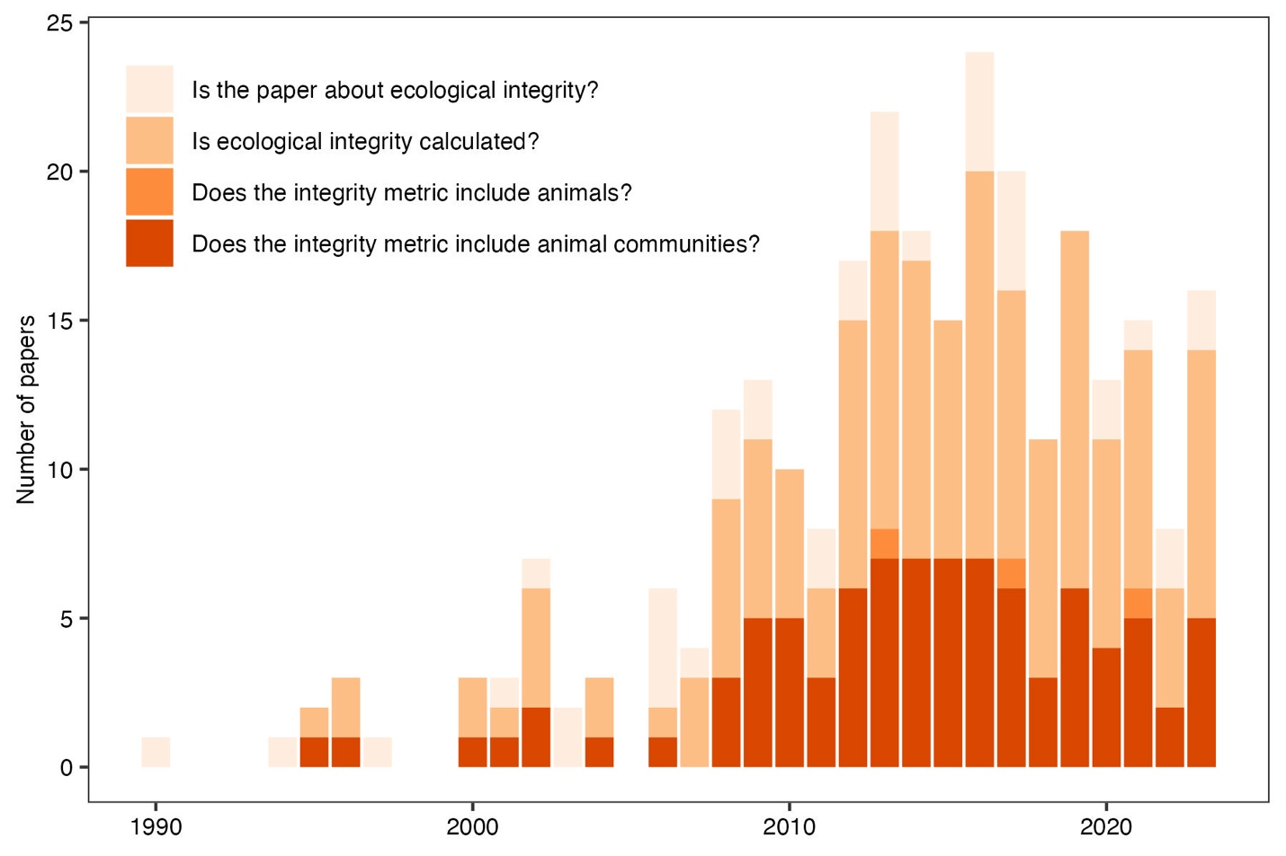

Figure 1: Number of papers in a literature review of ecological integrity by year. Each bar represents the total number of papers published in that year. The colors represent the proportions that a) are about ecological integrity (lightest orange), b) calculate ecological integrity (second lightest orange), c) include animals in their metrics of ecological integrity (second darkest orange), and d) include animal communities in metrics of ecological integrity (darkest orange). Methods for the literature review can be found in our Supporting Information.

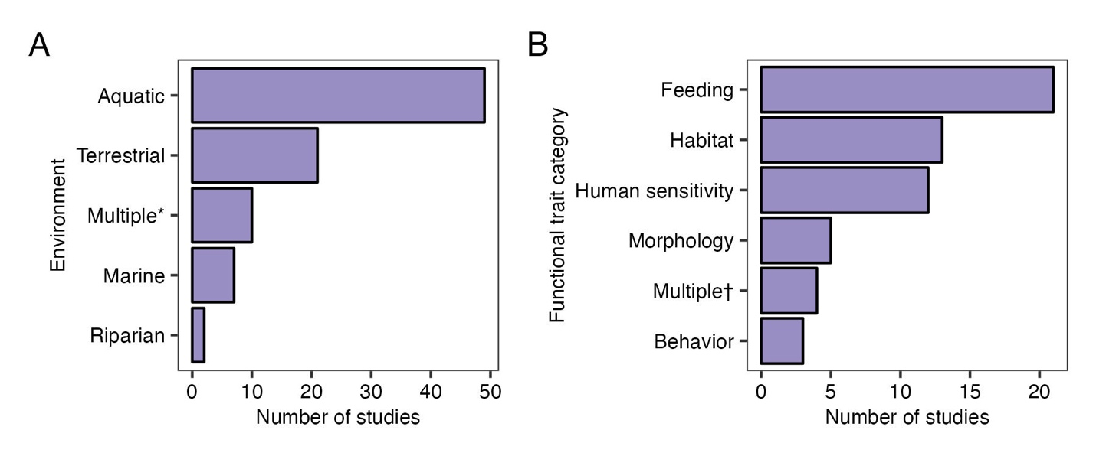

Figure 2: The number of studies per environment (A) in the literature review as well as the number of studies that documented different animal community traits (B). The * in (A) indicates that the study included multiple environments, usually the interface between an aquatic and riparian or marine and estuary environment. The † in (B) indicates that the study combined trait categories into a functional diversity metric.

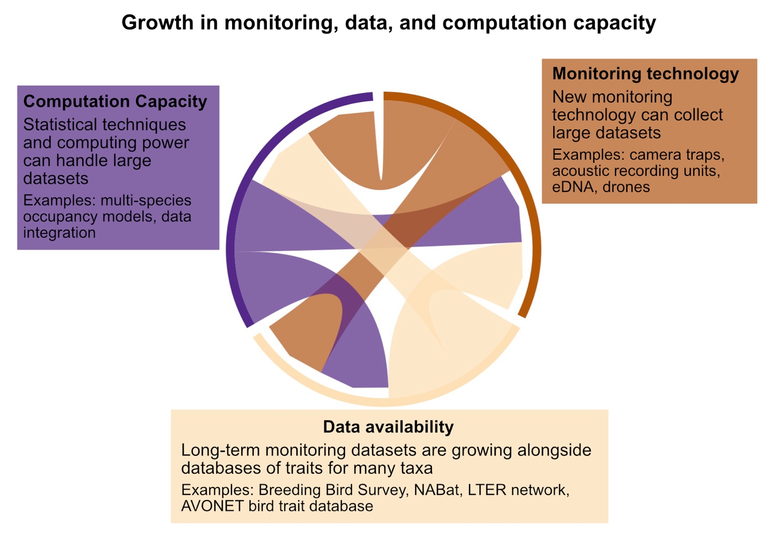

Figure 3: Three concurrent advances provide the ideal moment for adoption of animal communities into monitoring ecological integrity, including monitoring technology, data availability, and computation capacity.

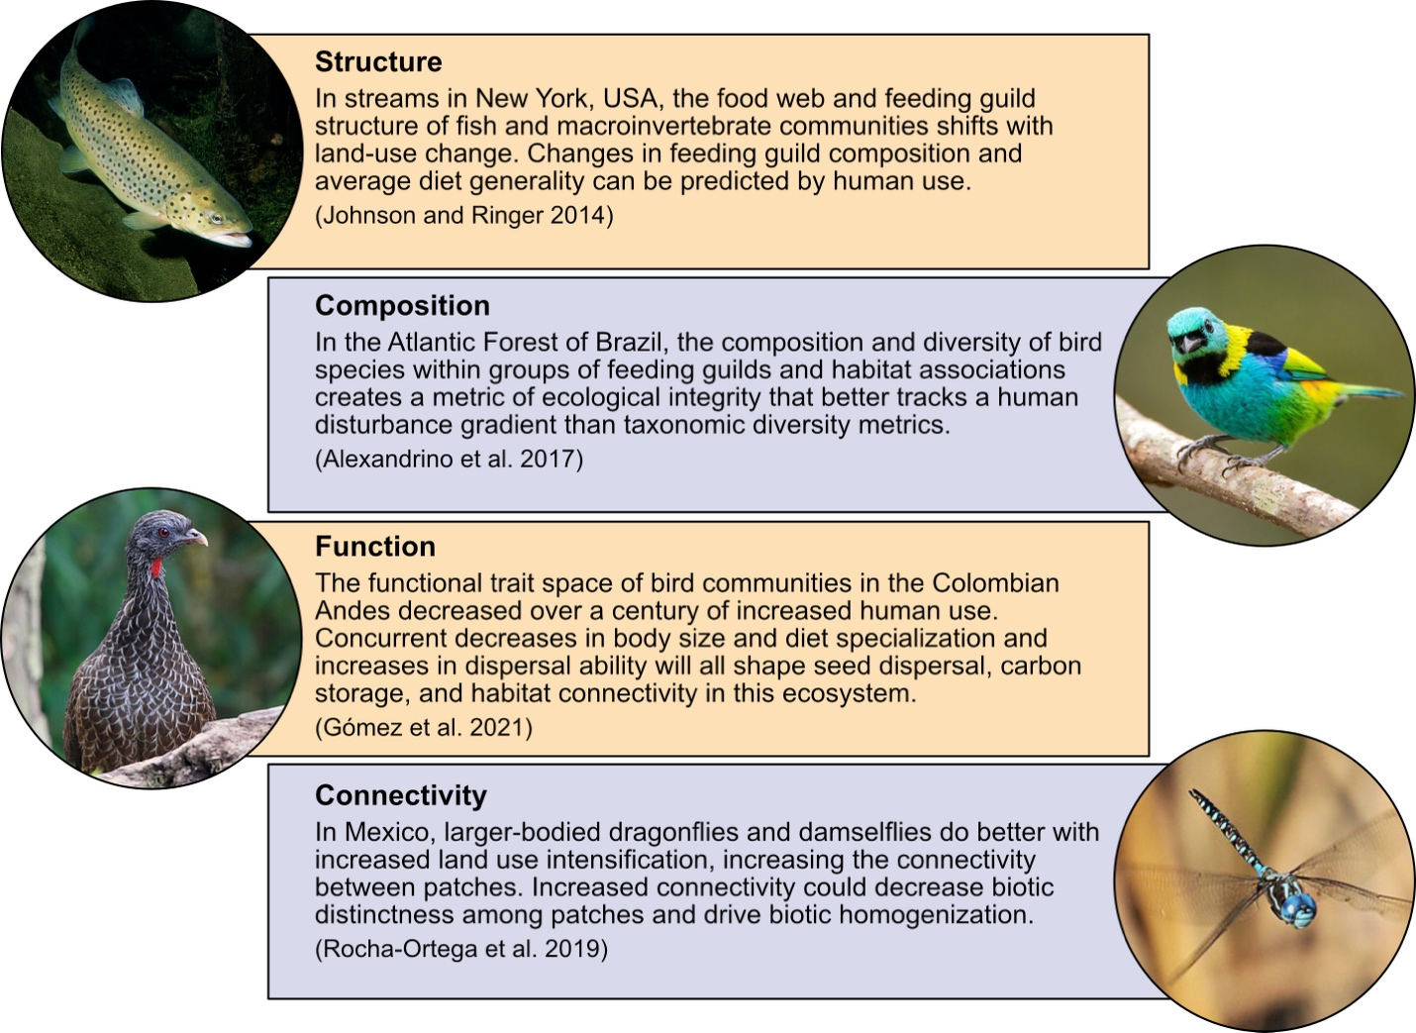

Figure 4: Examples of using animal community functional ecology to track the ecological integrity of ecosystems across the globe. We highlight examples from four common integrity components, including structure, composition, function, and connectivity. Images from Wikimedia Commons (Copyright CC-0).

**Supporting Information:**

*Methods for the qualitative literature review*

We searched SCOPUS on 3 November 2023 using the search string “ecological integrity” OR “biological integrity”. We reviewed papers from five journals that contained high numbers of citations and that we felt were sufficiently broad in scope to be representative of cross-disciplinary trends: Ecological Indicators, Biological Conservation, Ecological Applications, Conservation Biology, and Forest Ecology and Management. This resulted in 279 papers for review, representing approximately 7.5% of the total papers returned in the search. We highlight key patterns in these results in the main text (Figures 1 & 2) and they are consistent with a study that did a more comprehensive review on the topic (Carter et al. 2019). Of these, 178 were about ecological integrity, 146 actually measured ecological integrity (e.g., were not review or conceptual papers), 89 included animal communities in measures of ecological integrity.

For those papers that included animal communities in their measures of ecological integrity, we reviewed the abstract and main text and compiled information on the taxa, habitat, geographic region, and whether the animal community was measured in terms of functional traits. This resulted in 33 studies that documented functional traits and 6 of those with functional traits were from terrestrial environments. Key results of this scoring are highlighted in Figure 2 and SI Figure 1.

We provide the studies we reviewed as well as their scores for each of the categories described above in the data for this paper on Zenodo.

*Figures*

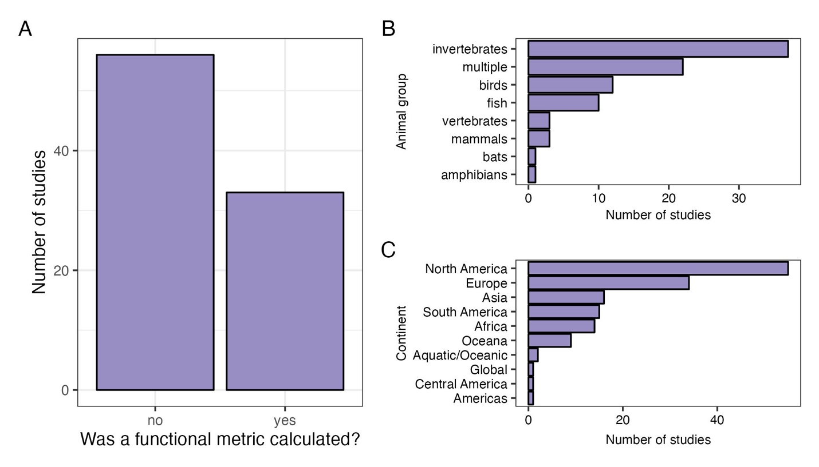

SI Figure 1: Summaries of different aspects of the literature review. (A) Whether or not a functional metric was calculated for animal communities, (B) which groups of animals were in the study (multiple usually included fish, aquatic invertebrates, and zooplankton), and (C) the continent on which the study occurred.