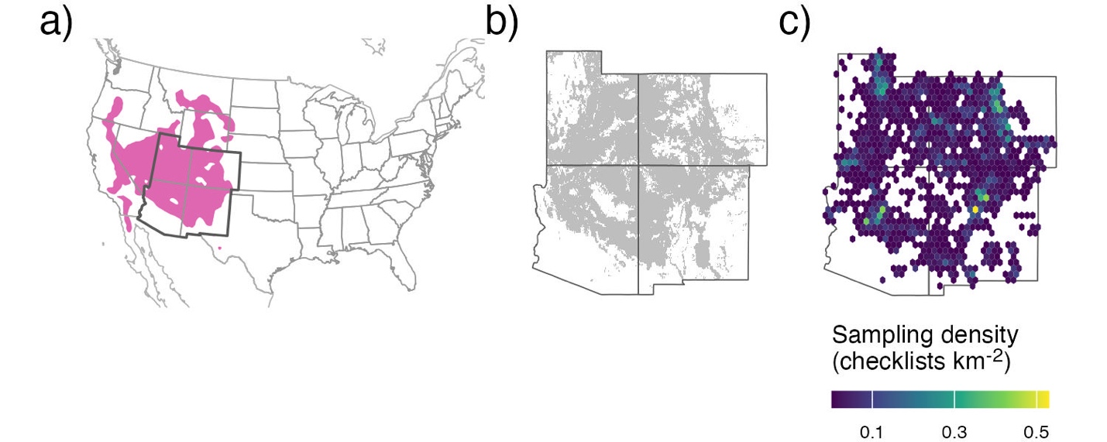

Figure 1: The full species range (a) for pinyon jays (pink region; data from eBird Status and Trends) with our study region indicated by darker borders (“US Southwest”, including Arizona, Colorado, New Mexico, and Utah). The range of two-needled pinyon (b) in our study region. Sampling density (c; in checklists km⁻²) across all years of eBird data (2010-2022) after spatial and temporal subsampling and filtering checklists only to areas with two-needle pinyon basal area.

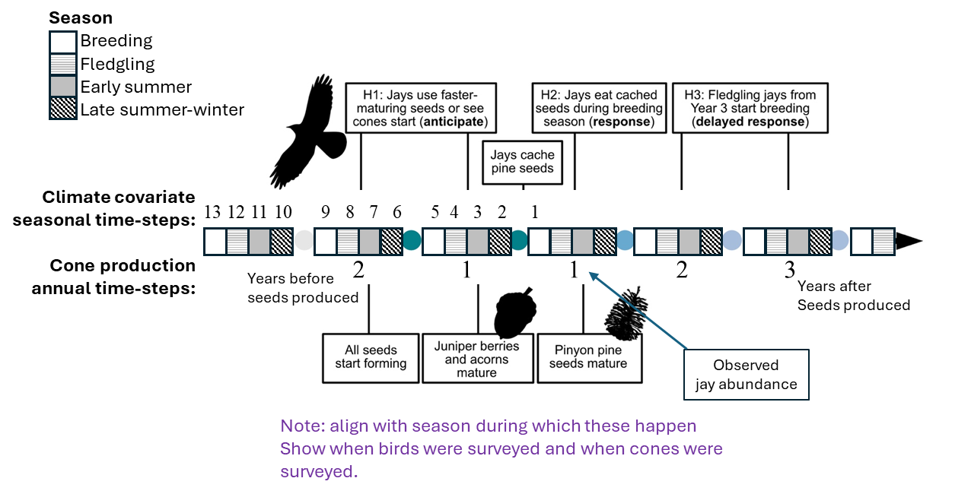
Figure 2: A timeline of hypothesized pinyon jay responses (top) and the progression of seed and cone development (bottom) following a favorable climate year for cone development. We outline three hypotheses driving the temporal relationships between pinyon jay and seed availability, including H1: jays ‘anticipate’ seed availability through utilization of other foods (e.g., acorns, juniper berries) or because they see cones developing in an area; H2: jays ‘respond’ to seed availability in the nesting season after they cache seeds and H3: jays have a ‘delayed response’ to seed availability with a delay as the young from the caching year enter the breeding population 1.5-2 years later.

H1: Jays use faster-maturing seeds or see cones start (anticipate)
H2: Jays eat cached seeds during breeding season (immediate response)
H3: Fledgling jays from Year 3 start breeding (delayed response)

All seeds start forming
Juniper berries and acorns mature
Pinyon pine seeds mature

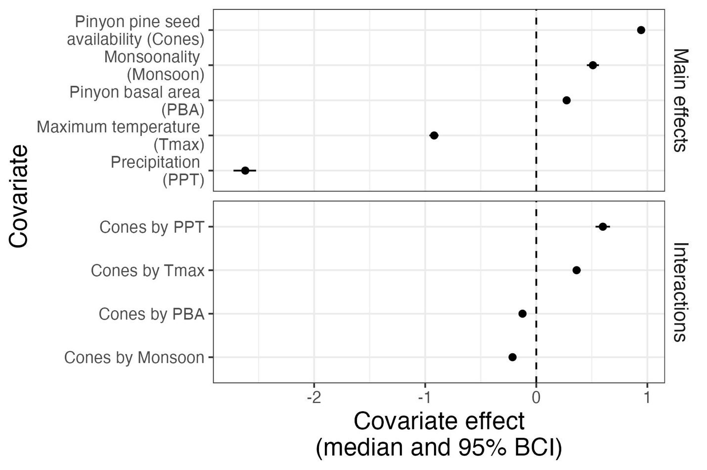
Figure 3: Covariate effects for all main covariates and their interactions with cones. All covariates were scaled and so their relative magnitudes of effect can be compared. All values represent posterior median and 95% Bayesian Credible Intervals and any covariate ranges that cross the dashed line at zero have no clear effect on pinyon jay abundance.

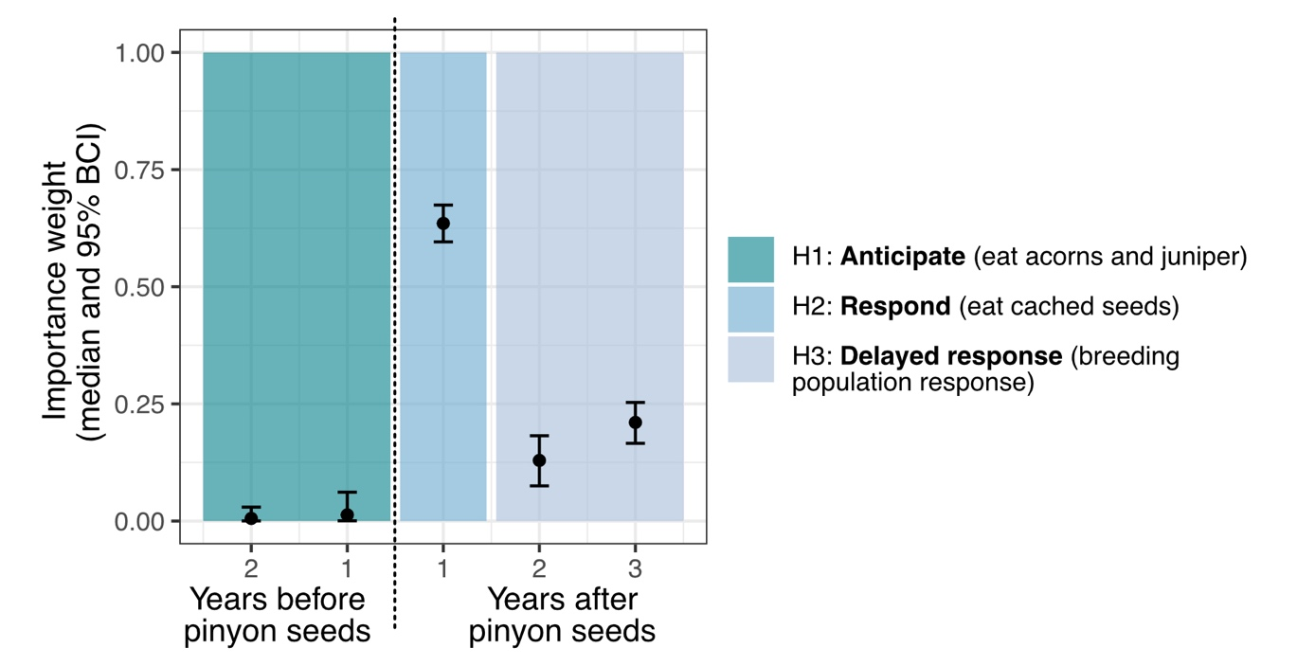
Figure 4: Importance weights for the years considered for the relationship between pinyon jays and pinyon cone (seed) availability. Colored boxes indicate the three ecological hypotheses about the time period(s) of the relationship between jays and cones. The dashed line indicates the distinction between the years before cones (left) and years after cones (right).

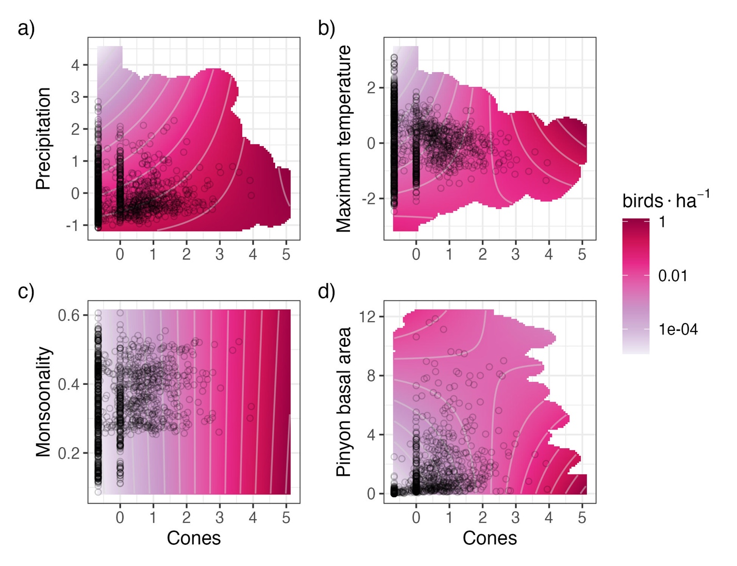
Figure 5: Interaction plots for the four covariates with significant interactive effects with cone (seed) availability, including: a) precipitation, b) maximum temperature, c) monsoonality, and d) pinyon basal area. Darker pink/red color corresponds to a greater number of birds in that combination of covariates. Black circles represent a random sample of the observed data.

