Title: Caching in: A seed dispersal mutualism signals the decline of a songbird-pine system
Author List: Ana Miller-ter Kuile^{1,2}, Andreas P. Wion³, Kyle C. Rodman⁴, Jamie S. Sanderlin², Kiona Ogle¹
Author Affiliations:
¹ School of Informatics, Computing, and Cyber Systems, Northern Arizona University, Flagstaff, Arizona, USA
² USDA Forest Service, Rocky Mountain Research Station, Flagstaff, Arizona, USA
³ Forest Stewards Guild, Santa Fe, New Mexico, USA
⁴ Ecological Restoration Institute, Northern Arizona University, Flagstaff, Arizona, USA
Corresponding author: Ana Miller-ter Kuile, ana.miller-ter-kuile@nau.edu, Northern Arizona University School of Informatics, Computing, and Cyber Systems, 1295 Knoles Drive, Flagstaff, Arizona 86011
Competing Interests: The authors declare no competing interests.
Author Contributions
AM-tK, APW, and KCR conceived the ideas; AM-tK, KO, and JSS developed statistical methods; AM-tK and KCR developed novel data layers and ran statistical models; AM-tK led the writing of the manuscript with support from APW, KCR, and KO. All authors contributed to the drafts and gave final approval for publication.
Data Availability
Data and code for this paper are available on Zenodo ¹.

Abstract
Global environmental change is driving population declines across the globe. While habitat loss is the primary driver of such trends, species are also impacted by changes in biotic interactions and interaction partners, factors that are rarely considered when evaluating populations. Here, we explored interactions between a declining seed disperser (pinyon jay; Gymnorhinus cyanocephalus) and a favored seed tree (two-needle pinyon pine; Pinus edulis) in the southwestern USA. We leveraged broad-scale (n > 800,000 observations) and long-term (2010-2022) eBird citizen science data on pinyon jay abundance, along with spatiotemporal reconstructions of yearly pinyon seed cone production, to evaluate the effects of seed availability on pinyon jay abundance. Pinyon jays were most abundant in the spring following years of high cone production (64% relative importance), likely because they nested near cached seeds. There was also a legacy effect of high seed years (34% relative importance) likely due to delayed population increases. These relationships varied across the species’ range due to interactions between resource use, habitat, and climate. This study provides insight into a potential driver of pinyon jay decline: climate-driven declines in seed availability. Importantly, we demonstrate the vital influence biotic interactions can have on the population status of declining species.

Keywords
Gymnorhinus cyanocephalus, Pinus edulis, eBird, species interactions, temporal legacies
Introduction
Importance of Biotic Interactions to Understanding Population Trends
We are witnessing Earth’s sixth mass extinction event ^{2,3}. While habitat conversion and climatic change are the most influential proximate drivers of global species decline ⁴, an indirect cause of loss comes from the consequences of reshuffling (‘rewiring’) species interaction networks ^{5,6}. Losses and declines of species in interaction networks can lead to co-extinctions ⁷, extinction cascades ⁸, and the loss of important ecosystem functions performed by those species and interactions (e.g., pollination; Valiente‐Banuet et al., 2015). Thus, explicitly measuring the impacts of species interactions on population trends will be crucial for predicting future biodiversity patterns and ecosystem processes ¹⁰.
Including biotic interactions between species in population assessments may give many common approaches more predictive power (e.g., climate envelope models, habitat suitability indices, and species distribution models; ^{11–13}. In their traditional application, these models can fail to predict observed population patterns ^{14,15}. However, including species interactions into these or similar models is challenging given the dynamic nature of biotic interactions ^{16,17}. Interactions are shaped by past population and community dynamics, reflecting ecological memory and biological legacies ^{18–20}. Interactions can also shift across space due to variation in individual-fitness, resource availability, and competitive interactions ^{21,22}. Given this spatiotemporal variation, such species interactions vary widely in strength and direction (e.g., mutualisms become consumptive; 22–24).
Seed consumption and dispersal are important species interactions that shape the structure and function of ecosystems across the globe ^{26,27}. Seed resources are often unreliable throughout the year and across years, especially in systems where plants mast, or have episodic but synchronous seed production at the community or population level ²⁸. Given the “boom and bust” nature of seed availability in masting systems ^{29,30}, animals that rely on masting plants adapt to and respond strongly to the availability of these seeds. For example, seed dispersers can display anticipatory or predictive behaviors, such as elevated reproduction preceding abundant seed production years (e.g., ^{31,32}. Further, dispersers may have immediate behavioral responses to seed availability by congregating near seeds in trees or they may cache (“bury”) seeds for days, weeks, or months and revisit those cache sites to consume seeds ^{23,33,34}. Finally, seed abundance pulses influence future population sizes by altering vital rates such as survival and fecundity ³⁵. Consequently, in masting systems, seed availability can leave a legacy on populations of seed dispersers due to multiple mechanisms that can vary across habitat contexts ³⁶.
The pinyon pine (Pinus edulis) and pinyon jay (Gymnorhinus cyanocephalus) mutualism is an iconic example of seed dispersal in a masting system. For example, in the early 1900’s, Aldo Leopold described the pinyon jay as the “numenon” (essence) of the pinyon-juniper ecosystem, and historical reports document flocks of thousands of jays descending upon woodlands during mast years ³⁷. However, pinyon jays have been broadly declining over the last several decades ³⁸. The cause of their decline likely involves a complex set of drivers, including climate change, habitat modifications, and changes in food resource availability ^{38–40}. As evidence of this third causal agent, the pinyon pine has also faced recent population declines, with limited tree regeneration and reduced seed production of the surviving trees ^{41–46}. The concurrent declines in this system are not unique: changes in climate are shaping masting dynamics globally in ways that will likely alter seed dispersal interactions ⁴⁷. Improved understanding of the mechanisms and patterns of these changes may help to predict and mitigate large-scale population declines for both masting trees and the dependent seed dispersers ^{48,49}.
In this study, we quantify the relationship between pinyon jay and pinyon pine seed (cone) production by leveraging two broad-scale, long-term datasets from the pinyon pine-pinyon jay system (Figure 1). We combine a large (~800,000 observations) eBird dataset and estimates of pinyon pine cone production ^{46,50}; these datasets cover more than half the range of pinyon jays (Figure 1), the full range of pinyon pine, and capture over a decade (2010-2022) of bird abundance and cone production. This observation period is also characterized by high variation in climate ⁵¹ and habitat conditions ⁵². We explicitly model the temporal dynamics of this mutualism using a stochastic antecedent modeling (SAM) framework ¹⁹ to examine how populations of pinyon jay respond to resource availability (cones) and climate across space and time. We address two key questions: 1) Do pinyon jays exhibit anticipatory, immediate, or delayed relationships with pinyon pine cone availability (Figure 2), and 2) How do interactions between pinyon jays and pinyon pine vary across a range of habitat quality and climate conditions? Addressing these questions is not only necessary for conservation of this system but also bolsters our understanding of how species interactions shape population trends ⁵³.
Potential Temporal Relationships Between Pinyon Jays and Pinyon Seeds
Previous work suggests that pinyon jays “predict” cone availability in response to visual cues associated with initial cone development and maturation ⁵⁴. Conversely, other work has documented pinyon jays “responding” to masting events by nesting near sites where they cached seeds produced during the previous masting year ⁵⁵. In addition, pinyon jays undergo delayed maturity such that individuals enter the breeding population 1.5-2 years after fledging ⁵⁶. Thus, pinyon seed resource pulses may have delayed effects on pinyon jay abundance if these resource pulses stimulate events earlier in the life cycle (e.g., productivity or fledging success). The typical lifespan of a pinyon jay is 5-6 years ⁵⁷ and high cone production (“masting”) events in pinyon pines in the southwestern USA occurred infrequently during the study period (~1-2 events in any location; Wion et al., 2020). Further, the timing of these masting events can be highly variable. Thus, pinyon jays may experience only one or two high cone events during their lifetime, despite relying heavily on pinyon seeds when seeds are available ⁵⁴.
Given the potential for multiple, non-exclusive temporal coupling patterns between pinyon jay abundance and pinyon masting, we developed a model with a stochastic component that simultaneously incorporates three hypothesized temporal relationships between pinyon jays and pinyon cones (a proxy for seeds, see Figure 2). The first (H1) hypothesizes that pinyon jays exhibit predictive or anticipatory behavior whereby their population abundance correlates with pinyon seed availability in subsequent (future) years. This anticipatory response would occur if jays visually respond to production of young, developing cones and/or they use seeds from other plant species that develop more quickly in response to favorable climate conditions that also stimulate pinyon pine cone formation (e.g., juniper berries and acorns; ⁵⁹). The second (H2) hypothesizes that pinyon jays respond quickly to pinyon pine seed availability such that jay abundance in the spring breeding season is highly correlated with seeds produced during the prior fall or winter. This immediate response would likely be due to birds nesting near cache sites from the previous fall and winter. Finally, the third (H3) describes a delayed response whereby pinyon jay abundance is highly correlated with seed availability during previous years (e.g., 1 or 2 fall seasons prior), reflecting a growth in the breeding jay population 1.5-2 years following pinyon seed resource pulses. Importantly, we implemented a modeling framework that facilitates explicit quantification of the relative importance of each of these hypotheses, and it allows for the possibility that one or more can occur simultaneously allowing for individual variation. These predicted temporal relationships between pinyon jays and pinyon cone (seed) production are illustrated in Figure 2.
Results
Coupling of Pinyon Jay Abundance and Pinyon Cone Production. To quantify coupling between pinyon jay abundance and pinyon cone (seed) production across various timescales and seasonal periods, we fit an N-mixture (occupancy) model to the jay abundance data. The model explicitly accounts for the effects of spatially and temporally varying pinyon seed availability, climate conditions (e.g., seasonal temperature and precipitation), and pinyon basal area, and site-specific monsoonality, which describes the contribution of summer rainfall to total annual precipitation and shapes alternative food availability for jays (e.g., invertebrates, ⁶⁰. Importantly, we included interactions between cone production and the other predictor variables (precipitation, temperature, basal area, and monsoonality) to understand how these climate and habit factors modulate the coupling between pinyon jays and cone production. Importantly, we simultaneously estimated the most influential seasonal and lagged periods for which jay abundance is most strongly coupled to climate and cone production, thus quantifying the relative importance of anticipatory, immediate, and delayed responses.
Our analysis clearly shows that pinyon jay abundance was positively related to pinyon cone availability (posterior mean and 95% CI for the cone availability effect, a₃: 0.95 [0.92, 0.98]; Figure 3). Pinyon jays had a strong, immediate response to cone production, with greater bird abundance in the late winter and spring months after prolific cone years (lag, l = -1 (prior year); importance weight, w_{1,-1}, estimate: 0.64 [0.60, 0.67]; Figure 4). Jays also had a moderate, delayed response, wherein local populations remained high for 2-3 years after large cone years (importance of cones produced 2-years ago: w_{1,-2}= 0.13 [0.07, 0.18], and 3-years ago: w_{1,-3} = 0.21 [0.17, 0.25]). Conversely, jays demonstrated no anticipatory response; negligible importance weights were estimated for cones (seeds) produced in years after jay abundance was observed (w_{1,+1} = 0.01 [0, 0.06] and w_{1,+2} = 0.01 [0, 0.03] for 1- and 2-years after, respectively). Overall, jay abundance in the spring breeding season had a strong, positive relationship with cone production in the prior fall, and jay abundance remained relatively high in these same areas for up to three years after cones were produced.
Climate and Habitat Effects. All four of the climate and habitat covariates also supported statistically significant main effects (Figure 3). In particular, pinyon jay abundance was negatively related to precipitation (α₄ = -2.62 [-2.72, -2.53]) and maximum temperature (α₅ = -0.92 [-0.96, -0.88]), but positively associated with pinyon basal area (α₂ = 0.27 [0.25, 0.29]) and monsoonality (α₁ = 0.51 [0.46, 0.56]). Temperature and precipitation were most influential during certain seasonal periods, as indicated by variation in their importance weights (Figure S1). For example, key seasons for precipitation included, in order of importance: two years ago during the spring/summer fledging season, three years ago during the spring breeding season, two years ago during breeding, and one year ago during fledging (importance weights, w₂, estimates = 0.37 [0.35, 0.39], 0.20 [0.18, 0.21], 0.16 [0.14, 0.18], and 0.12 [0.10, 0.14], respectively). All other precipitation weights were comparably small, indicating lack of importance of precipitation during other seasonal periods (Figure S1). In other words, pinyon jay abundance was negatively influenced by precipitation during the breeding and fledging seasons two years prior, which roughly corresponds to the time to reproductive maturity ⁵⁶, with some negative influence from precipitation during the prior fledging season and during the breeding season three years prior. Important seasons for maximum temperature included the spring breeding and spring/summer fledging seasons two years prior (importance weights, w₃, estimates = 0.60 [0.50, 0.69] and 0.34 [0.25, 0.44] for the breeding and fledging seasons, respectively). All other weights were near zero, indicating that temperature during other seasons and lag periods was inconsequential for jay abundance (Figure S1). In summary, high temperatures during the breeding and fledging season two years ago had a negative effect on pinyon jay abundance.
Mediating Effects of Habitat and Climate. All climate and habitat covariates modified the relationship between pinyon jay abundance and pinyon seed availability (significant interaction effects; Figure 3). The interaction effects indicate that the relationship between pinyon jay abundance and cone availability was strongest (more positive) under wetter conditions (higher precipitation; interaction effect, α₈ = 0.60 [0.56, 0.66]), hotter conditions (higher maximum temperature; α₉ = 0.37 [0.33, 0.40]), in sparser woodlands (lower pinyon basal area; α₇ = -0.12 [-0.14, -0.11]), and in sites defined by lower or weaker monsoonality (α₆ = -0.21 [-0.25, -0.19]; Figure 5). In summary, pinyon jays more closely track cone abundance during unseasonably wet and hot periods, which are also conditions that decrease jay abundance (see their negative main effects, Figure 3). Conversely, pinyon jays have a weaker dependence on cone abundance in areas with more pinyon basal area and monsoonal moisture, which are conditions that increase jay abundance (see positive main effects, Figure 3).

Discussion
In this study, we demonstrate that the link between pinyon jay abundance and pinyon pine seed availability is key to understanding pinyon jay population trends. As expected, we observed a positive relationship between bird abundance and cone (or seed) availability. Pinyon jays exhibited temporal relationships with cone availability in support of two hypotheses describing behavior and reproduction in this species. Specifically, birds aggregate near sites where they cached (buried) seeds produced during the previous fall (“immediate” response) and the legacy of population boons from masting years can be observed up to three years after high seed production year (“delayed” response, Figure 2). Furthermore, we found that the relationship between pinyon jay abundance and seed availability is mediated by habitat and climate. These interactive relationships suggest two ecological mediators of the jay-seed dependency: birds are more reliant on pinyon seeds following “stressful” climatic conditions during the nesting season and less reliant on pinyon seeds in more “suitable” habitat. While climate is clearly a strong proximate driver of population abundance in pinyon jays, dependence upon pinyon pine seed availability is of comparable importance to climate. This tight biotic interaction (pinyon jays and pinyon seeds) is likely an important factor underlying contemporary declines in pinyon jay populations that have been occurring in tandem with declines in pinyon cone production ^{43,46}. As the pinyon pine-pinyon jay system continues to change, incorporating interactions between these species into population models will be key for identifying conservation priorities.
Immediate and Delayed Responses of Jays to Cone Availability. Populations of seed dispersers and predators have various temporal responses to seed availability (“anticipatory”: ^{31,61,62}; “immediate” and “delayed”: ^{63–65}. Understanding which of these relationships shape seed disperser population responses is central to identifying conservation strategies, such as managing for or conserving critical habitat elements. In this case, we observed larger aggregations of pinyon jays in the spring breeding season following pinyon pine mast years, likely because birds nest near seed cache sites ⁵⁷. While the reproductive output of these aggregations is unmeasured, we observed a legacy effect of masting for the subsequent two breeding seasons, suggesting a three-year population increase in jays following a masting event. We did not uncover an “anticipatory” response to cone availability, which goes against some published observations (e.g., ⁵⁴. Pinyon cone maturation takes multiple years, and cones often abort before maturity ⁵⁹. Thus, it may be maladaptive for jays to predict a seed year when visual cues are not reliable. In other systems where anticipatory responses have been observed (e.g., red squirrels in both North America and Europe in response to seeds production of multiple tree species, ³¹, the anticipatory and synchronous responses are often reproductive, not behavioral. Thus, anticipatory or synchronous responses may be more likely in systems where masting plants have more reliable visual cues for realized seed availability or where seed-eating species have more flexible reproduction (e.g., rodents).
Habitat and Climate Shape the Relationship Between Jays and Pinyon Seeds. In addition to the temporal legacies of cone availability, we also observed that the importance of seed availability to pinyon jay populations varies with environmental conditions. We found two predictable patterns in these dynamics. First, jays rely more heavily on cones following climatic conditions that are unfavorable for reproduction and population growth (Figure 5a, 5b) ^{54,66}. Second, jays are less reliant on cones in areas with more favorable habitat (Figure 5c, 5d) ^{38,40,54,67,68}, as such areas are likely to support a greater diversity of food resources (e.g., invertebrates in areas with higher monsoon moisture; ⁶⁰. Projections of future climate change in the southwestern USA suggest both increased temperatures and more intense winter precipitation ⁶⁹. From the pinyon jay’s perspective, future climate conditions will likely be more “stressful,” making them more reliant on pinyon pine, which are expected to continue to decline. This will likely exacerbate the downward trajectory of pinyon jays in the southwestern USA.
The Status of the Pinyon Jay–Pinyon Pine System. Changes in pinyon jay-pinyon pine interactions over the past decade likely already reflect the effects of changing climate, habitat, and resource availability ^{41,43–46}. Across the varied landscape of the region, however, there are opportunities to prioritize conservation or management. For example, because we know pinyon jay populations persist in areas of high cone production, we can prioritize conservation in areas where cone production has been relatively stable through time (e.g., central Utah; Figure 4 in ⁴⁶. Further, while habitat variables had much weaker effects on jay abundance, areas with higher pinyon basal area and greater summer monsoonal moisture may be key for supporting local populations. More generally, future population assessments can use results from this study to develop informed moving windows for evaluating population trends (e.g., using a three-year broken window cutoff based on our observed temporal legacy; ⁷⁰. Importantly, our results highlight the importance of including biotic interactions in examinations of population status given that seed availability is one of the main drivers of abundance for pinyon jays. In this and other systems, population models that include biotic interactions will likely predict population responses better than models that ignore them ¹⁵.
Including Species Interactions in Population Models. Incorporating species interactions into models of population trends is no small feat; doing so requires information on the abundance or presence of multiple species, their interactions, and how those interactions change through space and time. However, we demonstrate that these interactions can be quantified when reliable, broad-scale data are available, and that interactions are likely to be important drivers of population trends. Further, we demonstrate the importance of including temporal legacies and spatiotemporal variation when quantifying such interactions. For seed consumption and dispersal, in particular, our approach advances previous methods (e.g., model selection or a priori assumptions; ^{31,36,61,63,65} by jointly evaluating the support for multiple competing hypotheses about the focal biotic interactions. This modeling framework can help inform observational or experimental studies examining how temporal signals vary across environmental conditions (e.g., ³⁶. In any system, understanding how species interactions are impacted by temporal legacies and environmental context will aid in building better predictive models not only of population trends ⁷¹, but also of other community patterns such as multi-trophic food webs ^{17,61,72} and disease dynamics ⁷³.
Species exist in the context of their environment and biological community; thus, declines in any species will likely have cascading impacts on other species and ecosystem processes ^{8,74}. Furthermore, species interactions are dynamic across space and time. Thus, we need long-term, large-scale analyses of these interactions to understand how they change with climate and habitat context ²². Incorporating species interactions and their complexity into models of population trends will help to improve predictions of biodiversity across the globe ^{10,75,76}.

Materials and Methods
Study System and Study Region. The pinyon jay (Gymnorhinus cyanocephalus) is an iconic avian species that resides across the western USA ⁷⁷ (Figure 1). To quantify relationships between pinyon jays and pinyon pine seed (cone) production, we focused on the intermountain and southwest regions of the USA, where broad-scale information is available on two-needle pinyon pine (Pinus edulis) cone production, providing a proxy for seed availability ⁴⁶. While two-needle pinyon (hereafter, “pinyon”) is an important seed source, it is likely that pinyon jays rely on other species of pinyon pine (e.g., P. cembroides, P. monophyla) and other seed-producing species (e.g., oaks, P. ponderosa) for food and habitat across their range, yet we lack wide-scale estimates of seed production for these other species. Overall, our study region represents ~55% of the total population range for pinyon jays, the total range of two-needle pinyon pine, and spans broad climatic gradients. Mean annual precipitation is 390 mm year ⁻¹ (range = 113 to 1374 mm) and mean annual temperature is 9.3 ºC (range = -0.7 to 23.4 ºC) (1991-2020 climate normals; ⁷⁸). Likewise, forests and woodlands in this region support a broad range of compositional and structural characteristics (Romme et al. 2009); for example, pinyon basal area ranges from 0 to 23 m² ha⁻¹.
Overview of Data Sources. We compiled data for pinyon jays, pinyon pine ecosystem attributes, and climate covariates from a variety of sources. Bird data came from eBird ⁵⁰ and pinyon cone abundance came from hindcast estimates from a previous study ⁴⁶. We also examined the mediating effects of habitat and climate on jay-cone relationships. In particular, we compiled two variables describing habitat quality: pinyon pine basal area (as a proxy of tree abundance) and the North American Monsoon contribution (late summer and early fall precipitation in the region; ^{60,79}. We also incorporated two variables describing climate suitability: seasonal maximum temperature and total seasonal precipitation during seasons that matter for pinyon jay biology ^{54,55,80,81}.
Pinyon Jay Abundance Data. We leveraged data from eBird ⁵⁰ to estimate pinyon jay abundance in the southwestern USA (Arizona, Colorado, New Mexico, and Utah; Figure 1). eBird has broad spatial and temporal coverage within the region of interest and its spatial scale aligns with the spatial resolution of the climate covariates (4 km × 4 km grid cells). We downloaded all checklists and kept years with good checklist coverage for the region (2010-2022). We filtered checklists to include areas supporting pinyon pine cover in the 2000s ⁸². eBird is a “participatory” science data product whereby members from the public contribute their bird observation data to the eBird database. Thus, these data require filtering to ensure spatial and temporal consistency. We followed the well-developed filtering methods suggested by the eBird database curators and others ^{83,84}. Specifically, we selected data that represented only complete checklists (e.g., observers recorded all birds of all species observed, not just individuals of species of interest). We selected checklists from the nesting season (late February to early May ⁸⁵) and included only observations from two common protocol types (“stationary” and “traveling”), thus excluding data from 14 uncommon protocols. We considered only the nesting season because this is a time of year during which birds are more stationary, so drivers of local bird abundance are easier to evaluate ^{54,85}. We also only included checklists with relatively similar effort: 1) collected in under five hours, 2) 0-5 km in survey distance, and 3) with 10 or fewer observers.
Because of its participatory nature, eBird data have no control over sampling location, effort, or survey methods, so we also performed data subsampling following standard practices ⁸³. To do this, we first divided the study region into 4 km × 4 km grid cells to match the spatial scale of the covariates. Then, we spatially sub-sampled eBird observations to include a set of checklists in each grid cell that represented relatively equal sampling effort across all years (time) and all grid cells (space). This meant we subsampled the number of checklists per grid cell based on the year with the fewest checklists per grid cell (i.e., 2010 had $≤$4 checklists per cell). After filtering to this level, we still had fewer checklists overall in earlier years. Thus, we further reduced temporal bias by randomly subsampling checklists again so that we had equal sample sizes across years based on the year with the fewest checklists (n = 1,715 checklists in 2010 across all grid cells). We then removed all checklists within 10 km of the exterior edges of the four focal states (Arizona, Colorado, New Mexico, and Utah). Of the 833,834 original checklists available for the region in the nesting seasons between 2010-2022, we fit our model to data based on the final (filtered) 22,295 checklists (1.4 ± 0.01 [mean ± s.e.] checklists per grid cell in a specific year, Figure 1). We downloaded eBird data in May 2024 (Colorado and New Mexico) and June 2024 (Arizona and Utah) ^{86,87}. In our final dataset, pinyon jays were observed in 600 of the selected checklists (2.7%). The maximum number of pinyon jays observed in one checklist was 350 (mean number of birds: 0.42 ± 0.04 s.e.).
Pinyon Cone Data. For cone abundance data, we used annual cone production estimates for two-needle pinyon produced at a 4 km × 4 km gridded resolution by ⁴⁶. Detailed methods on how cone availability was estimates are provided in the original publication. While the model predicts cone availability, not seeds, cone and seed abundances are highly correlated in co-occurring pine species (e.g., P. ponderosa ⁸⁸). We used the cone production dataset both as a direct measure of pinyon seed availability and as a proxy for the availability of other seeds eaten by pinyon jay (e.g., acorns, juniper berries) that respond to similar climate signals as pinyon pine, but with different temporal speed. Specifically, oaks and junipers produce seeds one year after favorable climate conditions, whereas pinyon pine seeds mature two years after ⁵⁹ (see Figure 2).
Habitat and Climate Covariate Data. As an indicator of habitat structure, which influences pinyon jay habitat use ⁴⁰, and to filter eBird observations to areas supporting pinyon (Figure 1), we derived yearly basal area (m² ha⁻¹) estimates for pinyon from 2010 to 2022 by combining pinyon BA maps 2000-2009 ⁸² with annual maps of pinyon cover from the Rangelands Analysis Platform (RAP, v.3.0) ⁸⁹. We used the RAP canopy cover maps to annualize spatially explicit pinyon BA estimates, and to project BA forward in time. First, we aggregated RAP canopy cover for each year to scale up from 30 m to 250 m resolution (using the mean value) to align with the BA maps. Next, for each 250 m pixel, we divided pinyon BA by percent canopy cover in that same location (i.e., the mean canopy cover from 2000 to 2009) to calculate the amount of pinyon BA represented by each unit of canopy cover (i.e., an expansion factor). Finally, we used these pixel-specific expansion factors, differences between 2000 and 2009 cover, and the cover of a focal year (e.g., 2010) to adjust pinyon BA up or down in each pixel and year, giving annual BA estimated from 2010 to 2022. This approach accounted for both increasing and decreasing trends in pinyon BA during our study period, reflecting patterns of ingrowth or mortality, respectively. The resulting BA estimates qualitatively aligned with patterns of forest change in different locations throughout the southwestern USA. For this study, we aggregated the BA estimates for the 250 m pixels to produce estimates at a 4 km × 4 km resolution to align with other covariates.
Monsoon moisture from the North American Monsoon (NAM) is critical to ecosystem productivity in the drylands of the southwestern USA ^{79,90}. Greater monsoon moisture can lead to increased invertebrate abundance, which is relevant to pinyon jays as they rely on invertebrates during the nesting season ^{54,60}. The location and intensity of the NAM is highly variable from year to year, but the long-term patterns strongly shape biogeography, and are more ecologically relevant than variables like MAT or MAP ⁹¹. Therefore, we calculated an index of the NAM that represents the proportional contribution to annual precipitation for a given location. Higher values indicate a greater contribution of summer precipitation, and lower values indicate a cool-season precipitation regime. We calculated the percentage of the 30-year monthly normal precipitation in each 4 km × 4 km grid cell falling in the months of July-September, referred to as “monsoonality” ⁹².
We also included two temporally varying climate covariates that shape pinyon jay and other avian species’ resource acquisition and reproductive success: precipitation and maximum temperature ^{54,55,66,80,81}. In particular, we extracted gridded (4 km × 4 km) monthly PRISM climate data for maximum temperature and total precipitation. These climate variables change through time for a given pixel and we combined monthly values into four seasonal variables based on important periods in the pinyon jay life cycle ⁸⁵. These included: 1) breeding season (February-April; spring), 2) fledgling season (May-June; late spring/early summer) when adults are caring for young, 3) early summer (July), a period during which bird behavior is not well documented, and 4) late summer through winter (August-January), a period during which birds are caching seeds, and potentially dispersing broadly (irrupting) in search of seeds (Wiggins 2005); pinyon seeds also mature during this period (fall). Seasonal climate values (mean of monthly values for temperature, seasonal totals for precipitation) were calculated for each year spanning the full study period.
Overview of Approach for Modeling Relationships Between Cones and Birds. To explore relationships between pinyon jay abundance, pinyon cone production, and other covariates related to seed availability, habitat, and climate, we used an N-mixture model that included an observation process model for the pinyon jay survey (eBird) data and a biological process model that estimates “latent” jay abundance values ⁹³. The observation process model includes covariates that describe variation in detection probabilities (e.g., survey conditions). The biological process model includes a likelihood that describes the biological drivers of latent pinyon jay abundance and includes the primary covariates of interest. Because we were interested in temporal relationships between jay abundance and important covariates (e.g., cones, climate), we incorporated a stochastic antecedent model (SAM) structure into the biological process model ¹⁹. Specifically, the framework allowed for the estimation of predictive (jays anticipated cone production in future years), immediate (cones produced in the fall stimulate a jay response in the following spring), and delayed (jay abundance peaks in the spring 2 and 3 years after cones are produced) responses of jays linked to yearly estimates of cone availability. We also included lagged seasonal climate effects to account for the potential influence of past climate on bird population dynamics that may be independent of pinyon cone production dynamics.
Accounting for imperfect detection is important for accurately estimating latent abundance ⁹⁴. Replicate surveys within a closed time and location are required for successfully implementing N-mixture models that account for detection error ⁹⁵. To use unstructured or semi-structured eBird data in this way (e.g., as a space-for-time substitution), checklists must represent locations across the range of potential covariate values (e.g., are not biased toward certain values of covariates of interest ⁹⁶). We verified that checklists within our filtered dataset met this assumption by comparing values for all covariates at locations with checklists to all gridded data available for those covariates (Figure S2).
Observation Process Model for Pinyon Jay Abundance. In our model, count data obtained from eBird checklists were used to estimate a “true” latent abundance, $N$, that varies across space and time. eBird checklists are recorded with a geographical point location and often include information about travel distance of the observer (< 5km in our dataset after filtering). Thus, there is spatial uncertainty arising from two sources: 1) uncertainty in the location that the survey was conducted (e.g., eBird point locations have uncertain precision) and 2) for traveling surveys, uncertainty in the location along a survey at which pinyon jays were observed (e.g., at the beginning, middle, or end of a walking survey). To account for this spatial uncertainty, we created circular buffers around each eBird checklist point location based on the sampling distance for that checklist; that is, we defined the radius of the buffer circle as 1/2 of the distance traveled for “traveling” checklists or 0.5 km for “stationary” checklists. Then, we created a merged polygon (“sample polygon”) of all the checklists within a 4 km × 4 km grid cell for each year by delineating the perimeter of the overlapping buffers of all checklists within a grid cell. Thus, the sample polygon and not the underlying 4 km ×4 km grid cell, is the spatial unit at which we incorporated covariates potentially shaping checklist level latent abundance, N.
For the observation process model, we define a likelihood for the observed eBird count data, Y, for checklist, $c$, in sample polygon, $i$, and year, $t$, based on a binomial distribution that accounts for the detection probability, p, and the latent true abundance of birds (“number of trials”), N, in the checklist:
$$Y_{c,i,t}∼Binomial\left(p_{c,i,t},N_{c,i,t}\right)$$ | Eqn 1
We modeled p as a function of four covariates that likely impact detection probability, including start time of the survey, duration of the survey, speed of the survey, and the number of observers for each checklist. Again, we filtered the available eBird data to select checklists that represented similar effort. We implemented the following model for the logit-scale detection probability:
$$logit\left(p_{c,i,t}\right)=γ_{0}+\sum_{j=1}^{4}{γ_{j}}⋅X_{j_{c,i,t}}$$ | Eqn 2
where $γ_{0}$ is intercept and each $γ_{j}$ is the coefficient (effect) associated with each covariate, Xj (j = 1, 2, … 4 covariates), whereby the covariates vary by checklist c, sample polygon i, and year t. All covariates were standardized such that $γ_{0}$ describes the logit-scale baseline detection probability at average covariate values. We assigned relatively non-informative, vague normal priors to all coefficients including the intercept.
Biological Process Model for Pinyon Jay Abundance. Following standard assumptions for N-mixture models, we assumed that latent jay abundance, $N_{c,i,t}$, followed a Poisson distribution with the expected abundance given by the intensity, $λ_{i,t}$ (number of jays per km²), multiplied by the sample polygon area, A_{c,i,t} (km²), associated with observed checklist c, sample polygon i, and year t:
$$N_{c,i,t}∼Poisson\left(λ_{i,t}∙A_{c,i,t}\right)$$ | Eqn 3
Furthermore, we modeled the log-scale $λ_{i,t}$ as a function of environmental covariates that likely impact the abundance of pinyon jays across space and time:
$$log\left(λ_{i,t}\right)=α_{0}+\sum_{k=1}^{2}{α_{k}}⋅X_{k_{i,t}}+\sum_{k=1}^{3}{α_{2+k}}⋅Z_{k_{i,t}}+\sum_{k=1}^{2}{α_{5+k}∙Z_{l_{i,t}}∙X_{k_{i,t}}\sum_{k=2}^{3}{α_{6+k}∙Z_{l_{i,t}}}}⋅Z_{k_{i,t}}$$ | Eqn 4
In this formulation, $X_{k_{i,t}}$ includes the static covariate of monsoonality (k = 1), which varies across space (by sample polygon, i) but not across time, t, and concurrent pinyon pine basal area (BA, k = 2), which varies across space and time. Importantly, $Z_{k_{i,t}}$ represents covariates that integrate over past and/or future time periods (i.e., pinyon cones [k = 1], maximum temperature [k = 2], and precipitation [k = 3]) and are defined using a SAM structure (Ogle et al., 2015). In particular, each $Z_{k_{i,t}}$ is defined as the weighted average of concurrent or past values for each focal covariate:
$$Z_{k_{i,t}}=\sum_{l=1}^{NLags}{X_{k_{i,t,l}}}⋅w_{k,l}$$ | Eqn 5
The weights, $w_{k,l}$, for each covariate, k, across all seasonal or yearly periods, l, were assigned a Dirichlet prior, constraining the weights to sum to 1 across all periods. In particular, l = -3, -2, -1, +1, +2, representing 5 yearly periods for cones (k = 1), and l = 1, 2, …, 13, representing concurrent and past seasonal periods for the climate variables (k = 2 or 3) (see Figure 2). The weights indicate the relative importance of each covariate k at time period l to its overall effect on pinyon jay abundance. The weights are constrained between zero and one, and larger values of a particular weight denote higher importance of that season or year to that covariate effect. We are particularly interested in the temporal relationships between jay abundance and pinyon seed availability; high weights for time periods denoted by l = +1 or l = +2, w_{k,+1} and/or w_{k+2}, would support a strong anticipatory response, a high weight for w_{k,-1} would support a strong immediate response, and high weights for w_{k,-2} and/or w_{k,-3} would be suggestive of a delayed response to cones.
As depicted in Equation (4), we also considered interactions between seed (cone) abundance (Z₁) and all other covariates, including monsoonality (X₁), pinyon BA (X₂), maximum temperature (Z₂), and precipitation (Z₃). This allowed us to evaluate how the relationship between pinyon jay abundance and pinyon seed production is mediated by other habitat and climate factors related to pinyon seed reliability and alternative food resources. We assigned relatively vague normal priors to the intercept (α₀) and all coefficients (covariate effects; α_{1,} α_{1, …,} α₉) in Equation (4).
Finally, because sample polygons sometimes covered more than one 4 km × 4 km grid cell, we determined the percent of a sample polygon covering each grid cell and then calculated weighted averages of the covariate values based on the covariate values of all overlapping grid cells multiplied by the percent of the sample polygons overlapping that cell. On average, polygons overlapped approximately two (mean = 2.13 ± 0.01 s.e.) grid cells, with a minimum of one grid cell and a maximum of nine cells for a single polygon.
The above model was implemented in JAGS to produce posterior estimates of model parameters. See additional Results and Materials and Methods in Supporting Information for details on model implementation, including assessment of convergence, model performance, and out-of-sample model validation.

Acknowledgements
AMtK was funded for this work under USDA Forest Service Agreement Challenge Cost Share 21-CS-11221635-194. Computational analyses were run on Northern Arizona University's Monsoon computing cluster, funded by Arizona's Technology and Research Initiative Fund. The views expressed in this piece are those of the authors and do not represent official views of the USDA or Forest Service.
References
1. Miller-ter Kuile, A., Wion, A., Rodman, K., Sanderlin, J. & Ogle, K. anamtk/pinyon_jay_archive: v1. Zenodo https://doi.org/10.5281/ZENODO.18343362 (2026).
2. Finn, C., Grattarola, F. & Pincheira‐Donoso, D. More losers than winners: investigating Anthropocene defaunation through the diversity of population trends. Biological Reviews 98, 1732–1748 (2023).
3. Hogue, A. S. & Breon, K. The greatest threats to species. Conservat Sci and Prac 4, e12670 (2022).
4. Jaureguiberry, P. et al. The direct drivers of recent global anthropogenic biodiversity loss. Sci. Adv. 8, eabm9982 (2022).
5. D’Alelio, D., Hay Mele, B., Libralato, S., Ribera d’Alcalà, M. & Jordán, F. Rewiring and indirect effects underpin modularity reshuffling in a marine food web under environmental shifts. Ecology and Evolution 9, 11631–11646 (2019).
6. Srinivasan, U. T., Dunne, J. A., Harte, J. & Martinez, N. D. RESPONSE OF COMPLEX FOOD WEBS TO REALISTIC EXTINCTION SEQUENCES. Ecology 88, 671–682 (2007).
7. Roopnarine, P. D. Extinction cascades and catastrophe in ancient food webs. Paleobiology 32, 1–19 (2006).
8. Kehoe, R., Frago, E. & Sanders, D. Cascading extinctions as a hidden driver of insect decline. Ecological Entomology 46, 743–756 (2021).
9. Valiente‐Banuet, A. et al. Beyond species loss: the extinction of ecological interactions in a changing world. Funct Ecol 29, 299–307 (2015).
10. Ockendon, N. et al. Mechanisms underpinning climatic impacts on natural populations: altered species interactions are more important than direct effects. Global Change Biology 20, 2221–2229 (2014).
11. Elith, J. & Leathwick, J. R. Species Distribution Models: Ecological Explanation and Prediction Across Space and Time. Annu. Rev. Ecol. Evol. Syst. 40, 677–697 (2009).
12. Hijmans, R. J. & Graham, C. H. The ability of climate envelope models to predict the effect of climate change on species distributions. Global Change Biology 12, 2272–2281 (2006).
13. Hirzel, A. H. & Le Lay, G. Habitat suitability modelling and niche theory. Journal of Applied Ecology 45, 1372–1381 (2008).
14. Evans, M. E. K. et al. Tree rings reveal the transient risk of extinction hidden inside climate envelope forecasts. Proc. Natl. Acad. Sci. U.S.A. 121, e2315700121 (2024).
15. Lee‐Yaw, J. A., McCune, J. L., Pironon, S. & Sheth, S. N. Species distribution models rarely predict the biology of real populations. Ecography 2022, (2022).
16. CaraDonna, P. J. et al. Interaction rewiring and the rapid turnover of plant–pollinator networks. Ecology Letters 20, 385–394 (2017).
17. Poisot, T., Stouffer, D. B. & Gravel, D. Beyond species: why ecological interaction networks vary through space and time. Oikos 124, 243–251 (2015).
18. Essl, F. et al. Historical legacies accumulate to shape future biodiversity in an era of rapid global change. Diversity and Distributions 21, 534–547 (2015).
19. Ogle, K. et al. Quantifying ecological memory in plant and ecosystem processes. Ecol Lett 18, 221–235 (2015).
20. Padisak, J. Seasonal Succession of Phytoplankton in a Large Shallow Lake (Balaton, Hungary)--A Dynamic Approach to Ecological Memory, Its Possible Role and Mechanisms. The Journal of Ecology 80, 217 (1992).
21. Langendorf, R. E. et al. Dynamic and context-dependent keystone species effects in kelp forests. Proc. Natl. Acad. Sci. U.S.A. 122, e2413360122 (2025).
22. Liu, O. R. & Gaines, S. D. Environmental context dependency in species interactions. Proc. Natl. Acad. Sci. U.S.A. 119, e2118539119 (2022).
23. Bogdziewicz, M., Crone, E. E. & Zwolak, R. Do benefits of seed dispersal and caching by scatterhoarders outweigh the costs of predation? An example with oaks and yellow‐necked mice. Journal of Ecology 108, 1009–1018 (2020).
24. Moore, C. M. & Dittel, J. W. On mutualism, models, and masting: The effects of seed‐dispersing animals on the plants they disperse. Journal of Ecology 108, 1775–1783 (2020).
25. Sawaya, G. M., Goldberg, A. S., Steele, M. A. & Dalgleish, H. J. Environmental variation shifts the relationship between trees and scatterhoarders along the continuum from mutualism to antagonism. Integrative Zoology 13, 319–330 (2018).
26. Bello, C. et al. Defaunation affects carbon storage in tropical forests. Sci. Adv. 1, e1501105 (2015).
27. Brodie, J. F. et al. Defaunation impacts on the carbon balance of tropical forests. Conservation Biology 39, e14414 (2025).
28. Pearse, I. S., Koenig, W. D. & Kelly, D. Mechanisms of mast seeding: resources, weather, cues, and selection. New Phytologist 212, 546–562 (2016).
29. Kelly, D. & Sork, V. L. Mast Seeding in Perennial Plants: Why, How, Where? Annu. Rev. Ecol. Syst. 33, 427–447 (2002).
30. Qiu, T. et al. Masting is uncommon in trees that depend on mutualist dispersers in the context of global climate and fertility gradients. Nat. Plants 9, 1044–1056 (2023).
31. Boutin, S. et al. Anticipatory Reproduction and Population Growth in Seed Predators. Science 314, 1928–1930 (2006).
32. Wauters, L. A. et al. Demography of alpine red squirrel populations in relation to fluctuations in seed crop size. Ecography 31, 104–114 (2008).
33. Pesendorfer, M. B., Sillett, T. S., Koenig, W. D. & Morrison, S. A. Scatter-hoarding corvids as seed dispersers for oaks and pines: A review of a widely distributed mutualism and its utility to habitat restoration. The Condor 118, 215–237 (2016).
34. Vander Wall, S. B. How plants manipulate the scatter-hoarding behaviour of seed-dispersing animals. Phil. Trans. R. Soc. B 365, 989–997 (2010).
35. Hallworth, M. T. et al. Boom and bust: the effects of masting on seed predator range dynamics and trophic cascades. Diversity and Distributions 30, e13861 (2024).
36. Gamelon, M. et al. Reproductive allocation in pulsed-resource environments: a comparative study in two populations of wild boar. Oecologia 183, 1065–1076 (2017).
37. Leopold, A. A Sand County Almanac and Sketches Here and There. (OUP, New York usw, 1949).
38. Boone, J. D., Ammon, E. & Johnson, K. Long-term declines in the Pinyon Jay and management implications for piñon–juniper woodlands. in Trends and Traditions: Avifaunal Change in Western North America 190–197 (Western Field Ornithologists, 2018). doi:10.21199/SWB3.10.
39. Sicich, B., Young, A. C., Bundy, C. S., Abadi, F. & Desmond, M. J. Open spaces and arthropod abundance are important foraging habitat components for Gymnorhinus cyanocephalus (Pinyon Jay) in south-central New Mexico. Ornithological Applications duaf046 (2025) doi:10.1093/ornithapp/duaf046.
40. Van Lanen, N. J., Monroe, A. P. & Aldridge, C. L. A hidden cost of single species management: Habitat-relationships reveal potential negative effects of conifer removal on a non-target species. Biological Conservation 280, 109959 (2023).
41. Breshears, D. D. et al. Regional vegetation die-off in response to global-change-type drought. Proc. Natl. Acad. Sci. U.S.A. 102, 15144–15148 (2005).
42. Meddens, A. J. H. et al. Patterns and causes of observed piñon pine mortality in the southwestern United States. New Phytologist 206, 91–97 (2015).
43. Redmond, M. D., Forcella, F. & Barger, N. N. Declines in pinyon pine cone production associated with regional warming. Ecosphere 3, 1–14 (2012).
44. Rodman, K. C. et al. Positive Drought Feedbacks Increase Tree Mortality Risk in Dry Woodlands of the US Southwest. Ecology and Evolution 15, e72667 (2025).
45. Shriver, R. K., Yackulic, C. B., Bell, D. M. & Bradford, J. B. Dry forest decline is driven by both declining recruitment and increasing mortality in response to warm, dry conditions. Global Ecol Biogeogr 31, 2259–2269 (2022).
46. Wion, A. P., Pearse, I. S., Broxson, M. & Redmond, M. D. Mast hindcasts reveal pervasive effects of extreme drought on a foundational conifer species. New Phytologist 246, 450–460 (2025).
47. Hacket-Pain, A. & Bogdziewicz, M. Climate change and plant reproduction: trends and drivers of mast seeding change. Phil. Trans. R. Soc. B 376, 20200379 (2021).
48. Foest, J. J. et al. Widespread breakdown in masting in European beech due to rising summer temperatures. Global Change Biology 30, e17307 (2024).
49. Mcshea, W. J. et al. Forestry Matters: Decline of Oaks Will Impact Wildlife in Hardwood Forests. J Wildl Manag 71, 1717–1728 (2007).
50. Sullivan, B. L. et al. eBird: A citizen-based bird observation network in the biological sciences. Biological Conservation 142, 2282–2292 (2009).
51. Williams, A. P., Cook, B. I. & Smerdon, J. E. Rapid intensification of the emerging southwestern North American megadrought in 2020–2021. Nat. Clim. Chang. 12, 232–234 (2022).
52. Romme, W. H. et al. Historical and Modern Disturbance Regimes, Stand Structures, and Landscape Dynamics in Piñon–Juniper Vegetation of the Western United States. Rangeland Ecology & Management 62, 203–222 (2009).
53. Belitz, M. W. et al. Potential for bird–insect phenological mismatch in a tri‐trophic system. Journal of Animal Ecology 94, 717–728 (2025).
54. Ligon, J. D. Reproductive Interdependence of Pinon Jays and Pinon Pines. Ecological Monographs 48, 111–126 (1978).
55. Stotz, N. G. & Balda, R. P. Cache and recovery behavior of wild pinyon jays in northern Arizona. The Southwestern Naturalist 40, 180–184 (1995).
56. Marzluff, J. M. & Balda, R. P. The Advantages of, and Constraints Forcing, Mate Fidelity in Pinyon Jays. The Auk 105, 286–295 (1988).
57. Marzluff & Balda, R. P. The Pinyon Jay: Behavioral Ecology of a Colonial and Cooperative Corvid. (T & AD Poyser Ltd, London, 1992).
58. Wion, A. P., Weisberg, P. J., Pearse, I. S. & Redmond, M. D. Aridity drives spatiotemporal patterns of masting across the latitudinal range of a dryland conifer. Ecography 43, 569–580 (2020).
59. Parmenter, R. R., Zlotin, R. I., Moore, D. I. & Myers, O. B. Environmental and endogenous drivers of tree mast production and synchrony in piñon–juniper–oak woodlands of New Mexico. Ecosphere 9, e02360 (2018).
60. Branson, D. H. Influence of a Large Late Summer Precipitation Event on Food Limitation and Grasshopper Population Dynamics in a Northern Great Plains Grassland. en 37, 686–695 (2008).
61. Bergeron, P., Réale, D., Humphries, M. M. & Garant, D. Anticipation and tracking of pulsed resources drive population dynamics in eastern chipmunks. Ecology 92, 2027–2034 (2011).
62. Fietz, J., Kager, T. & Schauer, S. Is energy supply the trigger for reproductive activity in male edible dormice (Glis glis)? J Comp Physiol B 179, 829–837 (2009).
63. Lindén, A., Lehikoinen, A., Hokkanen, T. & Väisänen, R. A. Modelling irruptions and population dynamics of the great spotted woodpecker – joint effects of density and cone crops. Oikos 120, 1065–1075 (2011).
64. Schnurr, J. L., Ostfeld, R. S. & Canham, C. D. Direct and indirect effects of masting on rodent populations and tree seed survival. Oikos 96, 402–410 (2002).
65. Selonen, V., Varjonen, R. & Korpimäki, E. Immediate or lagged responses of a red squirrel population to pulsed resources. Oecologia 177, 401–411 (2015).
66. Marzluff, J. M. Do pinyon jays alter nest placement based on prior experience? Animal Behaviour 36, 1–10 (1988).
67. Johnson, K., Neville, T. B., Smith, J. W. & Horner, M. W. Home range- and colony-scale habitat models for Pinyon Jays in piñon-juniper woodlands of New Mexico, USA. ACE 11, (2016).
68. Neilson, R. P. & Wullstein, L. H. Biogeography of Two Southwest American Oaks in Relation to Atmospheric Dynamics. Journal of Biogeography 10, 275 (1983).
69. Assessment of Climate Change in Southwest United States: A Report Prepared for the National Climate Assessment. (Island Press, Washington, [DC], 2013).
70. Bahlai, C. A., White, E. R., Perrone, J. D., Cusser, S. & Stack Whitney, K. The broken window: An algorithm for quantifying and characterizing misleading trajectories in ecological processes. Ecological Informatics 64, 101336 (2021).
71. Bogdziewicz, M., Zwolak, R. & Crone, E. E. How do vertebrates respond to mast seeding? Oikos 125, 300–307 (2016).
72. Ostfeld, R. S. & Keesing, F. Pulsed resources and community dynamics of consumers in terrestrial ecosystems. Trends in Ecology & Evolution 15, 232–237 (2000).
73. Bregnard, C., Rais, O. & Voordouw, M. J. Masting by beech trees predicts the risk of Lyme disease. Parasites Vectors 14, 168 (2021).
74. Donoso, I. et al. Downsizing of animal communities triggers stronger functional than structural decay in seed-dispersal networks. Nat Commun 11, 1582 (2020).
75. Svenning, J. et al. The influence of interspecific interactions on species range expansion rates. Ecography 37, 1198–1209 (2014).
76. Tylianakis, J. M., Didham, R. K., Bascompte, J. & Wardle, D. A. Global change and species interactions in terrestrial ecosystems. Ecology Letters 11, 1351–1363 (2008).
77. Fink, D. et al. eBird Status and Trends, Data Version 2023. Cornell Lab of Ornithology https://doi.org/10.2173/WZTW8903 (2025).
78. PRISM Climate Group. PRISM. (2025).
79. Maurer, G. E., Hallmark, A. J., Brown, R. F., Sala, O. E. & Collins, S. L. Sensitivity of primary production to precipitation across the United States. Ecology Letters 23, 527–536 (2020).
80. McDermott, M. E. & DeGroote, L. W. Long‐term climate impacts on breeding bird phenology in Pennsylvania, USA. Global Change Biology 22, 3304–3319 (2016).
81. Skagen, S. K. & Adams, A. A. Y. Weather effects on avian breeding performance and implications of climate change. Ecological Applications 22, 1131–1145 (2012).
82. Wilson, B. T., Lister, A. J., Riemann, R. I. & Griffith, D. M. Live tree species basal area of the contiguous United States (2000-2009). Forest Service Research Data Archive https://doi.org/10.2737/RDS-2013-0013 (2013).
83. Robinson, O. J. et al. Using citizen science data in integrated population models to inform conservation. Biological Conservation 227, 361–368 (2018).
84. Strimas-Mackey, M. et al. Best Practices for Using eBird Data. vol. Version 2.0 (Cornell Lab of Ornithology, Ithaca, New York, 2023).
85. Wiggins, D. A. Pinyon Jay (Gymnorhinus Cyanocephalus): A Technical Conservation Assessment. http://www.fs.fed.us/r2/projects/scp/assessments/pinyonjay.pdf (2005).
86. Cornell Lab of Ornithology. eBird Basic Dataset. (2024).
87. Cornell Lab of Ornithology. eBird Basic Dataset. (2024).
88. Shepperd, W. D., Edminster, C. B. & Mata, S. A. Long-Term Seedfall, Establishment, Survival, and Growth of Natural and Planted Ponderosa Pine in the Colorado Front Range. Western Journal of Applied Forestry 21, 19–26 (2006).
89. Allred, B. W. et al. Improving Landsat predictions of rangeland fractional cover with multitask learning and uncertainty. Methods Ecol Evol 12, 841–849 (2021).
90. Munson, S. M., Bradford, J. B., Butterfield, B. J. & Gremer, J. R. Primary production responses to extreme changes in North American Monsoon precipitation vary by elevation and plant functional composition through time. Journal of Ecology 110, 2232–2245 (2022).
91. Michalet, R., Choler, P., Callaway, R. M. & Whitham, T. G. Rainfall continentality, via the winter Gams angle, provides a new dimension to biogeographical distributions in the western United States. Global Ecol. Biogeogr. 30, 384–397 (2021).
92. Adams, D. K. & Comrie, A. C. The North American Monsoon. Bull. Amer. Meteor. Soc. 78, 2197–2213 (1997).
93. Royle, J. A. N‐Mixture Models for Estimating Population Size from Spatially Replicated Counts. Biometrics 60, 108–115 (2004).
94. Kéry, M. & Schmidt, B. Imperfect detection and its consequences for monitoring for conservation. Community Ecology 9, 207–216 (2008).
95. Royle, J. A., Nichols, J. D. & Kéry, M. Modelling occurrence and abundance of species when detection is imperfect. Oikos 110, 353–359 (2005).
96. Hochachka, W. M., Ruiz-Gutierrez, V. & Johnston, A. Considerations for fitting occupancy models to data from eBird and similar volunteer-collected data. Ornithology 140, (2023).

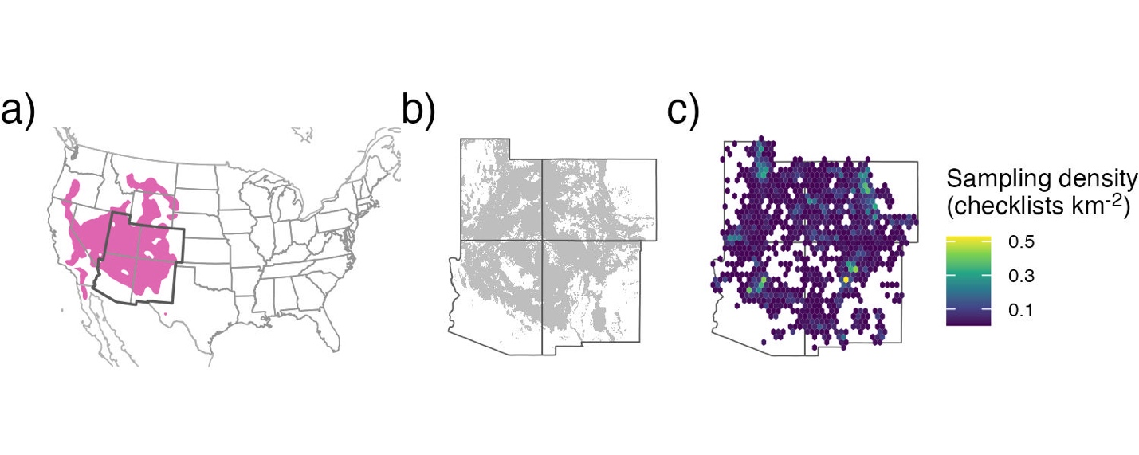
Figure 1. The full species range for (a) pinyon jays (pink region; data from eBird Status and Trends), with our study region delineated by the darker borders (southwestern USA, including Arizona, Colorado, New Mexico, and Utah). The (b) range of two-needled pinyon in our study region, along with the (c) sampling density (in checklists km⁻²) across all years for pinyon jay based on eBird data (2010-2022) after spatial and temporal subsampling and filtering checklists to areas with two-needle pinyon basal area as shown in (b).

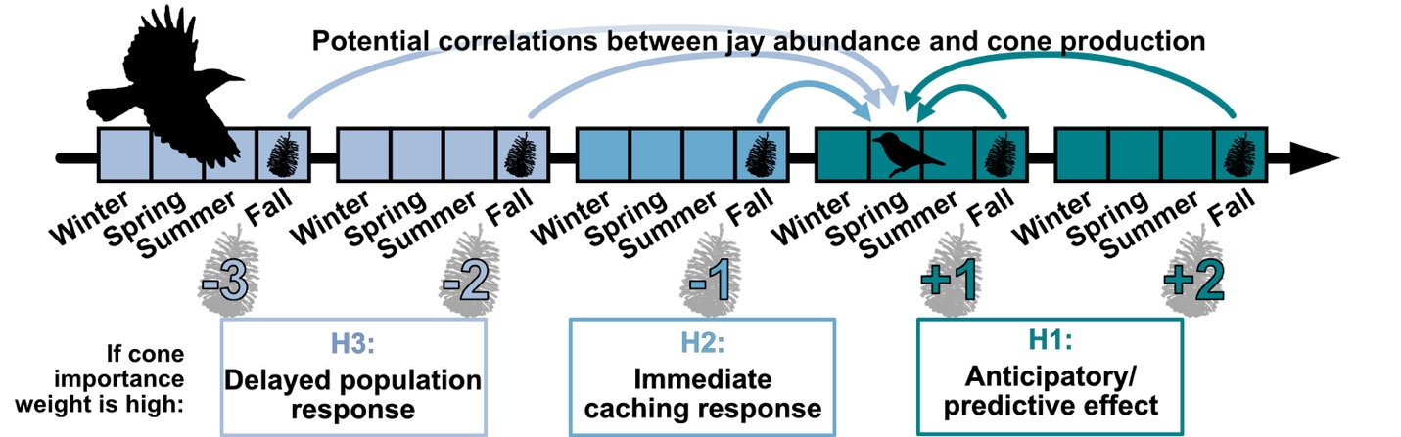

Figure 2. A timeline of hypothesized temporal relationships between pinyon jay abundance and pinyon cone availability. Three hypotheses describe how jay abundance in a given focal year (e.g., bird icon in timeline) is related to pinyon cone (seed) production in past and future time periods (cone icons along timeline), including H1: jays “anticipate” seed availability through utilization of other food resources (e.g., acorns, juniper berries) that mature more quickly than pinyon seeds or because they see pinyon cones developing in an area; H2: jays respond “immediately” to pinyon seeds produced in the previous fall and winter by nesting near cache sites the following spring nesting season; H3: jays have a “delayed” response to seed availability as the young produced during the caching year enter the breeding population 1.5-2 years later. The numerical values along the bottom of the timeline (-3, -2, …, +2) indicate potential temporal coupling (past, concurrent, future years) between jays and pinyon seeds.

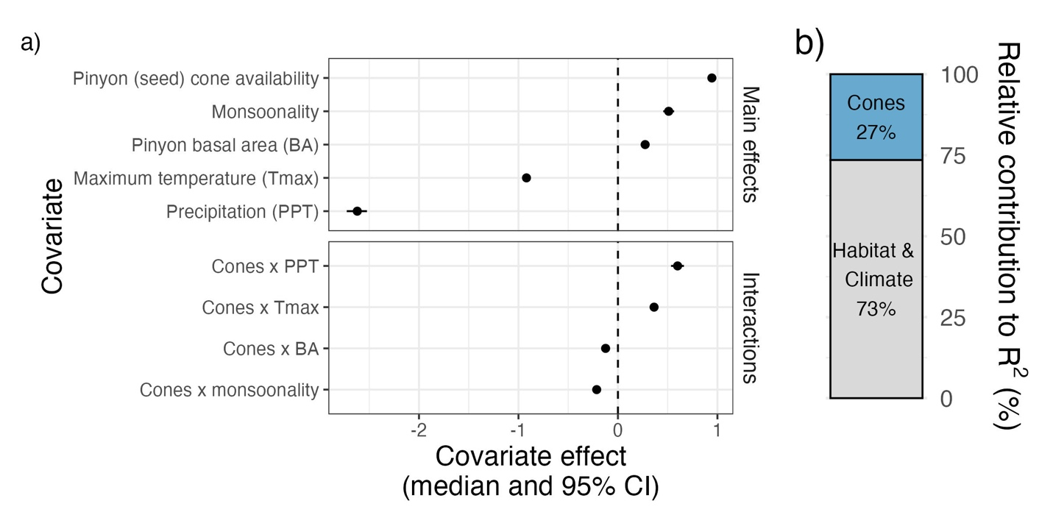
Figure 3. a) Covariate effects for all main effects and all two-way interactions involving pinyon cone (seed) production (“Cones”) and b) the relative contribution of covariates to model fit (R²), based on improvement to model fit between a null model and the addition of covariate groups. In a), all covariates were standardized, allowing for comparison of the effect sizes of the main effects across covariates. Covariate effects are shown as the posterior median (filled symbols) and 95% credible interval (CI, whiskers); any covariate effect with a 95% CI that crosses the dashed line at zero indicates that the corresponding covariate or interaction have no clear effect on pinyon jay abundance.

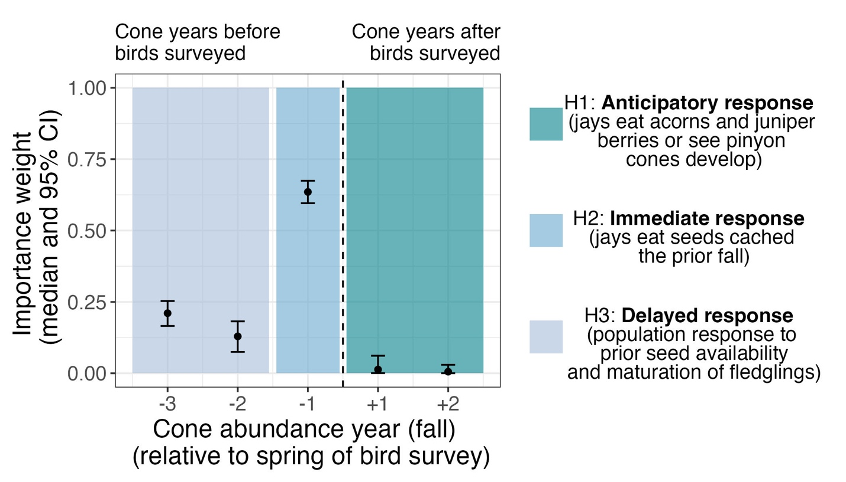
Figure 4. Posterior estimates (median and 95% CI) of the importance weights (w terms, see equation 5) describing the temporal coupling between pinyon jay abundance and pinyon cone (seed) availability (see Figure 2). Colored boxes indicate time periods that align with the three ecological hypotheses describing an anticipatory (H1), immediate (H2), and delayed (H3) response of jays to pinyon seed availability. The dotted vertical line separates periods that align with birds responding to past cone availability (left of the dotted line; H2 and H3) versus periods associated with birds responding to future seed availability (right of dotted line; H1).

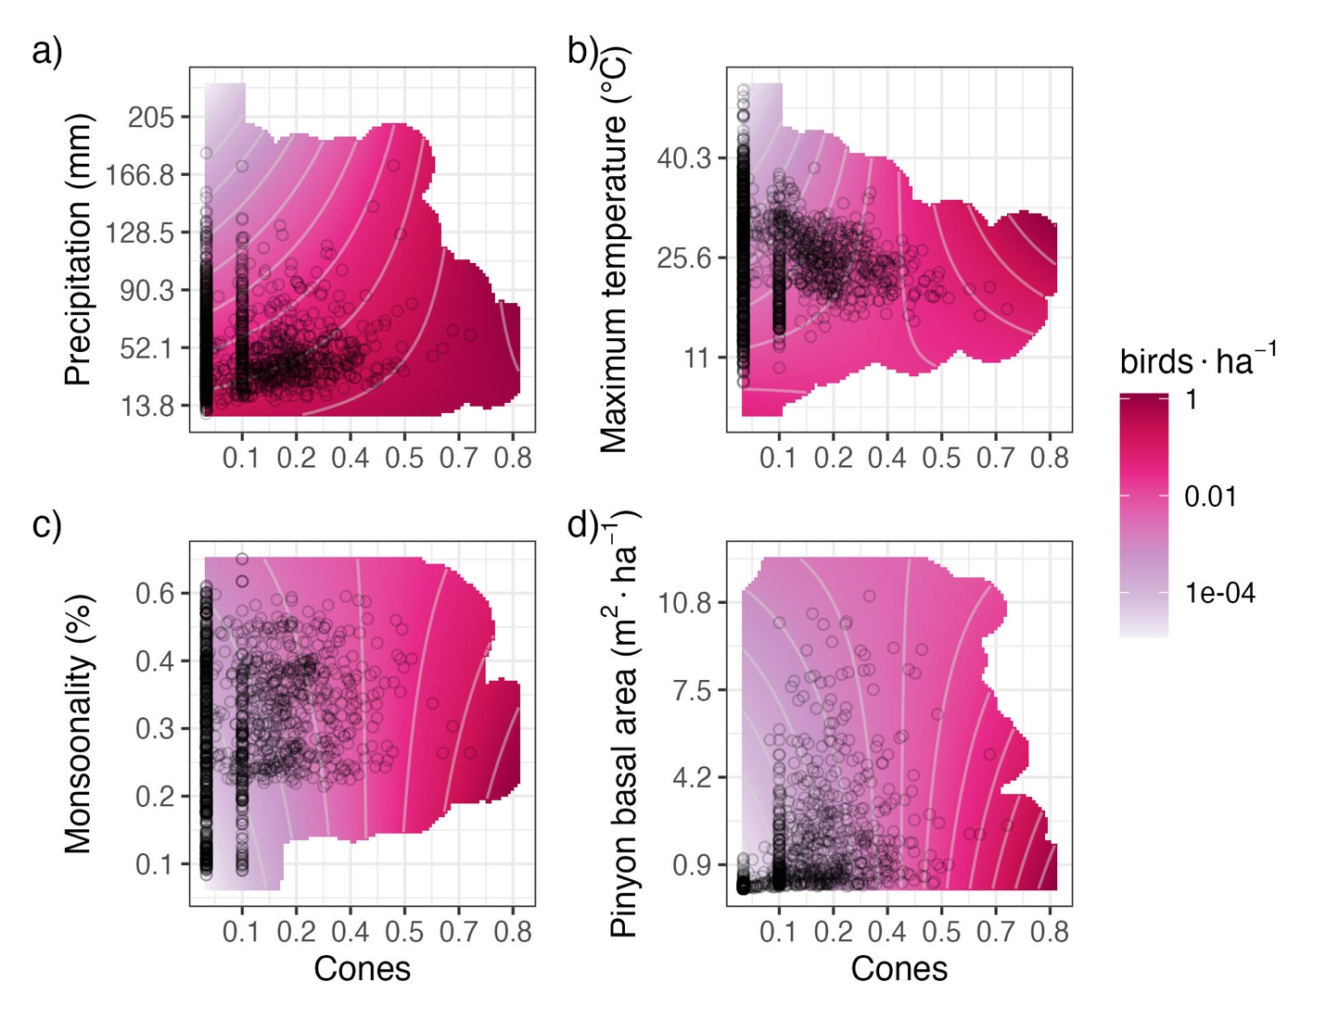

Figure 5. Interaction plots for the four covariates that significantly interacted with pinyon cone (seed) availability to influence pinyon jay abundance (see Figure 3), including: a) precipitation, b) maximum temperature, c) monsoonality, and d) pinyon basal area. The contour lines and color (pink) intensity denote the predicted number of birds per hectare, where darker pink/magenta colors correspond to a greater number of birds associated with that combination of covariates. Black circles represent a random sample of the observed covariate data, and the pink shading is trimmed to exclude covariate values that were not represented in the data.

