January 26, 2026

Dear Editorial Board,

Populations of species across the globe are declining due to a suite of forces, including habitat and climate change. However, the occurrence and abundance of interaction partners may be an under-examined driver of population trends. Examining the effects of species interactions on populations is challenging given the need for broad-scale and long-term datasets on multiple species. We attach a manuscript entitled “Caching in: A seed dispersal mutualism signals the decline of a songbird-pine system” in which we examine relationships between seed abundance and bird abundance in a system where both interacting partners are declining – pinyon jays and two-needle pinyon pine in the Southwest USA. We overcame data limitations by leveraging complementary data on both interacting partners: over 800,000 observations from the eBird citizen science program and a newly developed dataset on seed availability across the region. We feel this work is suitable for Proceedings of the National Academy of Sciences because it addresses key questions related to species interactions and informs species conservation.

This study used a Bayesian statistical modeling approach never used before in examining plant-animal interactions (‘stochastic antecedent modeling’) to examine the temporal legacies of species interactions on population abundance. We found that pinyon jay abundance is directly linked to seed abundance and that this effect is comparable to or of greater importance than many climate and habitat drivers. Further, the effect of cone availability has a three-year legacy on abundance of pinyon jays. While we focus on one ecological system of conservation concern, the modeling approach we developed using broad-scale citizen science data has broad applicability across systems with interacting mutualists. In particular, in many systems, the temporal legacies of species interactions may be key to determining future population, community, and ecosystem states.

The work in this manuscript is original and has not been submitted for publication elsewhere. All authors have read the manuscript and agree to be listed on the submitted version. Thank you for your consideration of our work.

Sincerely,
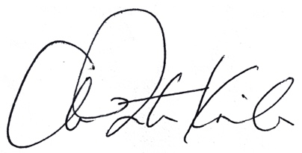
Ana Miller-ter Kuile, Ph.D.

