Supporting Information for: Caching in: A seed dispersal mutualism signals the decline of a songbird-pine system
Author List: Ana Miller-ter Kuile^{1,2}, Andreas P. Wion³, Kyle C. Rodman⁴, Jamie S. Sanderlin², Kiona Ogle¹
Author Affiliations:
¹ Northern Arizona University School of Informatics, Computing, and Cyber Systems, Flagstaff, Arizona, USA
² USDA Forest Service Rocky Mountain Research Station, Flagstaff, Arizona, USA
³ Forest Stewards Guild, Santa Fe, New Mexico, USA
⁴ Ecological Restoration Institute, Northern Arizona University, Flagstaff, Arizona, USA
Corresponding author: Ana Miller-ter Kuile, ana.miller-ter-kuile@nau.edu, Northern Arizona University School of Informatics, Computing, and Cyber Systems, 1295 Knoles Drive, Flagstaff, Arizona 86011

SI Methods
Pinyon Jay Abundance Data. We followed the well-developed filtering methods suggested by the eBird database curators and others (Robinson et al. 2018; Strimas-Mackey et al. 2023). Specifically, we selected data that represented only complete checklists (e.g., observers recorded all birds of all species observed, not just individuals of species of interest). We selected checklists from the nesting season (late February to early May (Wiggins 2005)) and included only observations from two common protocol types (“stationary” and “traveling”), thus excluding data from 14 uncommon protocols. We considered only the nesting season because this is a time of year during which birds are more stationary, so drivers of local bird abundance are easier to evaluate (Ligon 1978; Wiggins 2005). We also only included checklists with relatively similar effort: 1) collected in under five hours, 2) 0-5 km in survey distance, and 3) with 10 or fewer observers.
Because of its participatory nature, eBird data have no control over sampling location, effort, or survey methods, so we also performed data subsampling following standard practices (Robinson et al. 2018). To do this, we first divided the study region into 4 km × 4 km grid cells to match the spatial scale of the covariates. Then, we spatially sub-sampled eBird observations to include a set of checklists in each grid cell that represented relatively equal sampling effort across all years (time) and all grid cells (space). This meant we subsampled the number of checklists per grid cell based on the year with the fewest checklists per grid cell (i.e., 2010 had $≤$4 checklists per cell). After filtering to this level, we still had fewer checklists overall in earlier years. Thus, we further reduced temporal bias by randomly subsampling checklists again so that we had equal sample sizes across years based on the year with the fewest checklists (n = 1,715 checklists in 2010 across all grid cells). We then removed all checklists within 10 km of the exterior edges of the four focal states (Arizona, Colorado, New Mexico, and Utah).
Of the 833,834 original checklists available for the region in the nesting seasons between 2010-2022, we fit our model to data based on the final (filtered) 22,295 checklists (1.4 ± 0.01 [mean ± s.e.] checklists per grid cell in a specific year, Figure 1). In our final dataset, pinyon jays were observed in 600 of the selected checklists (2.7%). The maximum number of pinyon jays observed in one checklist was 350 (mean number of birds: 0.42 ± 0.04 s.e.).
Habitat and Climate Covariate Data. As an indicator of habitat structure, which influences pinyon jay habitat use (Van Lanen et al. 2023), and to filter eBird observations to areas supporting pinyon (Figure 1), we derived yearly basal area (m² ha⁻¹) estimates for pinyon from 2010 to 2022 by combining pinyon BA maps 2000-2009 (Wilson et al. 2013) with annual maps of pinyon cover from the Rangelands Analysis Platform (RAP, v.3.0) (Allred et al. 2021). We used the RAP canopy cover maps to annualize spatially explicit pinyon BA estimates, and to project BA forward in time. First, we aggregated RAP canopy cover for each year to scale up from 30 m to 250 m resolution (using the mean value) to align with the BA maps. Next, for each 250 m pixel, we divided pinyon BA by percent canopy cover in that same location (i.e., the mean canopy cover from 2000 to 2009) to calculate the amount of pinyon BA represented by each unit of canopy cover (i.e., an expansion factor). Finally, we used these pixel-specific expansion factors, differences between 2000 and 2009 cover, and the cover of a focal year (e.g., 2010) to adjust pinyon BA up or down in each pixel and year, giving annual BA estimated from 2010 to 2022. This approach accounted for both increasing and decreasing trends in pinyon BA during our study period, reflecting patterns of ingrowth or mortality, respectively. The resulting BA estimates qualitatively aligned with patterns of forest change in different locations throughout the southwestern USA. For this study, we aggregated the BA estimates for the 250 m pixels to produce estimates at a 4 km × 4 km resolution to align with other covariates.
Observation Process Model for Pinyon Jay Abundance. In our model, count data obtained from eBird checklists were used to estimate a “true” latent abundance, $N$, that varies across space and time. eBird checklists are recorded with a geographical point location and often include information about travel distance of the observer (< 5km in our dataset after filtering). Thus, there is spatial uncertainty arising from two sources: 1) uncertainty in the location that the survey was conducted (e.g., eBird point locations have uncertain precision) and 2) for traveling surveys, uncertainty in the location along a survey at which pinyon jays were observed (e.g., at the beginning, middle, or end of a walking survey). To account for this spatial uncertainty, we created circular buffers around each eBird checklist point location based on the sampling distance for that checklist; that is, we defined the radius of the buffer circle as 1/2 of the distance traveled for “traveling” checklists or 0.5 km for “stationary” checklists. Then, we created a merged polygon (“sample polygon”) of all the checklists within a 4 km × 4 km grid cell for each year by delineating the perimeter of the overlapping buffers of all checklists within a grid cell. Thus, the sample polygon and not the underlying 4 km ×4 km grid cell, is the spatial unit at which we incorporated covariates potentially shaping checklist level latent abundance, N.
For the observation process model, we define a likelihood for the observed eBird count data, Y, for checklist, $c$, in sample polygon, $i$, and year, $t$, based on a binomial distribution that accounts for the detection probability, p, and the latent true abundance of birds (“number of trials”), N, in the checklist:
$$Y_{c,i,t}∼Binomial\left(p_{c,i,t},N_{c,i,t}\right)$$ | Eqn 1
We modeled p as a function of four covariates that likely impact detection probability, including start time of the survey, duration of the survey, speed of the survey, and the number of observers for each checklist. Again, we filtered the available eBird data to select checklists that represented similar effort. We implemented the following model for the logit-scale detection probability:
$$logit\left(p_{c,i,t}\right)=γ_{0}+\sum_{j=1}^{4}{γ_{j}}⋅X_{j_{c,i,t}}$$ | Eqn 2
where $γ_{0}$ is intercept and each $γ_{j}$ is the coefficient (effect) associated with each covariate, Xj (j = 1, 2, … 4 covariates), whereby the covariates vary by checklist c, sample polygon i, and year t. All covariates were standardized such that $γ_{0}$ describes the logit-scale baseline detection probability at average covariate values. We assigned relatively non-informative, vague normal priors to all coefficients including the intercept.
Biological Process Model for Pinyon Jay Abundance. Following standard assumptions for N-mixture models, we assumed that latent jay abundance, $N_{c,i,t}$, followed a Poisson distribution with the expected abundance given by the intensity, $λ_{i,t}$ (number of jays per km²), multiplied by the sample polygon area, A_{c,i,t} (km²), associated with observed checklist c, sample polygon i, and year t:
$$N_{c,i,t}∼Poisson\left(λ_{i,t}∙A_{c,i,t}\right)$$ | Eqn 3
Furthermore, we modeled the log-scale $λ_{i,t}$ as a function of environmental covariates that likely impact the abundance of pinyon jays across space and time:
$$log\left(λ_{i,t}\right)=α_{0}+\sum_{k=1}^{2}{α_{k}}⋅X_{k_{i,t}}+\sum_{k=1}^{3}{α_{2+k}}⋅Z_{k_{i,t}}+\sum_{k=1}^{2}{α_{5+k}∙Z_{l_{i,t}}∙X_{k_{i,t}}\sum_{k=2}^{3}{α_{6+k}∙Z_{l_{i,t}}}}⋅Z_{k_{i,t}}$$ | Eqn 4
In this formulation, $X_{k_{i,t}}$ includes the static covariate of monsoonality (k = 1), which varies across space (by sample polygon, i) but not across time, t, and concurrent pinyon pine basal area (BA, k = 2), which varies across space and time. Importantly, $Z_{k_{i,t}}$ represents covariates that integrate over past and/or future time periods (i.e., pinyon cones [k = 1], maximum temperature [k = 2], and precipitation [k = 3]) and are defined using a SAM structure (Ogle et al., 2015). In particular, each $Z_{k_{i,t}}$ is defined as the weighted average of concurrent or past values for each focal covariate:
$$Z_{k_{i,t}}=\sum_{l=l^{*}}^{L}{X_{k_{i,t,l}}}⋅w_{k,l}$$ | Eqn 5
The weights, $w_{k,l}$, for each covariate, k, across all seasonal or yearly periods, l, were assigned a Dirichlet prior, constraining the weights to sum to 1 across all periods. In particular, l = -3 (l*), -2, -1, +1, +2 (L), representing 5 yearly periods for cones (k = 1), and l = 1 (l*), 2, …, 13 (L), representing 13 concurrent and past seasonal periods for the climate variables (k = 2 or 3) (see Figure 2). The weights indicate the relative importance of each covariate k at time period l to its overall effect on pinyon jay abundance (larger values denote higher importance). We are particularly interested in the temporal relationships between jay abundance and pinyon seed availability; high weights for time periods denoted by l = +1 or l = +2, w_{k,+1} and/or w_{k+2}, would support a strong anticipatory response, a high weight for w_{k,-1} would support a strong immediate response, and high weights for w_{k,-2} and/or w_{k,-3} would be suggestive of a delayed response to cones.
As depicted in Equation (4), we also considered interactions between seed (cone) abundance (Z₁) and all other covariates, including monsoonality (X₁), pinyon BA (X₂), maximum temperature (Z₂), and precipitation (Z₃). This allowed us to evaluate how the relationship between pinyon jay abundance and pinyon seed production is mediated by other habitat and climate factors related to pinyon seed reliability and alternative food resources. We assigned relatively vague normal priors to the intercept (α₀) and all coefficients (covariate effects; α_{1,} α_{1, …,} α₉) in Equation (4).
Finally, because sample polygons sometimes covered more than one 4 km × 4 km grid cell, we determined the percent of a sample polygon covering each grid cell and then calculated weighted averages of the covariate values based on the covariate values of all overlapping grid cells multiplied by the percent of the sample polygons overlapping that cell. On average, polygons overlapped approximately two (mean = 2.13 ± 0.01 s.e.) grid cells, with a minimum of one grid cell and a maximum of nine cells for a single polygon.
Model Implementation, Convergence, and Diagnostics. We implemented the above model in the Bayesian software JAGS (Plummer 2003) (version 4.3.0) using R (R Core Team 2020) (version 4.5.1) and the jagsUI wrapper package (Kellner 2021) (version 1.6.2). JAGS uses Markov chain Monte Carlo (MCMC) methods to sample from the joint posterior distribution of the model parameters. We initially produced 4000 samples for three parallel MCMC sequences to determine the number of iterations (samples) needed to sufficiently sample from the posterior based on the Raftery diagnostic (Raftery & Lewis 1995), and we re-ran the model to obtain a sufficient number of iterations. We qualitatively assessed convergence of the MCMC sequences by inspecting history and autocorrelation plots generated with the mcmcplots package (Curtis 2010) (version 0.4.3). We quantitatively evaluated convergence using the raftery.diag function in the coda package (Plummer et al. 1999) (version 0.19.4.1); the MCMC sequences were deemed to have converged if the Gelman-Rubin statistic, $\hat{R}$, for all root nodes in the model was less than 1.1 (Gelman & Rubin 1992). We assessed model goodness-of-fit by comparing observed eBird count data to predicted count data based on simulating “replicated” count data from the Binomial distribution in Equation (1). We tested for spatial dependence in the residuals (observed – predicted counts) within each year using spline correlograms produced by the R package ncf (Bjornstad 2008) (version 1.3-2).
Out of Sample Model Validation. To evaluate predictions outside of the data used to fit the model, we first removed the in-sample (“training”) data (22,295 checklists) from the available eBird checklist data (833,834 checklists). We performed the same set of steps for spatial and temporal stratification on the remaining checklists (811,539 checklists) for an additional 20,380 checklists that represented “out-of-sample” (“validation”) data. We evaluated out-of-sample model fit using ~1000 posterior samples for covariate effects and intercepts from the in-sample dataset and model. We then examined model replicative ability (RMSE) of the in-sample and out-of-sample datasets.
Variable Importance. We determined the relative contribution to model fit (R²) of cones by running a model with no biological covariates (“null”) and a model excluding cone (seed) availability and its interactions (“climate and habitat” model) and tracking R² for each model. Based on R² improvement from the sequential addition of covariates (e.g., null vs. climate and habitat; climate and habitat vs. full model), we determined the relative contribution to the full model R² from adding the cone availability covariate in addition to habitat and climate variables (Figure 3).(Liu et al. 2019)
Software Used. We prepared data using the here (Muller 2020) (version 1.0.1), tidyverse (Wickham et al. 2019) (version 2.0.0), sf (Pebesma & Bivand 2023) (version 1.0.21), terra (Hijmans 2020) (version 1.8.54), readxl (Wickham & Bryan 2015) (version 1.4.5), exactextractr (Daniel Baston 2019) (version 0.10.0), spatialEco (Evans & Murphy 2023) (version 2.0-2), nngeo (Dorman 2018) (version 0.4.8), auk (Strimas-Mackey et al. 2017) (version 0.8.2), lubridate (Grolemund & Wickham 2011) (version 1.9.4), prism (Hart & Bell 2015) (version 0.0.6), FNN (Beygelzimer et al. 2010) (version 1.1.4.1), and data.table (Barrett et al. 2006) (version 1.17.6) packages.
SI Results
Model Performance and Goodness-of-fit. All stochastic model parameters converged with an $\hat{R}≤$ 1.1 (Fig. S3). Regressions of observed data versus predicted data (based on the posterior mean of 1000 samples of replicated data) yielded a mean R² of 0.17 (s.e. = 0.005). In general, the model over-estimated small pinyon jay counts but performed well for most other values (Fig. S4). The RMSE for our in-sample dataset had an average value of 3.25 (s.e. = 0.001) and the out-of-sample dataset had a value of 5.10 (s.e. = 0.0002; Fig. S5). Thus, our model predicted our in-sample data slightly better than the out-of-sample data, but neither RMSE values are large considering the scale of the count data (counts per checklist ranged from 0 to 350), suggesting good model fit and predictive capacity. We observed no evidence for strong or consistent spatial autocorrelation in model residuals (Fig. S6 SI).
Covariates Influencing Detection. Pinyon jay detection probability was most influenced by the number of observers, such that fewer birds were observed on checklists involving more observers (observer number effect: -1.01 [-1.10, -1.04]). Checklists where observers walked at faster speeds had more detections (speed effect: 0.43 [0.40, 0.46]). Speed incorporated the distance (“effort”) and duration variables from the original checklists, and this effect is likely influenced by checklists where observers went further in a traveling checklist. Fewer birds were observed at later start times (time effect: -0.19 [-0.25, -0.14]) and there was a weak effect in which longer surveys had fewer detections (survey length effect: -0.03 [-0.07, -0.003]).

SI Figures
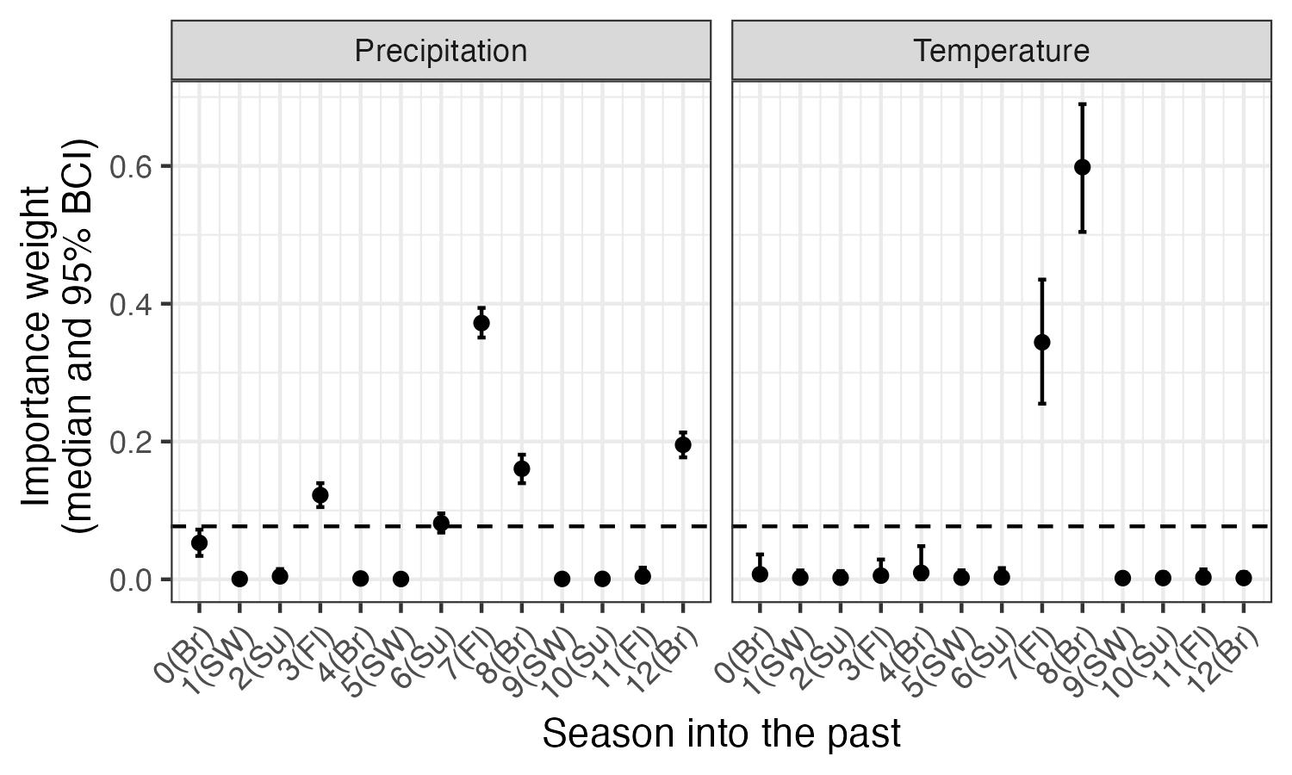
Fig. S1.Posterior estimates (median and 95% CI) for the seasonal importance weights for climate (precipitation and maximum temperature; w terms, see equation 5 in the main text). The dashed horizontal line indicates the ‘null’ weight in which all time periods would have equal weights. Any weights that extend clearly above this line suggest significant importance of the corresponding climate variable during that season to pinyon jay abundance. Seasons are based on pinyon jay biology: Br (breeding; February - May), Fl (fledging; May - June), Su (summer localized foraging; July), and SW (summer and winter dispersed foraging or ‘irruption’ period; August - January).

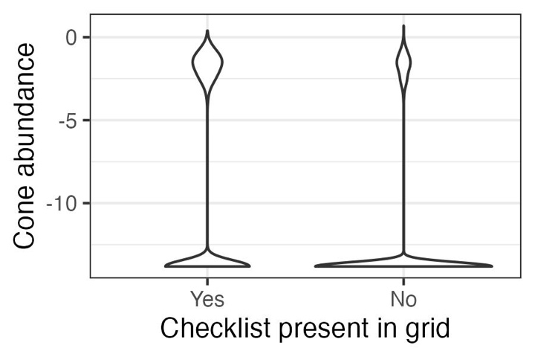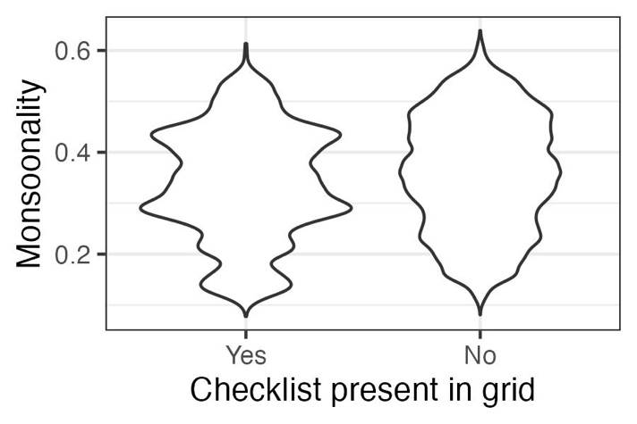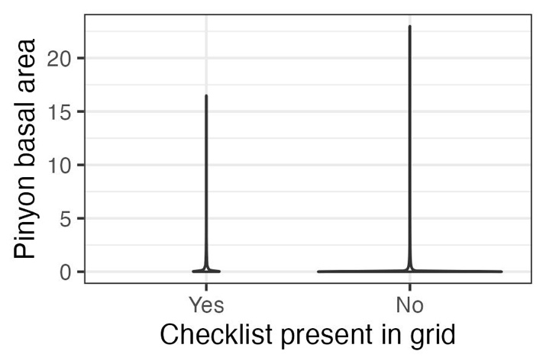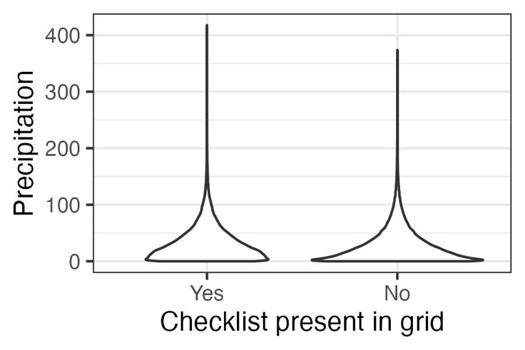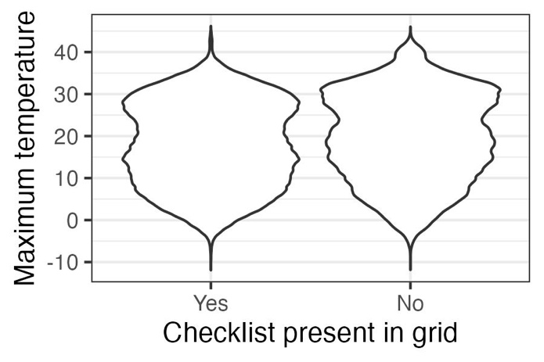
Fig. S2. Validation results supporting the use of space-for-time substitution of replicate checklists within sampling polygons. To use replicate eBird surveys within a year at a location in models such as N-mixture or occupancy models, checklists need to represent sites that display the full range of values for covariates of interest. In general, checklists in our dataset meet these criteria. Data represented here are values for all raster grid cells for all years (~1 million grid cells, depending on covariate). Thus, for the two covariates for which we are missing the upper tails, (a) cone availability and (e) pinyon basal area, these represent extreme outliers (<1% of total values in the dataset; ~20-200 raster grid cells, depending on covariate).

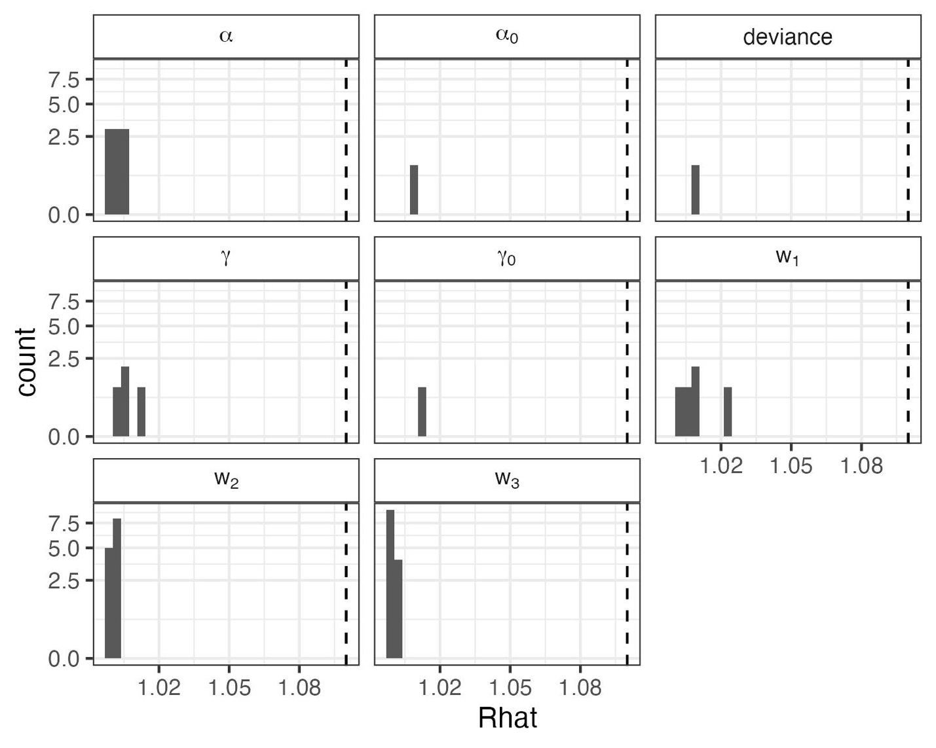
Fig. S3. Convergence statistics for stochastic parameters in the N-mixture for representing biological ($α$ and $α_{0}$) and detection ($γ$ and $γ_{0}$) covariate effects, deviance (an overall index of model fit), and the cone and climate importance weights (w₁, w₂, and w₃). All quantities converged with potential scale reduction ($\hat{R}$) values < 1.1 (dashed line).
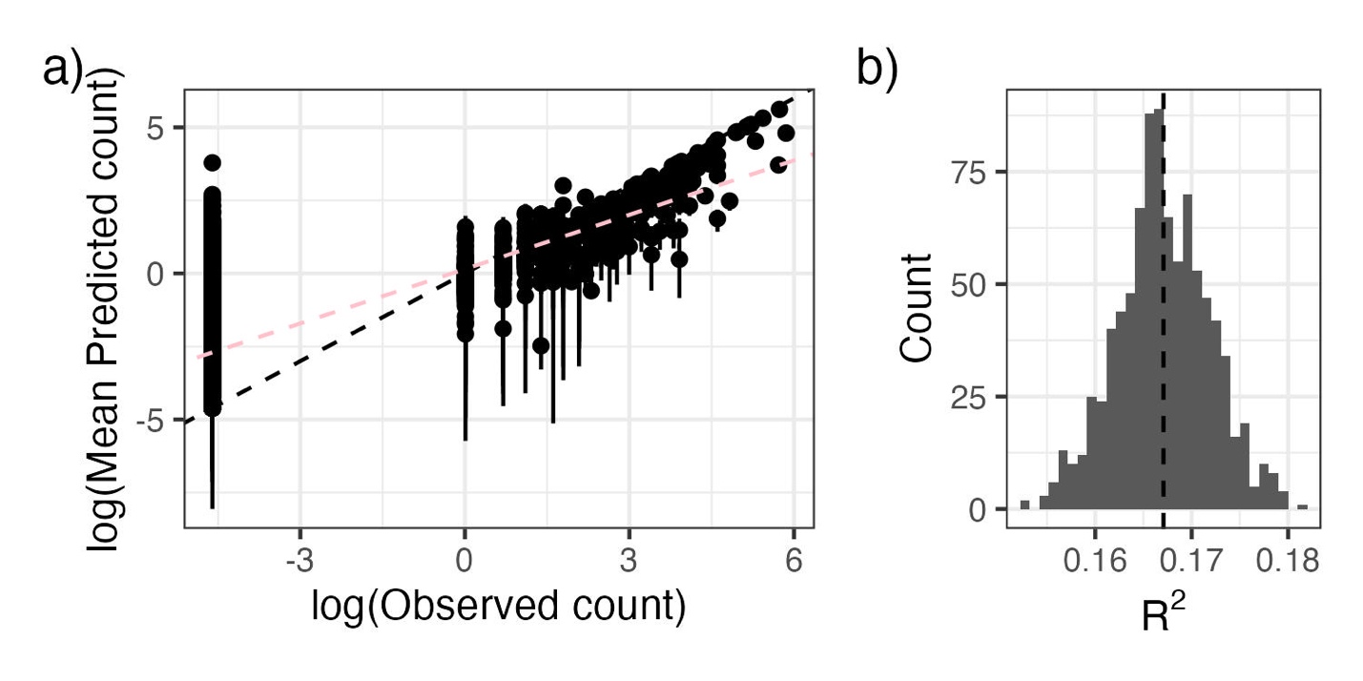
Fig. S4. As an evaluation of goodness-of-fit, we examined a) the relationship between observed pinyon jay counts and counts predicted from the model (median and 95% Bayesian Credible Interval) and b) the R² of this relationship from ~1000 posterior samples. In a), the black dashed line represents the 1:1 line; the pink line corresponds to the best-fit line between log-log predicted and observed bird count values. In b) the dashed vertical line represents the mean R².

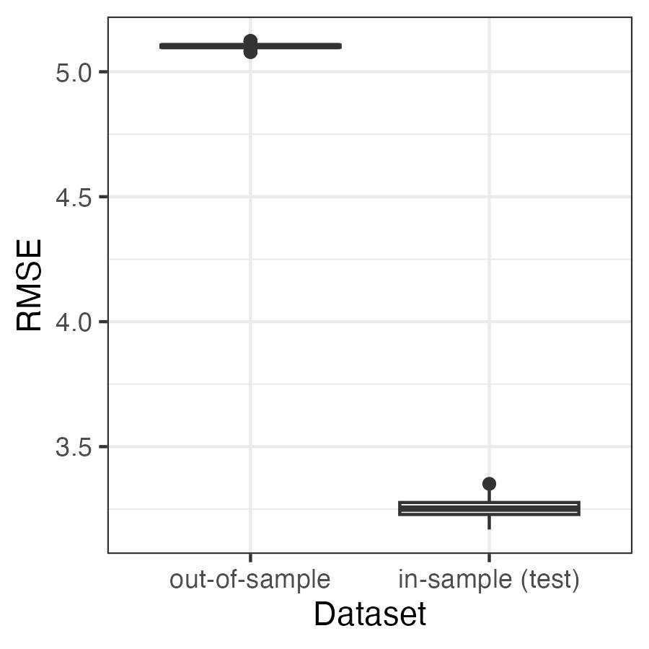
Fig. S5. Root mean squared error (RMSE) to evaluate the predictive ability of the model applied to the in-sample (“test”) and out-of-sample datasets. Values for RMSE are on the scale of the data (counts of pinyon jays per square kilometer). The RMSE values are relatively small compared to the range of possible counts in a checklist (0 to 350 birds per hectare in our test dataset).

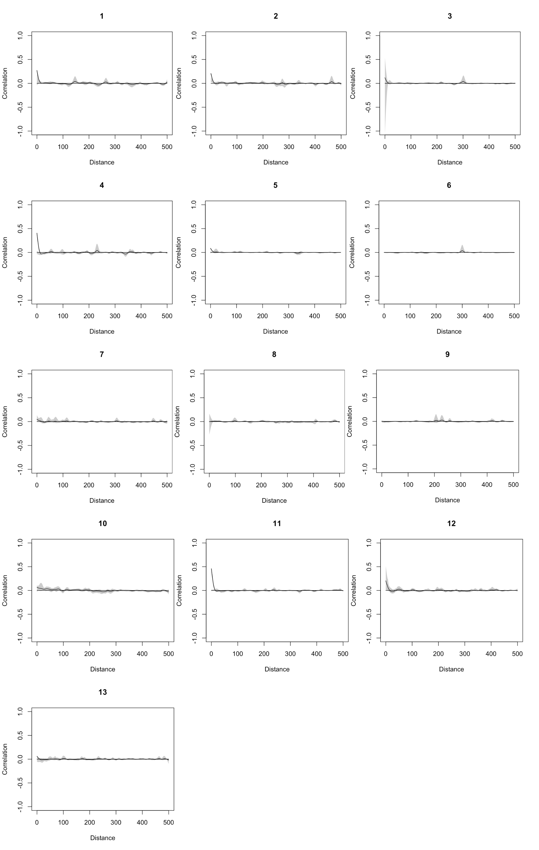


Fig. S6. Evaluation of spatial autocorrelation (Pearson correlation on the y-axis) for residuals in each year (year indices are indicated above each figure panel, where 1 = 2010, 2 = 2011, …, 13 = 2022). Distance values are in kilometers. There was no consistent evidence of spatial autocorrelation of residuals.

References
Barrett, T., Dowle, M., Srinivasan, A., Gorecki, J., Chirico, M., Hocking, T., et al. (2006). data.table: Extension of `data.frame`. CRAN: Contributed Packages.
Beygelzimer, A., Kakadet, S., Langford, J., Arya, S., Mount, D. & Li, S. (2010). FNN: Fast Nearest Neighbor Search Algorithms and Applications. CRAN: Contributed Packages.
Bjornstad, O.N. (2008). ncf: Spatial Covariance Functions. CRAN: Contributed Packages.
Curtis, S.M. (2010). mcmcplots: Create Plots from MCMC Output.
Daniel Baston. (2019). exactextractr: Fast Extraction from Raster Datasets using Polygons. CRAN: Contributed Packages.
Dorman, M. (2018). nngeo: k-Nearest Neighbor Join for Spatial Data. CRAN: Contributed Packages.
Evans, J.S. & Murphy, M.A. (2023). spatialEco.
Gelman, A. & Rubin, D.B. (1992). Inference from Iterative Simulation Using Multiple Sequences. Statist. Sci., 7.
Grolemund, G. & Wickham, H. (2011). Dates and Times Made Easy withlubridate. J. Stat. Soft., 40.
Hart, E. & Bell, K. (2015). prism: Access data from the Oregon State Prism climate project.
Hijmans, R.J. (2020). terra: Spatial Data Analysis. CRAN: Contributed Packages.
Kellner, K. (2021). jagsUI: a wrapper around “rjags” to streamline JAGS analyses.
Liu, Y., Schwalm, C.R., Samuels‐Crow, K.E. & Ogle, K. (2019). Ecological memory of daily carbon exchange across the globe and its importance in drylands. Ecology Letters, 22, 1806–1816.
Muller, K. (2020). here: A simpler way to find your files.
Pebesma, E. & Bivand, R. (2023). Spatial Data Science: With Applications in R. 1st edn. Chapman and Hall/CRC, New York.
Plummer, M. (2003). JAGS: A program for analysis of Bayesian graphical models using Gibbs sampling. Proceedings of the 3rd international workshop on distributed statistical computing, 124.
Plummer, M., Best, N., Cowles, K., Vines, K., Sarkar, D., Bates, D., et al. (1999). coda: Output Analysis and Diagnostics for MCMC.
R Core Team. (2020). R: A language and environment for statistical computing.
Raftery, A.E. & Lewis, S.M. (1995). The number of iterations, convergence diagnostics and generic Netropolis algorithms. In: Practical Markov Chain Monte Carlo. Chapman and Hall, London, U.K.
Strimas-Mackey, M., Miller, E. & Hochachka, W. (2017). auk: eBird Data Extraction and Processing in R. CRAN: Contributed Packages.
Wickham, H., Averick, M., Bryan, J., Chang, W., McGowan, L., François, R., et al. (2019). Welcome to the Tidyverse. JOSS, 4, 1686.
Wickham, H. & Bryan, J. (2015). readxl: Read Excel Files.

