Title: Caching in: A seed dispersal mutualism signals the decline of a songbird-pine system
Author List: Ana Miller-ter Kuile^{1,2}, Andreas P. Wion³, Kyle C. Rodman⁴, Jamie S. Sanderlin², Kiona Ogle¹
Author Affiliations:
¹ School of Informatics, Computing, and Cyber Systems, Northern Arizona University, Flagstaff, Arizona, USA
² USDA Forest Service, Rocky Mountain Research Station, Flagstaff, Arizona, USA
³ Forest Stewards Guild, Santa Fe, New Mexico, USA
⁴ Ecological Restoration Institute, Northern Arizona University, Flagstaff, Arizona, USA
Author Emails:
Ana Miller-ter Kuile: ana.miller-ter-kuile@nau.edu
Andreas P. Wion: apwion.work@gmail.com
Kyle C. Rodman: kyle.rodman@nau.edu
Jamie S. Sanderlin: jamie.l.sanderlin@usda.gov
Kiona Ogle: kiona.ogle@nau.edu
Running title: Species interactions shape populations
Keywords: Gymnorhinus cyanocephalus, Pinus edulis, eBird, species interactions, temporal legacies
Article Type: Letter
Number of words in Abstract: 150
Number of words in Main Text: 4946
Number of References: 96
Number of Figures: 5
Corresponding author: Ana Miller-ter Kuile, ana.miller-ter-kuile@nau.edu, Northern Arizona University School of Informatics, Computing, and Cyber Systems, 1295 Knoles Drive, Flagstaff, Arizona 86011
Statement of Authorship: AM-tK, APW, and KCR conceived the ideas; AM-tK, KO, and JSS developed statistical methods; AM-tK and KCR developed novel data layers and ran statistical models; AM-tK led the writing of the manuscript with support from APW, KCR, and KO. All authors contributed to the drafts and gave final approval for publication.
Data Accessibility Statement: Data and code for this paper are available on Zenodo (Miller-ter Kuile et al. 2026).

ABSTRACT
Environmental change is driving population declines globally. While habitat loss is a primary driver, changes in species interaction partners are also important. Here, we explored interactions between a declining seed disperser (pinyon jay) and its seed partner (two-needle pinyon pine) in the southwestern USA. We conducted a novel analysis of broad-scale (n>800,000) and long-term (2010-2022) eBird citizen science data on pinyon jay abundance and reconstructions of yearly pinyon seed production. Pinyon jays showed immediate and delayed responses such that jays were most abundant in the spring following years of high seed production (64% relative importance), likely because they nested near cached seeds. High seed years also had a legacy effect (34% relative importance) on jay abundance. These relationships varied across the species’ range due to interactions between resources, habitat, and climate. Importantly, we demonstrate the vital influence biotic interactions and their legacies have on the population status of declining species.

1 | Introduction
We are witnessing Earth’s sixth mass extinction event (Finn et al. 2023; Hogue & Breon 2022). While habitat conversion and climatic change are the most influential proximate drivers of global species decline (Jaureguiberry et al. 2022), an indirect cause of loss comes from the consequences of reshuffling (‘rewiring’) species interaction networks (D’Alelio et al. 2019; Srinivasan et al. 2007). Losses and declines of species in interaction networks can lead to co-extinctions (Roopnarine 2006), extinction cascades (Kehoe et al. 2021), and the loss of important ecosystem functions performed by those species and interactions (e.g., pollination; Valiente‐Banuet et al., 2015). Thus, explicitly quantifying the impacts of species interactions on population trends is crucial for predicting future biodiversity patterns and ecosystem processes (Ockendon et al. 2014).
Including biotic interactions between species in population assessments may give many common approaches more predictive power (e.g., climate envelope models, habitat suitability indices, and species distribution models; (Elith & Leathwick 2009; Hijmans & Graham 2006; Hirzel & Le Lay 2008)). In their traditional application, these models can fail to predict observed population patterns (Evans et al. 2024; Lee‐Yaw et al. 2022). However, including species interactions into population or similar models is challenging given the dynamic nature of biotic interactions (CaraDonna et al. 2017; Poisot et al. 2015). For example, interactions are shaped by past population and community dynamics, reflecting ecological memory and biological legacies (Essl et al. 2015; Ogle et al. 2015; Padisak 1992). Interactions can also shift across space due to variation in individual fitness, resource availability, and competitive interactions (Langendorf et al. 2025; Liu & Gaines 2022). Given this spatiotemporal variation, species interactions vary widely in strength and direction (e.g., mutualisms become consumptive; (Bogdziewicz et al. 2020; Moore & Dittel 2020; Sawaya et al. 2018)).
Seed consumption and dispersal are important species interactions that shape the structure and function of ecosystems across the globe (Bello et al. 2015; Brodie et al. 2025). Seed resources are often unreliable throughout the year and across years, especially in systems where plants mast, or have episodic but synchronous seed production at the community or population level (Pearse et al. 2016). Given the “boom and bust” nature of seed availability in masting systems (Kelly & Sork 2002; Qiu et al. 2023), animals that rely on masting plants adapt to and respond strongly to the availability of seeds. For example, seed dispersers can display anticipatory or predictive behaviors, such as elevated reproduction preceding abundant seed production years (Boutin et al. 2006; Wauters et al. 2008). Further, dispersers may have immediate behavioral responses to seed availability by congregating near seeds in trees or they may cache (“bury”) seeds for days, weeks, or months and revisit those cache sites to consume seeds (Bogdziewicz et al. 2020; Pesendorfer et al. 2016; Vander Wall 2010). Finally, pulsed seed abundance influences future population sizes by altering vital rates such as survival and fecundity (Hallworth et al. 2024). Consequently, in masting systems, seed availability can leave a legacy on populations of seed dispersers due to multiple mechanisms that can vary across habitat contexts (Gamelon et al. 2017).
The pinyon pine (Pinus edulis) and pinyon jay (Gymnorhinus cyanocephalus) mutualism is an iconic example of seed dispersal in a masting system. In the early 1900’s, Aldo Leopold described the pinyon jay as the “numenon” (essence) of the pinyon-juniper ecosystem, and historical reports document flocks of thousands of jays descending upon woodlands during mast years (Leopold 1949). However, pinyon jays have been broadly declining over the past several decades (Boone et al. 2018), likely due to a complex set of drivers, including climate change, habitat modifications, and changes in food resource availability (Boone et al. 2018; Sicich et al. 2025; Van Lanen et al. 2023). As evidence of this third causal agent, the pinyon pine has also faced recent population declines, with limited tree regeneration and reduced seed production of surviving trees (Breshears et al. 2005; Meddens et al. 2015; Redmond et al. 2012; Rodman et al. 2025; Shriver et al. 2022; Wion et al. 2025). The concurrent declines in this system are not unique: changes in climate are shaping masting dynamics globally in ways that will likely alter seed dispersal interactions (Hacket-Pain & Bogdziewicz 2021). Improved understanding of the mechanisms and patterns of these changes may help to predict and mitigate large-scale population declines for both masting trees and their dependent seed dispersers (Foest et al. 2024; Mcshea et al. 2007).
In this study, we quantify the relationship between pinyon jay and pinyon pine seed (cone) production across the southwestern USA by leveraging two broad-scale, long-term datasets (Figure 1). Specifically, we combine a large (~800,000 observations) eBird dataset and estimates of pinyon pine cone production (Sullivan et al. 2009; Wion et al. 2025); these datasets cover more than half the range of pinyon jays (Figure 1), the full range of pinyon pine, and capture over a decade (2010-2022) of bird abundance and cone production. This observation period is also characterized by high variation in climate (Williams et al. 2022) and habitat conditions (Romme et al. 2009). Previous work suggests pinyon jays may both “predict” (visual cues of cone development (Ligon 1978)) and “respond to” cone availability (nesting near cache sites (Stotz & Balda 1995)). Pinyon jays undergo delayed maturity such that individuals enter the breeding population 1.5-2 years after fledging (Marzluff & Balda 1988). Thus, pinyon seed resource pulses may have “delayed” effects on pinyon jay abundance if resource pulses stimulate productivity or fledging success. Thus, we explicitly model these temporal dynamics using a stochastic antecedent modeling (SAM) framework (Ogle et al. 2015) to examine how populations of pinyon jay respond to resource availability (cones) and climate across space and time. Importantly, this modeling approach allows for simultaneous evaluation of three hypothesized temporal relationships between pinyon jays and pinyon cones (Figure 2). The first (H1) hypothesizes that pinyon jays exhibit predictive or anticipatory behavior whereby their population abundance correlates with pinyon seed availability in subsequent (future) years. The second (H2) hypothesizes that pinyon jays respond quickly to pinyon pine seed availability such that jay abundance in the spring breeding season is highly correlated with seeds produced during the prior fall or winter. Finally, the third (H3) describes a delayed response whereby pinyon jay abundance is highly correlated with seed availability during previous years (e.g., 1 or 2 fall seasons prior). With this model, we address two key questions: 1) do pinyon jays exhibit anticipatory, immediate, or delayed relationships with pinyon pine cone availability (Figure 2), and 2) how do interactions between pinyon jays and pinyon pine vary across a range of habitat quality and climate conditions? Addressing these questions is not only necessary for conservation of this system but also bolsters our understanding of how species interactions shape population trends more generally (Belitz et al. 2025).

2 | Methods
2.1 | Study System and Study Region
The pinyon jay (Gymnorhinus cyanocephalus) is an iconic avian species that resides across the western USA (Fink et al. 2025) (Figure 1). To quantify relationships between pinyon jays and pinyon pine seed (cone) production, we focused on the intermountain and southwest regions of the USA, where broad-scale information is available on two-needle pinyon pine (Pinus edulis) cone production, providing a proxy for seed availability (Wion et al. 2025). While two-needle pinyon (hereafter, “pinyon”) is an important seed source, it is likely that pinyon jays rely on other species of pinyon pine (e.g., P. cembroides, P. monophyla) and other seed-producing species (e.g., oaks, P. ponderosa) for food and habitat across their range, yet we lack wide-scale estimates of seed production for these other species. Overall, our study region represents ~55% of the total population range for pinyon jays and the total range of two-needle pinyon pine. In the study region, mean annual precipitation is 390 mm (range = 113 to 1374 mm) and mean annual temperature is 9.3 ºC (range = -0.7 to 23.4 ºC) (1991-2020 climate normals; (PRISM Climate Group 2025)). Likewise, forests and woodlands in this region support a broad range of compositional and structural characteristics (Romme et al. 2009); for example, pinyon basal area ranges from 0 to 23 m² ha⁻¹.
2.2 | Pinyon Jay Abundance Data
We leveraged data from eBird (Sullivan et al. 2009) to estimate pinyon jay abundance in the southwestern USA (Arizona, Colorado, New Mexico, and Utah; Figure 1) during the nesting season (late February to early May (Wiggins 2005)). eBird has broad spatial and temporal coverage within the region of interest and its spatial scale aligns with the spatial resolution of the climate covariates (4 km × 4 km grid cells). We downloaded all checklists and kept years with good checklist coverage for the region (2010-2022). We filtered checklists to include areas supporting pinyon pine cover in the 2000s (Wilson et al. 2013). Importantly, eBird is a “participatory” science data product whereby members from the public contribute their bird observation data to the eBird database. Thus, we followed the well-developed filtering methods suggested by the eBird database curators and others (Robinson et al. 2018; Strimas-Mackey et al. 2023). We also removed spatial and temporal bias from sampling locations following recommendations from these same sources. We downloaded eBird data in May 2024 (Colorado and New Mexico) and June 2024 (Arizona and Utah) (Cornell Lab of Ornithology 2024a, b). More information on filtering and sampling of the checklists to produce our final dataset is provided in the Supporting Information (see Pinyon Jay Abundance Data).
2.3 | Pinyon Cone Data
For cone abundance data, we used annual cone production estimates for two-needle pinyon produced at a 4 km × 4 km gridded resolution; detailed methods on how cone availability was estimated are provided in the original publication (Wion et al. 2025). While these estimates are for predicted cone availability, not seeds, cone and seed abundances are highly correlated in co-occurring pine species (e.g., P. ponderosa (Shepperd et al. 2006)). We used the cone production dataset both as a direct measure of pinyon seed availability and as a proxy for the availability of other seeds eaten by pinyon jay (e.g., acorns, juniper berries) that respond to similar climate signals as pinyon pine, but with different temporal speed (Parmenter et al. 2018) (see Figure 2).
2.4 | Habitat and Climate Covariate Data
As an indicator of habitat structure, which influences pinyon jay habitat use (Van Lanen et al. 2023), and to filter eBird observations to areas supporting pinyon (Figure 1), we derived yearly basal area (BA, m² ha⁻¹) estimates for pinyon from 2010 to 2022 by combining pinyon BA maps for 2000-2009 (Wilson et al. 2013) with annual maps of pinyon cover from the Rangelands Analysis Platform (Allred et al. 2021). More information on this approach is provided in the Supporting Information (see Habitat and Climate Covariate Data).
Monsoon moisture from the North American Monsoon (NAM) is critical to ecosystem productivity in drylands of the southwestern USA (Maurer et al. 2020; Munson et al. 2022). Pinyon jays partly rely on invertebrate food throughout the year and greater monsoon moisture leads to increased invertebrate abundance (Branson 2008; Ligon 1978). As a measure of NAM importance, we calculated the percentage of the 30-year monthly normal precipitation in each 4 km × 4 km grid cell falling in the months of July-September, referred to as “monsoonality” (Adams & Comrie 1997). Climate data for monsoonality calculations came from PRISM (PRISM Climate Group 2025).
We also included two temporally varying climate covariates that shape avian resource acquisition and reproductive success: precipitation and maximum temperature (Ligon 1978; Marzluff 1988; McDermott & DeGroote 2016; Skagen & Adams 2012; Stotz & Balda 1995). We extracted these covariates from monthly PRISM gridded (4 km × 4 km) products. We combined monthly values into four seasonal variables for each grid and year based on important periods in the pinyon jay life cycle (Wiggins 2005). These included: 1) breeding season (February-April; spring), 2) fledgling season (May-June; late spring/early summer) when adults are caring for young, 3) early summer (July), a period for which bird behavior is not well documented, and 4) late summer through winter (August-January), when birds are caching seeds, and potentially dispersing broadly (irrupting) in search of seeds (Wiggins 2005); pinyon seeds also mature during this period (fall).
2.5 | Overview of Approach for Modeling Relationships Between Cones and Birds
To explore relationships between pinyon jay abundance, pinyon cone production, and other covariates related to seed availability, habitat, and climate, we used an N-mixture model that included an observation process model for the pinyon jay survey (eBird) data and a biological process model that estimates “latent” jay abundance values (Royle 2004). The observation process model includes covariates that describe variation in detection probabilities (e.g., survey conditions). The biological process model includes a likelihood that describes the biological drivers of latent pinyon jay abundance and includes the primary covariates of interest. Because we were interested in temporal relationships between jay abundance and important covariates (e.g., cones), we incorporated a stochastic antecedent model (SAM) structure into the biological process model (Ogle et al. 2015). Specifically, the framework allowed for the estimation of predictive (jays anticipated cone production in future years), immediate (cones produced in the fall stimulate a jay response in the following spring), and delayed (jay abundance peaks in the spring 2 and 3 years after cones are produced) responses of jays linked to yearly estimates of cone availability (Figure 2). We also included lagged seasonal climate effects to account for the potential influence of past climate on bird population dynamics that may be independent of pinyon cone production dynamics.
Accounting for imperfect detection is important for accurately estimating latent abundance (Kéry & Schmidt 2008). Replicate surveys within a closed time and location are required for implementing N-mixture models that account for detection error (Royle et al. 2005). To use unstructured or semi-structured eBird data in this way (e.g., as a space-for-time substitution), checklists must represent locations across the range of potential covariate values (e.g., are not biased toward certain values of covariates of interest (Hochachka et al. 2023)). We verified that checklists within our filtered dataset met this assumption by comparing values for all covariates at locations with checklists to all gridded data available for those covariates (Figure S2).
Our novel N-mixture model included detection covariates for each checklist, including start time, duration, speed, and the number of observers. Our biological covariates included cone availability, precipitation, maximum temperature, pinyon basal area, monsoonality, and the two-way interactions between cone availability and the other four covariates. A SAM submodel was used to compute cone availability, precipitation, and temperature over relevant lagged (all three variables) and future periods (cones only). The model followed the general structure of N-mixture models, which are described elsewhere (Royle 2004); however, we implemented novel and important attributes, including the ability to simultaneously estimate predictive, immediate, and delayed responses via the SAM framework. The model was implemented in JAGS to produce posterior estimates of model parameters. See the Supporting Information Methods for details on the full model formulation and model implementation, including assessment of convergence, model performance, and out-of-sample model validation.
2.6 | Novel Aspects of the N-mixture Model: Spatial Uncertainty and Temporal Legacies
eBird checklists are recorded with a geographical point location and often include information about travel distance of the observer (< 5km in our dataset after filtering). Thus, there is spatial uncertainty arising from two sources: 1) uncertainty in the location that the survey was conducted (e.g., eBird point locations have uncertain precision) and 2) for traveling surveys, uncertainty in the location along a survey at which pinyon jays were observed (e.g., at the beginning, middle, or end of a walking survey). To account for this spatial uncertainty, we created circular buffers around each eBird checklist point location based on the sampling distance for that checklist; that is, we defined the radius of the buffer circle as 1/2 of the distance traveled for “traveling” checklists or 0.5 km for “stationary” checklists. Then, we created a merged polygon (“sample polygon”) of all the checklists within a 4 km × 4 km grid cell for each year by delineating the perimeter of the overlapping buffers of all checklists within a grid cell. Thus, the sample polygon and not the underlying 4 km × 4 km grid cell, is the spatial unit at which we incorporated covariates potentially shaping checklist level latent abundance. Because sample polygons sometimes covered more than one 4 km × 4 km grid cell, we determined the percent of a sample polygon overlapping each grid cell and then calculated weighted averages of the covariate values based on the covariate values of all overlapping grid cells multiplied by the percent of the sample polygons overlapping that cell. On average, polygons overlapped approximately two (mean = 2.13 ± 0.01 s.e.) grid cells, with a minimum of one grid cell and a maximum of nine cells for a single polygon.
Because we were interested in the temporal relationships between pinyon jay abundance, cone availability, and climate, we also incorporated a stochastic antecedent model (SAM) structure for these covariates (Ogle et al., 2015). In this formulation, each of the covariates, $Z_{k_{i,t}}$, “integrate” over past and/or future time periods (i.e., pinyon cones [k = 1], maximum temperature [k = 2], and precipitation [k = 3]). In particular, each $Z_{k_{i,t}}$ is defined as the weighted average of concurrent, past, and future (for k = 1 only) values for each focal covariate:
$$Z_{k_{i,t}}=\sum_{l=l^{*}}^{L}{X_{k_{i,t,l}}}⋅w_{k,l}$$ | Eqn 1
The weights, $w_{k,l}$, for each covariate, k, across all seasonal or yearly periods, l, were assigned a Dirichlet prior, constraining the weights to sum to 1 across all periods. In particular, l = -3 (l*), -2, -1, +1, +2 (L), representing 5 yearly periods for cones (k = 1), and l = 1 (l*), 2, …, 13 (L), representing 13 concurrent and past seasonal periods for the climate variables (k = 2 or 3) (see Figure 2). The weights indicate the relative importance of each covariate k at time period l to its overall effect on pinyon jay abundance (larger values denote higher importance). Within the N-mixture model, the latent pinyon jay abundance is modeled as a function of these covariates, $Z_{k_{i,t}}$, and relevant interactions; the Supporting Information Methods.
3 | Results
3.1 | Coupling of Pinyon Jay Abundance and Pinyon Cone Production
Our analysis clearly shows that pinyon jay abundance was positively related to pinyon cone availability (posterior mean and 95% CI for the cone availability effect: 0.95 [0.92, 0.98]; Figure 3). Pinyon jays had a strong, immediate response to cone production, with greater bird abundance in the late winter and spring months after prolific cone years (lag l = -1 (prior year); importance weight, w_{1,-1}, estimate: 0.64 [0.60, 0.67]; Figure 4). Jays also had a moderate, delayed response, wherein local populations remained high for 2-3 years after large cone years (importance of cones produced 2- and 3-years ago: w_{1,-2}= 0.13 [0.07, 0.18] and w_{1,-3} = 0.21 [0.17, 0.25], respectively). Conversely, jays demonstrated no anticipatory response; negligible importance weights were estimated for cones (seeds) produced in years after jay abundance was observed (w_{1,+1} = 0.01 [0, 0.06] and w_{1,+2} = 0.01 [0, 0.03] for 1- and 2-years after, respectively). Overall, jay abundance in the spring breeding season had a strong, positive relationship with cone production in the prior fall, and jay abundance remained relatively high in these same areas for up to three years after cones were produced.
3.2 | Climate and Habitat Effects
All four of the climate and habitat covariates supported statistically significant main effects (Figure 3). In particular, pinyon jay abundance was negatively related to precipitation (precipitation effect: -2.62 [-2.72, -2.53]) and maximum temperature (effect: -0.92 [-0.96, -0.88]), but positively associated with pinyon basal area (effect: 0.27 [0.25, 0.29]) and monsoonality (effect: 0.51 [0.46, 0.56]). Temperature and precipitation were most influential during certain seasonal periods, as indicated by variation in their importance weights (Figure S1). For example, key seasons for precipitation included, in order of importance: two years ago during the spring/summer fledging season, three years ago during the spring breeding season, two years ago during breeding, and one year ago during fledging (importance weights, w₂,_{l}, estimates = 0.37 [0.35, 0.39], 0.20 [0.18, 0.21], 0.16 [0.14, 0.18], and 0.12 [0.10, 0.14], respectively). All other precipitation weights were comparably small, indicating lack of importance of precipitation during other seasonal periods (Figure S1). In other words, pinyon jay abundance was negatively influenced by precipitation during the breeding and fledging seasons two years prior, which roughly corresponds to the time to reproductive maturity (Marzluff & Balda 1988), with some negative influence from precipitation during the prior fledging season and during the breeding season three years prior. Important seasons for maximum temperature included the spring breeding and spring/summer fledging seasons two years prior (importance weights, w₃,_{l}, estimates = 0.60 [0.50, 0.69] and 0.34 [0.25, 0.44] for the breeding and fledging seasons, respectively). All other weights were near zero, indicating that temperature during other seasons and lag periods was inconsequential for jay abundance (Figure S1). In summary, high temperatures during the breeding and fledging season two years ago had a negative effect on pinyon jay abundance.
3.3 | Mediating Effects of Habitat and Climate
All climate and habitat covariates modified the relationship between pinyon jay abundance and pinyon seed availability (significant interaction effects; Figure 3). For example, the relationship between pinyon jay abundance and cone availability was strongest (more positive) under wetter conditions (higher precipitation; cone abundance × precipitation effect: 0.60 [0.56, 0.66]), hotter conditions (cone abundance × maximum temperature effect: 0.37 [0.33, 0.40]), in sparser woodlands (cone abundance × pinyon BA effect: -0.12 [-0.14, -0.11]), and in sites defined by lower or weaker monsoonality (cone abundance × monsoonality effect: -0.21 [-0.25, -0.19]; Figure 5). In summary, pinyon jays more closely track cone abundance during unseasonably wet and hot periods, which are also conditions that decrease jay abundance (see their negative main effects, Figure 3). Conversely, pinyon jays have a weaker dependence on cone abundance in areas with more pinyon basal area and monsoonal moisture, which are conditions that increase jay abundance (see positive main effects, Figure 3). Additional results from the model can be found in the Supporting Information.

4 | Discussion
In this study, we demonstrate that the link between pinyon jay abundance and pinyon pine seed availability is key to understanding pinyon jay population trends. As expected, we observed a positive relationship between bird abundance and cone (or seed) availability. Pinyon jays exhibited temporal relationships with cone availability in support of two hypotheses describing behavior and reproduction in this species. Specifically, birds aggregate near sites where they cached (buried) seeds produced during the previous fall (“immediate” response) and the legacy of population boons from masting years can be observed up to three years after high seed productions (“delayed” response, Figure 2). Furthermore, we found that the relationship between pinyon jay abundance and seed availability is mediated by habitat and climate. These interactive relationships suggest two ecological mediators of the jay-seed dependency: birds are more reliant on pinyon seeds following “stressful” climatic conditions during the nesting season and less reliant on pinyon seeds in more “suitable” habitat. While climate is clearly a strong proximate driver of population abundance in pinyon jays, dependence upon pinyon pine seed availability is of comparable importance to climate. This tight biotic interaction (pinyon jays and pinyon seeds) is likely an important factor underlying contemporary declines in pinyon jay populations that have been occurring in tandem with declines in pinyon populations and associated cone production (Redmond et al. 2012; Wion et al. 2025). As the pinyon pine-pinyon jay system continues to change, incorporating interactions between these species into population models will be key for identifying conservation priorities.
4.1 | Immediate and Delayed Responses of Jays to Cone Availability
Populations of seed dispersers and predators have various temporal responses to seed availability, including “anticipatory” (Bergeron et al. 2011; Boutin et al. 2006; Fietz et al. 2009), “immediate”, and “delayed” (Lindén et al. 2011; Schnurr et al. 2002; Selonen et al. 2015). Understanding which of these relationships shape seed disperser population responses is central to identifying conservation strategies, such as managing for or conserving critical habitat elements. In this case, we observed larger aggregations of pinyon jays in the spring breeding season following pinyon pine mast years, likely because birds nest near seed cache sites (Marzluff & Balda 1992). While the reproductive output of these aggregations is unmeasured, we observed a legacy effect of masting on jay population abundance in the subsequent two breeding seasons, suggesting a three-year population increase in jays following a masting event. We did not uncover an “anticipatory” response to cone availability, which goes against some published observations (Ligon 1978). Pinyon cone maturation takes multiple years, and cones often abort before maturity (Parmenter et al. 2018). Thus, it may be maladaptive for jays to predict a seed year when visual cues are not reliable. In other systems where anticipatory responses have been observed (e.g., red squirrels in both North America and Europe in response to seeds production of multiple tree species (Boutin et al. 2006), the anticipatory and synchronous responses are often reproductive, not behavioral. Thus, anticipatory or synchronous responses may be more likely in systems where masting plants have more reliable visual cues for realized seed availability or where seed-eating species have more flexible reproduction (e.g., rodents).
4.2 | Habitat and Climate Shape the Relationship Between Jays and Pinyon Seeds
In addition to the temporal legacies of cone availability, we also observed that the importance of seed availability to pinyon jay populations varies with environmental conditions. We found two predictable patterns. First, jays rely more heavily on cones following climatic conditions that are unfavorable for reproduction and population growth (Figure 5a, 5b) (Ligon 1978; Marzluff 1988). Second, jays are less reliant on cones in areas with more favorable habitat (Figure 5c, 5d) (Boone et al. 2018; Johnson et al. 2016; Ligon 1978; Neilson & Wullstein 1983; Van Lanen et al. 2023), as such areas are likely to support a greater diversity of food resources (e.g., invertebrates in areas with higher monsoon moisture (Branson 2008). Projections of future climate change in the southwestern USA suggest both increased temperatures and more intense winter precipitation (Garfin et al. 2013). From the pinyon jay’s perspective, future climate conditions will likely be more “stressful,” making them more reliant on pinyon pine, which are expected to continue to decline. This will likely exacerbate the downward trajectory of pinyon jays in this region.
4.3 | The Status of the Pinyon Jay–Pinyon Pine System
Changes in pinyon jay-pinyon pine interactions over the past decade likely already reflect the effects of changing climate, habitat, and resource availability (Breshears et al. 2005; Redmond et al. 2012; Rodman et al. 2025; Shriver et al. 2022; Wion et al. 2025). Across the varied landscape of the region, however, there are opportunities to prioritize conservation or management. For example, because we know pinyon jay populations persist in areas of high cone production, conservation strategies might areas where cone production has been relatively stable through time (e.g., central Utah; Figure 4 in (Wion et al. 2025)). Further, while habitat variables had much weaker effects on jay abundance, areas with higher pinyon basal area and greater summer monsoonal moisture may be key for supporting local populations. More generally, future population assessments can use results from this study to develop informed moving windows for evaluating population trends (e.g., using a three-year broken window cutoff based on our observed temporal legacy; (Bahlai et al. 2021)). Importantly, our results highlight the importance of including biotic interactions in examinations of population status given that seed availability is one of the main drivers pinyon jay abundance. In this and other systems, population models that include biotic interactions will likely predict population responses better than models that ignore them (Lee‐Yaw et al. 2022).
4.4 | Including Species Interactions in Population Models
Incorporating species interactions into models of population trends is no small feat; doing so requires information on the abundance or presence of multiple species, their interactions, and how those interactions change through space and time. However, we demonstrate that these interactions can be quantified when reliable, broad-scale data are available, and that interactions are likely to be important drivers of population trends. Further, we demonstrate the importance of including temporal legacies and spatiotemporal variation when quantifying such interactions. For seed consumption and dispersal, in particular, our approach advances previous methods (e.g., model selection or a priori assumptions; (Bergeron et al. 2011; Boutin et al. 2006; Gamelon et al. 2017; Lindén et al. 2011; Selonen et al. 2015)) by jointly evaluating the support for multiple competing hypotheses about the focal biotic interactions. This modeling framework can help inform observational or experimental studies examining how temporal signals vary across environmental conditions (Gamelon et al. 2017). In any system, understanding how species interactions are impacted by temporal legacies and environmental context will aid in building better predictive models not only of population trends (Bogdziewicz et al. 2016), but also of other community patterns such as multi-trophic food webs (Bergeron et al. 2011; Ostfeld & Keesing 2000; Poisot et al. 2015) and disease dynamics (Bregnard et al. 2021).
Species exist in the context of their environment and biological community; thus, declines in any species will likely have cascading impacts on other species and ecosystem processes (Donoso et al. 2020; Kehoe et al. 2021). Furthermore, species interactions are dynamic across space and time, requiring long-term, large-scale analyses of these interactions to understand how they change with climate and habitat context (Liu & Gaines 2022). Incorporating species interactions and their complexity into models of population trends will help to improve predictions of biodiversity across the globe (Ockendon et al. 2014; Svenning et al. 2014; Tylianakis et al. 2008).
Acknowledgements
AMtK was funded for this work under USDA Forest Service Agreement Challenge Cost Share 21-CS-11221635-194. Computational analyses were run on Northern Arizona University's Monsoon computing cluster, funded by Arizona's Technology and Research Initiative Fund. The views expressed in this piece are those of the authors and do not represent official views of the USDA or Forest Service.

References
Adams, D.K. & Comrie, A.C. (1997). The North American Monsoon. Bull. Amer. Meteor. Soc., 78, 2197–2213.
Allred, B.W., Bestelmeyer, B.T., Boyd, C.S., Brown, C., Davies, K.W., Duniway, M.C., et al. (2021). Improving Landsat predictions of rangeland fractional cover with multitask learning and uncertainty. Methods Ecol Evol, 12, 841–849.
Bahlai, C.A., White, E.R., Perrone, J.D., Cusser, S. & Stack Whitney, K. (2021). The broken window: An algorithm for quantifying and characterizing misleading trajectories in ecological processes. Ecological Informatics, 64, 101336.
Belitz, M.W., Larsen, E.A., Hurlbert, A.H., Di Cecco, G.J., Neupane, N., Ries, L., et al. (2025). Potential for bird–insect phenological mismatch in a tri‐trophic system. Journal of Animal Ecology, 94, 717–728.
Bello, C., Galetti, M., Pizo, M.A., Magnago, L.F.S., Rocha, M.F., Lima, R.A.F., et al. (2015). Defaunation affects carbon storage in tropical forests. Sci. Adv., 1, e1501105.
Bergeron, P., Réale, D., Humphries, M.M. & Garant, D. (2011). Anticipation and tracking of pulsed resources drive population dynamics in eastern chipmunks. Ecology, 92, 2027–2034.
Bogdziewicz, M., Crone, E.E. & Zwolak, R. (2020). Do benefits of seed dispersal and caching by scatterhoarders outweigh the costs of predation? An example with oaks and yellow‐necked mice. Journal of Ecology, 108, 1009–1018.
Bogdziewicz, M., Zwolak, R. & Crone, E.E. (2016). How do vertebrates respond to mast seeding? Oikos, 125, 300–307.
Boone, J.D., Ammon, E. & Johnson, K. (2018). Long-term declines in the Pinyon Jay and management implications for piñon–juniper woodlands. In: Trends and Traditions: Avifaunal Change in Western North America. Western Field Ornithologists, pp. 190–197.
Boutin, S., Wauters, L.A., McAdam, A.G., Humphries, M.M., Tosi, G. & Dhondt, A.A. (2006). Anticipatory Reproduction and Population Growth in Seed Predators. Science, 314, 1928–1930.
Branson, D.H. (2008). Influence of a Large Late Summer Precipitation Event on Food Limitation and Grasshopper Population Dynamics in a Northern Great Plains Grassland. en, 37, 686–695.
Bregnard, C., Rais, O. & Voordouw, M.J. (2021). Masting by beech trees predicts the risk of Lyme disease. Parasites Vectors, 14, 168.
Breshears, D.D., Cobb, N.S., Rich, P.M., Price, K.P., Allen, C.D., Balice, R.G., et al. (2005). Regional vegetation die-off in response to global-change-type drought. Proc. Natl. Acad. Sci. U.S.A., 102, 15144–15148.
Brodie, J.F., Bello, C., Emer, C., Galetti, M., Luskin, M.S., Osuri, A., et al. (2025). Defaunation impacts on the carbon balance of tropical forests. Conservation Biology, 39, e14414.
CaraDonna, P.J., Petry, W.K., Brennan, R.M., Cunningham, J.L., Bronstein, J.L., Waser, N.M., et al. (2017). Interaction rewiring and the rapid turnover of plant–pollinator networks. Ecology Letters, 20, 385–394.
Cornell Lab of Ornithology. (2024a). eBird Basic Dataset.
Cornell Lab of Ornithology. (2024b). eBird Basic Dataset.
D’Alelio, D., Hay Mele, B., Libralato, S., Ribera d’Alcalà, M. & Jordán, F. (2019). Rewiring and indirect effects underpin modularity reshuffling in a marine food web under environmental shifts. Ecology and Evolution, 9, 11631–11646.
Donoso, I., Sorensen, M.C., Blendinger, P.G., Kissling, W.D., Neuschulz, E.L., Mueller, T., et al. (2020). Downsizing of animal communities triggers stronger functional than structural decay in seed-dispersal networks. Nat Commun, 11, 1582.
Elith, J. & Leathwick, J.R. (2009). Species Distribution Models: Ecological Explanation and Prediction Across Space and Time. Annu. Rev. Ecol. Evol. Syst., 40, 677–697.
Essl, F., Dullinger, S., Rabitsch, W., Hulme, P.E., Pyšek, P., Wilson, J.R.U., et al. (2015). Historical legacies accumulate to shape future biodiversity in an era of rapid global change. Diversity and Distributions, 21, 534–547.
Evans, M.E.K., Dey, S.M.N., Heilman, K.A., Tipton, J.R., DeRose, R.J., Klesse, S., et al. (2024). Tree rings reveal the transient risk of extinction hidden inside climate envelope forecasts. Proc. Natl. Acad. Sci. U.S.A., 121, e2315700121.
Fietz, J., Kager, T. & Schauer, S. (2009). Is energy supply the trigger for reproductive activity in male edible dormice (Glis glis)? J Comp Physiol B, 179, 829–837.
Fink, D., Auer, T., Johnston, A., Strimas-Mackey, M., Ligocki, S., Robinson, O., et al. (2025). eBird Status and Trends, Data Version 2023.
Finn, C., Grattarola, F. & Pincheira‐Donoso, D. (2023). More losers than winners: investigating Anthropocene defaunation through the diversity of population trends. Biological Reviews, 98, 1732–1748.
Foest, J.J., Bogdziewicz, M., Pesendorfer, M.B., Ascoli, D., Cutini, A., Nussbaumer, A., et al. (2024). Widespread breakdown in masting in European beech due to rising summer temperatures. Global Change Biology, 30, e17307.
Gamelon, M., Focardi, S., Baubet, E., Brandt, S., Franzetti, B., Ronchi, F., et al. (2017). Reproductive allocation in pulsed-resource environments: a comparative study in two populations of wild boar. Oecologia, 183, 1065–1076.
Garfin, G., Jardine, A., Merideth, R., Black, M. & LeRoy, S. (Eds.). (2013). Assessment of climate change in southwest United States: a report prepared for the National Climate Assessment. National Climate Assessment regional technical input report series. Island Press, Washington, [DC].
Hacket-Pain, A. & Bogdziewicz, M. (2021). Climate change and plant reproduction: trends and drivers of mast seeding change. Phil. Trans. R. Soc. B, 376, 20200379.
Hallworth, M.T., Sirén, A.P.K., DeLuca, W.V., Duclos, T.R., McFarland, K.P., Hill, J.M., et al. (2024). Boom and bust: the effects of masting on seed predator range dynamics and trophic cascades. Diversity and Distributions, 30, e13861.
Hijmans, R.J. & Graham, C.H. (2006). The ability of climate envelope models to predict the effect of climate change on species distributions. Global Change Biology, 12, 2272–2281.
Hirzel, A.H. & Le Lay, G. (2008). Habitat suitability modelling and niche theory. Journal of Applied Ecology, 45, 1372–1381.
Hochachka, W.M., Ruiz-Gutierrez, V. & Johnston, A. (2023). Considerations for fitting occupancy models to data from eBird and similar volunteer-collected data. Ornithology, 140.
Hogue, A.S. & Breon, K. (2022). The greatest threats to species. Conservat Sci and Prac, 4, e12670.
Jaureguiberry, P., Titeux, N., Wiemers, M., Bowler, D.E., Coscieme, L., Golden, A.S., et al. (2022). The direct drivers of recent global anthropogenic biodiversity loss. Sci. Adv., 8, eabm9982.
Johnson, K., Neville, T.B., Smith, J.W. & Horner, M.W. (2016). Home range- and colony-scale habitat models for Pinyon Jays in piñon-juniper woodlands of New Mexico, USA. ACE, 11.
Kehoe, R., Frago, E. & Sanders, D. (2021). Cascading extinctions as a hidden driver of insect decline. Ecological Entomology, 46, 743–756.
Kelly, D. & Sork, V.L. (2002). Mast Seeding in Perennial Plants: Why, How, Where? Annu. Rev. Ecol. Syst., 33, 427–447.
Kéry, M. & Schmidt, B. (2008). Imperfect detection and its consequences for monitoring for conservation. Community Ecology, 9, 207–216.
Langendorf, R.E., Estes, J.A., Watson, J.C., Kenner, M.C., Hatfield, B.B., Tinker, M.T., et al. (2025). Dynamic and context-dependent keystone species effects in kelp forests. Proc. Natl. Acad. Sci. U.S.A., 122, e2413360122.
Lee‐Yaw, J.A., McCune, J.L., Pironon, S. & Sheth, S.N. (2022). Species distribution models rarely predict the biology of real populations. Ecography, 2022.
Leopold, A. (1949). A Sand county almanac and sketches here and there. OUP, New York usw.
Ligon, J.D. (1978). Reproductive Interdependence of Pinon Jays and Pinon Pines. Ecological Monographs, 48, 111–126.
Lindén, A., Lehikoinen, A., Hokkanen, T. & Väisänen, R.A. (2011). Modelling irruptions and population dynamics of the great spotted woodpecker – joint effects of density and cone crops. Oikos, 120, 1065–1075.
Liu, O.R. & Gaines, S.D. (2022). Environmental context dependency in species interactions. Proc. Natl. Acad. Sci. U.S.A., 119, e2118539119.
Marzluff & Balda, R.P. (1992). The Pinyon Jay: Behavioral Ecology of a Colonial and Cooperative Corvid. T & AD Poyser Ltd, London.
Marzluff, J.M. (1988). Do pinyon jays alter nest placement based on prior experience? Animal Behaviour, 36, 1–10.
Marzluff, J.M. & Balda, R.P. (1988). The Advantages of, and Constraints Forcing, Mate Fidelity in Pinyon Jays. The Auk, 105, 286–295.
Maurer, G.E., Hallmark, A.J., Brown, R.F., Sala, O.E. & Collins, S.L. (2020). Sensitivity of primary production to precipitation across the United States. Ecology Letters, 23, 527–536.
McDermott, M.E. & DeGroote, L.W. (2016). Long‐term climate impacts on breeding bird phenology in Pennsylvania, USA. Global Change Biology, 22, 3304–3319.
Mcshea, W.J., Healy, W.M., Devers, P., Fearer, T., Koch, F.H., Stauffer, D., et al. (2007). Forestry Matters: Decline of Oaks Will Impact Wildlife in Hardwood Forests. J Wildl Manag, 71, 1717–1728.
Meddens, A.J.H., Hicke, J.A., Macalady, A.K., Buotte, P.C., Cowles, T.R. & Allen, C.D. (2015). Patterns and causes of observed piñon pine mortality in the southwestern United States. New Phytologist, 206, 91–97.
Michalet, R., Choler, P., Callaway, R.M. & Whitham, T.G. (2021). Rainfall continentality, via the winter Gams angle, provides a new dimension to biogeographical distributions in the western United States. Global Ecol. Biogeogr., 30, 384–397.
Miller-ter Kuile, A., Wion, A., Rodman, K., Sanderlin, J. & Ogle, K. (2026). anamtk/pinyon_jay_archive: v1.
Moore, C.M. & Dittel, J.W. (2020). On mutualism, models, and masting: The effects of seed‐dispersing animals on the plants they disperse. Journal of Ecology, 108, 1775–1783.
Munson, S.M., Bradford, J.B., Butterfield, B.J. & Gremer, J.R. (2022). Primary production responses to extreme changes in North American Monsoon precipitation vary by elevation and plant functional composition through time. Journal of Ecology, 110, 2232–2245.
Neilson, R.P. & Wullstein, L.H. (1983). Biogeography of Two Southwest American Oaks in Relation to Atmospheric Dynamics. Journal of Biogeography, 10, 275.
Ockendon, N., Baker, D.J., Carr, J.A., White, E.C., Almond, R.E.A., Amano, T., et al. (2014). Mechanisms underpinning climatic impacts on natural populations: altered species interactions are more important than direct effects. Global Change Biology, 20, 2221–2229.
Ogle, K., Barber, J.J., Barron‐Gafford, G.A., Bentley, L.P., Young, J.M., Huxman, T.E., et al. (2015). Quantifying ecological memory in plant and ecosystem processes. Ecol Lett, 18, 221–235.
Ostfeld, R.S. & Keesing, F. (2000). Pulsed resources and community dynamics of consumers in terrestrial ecosystems. Trends in Ecology & Evolution, 15, 232–237.
Padisak, J. (1992). Seasonal Succession of Phytoplankton in a Large Shallow Lake (Balaton, Hungary)--A Dynamic Approach to Ecological Memory, Its Possible Role and Mechanisms. The Journal of Ecology, 80, 217.
Parmenter, R.R., Zlotin, R.I., Moore, D.I. & Myers, O.B. (2018). Environmental and endogenous drivers of tree mast production and synchrony in piñon–juniper–oak woodlands of New Mexico. Ecosphere, 9, e02360.
Pearse, I.S., Koenig, W.D. & Kelly, D. (2016). Mechanisms of mast seeding: resources, weather, cues, and selection. New Phytologist, 212, 546–562.
Pesendorfer, M.B., Sillett, T.S., Koenig, W.D. & Morrison, S.A. (2016). Scatter-hoarding corvids as seed dispersers for oaks and pines: A review of a widely distributed mutualism and its utility to habitat restoration. The Condor, 118, 215–237.
Poisot, T., Stouffer, D.B. & Gravel, D. (2015). Beyond species: why ecological interaction networks vary through space and time. Oikos, 124, 243–251.
PRISM Climate Group. (2025). PRISM.
Qiu, T., Aravena, M.-C., Ascoli, D., Bergeron, Y., Bogdziewicz, M., Boivin, T., et al. (2023). Masting is uncommon in trees that depend on mutualist dispersers in the context of global climate and fertility gradients. Nat. Plants, 9, 1044–1056.
Redmond, M.D., Forcella, F. & Barger, N.N. (2012). Declines in pinyon pine cone production associated with regional warming. Ecosphere, 3, 1–14.
Robinson, O.J., Ruiz-Gutierrez, V., Fink, D., Meese, R.J., Holyoak, M. & Cooch, E.G. (2018). Using citizen science data in integrated population models to inform conservation. Biological Conservation, 227, 361–368.
Rodman, K.C., Wilkerson, K.J., Wion, A.P., Huffman, D.W., Antoninka, A.J., Barrera, M., et al. (2025). Positive Drought Feedbacks Increase Tree Mortality Risk in Dry Woodlands of the US Southwest. Ecology and Evolution, 15, e72667.
Romme, W.H., Allen, C.D., Bailey, J.D., Baker, W.L., Bestelmeyer, B.T., Brown, P.M., et al. (2009). Historical and Modern Disturbance Regimes, Stand Structures, and Landscape Dynamics in Piñon–Juniper Vegetation of the Western United States. Rangeland Ecology & Management, 62, 203–222.
Roopnarine, P.D. (2006). Extinction cascades and catastrophe in ancient food webs. Paleobiology, 32, 1–19.
Royle, J.A. (2004). N‐Mixture Models for Estimating Population Size from Spatially Replicated Counts. Biometrics, 60, 108–115.
Royle, J.A., Nichols, J.D. & Kéry, M. (2005). Modelling occurrence and abundance of species when detection is imperfect. Oikos, 110, 353–359.
Sawaya, G.M., Goldberg, A.S., Steele, M.A. & Dalgleish, H.J. (2018). Environmental variation shifts the relationship between trees and scatterhoarders along the continuum from mutualism to antagonism. Integrative Zoology, 13, 319–330.
Schnurr, J.L., Ostfeld, R.S. & Canham, C.D. (2002). Direct and indirect effects of masting on rodent populations and tree seed survival. Oikos, 96, 402–410.
Selonen, V., Varjonen, R. & Korpimäki, E. (2015). Immediate or lagged responses of a red squirrel population to pulsed resources. Oecologia, 177, 401–411.
Shepperd, W.D., Edminster, C.B. & Mata, S.A. (2006). Long-Term Seedfall, Establishment, Survival, and Growth of Natural and Planted Ponderosa Pine in the Colorado Front Range. Western Journal of Applied Forestry, 21, 19–26.
Shriver, R.K., Yackulic, C.B., Bell, D.M. & Bradford, J.B. (2022). Dry forest decline is driven by both declining recruitment and increasing mortality in response to warm, dry conditions. Global Ecol Biogeogr, 31, 2259–2269.
Sicich, B., Young, A.C., Bundy, C.S., Abadi, F. & Desmond, M.J. (2025). Open spaces and arthropod abundance are important foraging habitat components for Gymnorhinus cyanocephalus (Pinyon Jay) in south-central New Mexico. Ornithological Applications, duaf046.
Skagen, S.K. & Adams, A.A.Y. (2012). Weather effects on avian breeding performance and implications of climate change. Ecological Applications, 22, 1131–1145.
Srinivasan, U.T., Dunne, J.A., Harte, J. & Martinez, N.D. (2007). RESPONSE OF COMPLEX FOOD WEBS TO REALISTIC EXTINCTION SEQUENCES. Ecology, 88, 671–682.
Stotz, N.G. & Balda, R.P. (1995). Cache and recovery behavior of wild pinyon jays in northern Arizona. The Southwestern Naturalist, 40, 180–184.
Strimas-Mackey, M., Hochachka, W.M., Ruiz-Gutierrez, V., Robinson, O.J., Miller, E.T., Auer, T., et al. (2023). Best Practices for Using eBird Data. Cornell Lab of Ornithology, Ithaca, New York.
Sullivan, B.L., Wood, C.L., Iliff, M.J., Bonney, R.E., Fink, D. & Kelling, S. (2009). eBird: A citizen-based bird observation network in the biological sciences. Biological Conservation, 142, 2282–2292.
Svenning, J., Gravel, D., Holt, R.D., Schurr, F.M., Thuiller, W., Münkemüller, T., et al. (2014). The influence of interspecific interactions on species range expansion rates. Ecography, 37, 1198–1209.
Tylianakis, J.M., Didham, R.K., Bascompte, J. & Wardle, D.A. (2008). Global change and species interactions in terrestrial ecosystems. Ecology Letters, 11, 1351–1363.
Valiente‐Banuet, A., Aizen, M.A., Alcántara, J.M., Arroyo, J., Cocucci, A., Galetti, M., et al. (2015). Beyond species loss: the extinction of ecological interactions in a changing world. Funct Ecol, 29, 299–307.
Van Lanen, N.J., Monroe, A.P. & Aldridge, C.L. (2023). A hidden cost of single species management: Habitat-relationships reveal potential negative effects of conifer removal on a non-target species. Biological Conservation, 280, 109959.
Vander Wall, S.B. (2010). How plants manipulate the scatter-hoarding behaviour of seed-dispersing animals. Phil. Trans. R. Soc. B, 365, 989–997.
Wauters, L.A., Githiru, M., Bertolino, S., Molinari, A., Tosi, G. & Lens, L. (2008). Demography of alpine red squirrel populations in relation to fluctuations in seed crop size. Ecography, 31, 104–114.
Wiggins, D.A. (2005). Pinyon Jay (Gymnorhinus cyanocephalus): a technical conservation assessment. USDA Forest Service, Rocky Mountain Region.
Williams, A.P., Cook, B.I. & Smerdon, J.E. (2022). Rapid intensification of the emerging southwestern North American megadrought in 2020–2021. Nat. Clim. Chang., 12, 232–234.
Wilson, B.T., Lister, A.J., Riemann, R.I. & Griffith, D.M. (2013). Live tree species basal area of the contiguous United States (2000-2009).
Wion, A.P., Pearse, I.S., Broxson, M. & Redmond, M.D. (2025). Mast hindcasts reveal pervasive effects of extreme drought on a foundational conifer species. New Phytologist, 246, 450–460.
Wion, A.P., Weisberg, P.J., Pearse, I.S. & Redmond, M.D. (2020). Aridity drives spatiotemporal patterns of masting across the latitudinal range of a dryland conifer. Ecography, 43, 569–580.

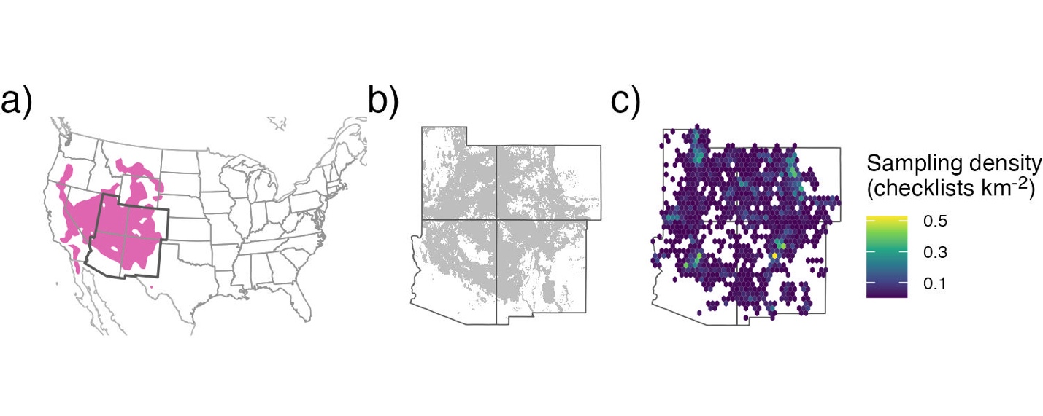
Figure 1. The full species range for (a) pinyon jays (pink region; data from eBird Status and Trends), with our study region delineated by the darker borders (southwestern USA, including Arizona, Colorado, New Mexico, and Utah). The (b) range of two-needled pinyon in our study region, along with the (c) sampling density (in checklists km⁻²) across all years for pinyon jay based on eBird data (2010-2022) after spatial and temporal subsampling and filtering checklists to areas with two-needle pinyon basal area as shown in (b).

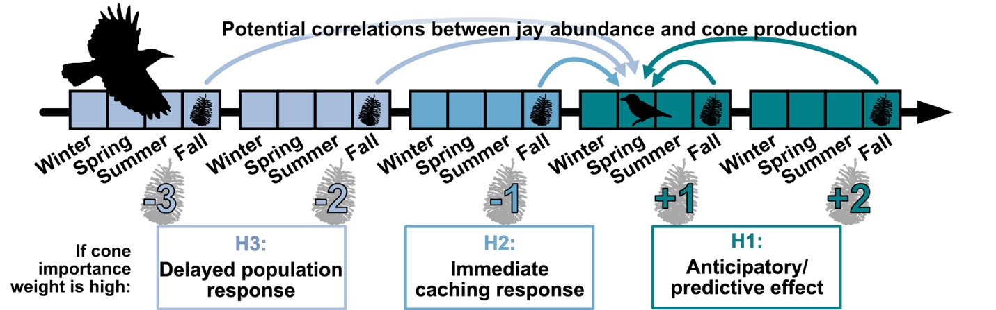

Figure 2. A timeline of hypothesized temporal relationships between pinyon jay abundance and pinyon cone availability. Three hypotheses describe how jay abundance in a given focal year (e.g., bird icon in timeline) is related to pinyon cone (seed) production in past and future time periods (cone icons along timeline), including H1: jays “anticipate” seed availability through utilization of other food resources (e.g., acorns, juniper berries) that mature more quickly than pinyon seeds or because they see pinyon cones developing in an area; H2: jays respond “immediately” to pinyon seeds produced in the previous fall and winter by nesting near cache sites the following spring nesting season; H3: jays have a “delayed” response to seed availability as the young produced during the caching year enter the breeding population 1.5-2 years later. The numerical values along the bottom of the timeline (-3, -2, …, +2) indicate potential temporal coupling (past, concurrent, future years) between jays and pinyon seeds.

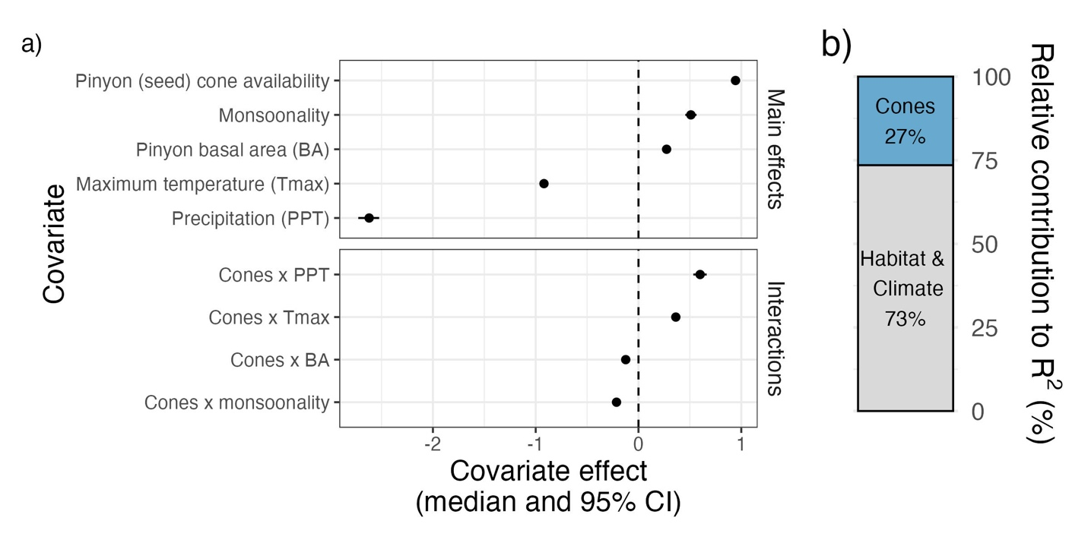
Figure 3. a) Covariate effects for all main effects and all two-way interactions involving pinyon cone (seed) production (“Cones”) and b) the relative contribution of covariates to model fit (R²), based on improvement to model fit between a null model and the addition of covariate groups. In a), all covariates were standardized, allowing for comparison of the effect sizes of the main effects across covariates. Covariate effects are shown as the posterior median (filled symbols) and 95% credible interval (CI, whiskers); any covariate effect with a 95% CI that crosses the dashed line at zero indicates that the corresponding covariate or interaction have no clear effect on pinyon jay abundance.

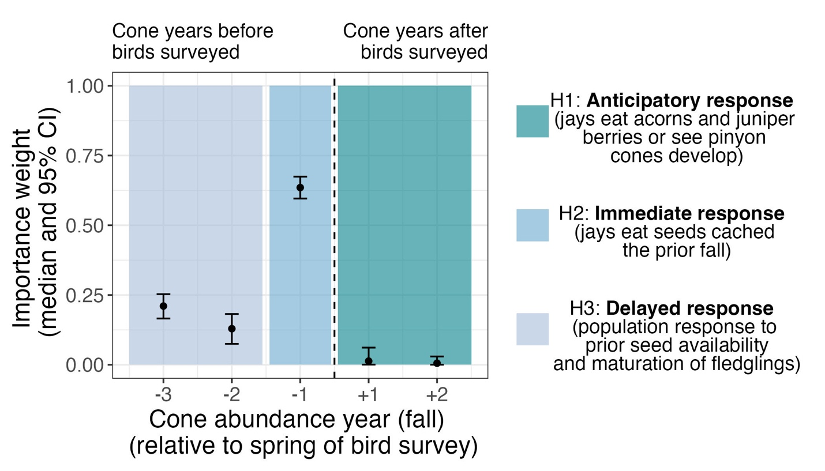
Figure 4. Posterior estimates (median and 95% CI) of the importance weights (w terms, see equation 5) describing the temporal coupling between pinyon jay abundance and pinyon cone (seed) availability (see Figure 2). Colored boxes indicate time periods that align with the three ecological hypotheses describing an anticipatory (H1), immediate (H2), and delayed (H3) response of jays to pinyon seed availability. The dotted vertical line separates periods that align with birds responding to past cone availability (left of the dotted line; H2 and H3) versus periods associated with birds responding to future seed availability (right of dotted line; H1).

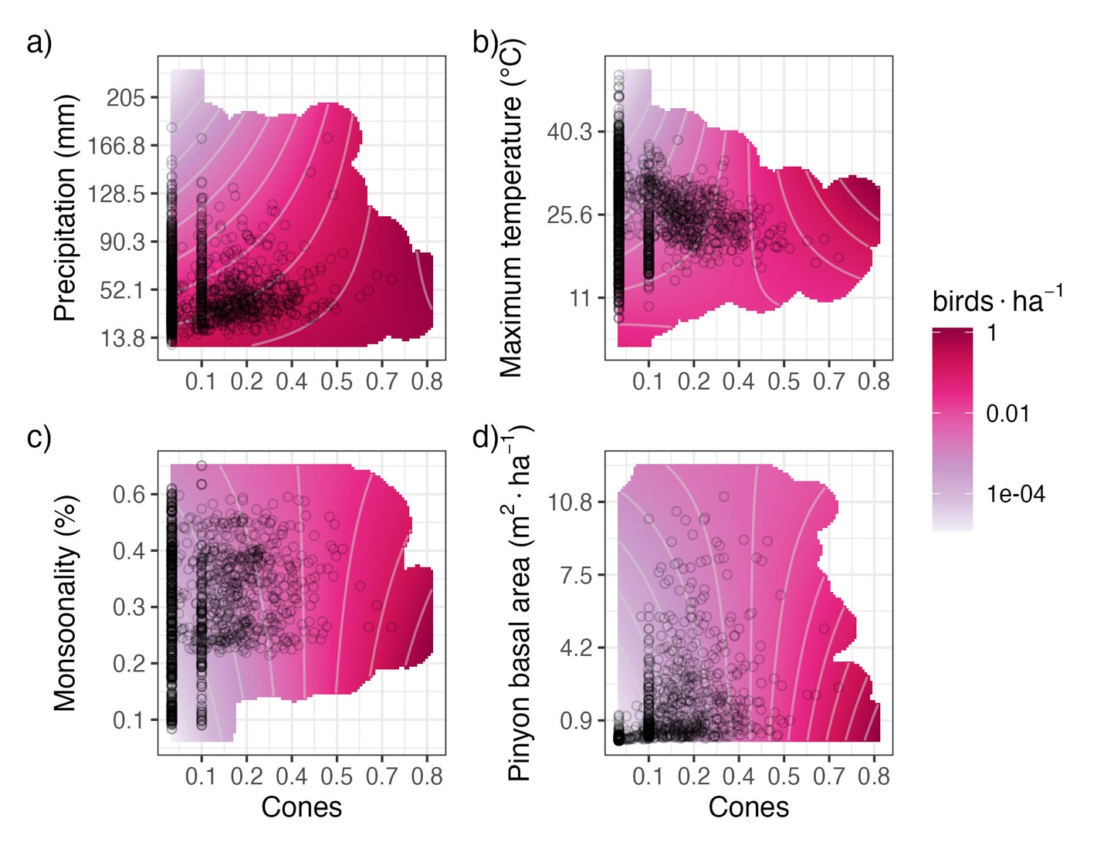

Figure 5. Interaction plots for the four covariates that significantly interacted with pinyon cone (seed) availability to influence pinyon jay abundance (see Figure 3), including: a) precipitation, b) maximum temperature, c) monsoonality, and d) pinyon basal area. The contour lines and color (pink) intensity denote the predicted number of birds per hectare, where darker pink/magenta colors correspond to a greater number of birds associated with that combination of covariates. Black circles represent a random sample of the observed covariate data, and the pink shading is trimmed to exclude covariate values that were not represented in the data.

