PNAS Template for Supporting Information

This PNAS template for supporting information (SI) may be used to organize your SI Appendix. Once formatted, this first page should be deleted. The template is intended to provide a clearly organized PDF that readers can easily navigate to specific information, figures, and tables. Movie files or large datasets must be presented as separate files. Further information is available in the PNAS Author Center.

Using the Template
Paste the appropriate text (title, author list, and corresponding authors) into the cover page. You may maintain the template formatting or reapply the styles after pasting your text into the template. On the cover page, complete the relevant description of the SI and delete text that does not apply.

Supporting information for Brief Reports is limited to extended methods, essential supporting datasets, and videos (no additional tables or figures).

SI figures should be placed on separate pages with a figure legend set immediately below each figure. Table titles should be set immediately above each SI table. Note that tables extending beyond the width of the page can be included; nonstandard page sizes are accepted as part of your SI Appendix file.

All references cited in the SI Appendix should be included in a separate reference list at the end of this file.

Save your completed SI Appendix file as a PDF. SI will be published as provided by the authors; it will not be edited or composed.

Delete this first page prior to submission.

Updated August 2025

Supporting Information for
Caching in: A seed dispersal mutualism signals the decline of a songbird-pine system

Ana Miller-ter Kuile^{1,2}, Andreas P. Wion³, Kyle C. Rodman⁴, Jamie S. Sanderlin², Kiona Ogle¹

Ana Miller-ter Kuile
Email: ana.miller-ter-kuile@nau.edu

This PDF file includes:

Supporting text
Figures S1 to S6
SI References

Supporting Information Text
SI Materials and Methods
Model Implementation, Convergence, and Diagnostics. We implemented the N-mixture model in the Bayesian software JAGS (1) (version 4.3.0) using R (2) (version 4.5.1) and the jagsUI wrapper package (3) (version 1.6.2). JAGS uses Markov chain Monte Carlo (MCMC) methods to sample from the joint posterior distribution of the model parameters. We initially produced 4000 samples for three parallel MCMC sequences to determine the number of iterations (samples) needed to sufficiently sample from the posterior based on the Raftery diagnostic (4), and we re-ran the model to obtain a sufficient number of iterations. We qualitatively assessed convergence of the MCMC sequences by inspecting history and autocorrelation plots generated with the mcmcplots package (5) (version 0.4.3). We quantitatively evaluated convergence using the raftery.diag function in the coda package (6) (version 0.19.4.1); the MCMC sequences were deemed to have converged if the Gelman-Rubin statistic, $\hat{R}$, for all root nodes in the model was less than 1.1 (7). We assessed model goodness-of-fit by comparing observed eBird count data to predicted count data based on simulating “replicated” count data from the Binomial distribution in Equation (1). We tested for spatial dependence in the residuals (observed – predicted counts) within each year using spline correlograms produced by the R package ncf (8) (version 1.3-2).
Out of Sample Model Validation. To evaluate predictions outside of the data used to fit the model, we first removed the in-sample (“training”) data (22,295 checklists) from the available eBird checklist data (833,834 checklists). We performed the same set of steps for spatial and temporal stratification on the remaining checklists (811,539 checklists) for an additional 20,380 checklists that represented “out-of-sample” (“validation”) data. We evaluated out-of-sample model fit using ~1000 posterior samples for covariate effects and intercepts from the in-sample dataset and model. We then examined model replicative ability (RMSE) of the in-sample and out-of-sample datasets.
Permuted Variable Importance. We determined variable importance for our 5 covariates by permuting each covariate 100 times and assessing mean decrease in accuracy relative to intact data based on changes in RMSE (9)
Software Used. We prepared data using the here (10) (version 1.0.1), tidyverse (11) (version 2.0.0), sf (12) (version 1.0.21), terra (13) (version 1.8.54), readxl (14) (version 1.4.5), exactextractr (15) (version 0.10.0), spatialEco (16) (version 2.0-2), nngeo (17) (version 0.4.8), auk (18) (version 0.8.2), lubridate (19) (version 1.9.4), prism (20) (version 0.0.6), FNN (21) (version 1.1.4.1), and data.table (22) (version 1.17.6) packages.
SI Results
Model Performance and Goodness-of-fit. All stochastic model parameters converged with an $\hat{R}≤$ 1.1 (Fig. S3). Regressions of observed data versus predicted data (based on the posterior mean of 1000 samples of replicated data) yielded a mean R² of 0.17 (s.e. = 0.005). In general, the model over-estimated small pinyon jay counts but performed well for most other values (Fig. S4). The RMSE for our in-sample dataset had an average value of 3.25 (s.e. = 0.001) and the out-of-sample dataset had a value of 5.10 (s.e. = 0.0002; Fig. S5). Thus, our model predicted our in-sample data slightly better than the out-of-sample data, but neither RMSE values are large considering the scale of the count data (counts per checklist ranged from 0 to 350), suggesting good model fit and predictive capacity. We observed no evidence for strong or consistent spatial autocorrelation in model residuals (Fig. S6).
Covariates Influencing Detection. Pinyon jay detection probability was most influenced by the number of observers, such that fewer birds were observed on checklists involving more observers (observer number effect: -1.01 [-1.10, -1.04]). Checklists where observers walked at faster speeds had more detections (speed effect: 0.43 [0.40, 0.46]). Speed incorporated the distance (“effort”) and duration variables from the original checklists, and this effect is likely influenced by checklists where observers went further in a traveling checklist. Fewer birds were observed at later start times (time effect: -0.19 [-0.25, -0.14]) and there was a weak effect in which longer surveys had fewer detections (survey length effect: -0.03 [-0.07, -0.003]).

Figures

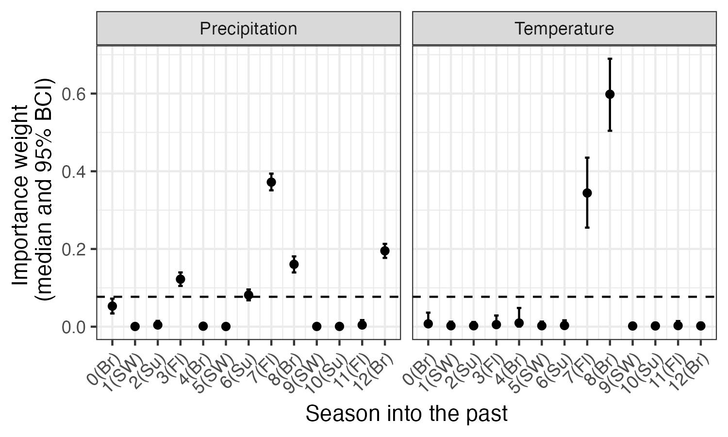

Fig. S1. Posterior estimates (median and 95% CI) for the seasonal importance weights for climate (precipitation and maximum temperature; w terms, see equation 5 in the main text). The dashed horizontal line indicates the ‘null’ weight in which all time periods would have equal weights. Any weights that extend clearly above this line suggest significant importance of the corresponding climate variable during that season to pinyon jay abundance. Seasons are based on pinyon jay biology: Br (breeding; February - May), Fl (fledging; May - June), Su (summer localized foraging; July), and SW (summer and winter dispersed foraging or ‘irruption’ period; August - January).

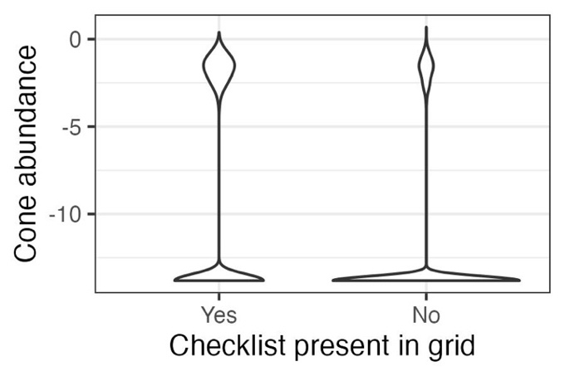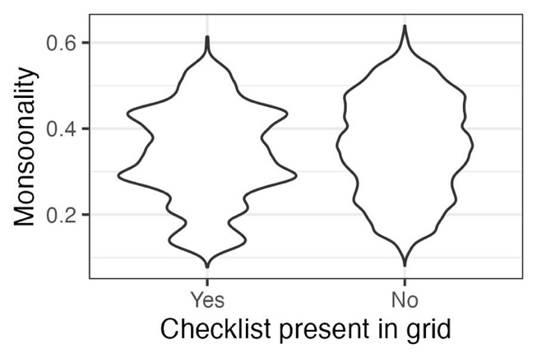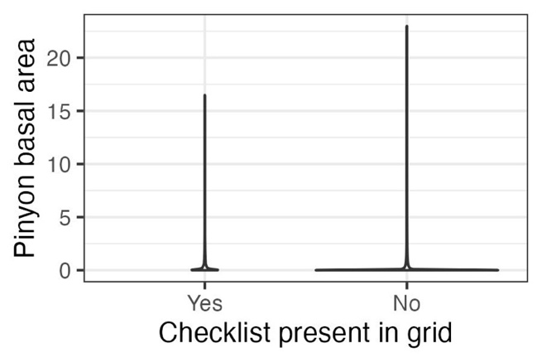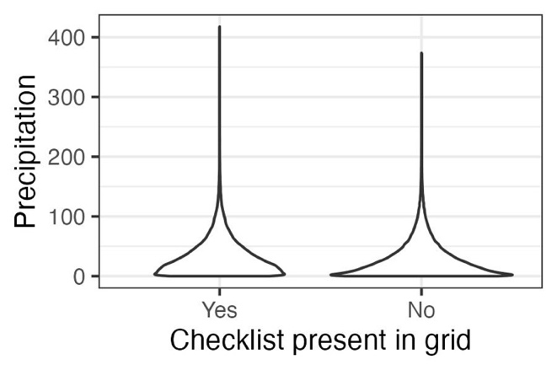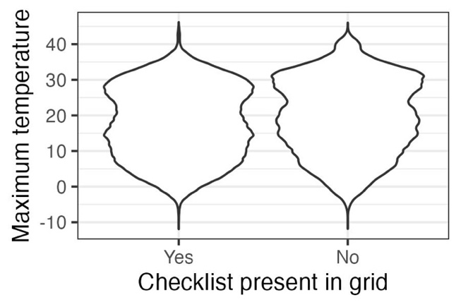

Fig. S2. Validation results supporting the use of space-for-time substitution of replicate checklists within sampling polygons. To use replicate eBird surveys within a year at a location in models such as N-mixture or occupancy models, checklists need to represent sites that display the full range of values for covariates of interest. In general, checklists in our dataset meet these criteria. Data represented here are values for all raster grid cells for all years (~1 million grid cells, depending on covariate). Thus, for the two covariates for which we are missing the upper tails, (a) cone availability and (e) pinyon basal area, these represent extreme outliers (<1% of total values in the dataset; ~20-200 raster grid cells, depending on covariate).

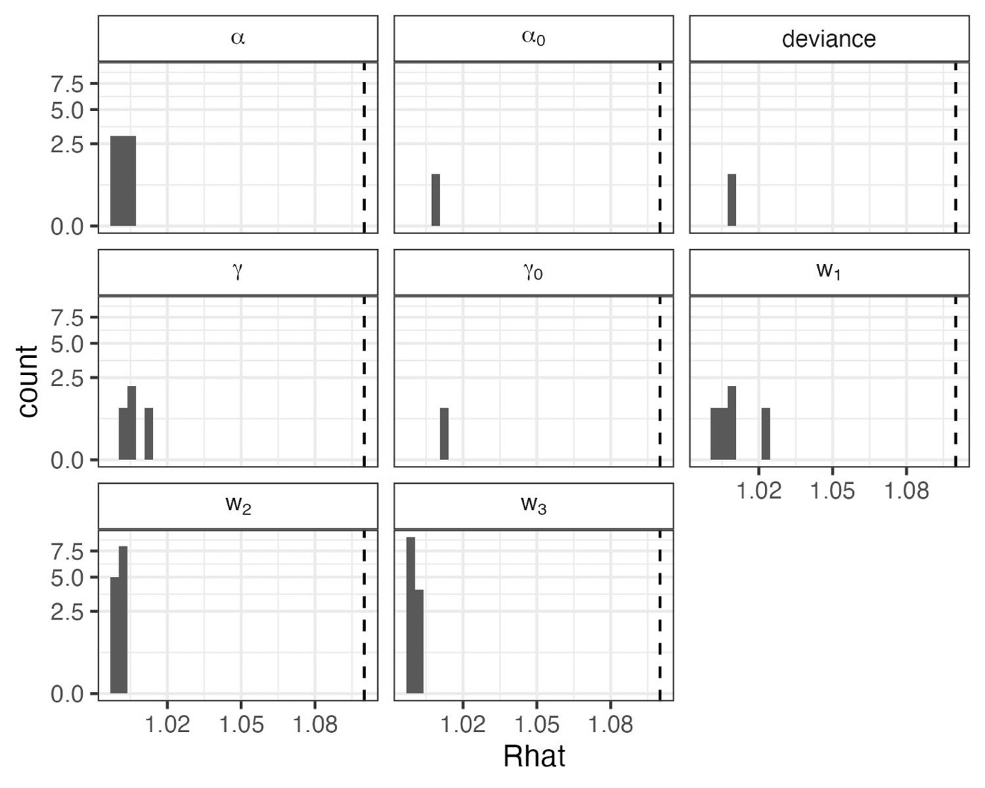

Fig. S3. Convergence statistics for stochastic parameters in the N-mixture for representing biological ($α$ and $α_{0}$) and detection ($γ$ and $γ_{0}$) covariate effects, deviance (an overall index of model fit), and the cone and climate importance weights (w₁, w₂, and w₃). All quantities converged with potential scale reduction ($\hat{R}$) values < 1.1 (dashed line).

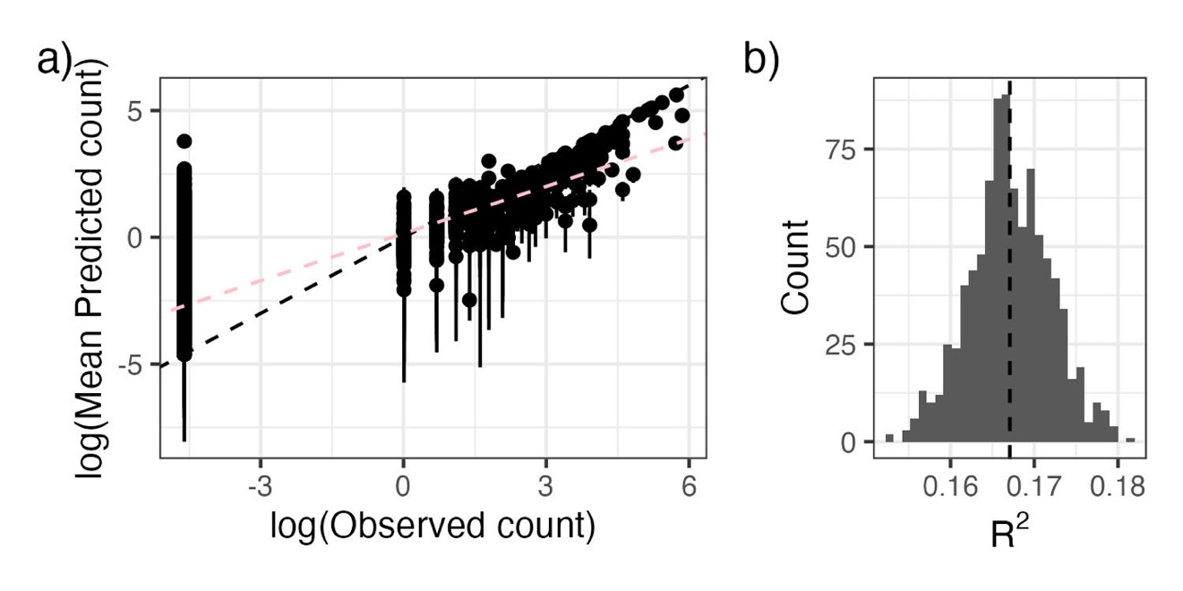

Fig. S4. As an evaluation of goodness-of-fit, we examined a) the relationship between observed pinyon jay counts and counts predicted from the model (median and 95% Bayesian Credible Interval) and b) the R² of this relationship from ~1000 posterior samples. In a), the black dashed line represents the 1:1 line; the pink line corresponds to the best-fit line between log-log predicted and observed bird count values. In b) the dashed vertical line represents the mean R².

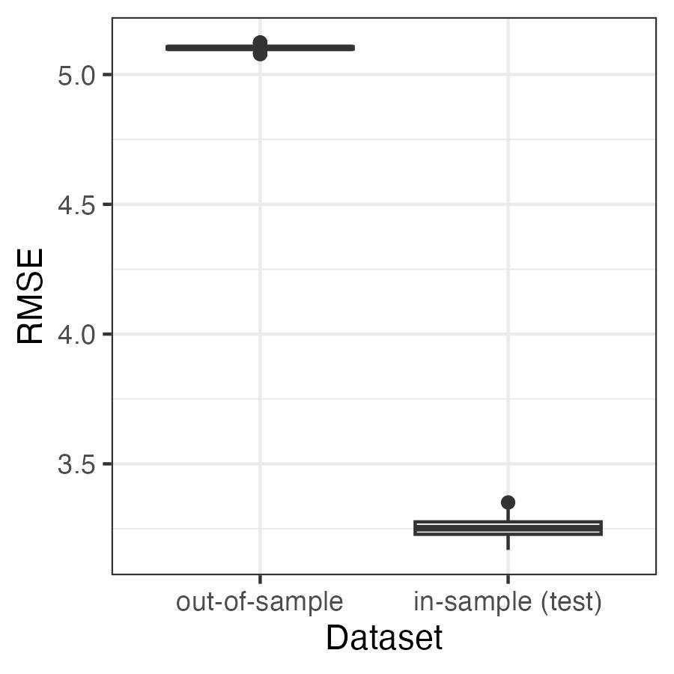

Fig. S5. Root mean squared error (RMSE) to evaluate the predictive ability of the model applied to the in-sample (“test”) and out-of-sample datasets. Values for RMSE are on the scale of the data (counts of pinyon jays per square kilometer). The RMSE values are relatively small compared to the range of possible counts in a checklist (0 to 350 birds per hectare in our test dataset).

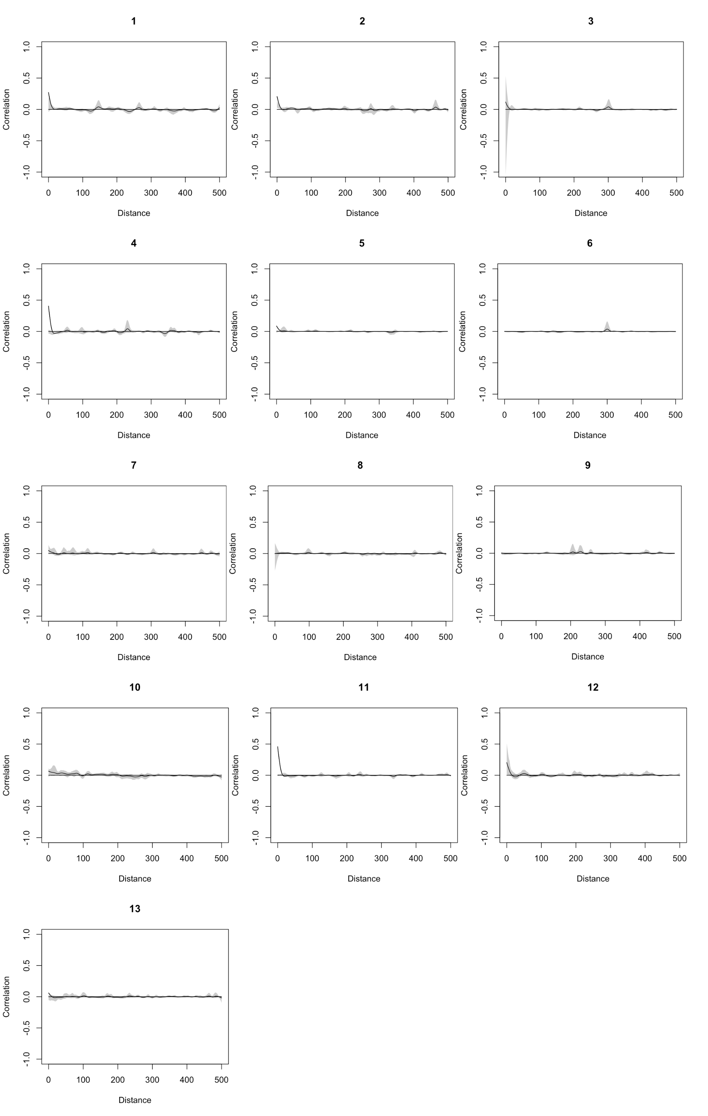













Fig. S6. Evaluation of spatial autocorrelation (Pearson correlation on the y-axis) for residuals in each year (year indices are indicated above each figure panel, where 1 = 2010, 2 = 2011, …, 13 = 2022). Distance values are in kilometers. There was no consistent evidence of spatial autocorrelation of residuals.

SI References

1. M. Plummer, JAGS: A program for analysis of Bayesian graphical models using Gibbs sampling. Proceedings of the 3rd international workshop on distributed statistical computing 124 (2003).
2. R Core Team, R: A language and environment for statistical computing. (2020). Deposited 2020.
3. K. Kellner, jagsUI: a wrapper around “rjags” to streamline JAGS analyses. (2021). Deposited 2021.
4. A. E. Raftery, S. M. Lewis, “The number of iterations, convergence diagnostics and generic Netropolis algorithms” in Practical Markov Chain Monte Carlo, (Chapman and Hall, 1995).
5. S. M. Curtis, mcmcplots: Create Plots from MCMC Output. https://doi.org/10.32614/CRAN.package.mcmcplots. Deposited 6 July 2010.
6. M. Plummer, et al., coda: Output Analysis and Diagnostics for MCMC. https://doi.org/10.32614/CRAN.package.coda. Deposited 4 June 1999.
7. A. Gelman, D. B. Rubin, Inference from Iterative Simulation Using Multiple Sequences. Statist. Sci. 7 (1992).
8. O. N. Bjornstad, ncf: Spatial Covariance Functions. The R Foundation. https://doi.org/10.32614/cran.package.ncf. Deposited 14 April 2008.
9. L. Breiman, Random Forests. Machine Learning 45, 5–32 (2001).
10. K. Muller, here: A simpler way to find your files. (2020). Deposited 2020.
11. H. Wickham, et al., Welcome to the Tidyverse. JOSS 4, 1686 (2019).
12. E. Pebesma, R. Bivand, Spatial Data Science: With Applications in R, 1st Ed. (Chapman and Hall/CRC, 2023).
13. R. J. Hijmans, terra: Spatial Data Analysis. The R Foundation. https://doi.org/10.32614/cran.package.terra. Deposited 20 March 2020.
14. H. Wickham, J. Bryan, readxl: Read Excel Files. https://doi.org/10.32614/CRAN.package.readxl. Deposited 14 April 2015.
15. Daniel Baston, exactextractr: Fast Extraction from Raster Datasets using Polygons. The R Foundation. https://doi.org/10.32614/cran.package.exactextractr. Deposited 1 August 2019.
16. J. S. Evans, M. A. Murphy, spatialEco. (2023). Deposited 2023.
17. M. Dorman, nngeo: k-Nearest Neighbor Join for Spatial Data. The R Foundation. https://doi.org/10.32614/cran.package.nngeo. Deposited 16 January 2018.
18. M. Strimas-Mackey, E. Miller, W. Hochachka, auk: eBird Data Extraction and Processing in R. The R Foundation. https://doi.org/10.32614/cran.package.auk. Deposited 5 July 2017.
19. G. Grolemund, H. Wickham, Dates and Times Made Easy withlubridate. J. Stat. Soft. 40 (2011).
20. E. Hart, K. Bell, prism: Access data from the Oregon State Prism climate project. (2015). https://doi.org/10.5281/ZENODO.33663. Deposited 12 November 2015.
21. A. Beygelzimer, et al., FNN: Fast Nearest Neighbor Search Algorithms and Applications. The R Foundation. https://doi.org/10.32614/cran.package.fnn. Deposited 17 March 2010.
22. T. Barrett, et al., data.table: Extension of `data.frame`. The R Foundation. https://doi.org/10.32614/cran.package.data.table. Deposited 15 April 2006.

