Supporting Information for: Caching in: Quantifying the temporal relationships of seed dispersal interactions
Author List: Ana Miller-ter Kuile^{1,2}, Andreas P. Wion³, Kyle C. Rodman⁴, Kiona Ogle¹, Jamie S. Sanderlin²
Author Affiliations:
¹ Northern Arizona University School of Informatics, Computing, and Cyber Systems, Flagstaff, Arizona, USA
² USDA Forest Service Rocky Mountain Research Station, Flagstaff, Arizona, USA
³ Forest Stewards Guild, Santa Fe, New Mexico, USA
⁴ Ecological Restoration Institute, Northern Arizona University, Flagstaff, Arizona, USA
Corresponding author: Ana Miller-ter Kuile, ana.miller-ter-kuile@nau.edu, Northern Arizona University School of Informatics, Computing, and Cyber Systems, 1295 Knoles Drive, Flagstaff, Arizona 86011

SI Methods
We implemented the above model in the Bayesian software JAGS (Plummer, 2003, version 4.3.0) using R (R Core Team, 2020, version 4.5.1) and the jagsUI wrapper package (Kellner, 2021, version 1.6.2). We prepared data using the here (Muller, 2020, version 1.0.1), tidyverse (Wickham et al., 2019, version 2.0.0), sf (Pebesma & Bivand, 2023, version 1.0.21), terra (Hijmans, 2020, version 1.8.54), readxl (Wickham & Bryan, 2015, version 1.4.5), exactextractr (Daniel Baston, 2019, version 0.10.0), spatialEco (Evans & Murphy, 2023, version 2.0-2), nngeo (Dorman, 2018, version 0.4.8), auk (Strimas-Mackey et al., 2017, version 0.8.2), lubridate (Grolemund & Wickham, 2011, version 1.9.4), prism (Hart & Bell, 2015, version 0.0.6), FNN (Beygelzimer et al., 2010, version 1.1.4.1), and data.table (Barrett et al., 2006, version 1.17.6) packages.

SI Results
Covariates influencing detection
Pinyon jay detection probability was most influenced by the number of observers, with fewer birds observed on checklists with more observers (-1.01 [-1.10, -1.04]). Checklists where observers walked at faster speeds had more detections (0.43 [0.40, 0.46]). Speed incorporated the distance (“effort”) and duration variables from the original checklists and this effect is likely influenced by checklists where observers went further in a traveling checklist. Fewer birds were observed at later start times (-0.19 [-0.25, -0.14]) and there was a weak effect in which longer surveys had fewer detections (-0.03 [-0.07, -0.003]).

SI Figures
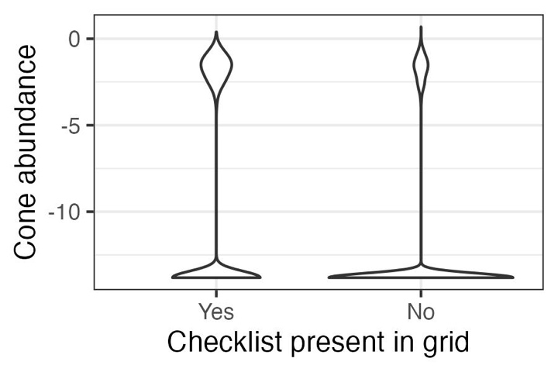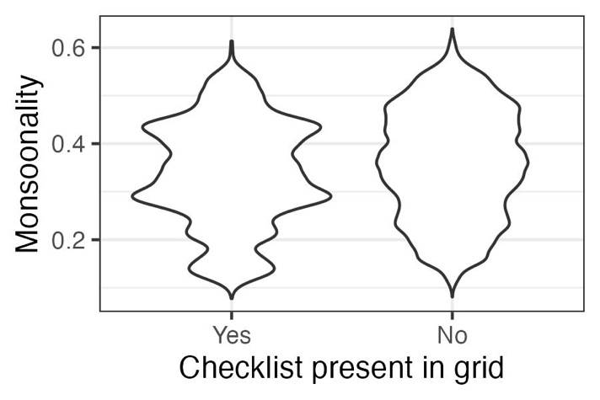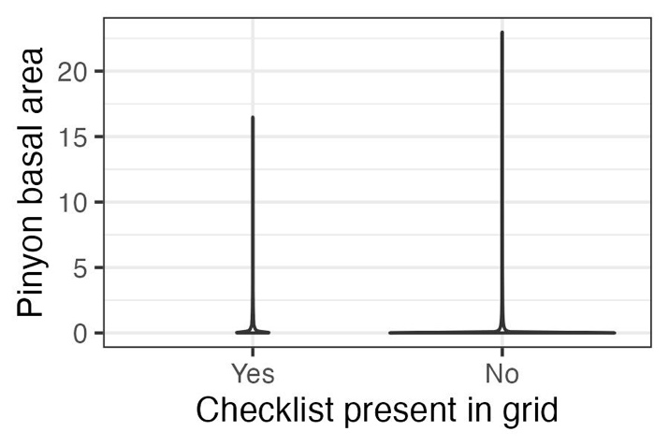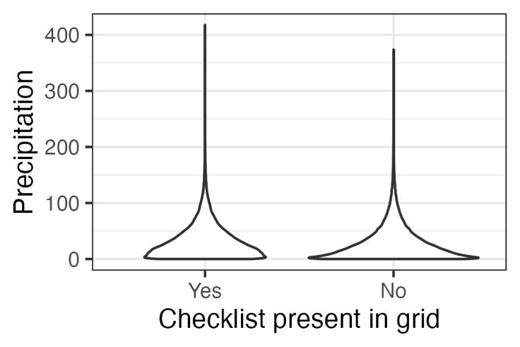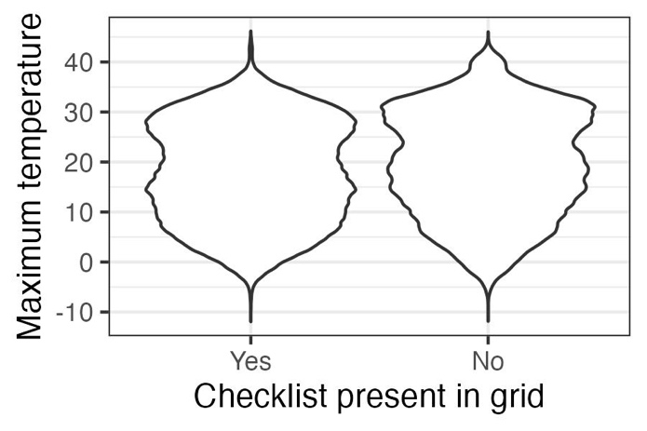
SI Figure 1. Validation results supporting the use of space-for-time substitution of replicate checklists within sampling polygons. To use replicate eBird surveys within a year at a location in models such as N-mixture or occupancy models, checklists need to represent sites that display the full range of values for covariates of interest. In general, checklists in our dataset meet these criteria. Data represented here are values for all raster grid cells for all years (~1 million grid cells, depending on covariate). Thus, for the two covariates for which we are missing the upper tails, (a) cone availability and (e) pinyon basal area, these represent extreme outliers (<1% of total values in the dataset; ~20-200 raster grid cells, depending on covariate).

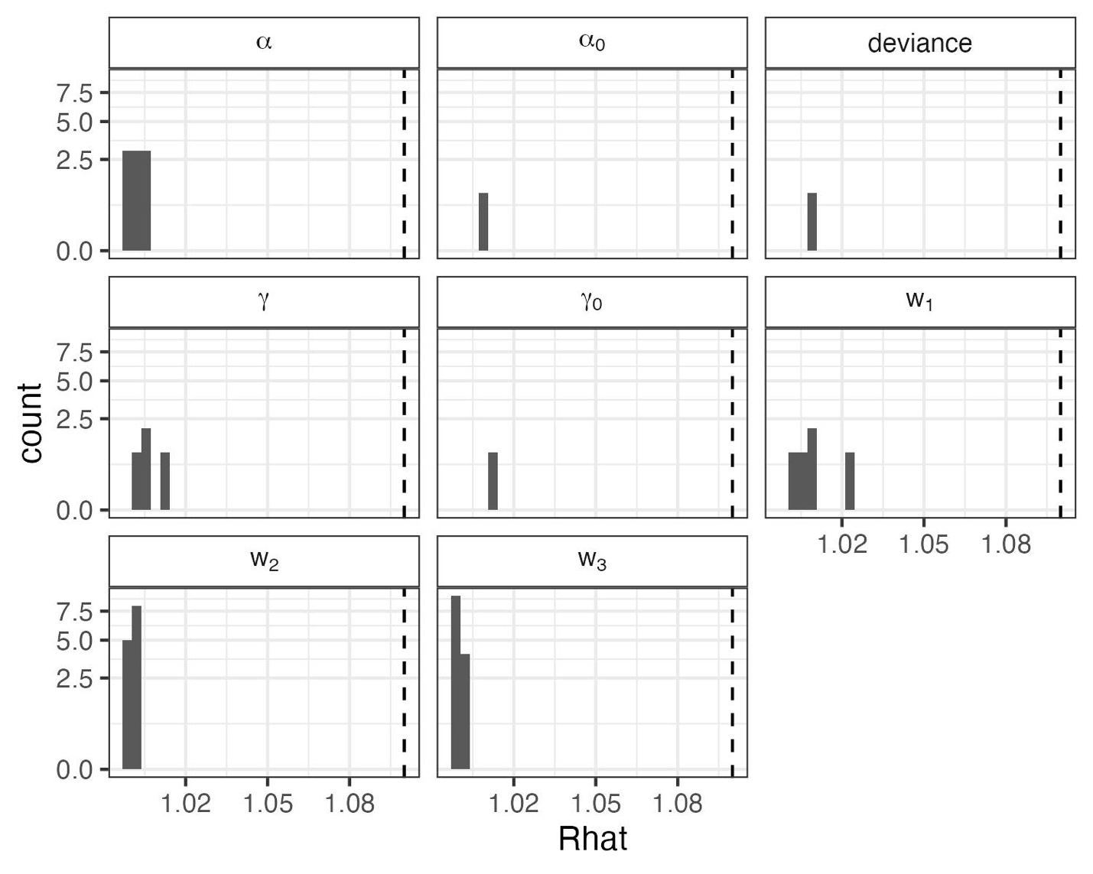
SI Figure 2. Convergence statistics for stochastic parameters in the N-mixture for representing biological ($α$ and $α_{0}$) and detection ($γ$ and $γ_{0}$) covariate effects, deviance (an overall index of model fit), and the cone and climate weights (w₁, w₂, and w₃). All parameters converged with potential scale reduction ($\hat{R}$) values < 1.1 (dashed line).
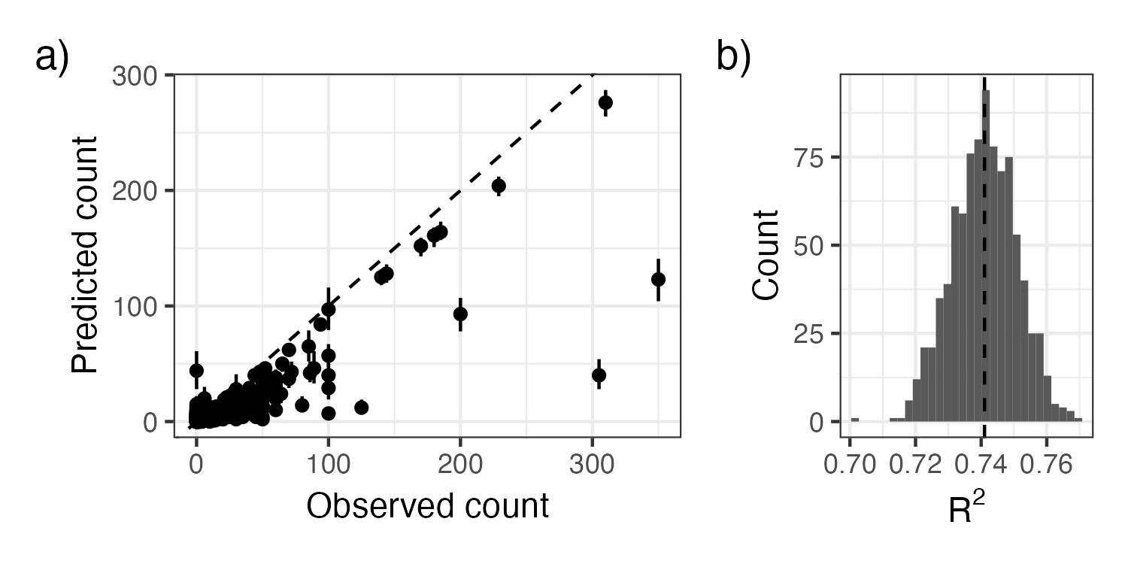
SI Figure 3. As an evaluation of goodness-of-fit, we examined a) the relationship between observed pinyon jay counts and counts predicted from the model (median and 95% Bayesian Credible Interval) and b) the R² of this relationship from ~1000 posterior samples. In a), the dashed line represents the 1:1 line where predictions exactly match. In b) the dashed vertical line represents the mean R².

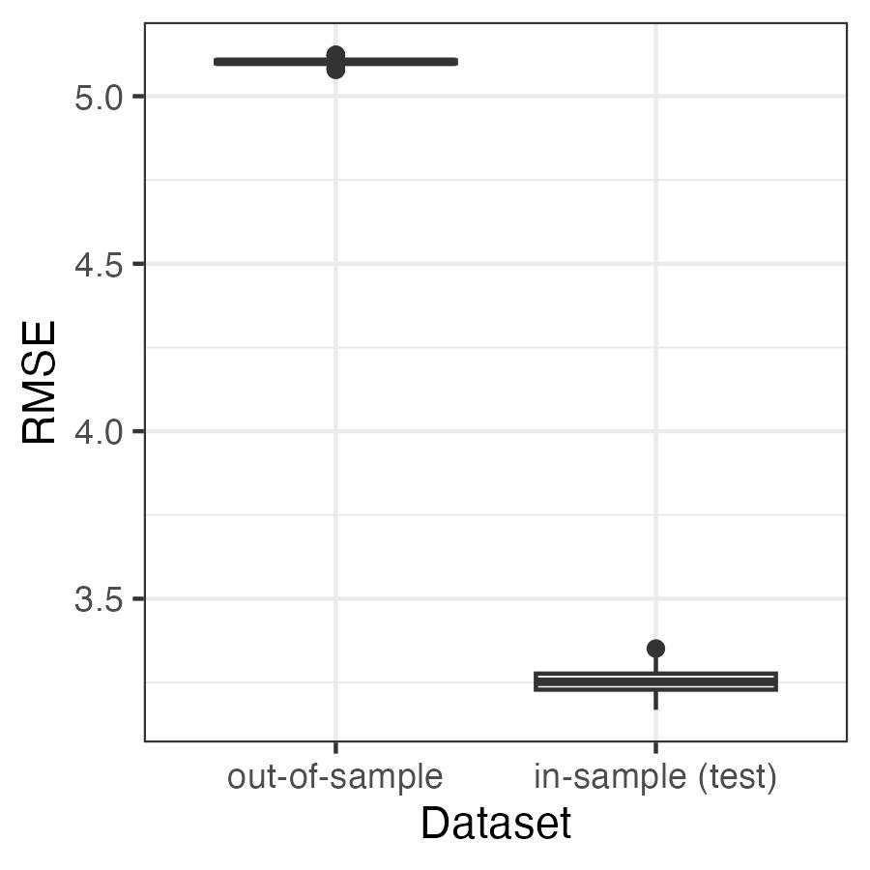
SI Figure 4. Root mean squared error (RMSE) to evaluate the predictive ability of the model applied to the in-sample (“test”) and out-of-sample datasets. Values for RMSE are on the scale of the data (counts of pinyon jays per square kilometer). The RMSE values are relatively small compared to the range of possible counts in a checklist (0 to 350 birds per hectare in our test dataset).

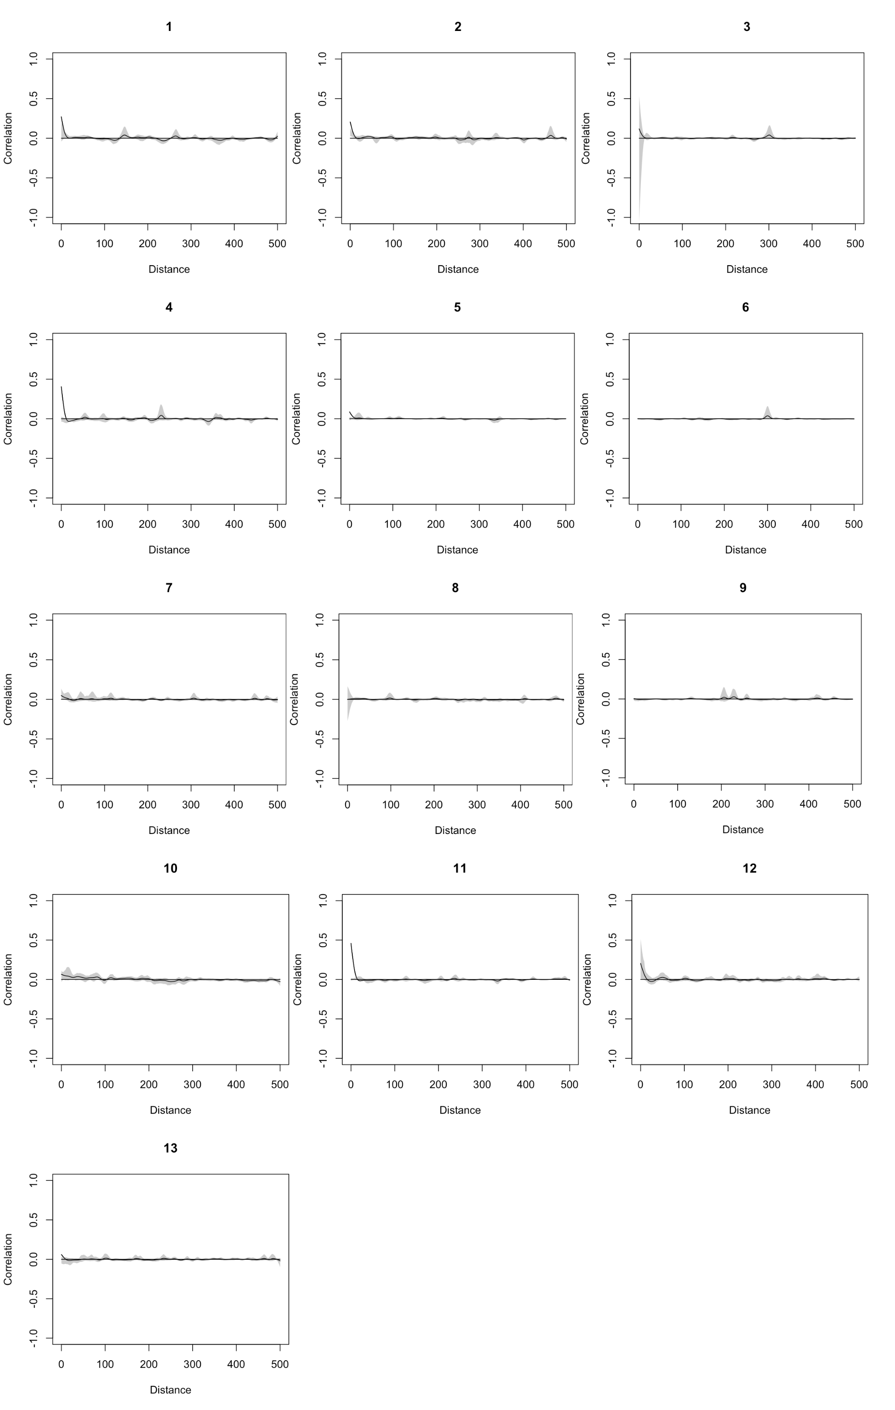


SI Figure 5. Evaluation of spatial autocorrelation (Pearson correlation on the y-axis) for residuals in each year (year indices are indicated above each figure panel, where 1 = 2010, 2 = 2011, …, 13 = 2022). There was no consistent evidence of spatial autocorrelation of residuals.
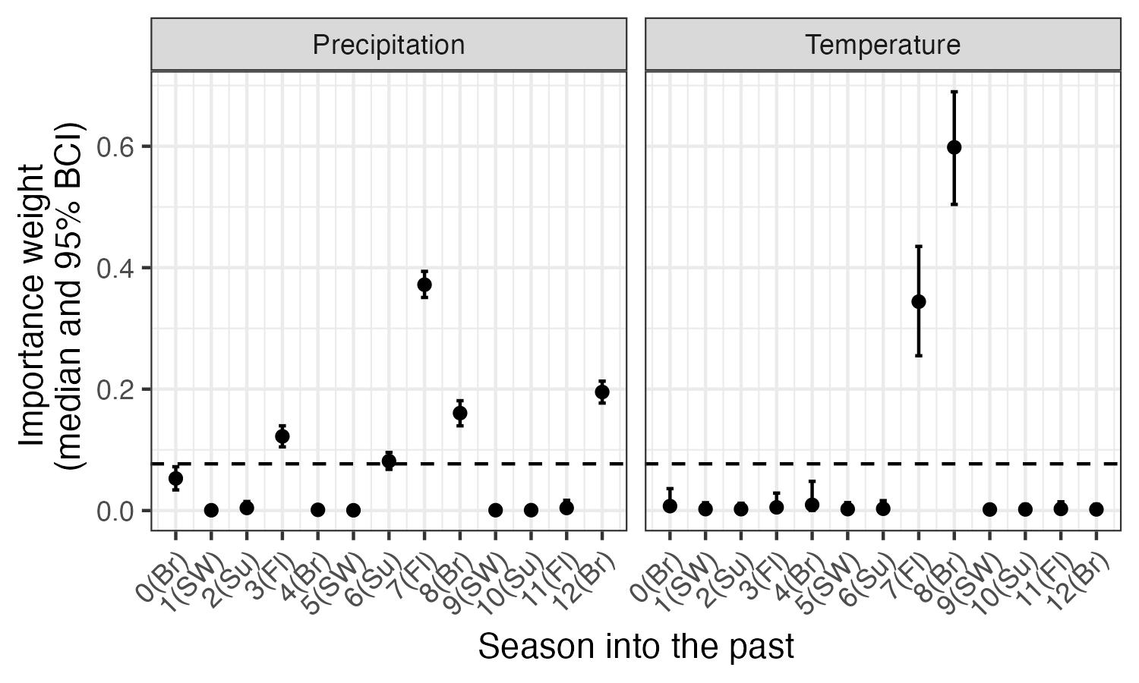
SI Figure 6. Posterior estimates (median and 95% CI) for the seasonal importance weights for climate (precipitation and maximum temperature; w terms, see equation 5). The dashed horizontal line indicates the ‘null’ weight in which all time periods would have equal weights. Any weights that extend clearly above this line suggest significant importance of the corresponding climate variable during that season to pinyon jay abundance. Seasons are based on pinyon jay biology and include: Br (breeding; February - May), Fl (fledging; May - June), Su (summer localized foraging; July), and SW (summer and winter dispersed foraging or ‘irruption’ period; August - January).

